You can do this project on any computer with XP Pro or Home, but since it involves using a script I wrote to modify the registry, there is a chance that it could crash your machine, so I recommend that you work in S214.

Starting Your Computer
- Start your virtual machine. Log in with your usual account, which has Administrative privileges. This project works in VMWare, but not in Microsoft Virtual PC. If you are working at home, use a real machine, not Microsoft Virtual PC.

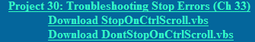
Downloading the Scripts
- Open a browser and go to samsclass.info . Click the CNIT 235 link. Click the Projects link and scroll down to Project 30.
- Right-click the Download StopOnCtrlScroll.vbs link and select Save Target As…. Save the file on your desktop.
- Right-click the Download DontStopOnCtrlScroll.vbs link and select Save Target As…. Save the file on your desktop.

Configuring Your PC to Stop With Right-Ctrl-ScrollLock-ScrollLock
- Double-click the Download StopOnCtrlScroll.vbs icon on the desktop.
- If a Microsoft AntiSpyware Alert box pops up, saying A script file E:\Documents and Settings\CNIT\Desktop\StopOnCtrlScroll.vbs is trying to execute, click the Allow button.
- If an Open File/Security Warning box opens saying Do you want to open this file? with a File Name of StopOnCtrlScroll.vbs, click Open.
- A Windows Script Host box should open, as shown below on this page. This registry key allows you to crash Windows from the keyboard, as explained in link Ch_33e on my Web page. Click OK to close the Windows Script Host box.
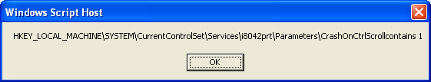

- Restart your computer – the registry key does not take effect until after a restart. Log in with an administrative account again.

Customizing How Windows Handles STOP Errors – Using the Default Condition
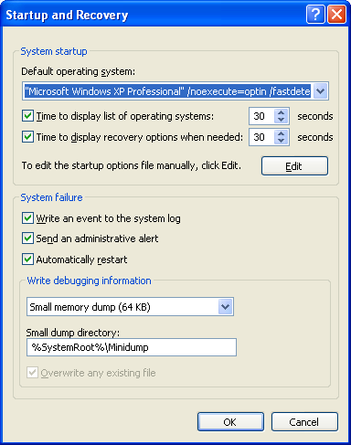
- Click Start, right-click My Computer, and click Properties.
- In System Properties, click the Advanced tab. In the Startup and Recovery section, click the Settings button.
- In the Startup and Recovery box, in the System failure section, make sure that the Write an event to the system log box is checked, as shown to the right on this page.
- In the System failure section, make sure that the Automatically Restart box is checked, as shown to the right on this page.
- In the Write debugging information section, make sure Small memory dump (64 KB) is selected, as shown to the right on this page.
- In the Startup and Recovery box, click OK.
- In the System Properties box, click OK.

Stopping Windows
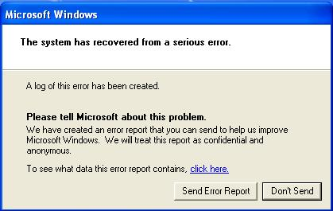
- If any windows are open, close them.
- Hold down the right Ctrl key on the keyboard and press the Scroll Lock key twice. The computer immediately restarts – the Blue Screen of Death is shown only very briefly, if at all.
- Log in with your usual account.
- A few seconds after logging in, you will see a box open saying Windows has recovered from a serious error, as shown to the right on this page. Click the Don’t Send button.

Observing the Stop Event in the System Log
- Click Start, right-click My Computer, and click Manage.
- In the left pane of Computer Management, expand Event Viewer. Click System once to select it.
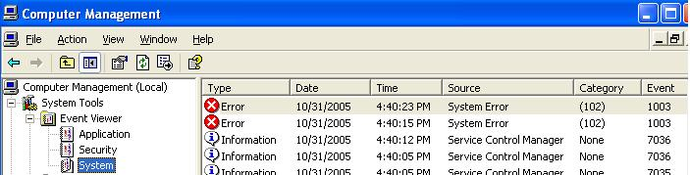
- Find the Error event with an Event ID of 1003 (or 1001, if you are not using VMware), as shown below on this page.

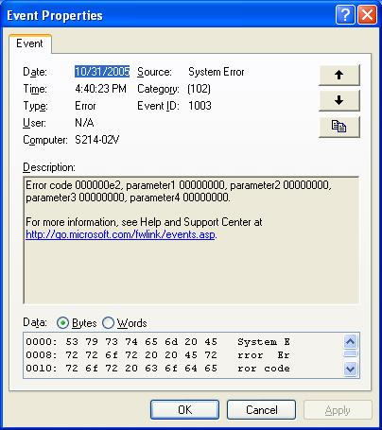
- Double-click the event 1001 item in the right pane of Computer Management.
- When the Event Properties box opens, compare it to the example shown to the right on this page. Make sure it shows an Event ID of 1003 (or 1001, if you are not using VMware).
- Press Alt+PrtScn to copy the window to the clipboard.
- On the Start menu, click Run. Enter the command mspaint and press the Enter key. Paint opens.
- Press Ctrl+V on the keyboard to paste the image into the Paint window. Save the document in the Shared Documents folder with the filename Your Name Proj 30a. Select a Save as type of JPEG. Close Paint.

Revealing the Blue Screen of Death
- Click Start, right-click My Computer, and click Properties.
- In System Properties, click the Advanced tab. In the Startup and Recovery section, click the Settings button.
- In the Startup and Recovery box, in the System failure section, make sure that the Write an event to the system log box is checked.
- In the System failure section, clear the Automatically Restart box.
- In the Startup and Recovery box, click OK.
- In the System Properties box, click OK.

Stopping Windows
- If any windows are open, close them.
- Hold down the right Ctrl key on the keyboard and press the Scroll Lock key twice. The Blue Screen of Death appears as shown on the next page, although the details shown on the screen are different.
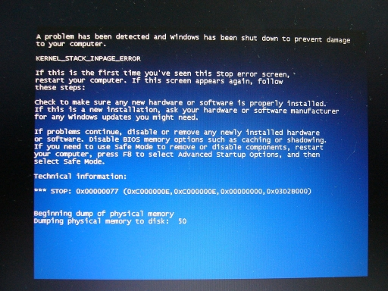
Symbolic Error Name

Error Number

- In the example above, the Symbolic Error Name is KERNEL_STACK_INPAGE_ERROR. Find the information that appears in that part of your screen and write it in the box below.
- In the example above, the Error Number is 0x00000077 or just 77. Find the Error Number on your screen and write it in the box below.

Symbolic Error Name:

Error Number:

- In the menu bar of the virtual machine, click VM, Power, Reset. A VMware Workstation box opens asking if you are sure you want to restart the guest operating system. Click OK. (If you are working at home on a physical machine, press the reset button on the front panel.)

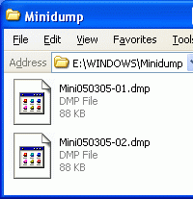
Viewing the Dump Files
- Log in with your usual account. Open My Computer. Open drive C:. Open the Windows folder, and the Minidump folder. You should see at least two .dmp files, as shown to the right on this page.
- Press Alt+PrtScn to copy the window to the clipboard.
- On the Start menu, click Run. Enter the command mspaint and press the Enter key. Paint opens.
- Press Ctrl+V on the keyboard to paste the image into the Paint window. Save the document in the Shared Documents folder with the filename Your Name Proj 30b. Select a Save as type of JPEG. Close Paint.

Returning Your Computer to Normal – Startup and Recovery Settings
- Click Start, right-click My Computer, and click Properties.
- In System Properties, click the Advanced tab. In the Startup and Recovery section, click the Settings button.
- In the Startup and Recovery box, in the System failure section, make sure that the Write an event to the system log box is checked, as shown to the right on this page.
- In the System failure section, make sure that the Automatically Restart box is checked, as shown to the right on this page.
- In the Write debugging information section, make sure Small memory dump (64 KB) is selected, as shown to the right on this page.
- In the Startup and Recovery box, click OK. In the System Properties box, click OK.

Returning Your Computer to Normal – Registry Key
- Double-click the Download DontStopOnCtrlScroll.vbs icon on the desktop.
- If a Microsoft AntiSpyware Alert box pops up, saying A script file E:\Documents and Settings\CNIT\Desktop\StopOnCtrlScroll.vbs is trying to execute, click the Allow button.
- If an Open File/Security Warning box opens saying Do you want to open this file? with a File Name of DontStopOnCtrlScroll.vbs, click Open.
- A Windows Script Host box should open, as shown below on this page. Make sure it ends with the numeral 0, not with a 1 or with no visible number at all.
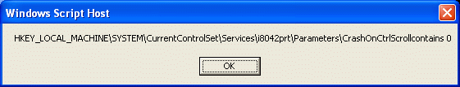

- Press Alt+PrtScn to copy the Windows Script Host box to the clipboard.
- On the Start menu, click Run. Enter the command mspaint and press the Enter key. Paint opens.
- Press Ctrl+V on the keyboard to paste the image into the Paint window. Save the document in the Shared Documents folder with the filename Your Name Proj 30c. Select a Save as type of JPEG. Close Paint.
- Click OK to close the Windows Script Host box.

Turning in your Project
- Email the JPEG images to me as attachments to one e-mail message. Put the Symbolic error name and the Error number in the body of the email message. Send the message to: cnit.235@gmail.com with a subject line of CNIT 235 Proj 30 From Your Name, replacing Your Name with your own first and last name. Send a Cc to yourself.

Revised 6-25-06

