This project must be done in S214, unless you have a domain controller of your own.

Joining Your Computer to a Domain
- You should be using your virtual PC, and logged in with your own account. Your account should have your own name on it, and have Administrative privileges.
- Click Start, right-click My Computer, select Properties.
- A System Properties window opens. On the Computer Name tab, click the Change button.
- Select Domain and enter the domain name S214 and then click OK.
- You should see a Computer Name Change box asking for a user name and password: use a user name of Administrator and a password of P@ssw0rd. This account is a Domain Admin, and has the rights needed to create your computer’s account on the domain controller. Click OK and wait for a minute or two for the domain controller to acknowledge your request.
- When your computer’s account on the domain controller has been created, you will see a Computer Name Changes box saying Welcome to the S214 domain. Click OK.
- A Computer Name Changes box opens saying You must restart the computer for the changes to take effect. Click OK.
- Click OK to close the System Properties window.
- You will see a System Settings Change box saying Do you want to restart your computer now? Click Yes. Wait while your virtual PC restarts.
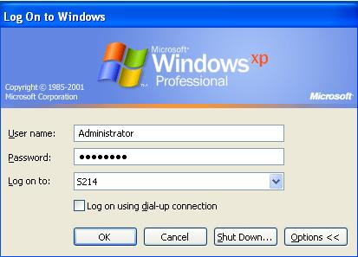
- Notice that the log on process is different now – you no longer see the Windows Welcome screen, but instead you see a Welcome to Windows box.
- Press Ctrl+Alt+Insert. In the Log On to Windows box, click the Options >> button.
- In the Log on to: box, click the drop-down arrow. You may have to wait for a long time while the list of available domains is populated. When you can, select S214.
- Enter a User name of Administrator and a password of P@ssw0rd, as shown in the figure to the right on this page. Click OK. You are now logged in to the domain as the domain administrator.
Installing the Administrative Tools
- End users do not need access to many administrative tools, so only a few are installed with Windows XP Professional. To see them, Click Start, Control Panel. In Control Panel, click Performance and Maintenance. Click Administrative Tools. Look at the list – there are only about seven items. Close Administrative Tools.
- Domain user accounts must be managed on the domain controller, but domain controllers are usually in locked rooms and hard to access. For that reason, most routine administrative tasks are done remotely. In order to add the necessary tools to a Windows XP machine for controlling a Windows 2003 Server domain controller, you have to run adminpak.msi. The Adminpak files are on the Windows Server 2003 installation CD, and for convenience, I copied them to a folder on the server.
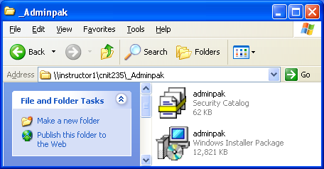
- Click Start, Run. In the Run box, enter \\192.168.1.3 and then press the Enter key.
- Double-click the CNIT235 folder to open it. In the CNIT235 window, double-click the _Adminpak folder.
- An _Adminpak window opens, showing two files named adminpak, as shown to the right on this page. Drag both the adminpak files to the desktop of your virtual PC and close the _Adminpak window.
- Double-click the adminpak windows installer package on your desktop (its icon looks like a computer screen with a CD-ROM). Click Next twice when it prompts you to, and then click Finish.
Creating a Domain User Account
- Click Start, Control Panel.
- In Control Panel, click Performance and Maintenance. Click Administrative Tools.
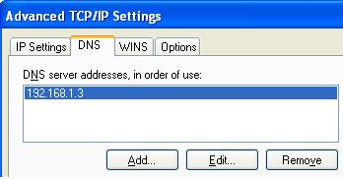
- There are many tools here now. Double-click Active Directory Users and Computers. Active Directory Users and Computers is used to manage domain accounts on the domain controller. If you get a message saying “The specified either does not exist or could not be contacted”, open Network Connections and set your Local Area Connections to DHCP addressing, and restart your virtual machine. If that still doesn’t work, go to Network Connections Properties, TCP/IP Properties, click the Advanced button, and click the DNS tab. Click the Add button and add the address 192.168.1.3 to the DNS list, as shown to the right on this page. Then click OK three times.

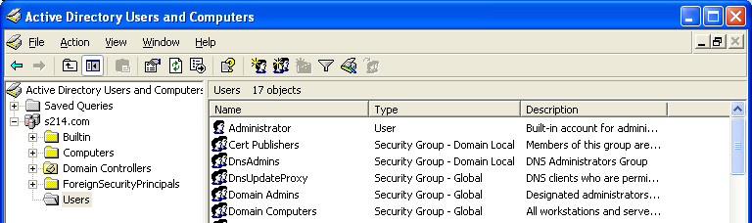
- In the Active Directory Users and Computers window, in the left pane, expand S214.com and click the Users folder, as shown below.
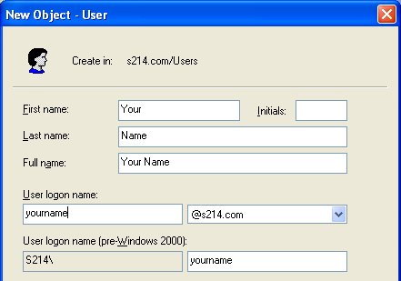
- From the menu bar of the Active Directory Users and Computers window, click Action, New, User.
- In the New Object – User window, fill in your first name, your last name, and a user logon name, as shown to the right on this page. Do not use the literal string yourname – use your own name. After you have filled in the form, click Next.
- In the next screen, enter a password twice. Use P@ssw0rd as your password – notice that you cannot use password or any other simple password, because your password must satisfy these password complexity requirements:

Not contain all or part of the user's account name

Be at least six characters in length

Contain characters from three of the following four categories:

English uppercase characters (A through Z)

English lowercase characters (a through z)

Base 10 digits (0 through 9)

Non-alphabetic characters (for example, !, $, #, %)

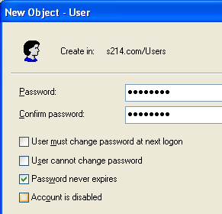
- Clear the User must change password at next logon box and check the Password never expires box, as shown to the right on this page. Click Next.
- In the next screen, review the information and click Finish.
- Close Active Directory Users and Computers.

Adding Your Domain User Account to the Local Administrators Group
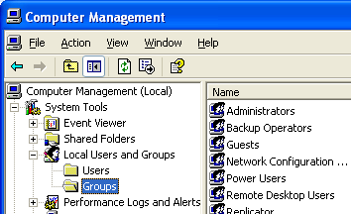
- Now you have your own domain account. But that domain account does not have Administrative privileges over your own virtual PC, so you will not be able to install software or change Windows settings with this account. To give yourself full control over your own virtual computer, you have to add your domain account to the local Administrators group.
- Click Start, right-click My Computer, and select Manage.
- In the left pane of the Computer Management window, expand Local Users and Groups and click on Groups as shown to the right on this page.
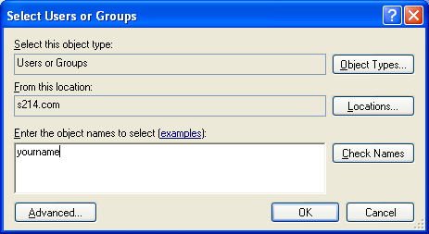
- Double-click the Administrators group in the right pane of Computer Management.
- An Administrators Properties box opens. Click the Add button near the bottom of the box.
- In the Select Users or Groups box, type in your domain account login name, as shown to the right on this page. Click the OK button.

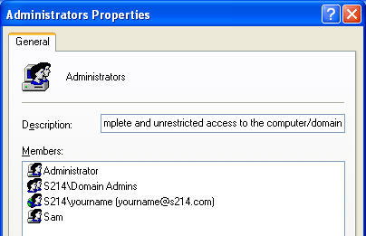
- You should now see your domain account in the Administrators Properties list. The domain name is a prefix, so the entry looks like S214\yourname, as shown in the third item in the Members: list in the figure to the right on this page. Verify that your account is on the list and click the OK button.
- Close all windows and log off.

Using Your Domain Account
- Log in with your own account, with yourname as the User ID, a password of P@ssw0rd, and onto the domain S214.
- Once you have logged in, double-click the clock in the lower-right corner. It opens, offering you a chance to change the system time. You have the right to change the system time because your domain user account is a member of the local Administrators group.
- Find a partner who has reached this step. Go to your partner’s machine and log in with your own account. Notice that you can log in to any machine in the domain with this account, without having to have an account on the local Windows XP computer. Double-click the system clock. Are you able to change it? Do you understand why this happened? If not, talk to your instructor.

Signing Up on the Bulletin Board
- There is a list on the wall in S214 with all the student names on it. Write your domain user name on it. After the due date, your instructor will examine the domain user accounts on the server to verify that they have been created and you will get the points.
- You do not need to save any screen images or send an email for this project. I can tell if you completed it by examining the accounts on the domain controller.

Revised 11-9-06

