This project requires a domain, so you will have to do it in S214, unless you have your own domain controller.
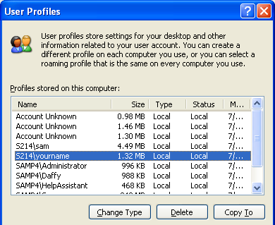
Copying your Profile to a Network Share
- Start your virtual PC. Use the machine you did project 32 on: the machine you use must be a member of the domain, and you must have logged into it at least once with your personal domain user account.
- Log onto the S214 domain as Administrator with a password of P@ssw0rd.
- Click Start, right-click My Computer, and select Properties. Click the Advanced tab and under User Profiles, click the Settings button.
- A User Profiles window opens as shown to the right on this page. Find the domain account with your name on it, which will appear as S214\YourName. Notice the Size. It should be something reasonable, under 30 MB. If it’s bigger than that, call your instructor over to talk about it – if you have placed large files in the My Documents folder, your profile might be very big. If it’s too big, it could fill the hard disk on the server or cause long delays for other students by clogging the network. If the profile is less than 30 MB, proceed to the next step.
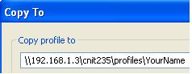
- In the User Profiles window, select the S214\YourName account. Click the Copy To button.
- In the Copy To window, enter this path:
\\192.168.1.3\CNIT235\Profiles\YourName
as shown in the figure to the right on this page Replace YourName with your own name. Click the OK button.
- In the User Profiles window, click OK.
- In System Properties, click OK.
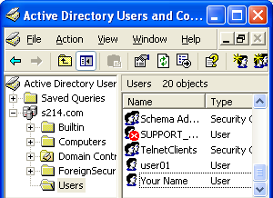
Changing Your Domain Account’s Profile Path
- Click Start, Control Panel, Performance and Maintenance, Administrative Tools. Double-click Active Directory Users and Computers. (If you don't see Active Directory Users and Computers, you may not have the Administrative Tools installed. See Project 33: Joining a Domain.)
- In the left pane of Active Directory Users and Computers, expand S214.com. Click the Users folder. Your window should look like the example to the right on this page, with your name in the right pane.
- Double-click your name in the right pane.

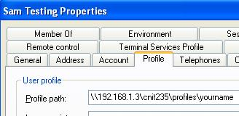
- In the YourName Properties window, click the Profile tab and enter this path, as shown to the right on this page:
\\192.168.1.3\CNIT235\Profiles\YourName
Replace YourName with your own name
- Press Alt+PrtScn to copy this window to the clipboard.
- On the Start menu, click Run. Enter the command mspaint and press the Enter key. Paint opens.
- Press Ctrl+V on the keyboard to paste the image into the Paint window. Save the document in the My Documents folder with the filename Your Name Proj 33a. Select a Save as type of JPEG. Close Paint.
- In the YourName Properties window, click the OK button. Close Active Directory Users and Computers.
Customizing the YourName Profile
- Log out and log into the domain as YourName with a password of P@ssw0rd. Right-click the desktop and select New, Text Document. Name the file Roaming Profile Test. This document is stored on your desktop, which is part of your user profile.
- The change you made did not really change your roaming profile yet – all it did was to change the local copy. The settings are only saved to the network share when you log off.
- Log off. Notice the message that says "Saving your settings" – that's the point at which your changes are saved to the network share.
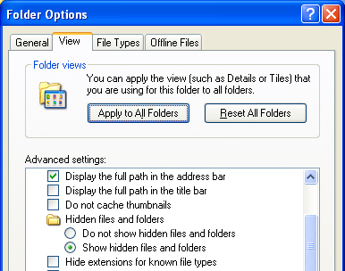
- Go to any other virtual PC that has joined the domain and log on to the domain as YourName. Your settings should travel with you – the Roaming Profile Test file should be on the desktop wherever you go. Sometimes you have to log in and out a few times to get it to start working.
Making the Your Profile Mandatory
- Make sure your roaming profile is working before you do these steps.
- Log out and log into the domain as Administrator with a password of P@ssw0rd.
- Click Start, Run, type in \\192.168.1.3\Cnit235\Profiles\YourName, and press Enter. Don’t use the literal string YourName – use your own domain login name.
- In the YourName window, click Tools, Folder Options. On the View tab, select the Show hidden files and folders button, and clear the Hide extensions for known file types check box, as shown to the right on this page. Click OK.

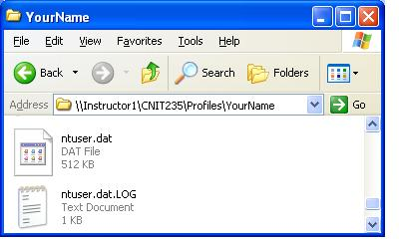
- Find the ntuser.dat file and the ntuser.dat.LOG file, as shown to the right on this page. You may only see the ntuser.dat file – the ntuser.dat.LOG file is not always present. Press Alt+PrtScn to copy this window to the clipboard.
- On the Start menu, click Run. Enter the command mspaint and press the Enter key. Paint opens.
- Press Ctrl+V on the keyboard to paste the image into the Paint window. Save the document in the My Documents folder with the filename Your Name Proj 33b. Select a Save as type of JPEG. Close Paint.
- Right-click Ntuser.dat, select Rename, and change the name to Ntuser.man.
- Log out and log in to the domain as YourName. The password should be P@ssw0rd.
- Right-click the desktop and select New, Text Document. Name the document Mandatory.
- Log out. Notice that the window that says “Saving your settings” is only visible for a couple of seconds.
- Log in to the domain as YourName. The new document is not there – your local profile was not copied to the network share.
- If you want to be able to change your profile again, you will have to rename the Ntuser.man file back to Ntuser.dat
Turning in your Project
- Email the JPEG images to me as attachments to one e-mail message. Send the message to: cnit.235@gmail.com with a subject line of CNIT 235 Proj 33 From Your Name, replacing Your Name with your own first and last name. Send a Cc to yourself.

Last modified 11-9-06

