Starting Your Computer
- Start your computer with the appropriate L removable hard drive in it. Boot it up to the Windows XP operating system. Start your virtual PC, and log in as usual, with an account with Administrator privileges.

Creating a Limited Account
- Click Start, Control Panel. If you see the words Pick a Category, click Switch to Classic View in the upper left. Double-click User Accounts.
- In User Accounts, click Create a new account. Enter a name of Your Name Limited and click Next.
- In the Pick and account type screen, click Limited and click Create Account.
- Close all windows.
- Click Start, Log Off, Log Off.

Logging in With the Limited Account
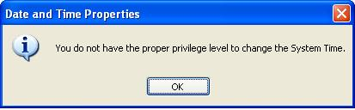
- Log in with your new Limited account. Double-click the clock in the lower right corner of the virtual desktop – A box should open saying You do not have the proper privilege level to change the System Time, as shown to the right on this page.
- Press Alt + PrintScrn to capture an image of the Date and Time Properties box.
- Click Start, Programs, Accessories, Paint. In the untitled - Paint window, select Edit, Paste from the menu bar. The image appears in the Paint window.
- In the untitled - Paint window, click File, Save. Save the document in the My Pictures folder (or any other place you wish, such as a floppy disk) with the filename Your Name Proj X10a. Select a Save as type of JPEG. Close Paint.

The Scenario
- Suppose this Limited account is the only account you have, but you need Administrative privileges. This can happen because the Administrator is out sick, or forgot the password, for example. Normally there is no way to elevate your privileges from Limited to Administrator, but we will do it with a well-known hack: a Repair Installation.

Booting the Virtual PC from the Windows XP Installation CD ISO File
- Your Virtual Machine is probably already set to boot from the XP2CCSF.iso file on the desktop. If it is not, set it up as follows.
  - First make sure there is an XP2CCSF.iso file on the desktop. If there is not, make sure you are logged in as cnit235, not cnit. If you need to copy the file, click Start, Run, enter \\192.168.1.3 and open the cnit235 folder. Then drag the XP2CCSF.iso file to the desktop.
  - Press Ctrl+Alt to release the cursor from the virtual PC. From the Menu bar, select VM, Settings.
  - In the Virtual Machine Settings box, click CD-ROM in the left pane. In the right pane, click Use ISO Image. Click the Browse button, navigate to the Desktop, and select the XP2CCSF.iso file.
  - Click OK to close the Virtual Machine Settings box
- From the VMWare menu bar, click VM, Power, Restart Guest. In the VMWare Workstation box asking if you are sure, click OK.

Adjusting the Boot Device Order in the BIOS
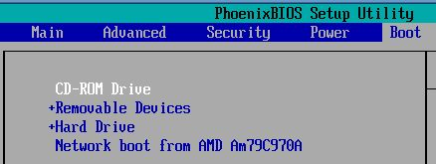
- When you see text appear in the virtual machine, click inside the window and press F2 to open the BIOS Setup Utility.
- Press the right-arrow key several times to open the Boot menu, and use the down-arrow key to highlight CD-ROM Drive. Then, if necessary, press the + key twice to move it up in the boot order, until your screen looks like the example to the right on this page.
- Press the F10 key to save BIOS changes. When the Setup Confirmation box appears, press the Enter key to save changes.

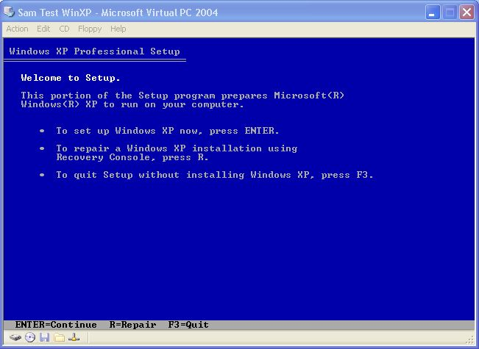
Beginning a Repair Installation
- The virtual PC restarts again. When you see the message Press any key to start from CD, press any key.
- When you see the Welcome to Setup screen shown to the right on this page, press Enter to set up Windows XP now.
- When you see the Windows XP Licensing Agreement, press F8 to accept it.
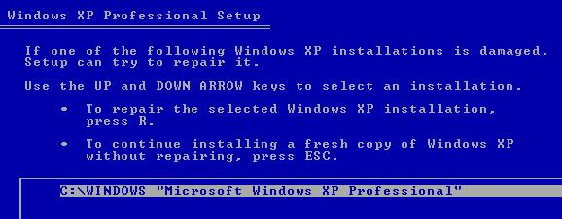
- When you see the Windows XP Professional Setup screen shown to the right on this page, press R to repair the selected installation.
- Wait while files are copied. This will only take about 5 minutes because the ISO file runs a lot faster than a real CD drive. Don’t walk away now! You have to notice when the virtual machine restarts!

The Hack: Shift F10
- When the Copying Files stage finishes, you will see a progress bar stating “Your computer will reboot in 15 seconds”
- During the reboot, do not make the mistake of “pressing any key” to boot from the CD again! Setup will resume automatically with the standard billboard screens and you will notice Installing Windows is highlighted.

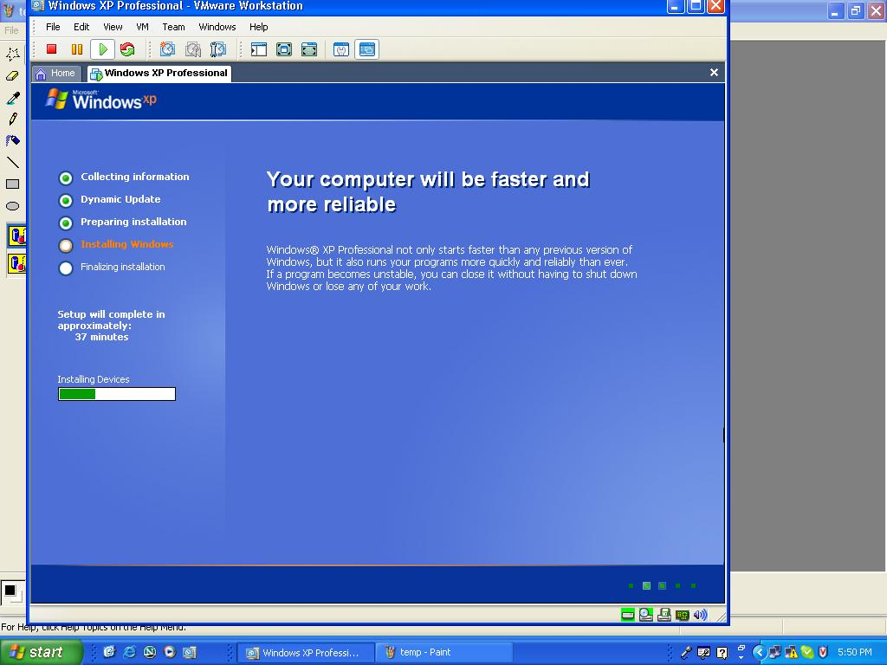
- When you see a pretty blue screen, as shown to the right on this page, keep your eye on the lower left hand side of the screen. When you see the Installing Devices progress bar, press SHIFT + F10. This is the security hole! A command console will now open up giving you the potential for wide access to your system.
- At the prompt, type NUSRMGR.CPL and press Enter. Voila! You have just gained graphical access to your User Accounts in the Control Panel.
- In the lower section of the user Accounts box, click the your Name Limited icon.
In the next box, click Change the account type.
- In the next box, click Computer administrator and click the Change Account Type button.
Close User Accounts.
- At the prompt, type taskmgr and press Enter. Windows Task Manager opens.
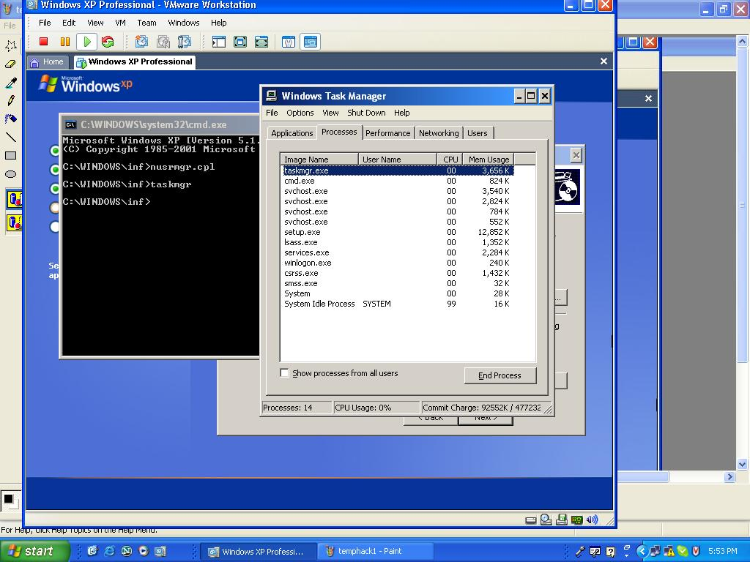
- In the Windows Task Manager box, click the Processes tab as shown to the right on this page. Notice that many processes, such as taskmgr.exe, are running with no User Name at all. This is kernel-level access – not just Administrative access. You are in direct control of the computer, not passing through any restrictions at all.

Saving the Screen Image
- Press Ctrl+Alt to move the mouse outside the Vmware window and click on the host system’s desktop.
- Press the PrintScrn key to capture the whole screen.
- In the host operating system (not the virtual PC), click Start, Programs, Accessories, Paint. In the untitled - Paint window, select Edit, Paste from the menu bar. The image appears in the Paint window.
- In the untitled - Paint window, click File, Save. Save the document in the My Pictures folder (or any other place you wish, such as a floppy disk) with the filename Your Name Proj X10b. Select a Save as type of JPEG. Close Paint.

Completing the Repair Installation
- Close Task Manager. Close the Command Prompt window.
- In the Regional and Language Options screen, click Next. Continue with the installation just as you did before, entering the Product Key and making other selections as prompted.
- When Windows XP is repaired, log in with your Limited account. Double-click the clock on the desktop—you should be able to set the time now. You have become an administrator without having an administrator account or password!

Updating Windows XP
- The Repair installation replaced system files with files from the ISO image, so you need to reapply Windows Updates. The exact procedure varies, as Microsoft constantly changes the Windows Update site. Here are the steps I did on September 27, 2006.
- Click Start, Help and Support. In the Pick a task section, click on Keep your computer up-to-date with Windows Update. In the Microsoft Help and Support Center – Security Warning box, click Install.
- In the Get the latest Windows Update software screen, click Install Now.
- In the Windows Update screen, click Express. Wait while Windows Update scans your system. If an Internet Explorer box pops up saying When you send information to the Internet, it might be possible for others to see that information…, click Yes.
- If Windows Update finds any updates you need, follow the instructions on the screen to put in all recommended updates.
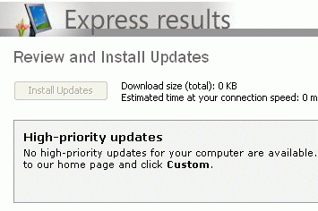
- Often you cannot install all the Windows Updates at once. Some of them require restarting your computer, or must be installed singly for other reasons. Keep running Windows Update as many times as necessary until you get all the updates.
- When you see the message shown to the right on this page, saying No high-priority updates for your computer are available, or a similar message, you are done updating.

Saving the Screen Image
- Click on the Windows Update window to make sure it is the active window.
- Hold down the Alt key and press the PrintScrn key in the upper-right portion of the keyboard. That will copy the active window to the clipboard.
- In the virtual machine, click Start, Programs, Accessories, Paint. In the untitled - Paint window, select Edit, Paste from the menu bar. The window image appears in the Paint window.
- In the untitled - Paint window, click File, Save. Save the document in the My Pictures folder (or any other place you wish, such as a floppy disk) with the filename Your Name Proj X10c. Select a Save as type of JPEG.

Turning In your Project
- Email the JPEG images to me as attachments to a single email message. Send it to: cnit.235@gmail.com with a subject line of CNIT 235 Proj X10 From Your Name. Send a Cc to yourself.
Based on this article: http://pubs.logicalexpressions.com/Pub0009/LPMArticle.asp?ID=305
Last modified 9-27-06

