You can do this project on any Windows XP computer for which you have Administrative privileges, as long as it is ACPI-compliant (see steps 1-4 below).
Determining Whether Your System Is ACPI-Compliant
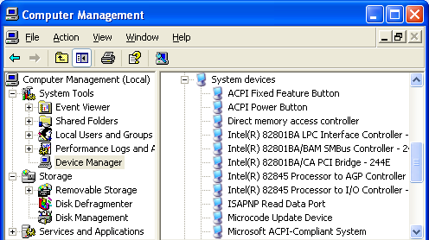
- You should be logged in as an Administrator.
- Only ACPI-compliant systems can Hibernate. To find out if your system is ACPI-compliant, click Start, right-click My Computer and select Manage.
- In the left pane of Computer Manager, click Device Manager.
- In the right pane of Computer Manager, expand the System Devices entry. Look for Microsoft ACPI-Compliant System, as shown in the figure to the right on this page.
- If your computer is not ACPI-compliant, you cannot do this activity on it. You will have to use the computers in S214, or some other machine.
Comparing RAM to Disk Space Required for Hibernation
- Right-click the Start button, and click Explore. Find the System drive (E: in S214:), right-click it and select Properties. Write the amount of free space on the system drive in the box to the right on this page.

Free space: ____________________
- Right-click the desktop, and click Properties.
- In the Display Properties window, on the Screen Saver tab, click the Power button.
- In the Power Options Properties dialog box, on the Hibernate tab, check the Enable Hibernation box. Note the disk space required to hibernate, and write it in the box to the right on this page. Then click the OK button to close the Power Options Properties dialog box, and click the OK button to close the Display Properties window.

Disk space required to hibernate: ___________

RAM: ________________________________
- Click Start, right-click My Computer and select Properties. Find the amount of RAM on your machine and write it in the box above. Then click OK to close System Properties. Explain the relationship between these two numbers below (if necessary, read the explanation of Hibernation in your textbook on page 497).
What is the relationship between Disk space required to hibernate and RAM? Why?

- Right-click the Start button, and click Explore. Find the System drive (E: in S214), right-click it and select Properties. Write the amount of free space on the system drive in the box to the right on this page.

Free space: ____________________

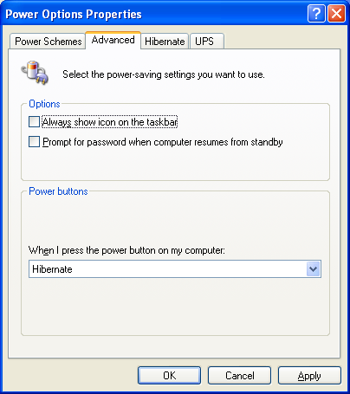
Creating a Custom Power Scheme Enabling Hibernation
- Right-click the desktop, and click Properties.
- In the Display Properties window, on the Screen Saver tab, click the Power button.
- In the Power Options Properties dialog box, on the Advanced tab, in the When I press the power button on my computer: drop-down list box, select Hibernate, as shown to the right on this page.
- Click OK to close the Power Options Properties dialog box, and click OK to close Display Properties.
Starting Applications
- Click Start, All Programs, Accessories, Notepad to open Notepad. Type in some text, but do not save the file.
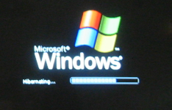
- Click Start, All Programs, Accessories, Paint to open Paint. Draw something, but do not save the file.
Hibernating
- Press the power button on the front panel of your system unit. A Hibernating message appears on the screen, as shown to the right on this page, and your computer shuts down. The power light on the system unit goes off.
- The power consumption of your computer is now zero. To demonstrate that, carefully unplug the power cord going to the system unit. Do not touch the keyboard or mouse.
Waking your Machine
- Move the mouse. Does the computer wake up?
- Type on the keyboard. Does the computer wake up?
- If neither of those things woke your machine, press the Power button on the front panel. Then fill in the box below.

Which device woke up your computer?

- Watch the screen: the BIOS part of start-up is normal, but the second part looks different – instead of starting Windows the normal way, your machine is loading the memory from the hiberfil.sys file. It does not give you a choice of operating systems, even if it’s a multiple-boot system.
- When your machine wakes up, note that the applications you opened are still there, and the unsaved data are still intact.

- Right-click the Start button, select Explore, and navigate to the root of the system volume (usually C:).
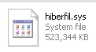
- In the Windows Explorer window, click Tools, Folder Options. On the View tab, in the Advanced settings scrolling list, make sure Show hidden files and folders is checked, and that Hide protected operating system files (Recommended) is not checked. If a Warning box appears saying You have chosen to display protected operating system files … , read it and click Yes. Click OK to close Folder Options.
- Now you should be able to see the Hiberfil.sys file in the Explorer window, as shown to the right on this page. This is the file the Hibernation process created to store the data from RAM.
Adjusting the Custom Power Scheme to Use Standby
- Right-click the desktop, and click Properties.
- In the Display Properties window, on the Screen Saver tab, click the Power button.
- In the lower portion of the Power Options Properties window, set System Standby to After 1 min.
- Click OK to close the Power Options Properties dialog box, and click OK to close Display Properties.
Letting Automatic Standby Happen
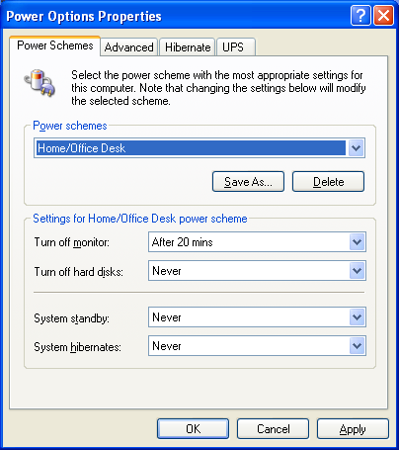
- Wait for a minute without touching the mouse or keyboard. A message may appear briefly saying Preparing to stand by, and the monitor will go dark, but the power light on the system unit will stay on. This is Standby mode.
Waking your Machine
- Move the mouse. Your computer should wake up.
Returning to a Normal Power Scheme
- Right-click the desktop, and click Properties.
- In the Display Properties window, on the Screen Saver tab, click the Power button.
- In the Power Options Properties dialog box, on the Power Schemes tab, set Turn off monitor to After 20 minutes and the next three choices to Never, as shown to the right on this page.
- In the Power Options Properties dialog box, click the Hibernate tab, and uncheck the the Enable Hibernation box.
- In the Power Options Properties dialog box, click the Advanced tab, and set When I press the power button on my computer: to Shut Down.
- Click OK to close the Power Options Properties dialog box, and click OK to close Display Properties.
- Right-click the Start button, and click Explore. Find the System drive (E: in S214), right-click it and select Properties. Write the amount of free space on the system drive in the box to the right on this page.

Free space: ____________________
- After you have filled in the boxes, turn in this page with your name on it.
Last modified 10-8-06

