Background Information
Most computers use a PC/AT BIOS and boot using a Master Boot Record (MBR). For versions of Windows prior to Vista, the MBR then executes Ntldr which loads Windows. Ntldr locates the operating system to load by reading the boot.ini file.
Newer computers use a completely different boot process called Extensible Firmware Interface (EFI), but we don’t have any computers that new in the lab. The rest of this project considers only the situation of Vista installed on a computer with the older PC/AT BIOS.
Microsoft has completely reengineered the boot environment for Microsoft® Windows Vista™. The new system is called Boot Configuration Data (BCD). This new data store serves essentially the same purpose as boot.ini, but it is more versatile and programmable. Other new components include:

Bootmgr: A system-wide application that controls boot flow. With a multiboot system, the boot manager displays an operating system selection menu. In the \Windows\Boot\PCAT folder.

Winload.exe: The Windows Vista operating system loader. Each version of Microsoft Windows Vista™ and Microsoft Windows Server™ Code Name "Longhorn" that is installed on a computer has its own instance of winload.exe. The operating system loader creates the execution environment for the operating system and also loads the Windows Vista kernel, hardware abstraction layer (HAL), and boot drivers into memory. In the Windows\System32 folder.

Winresume.exe: The Windows Vista resume loader. Each version of Windows Vista and Windows Server Longhorn that is installed on a computer has its own instance of winresume.exe. The resume loader restores Windows to its running state when a computer resumes from hibernation. In the Windows\System32 folder.

For more information see links Vista 1a and Vista 1b on my Web page.

Selecting a Machine to Use
- Use one of the hard drives with Vista installed on it. As of August 2006, those are: L4, L6, L8, L10, L12, L16, and L18. There are also two removable hard drives with Vista on them, labeled V1 and V2.
- Start Windows Vista. You should be automatically logged in as Student.
Creating a Restore Point
- Click Start, All Programs, Accessories, System Tools, System Restore.
- In the User Account Control box, click Continue.
- In the System Restore box, at the bottom, click the open System Protection link.
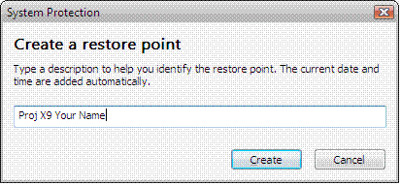
- In the System Properties box, click the Create… button.
- In the Create a restore point box, type in Proj X9 Your Name, as shown to the right on this page. Don’t enter the literal words Your Name – put in your own name. Click the Create button.
- When you see a Create restore point Success box, click OK. Close all windows.
Trying to Wreck Vista – rename Windows\system32\winload.exe to winloadx.exe
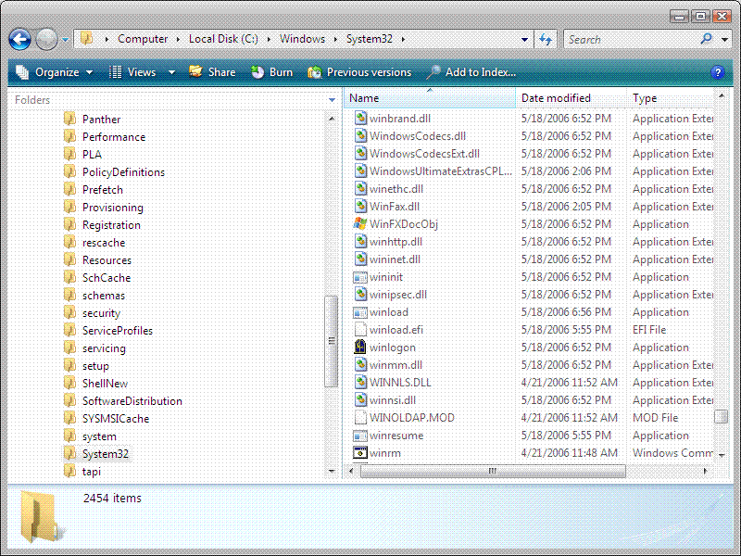
- Right-click the Start button and select Explore. Drag the borders of the lower left pane to ake it bigger, and navigate to \Windows\System32 on your Vista system drive, which might be C: or E:, as shown below.

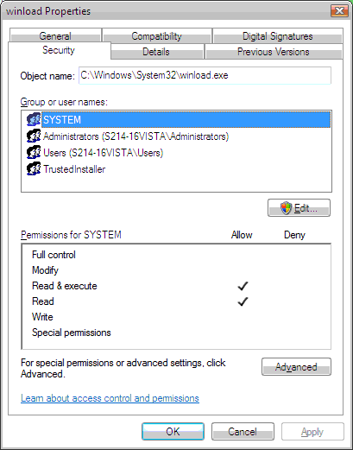
- Right-click the winload file and select rename. Change the name to winloadx and press Enter.
- A File Access Denied box appears. Click Continue.
- A User Account Control box appears. Click Continue.
- The File Access Denied box appears again. Your current permissions do not allow you to modify this file. Click Cancel.
Taking Ownership of winload
- Right-click the winload file and select Properties.
- In the winload Properties box, click the Security tab, as shown to the right on this page. Click the Edit button.
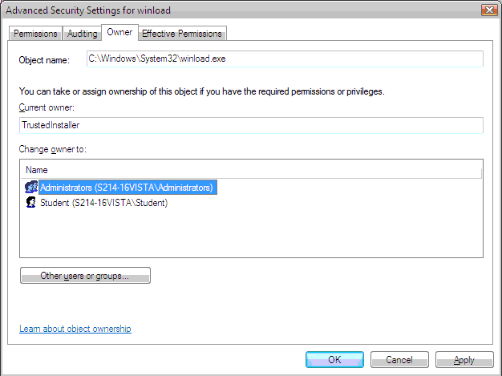
- A User Account Control box appears. Click Continue.
- In the Permissions for winload box, click the Advanced button.
- In the Advanced Security Settings for winload window, click the Owner tab. In the Change owner to: section, click Administrators to highlight it, as shown to the right on this page.
- In the Advanced Security Settings for winload box, click OK.
- In the Permissions for winload box, click OK.
- In the winload Properties box, click OK.

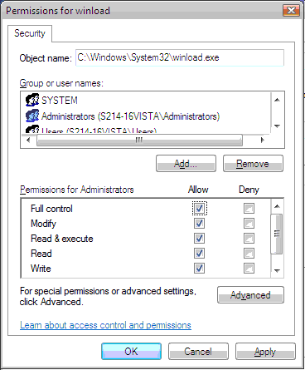
Changing Permissions for winload
- Right-click the winload file and select Properties.
- In the winload Properties box, click the Security tab. Click the Edit button.
- A User Account Control box appears. Click Continue.
- In the Permissions for winload box, in the Group or user names: section, click Administrators. In the Permissions for Administrators section, in the Full Control line, click in the Allow column to check all the Allow boxes, as shown to the right on this page. Click OK.
- A Windows Security box opens, warning you that what you are about to do can result in “unexpected access problems”. It’s not lying – we are going to wreck Vista. Click Yes.
- In the winload Properties box, click OK.
Wrecking Vista – Renaming Windows\system32\winload.exe to winloadx.exe
- In the ► Computer ► Local Disk (C:) ► Windows ► System32 ► window, right-click the winload file and select rename. Change the name to winloadx and press Enter.
- A File Access Denied box appears. Click Continue.
- A User Account Control box appears. Click Continue.
Attempting to Restart Vista
- Click Start, click the rightward arrow to the right of the padlock, and click Restart.
- A Windows Boot Manager screen appears, saying Windows did not start correctly. It correctly tells you that the problem is that \Windows\system32\winload.exe is missing or corrupt. We have killed Vista!
Booting from the Vista Install DVD
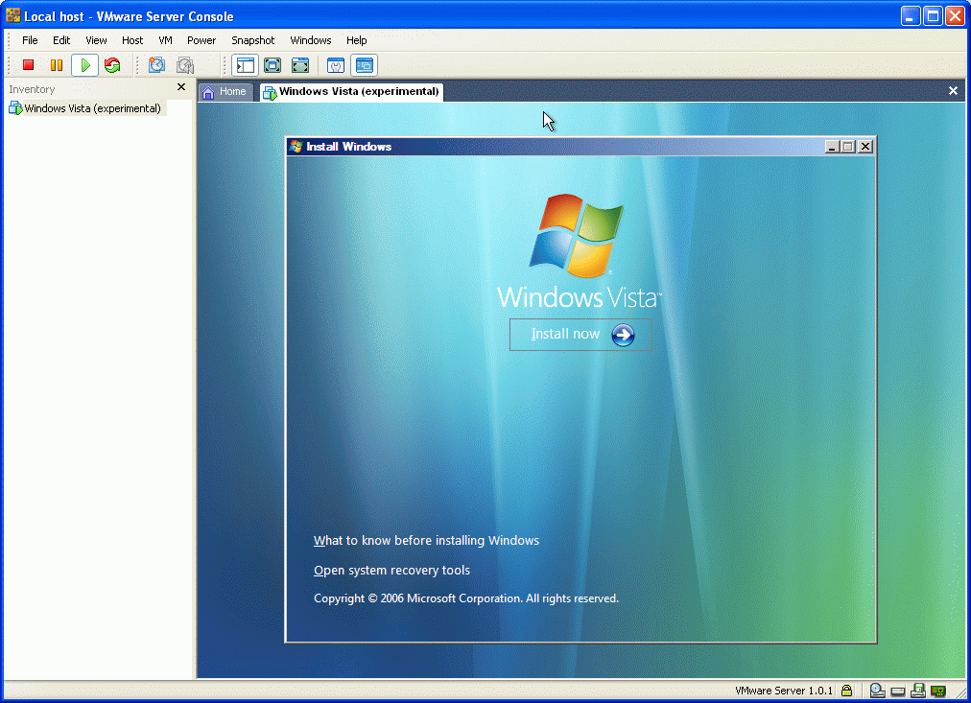
- Insert a Vista installation DVD. Press Ctrl+Alt+Delete. When you see the message Press any key to boot from CD or DVD, press the Enter key.
- In the first Install Windows box, accept the defaults for Installation Language, Time and Currency Format, and Keyboard layout, and click Next.
- The next Install Windows box is shown to the right on this page. In the lower left, click System recovery options.
- In the System recovery options box, accept the default keyboard layout, and click Next.
- In the System Recovery Options box, accept the default selection of Microsoft Windows and click Next.

Using Startup Repair
- A System Recovery Options box appears, showing a list of recovery tools, as shown to the right on this page. Click Startup Repair.
- A message appears saying Startup Repair cannot repair this computer automatically. Close that window.
- Click View advanced options for system recovery and support. .

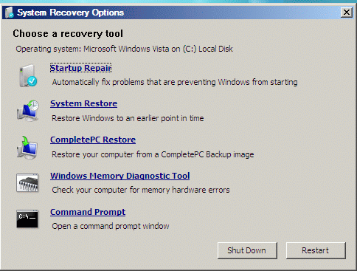
Using Command Prompt
- A System Recovery Options box appears, showing a list of recovery tools, as shown to the right on this page. Click Command Prompt.
Finding Vista in the Command Prompt
- The first problem is that the Command Prompt identified the drives with different letters than Vista does, at least when I tried it. So first we have to find Vista again.
- Type in the command C: and press Enter.
- Type in the command DIR and press Enter.
- If you see a folder named Documents and Settings, this is Windows XP, not Vista. If you see Users but not Documents and Settings, this is Vista.
- Type in the command D: and press Enter.
- Type in the command DIR and press Enter.
- If you see a folder named Documents and Settings, this is Windows XP, not Vista. If you see Users but not Documents and Settings, this is Vista.
- Make a note of which partition Vista is in. Type in that drive letter with a colon, and press Enter to go to the root of that drive – in my case, it was D:
Fixing Vista With the Command Prompt
- Type in the command CD WINDOWS and press Enter.
- Type in the command CD SYSTEM32 and press Enter.
- Type in the command COPY WINLOADX.EXE WINLOAD.EXE and press Enter.
- Type in the command EXIT and press Enter.
- In the System Recovery Options box, click Restart.
- Select Microsoft Windows from the boot menu to start Vista.
Demonstrating Your Repaired Vista
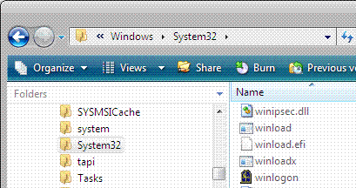
- Right-click the Start button and select Explore. Drag the borders of the lower left pane to make it bigger, and navigate to \Windows\System32 on your Vista system drive, which might be C: or E:,. Make sure both the winloadx and winload files are visible, as shown to the right on this page.

Saving the Screen Image
- Press the PrintScrn key in the upper-right portion of the keyboard. That will copy the whole desktop to the clipboard.
- Click Start and click in the Search box. Type in mspaint and press the Enter key to open Paint. In the untitled - Paint window, select Edit, Paste from the menu bar. The window image appears in the Paint window.
- In the untitled - Paint window, click File, Save. Save the document in the Student ► Pictures folder (or any other place you wish, such as a floppy disk) with the filename Your Name Proj X9a. Select a Save as type of JPEG.
Restoring the Original System
- Click Start, All Programs, Accessories, System Tools, System Restore.
- In the User Account Control box, click Continue.
- In the System Restore screen, click the Choose a different restore point radio button. Click Next.
- In the Choose a restore point dialog, make sure that the restore point with your name on it is highlighted, and click Next.
- In the Confirm your restore point screen, click Finish.
- In the System Restore box, click Yes.

Turning in your Project
- Email the JPEG image to me as an attachment to an e-mail message. Send the message to: cnit.235@gmail.com with a subject line of CNIT 235 Proj X9 From Your Name, replacing Your Name with your own first and last name. Send a Cc to yourself.

Last Modified: 9-7-06

