Required Equipment:
- Windows XP Installation CD
- A virtual machine or a machine with a hard disk you don’t mind reformatting
- A Windows 98 boot disk with FDISK on it (you can download one at bootdisk.com)
Starting Your Computer
- Start your computer with the appropriate L removable hard drive in it. Do not use your virtual machine yet. Log in with the account information your instructor provided to you. In Fall 2005, the User name is CNIT235 with a password of windowsxp
Extracting Deployment Files from the Windows XP CD-ROM
- Make sure the Windows XP Installation CD is inserted.
- If the Welcome to Microsoft Windows XP screen, click Exit.
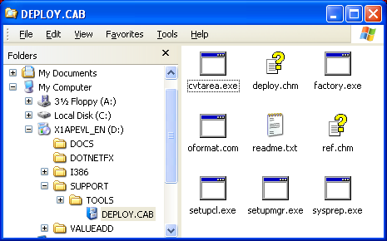
- Click Start. Right-click My Computer and select Explore. Navigate to the CD-ROM, and into the SUPPORT\TOOLS folder, and double-click the DEPLOY.CAB file. This is a Cabinet file, which is like a Zip archive – a single file that contains several compressed files. In Windows XP cabinet files can be opened like folders. The right pane of the Explorer window should show 9 files, as shown in the figure to the right on this page.
- Select all the files in the right pane, right-click any file, and click Extract.
- In the Select a Destination window, expand My Computer, click Local Disk (C:) and click Make a New Folder. Name the folder DEPLOY and click Extract.
- Close the DEPLOY.CAB window.
Creating an Unattended Installation File With the Setup Manager Wizard
- Click Start. Right-click My Computer and select Explore.
- Navigate to C:\DEPLOY. Find the setupmgr.exe file and double-click it.
- On the Welcome to Setup Manager screen, click Next.
- On the New or Existing Answer File screen, note that you can either create a new answer file, or edit an existing one. Verify that Create new is selected and click Next.
- On the Type of Setup screen, note that you can create three types of answer files with this wizard: Unattended setup for use when installing from the CD-ROM (or a shared network folder containing the CD-ROM files), Sysprep setup used for the mini-setup performed after disk imaging, and Remote Installation Services (RIS) used for installing from a server in a domain environment. Verify that Unattended setup is selected and click Next.
- On the Product screen, verify that Windows XP Professional is selected and click Next.
- On the User Interaction screen, read through the options. Select Fully automated and click Next.
- On the Distribution Share screen, you can specify where the source files required for installation are. These source files include files from the installation CD-ROM, and may also include device drivers and OPK tools (Original Equipment Manufacturers Preinstallation Kits). OPK tools are used by companies like Dell to add their company logo to the Windows XP installation. Select Set up from a CD and click Next.
- On the License Agreement screen, check the box and click Next.
- On the Name and Organization screen, enter your name and CCSF and click Next.
- On the Display Settings page, in the Screen area box, click 800 x 600 and click Next.
- On the Time Zone page, select GMT -08:00 and click Next.
- On the Product Key page, enter your Product Key and click Next.
- On the Computer Names page, enter your computer name from its front panel, click Add, and click Next. Note that if you provide more than one name here, a Uniqueness Database file will be created.
- On the Administrator Password page, enter a password of password in both boxes. Check the Encrypt the Administrator password in the answer file box and click Next.
- On the Networking Components page, verify that Typical settings is selected and click Next.
- On the Workgroup or Domain page, verify that Workgroup is selected and click Next. Accept the default workgroup name of WORKGROUP.
- Accept the default settings on the Telephony, Regional Settings, Languages, Browser and Shell Settings, Installation Folder, Install Printers, and Run Once pages -- click Next on each page.
- On the Additional Commands page, click Finish.
- A smaller Setup Manager box opens, showing the default file name of C:\DEPLOY\unattend.txt. Click OK.
- Close the Setup Manager Complet window.
Viewing, Renaming, and Copying the Unattended Installation File
- Click Start. Right-click My Computer and select Explore.
- Navigate to C:\DEPLOY. Double-click the unattend.txt file. Scroll through the file, observing the headings on the sections” [Data], [Unattended], and so on. If you are careful, you can edit this file in NotePad, but it is probably better to use the Setup Manager Wizard to edit it.
- Close the Notepad window.
- In Windows Explorer, click Tools, Folder Options.
- On the View tab, make sure that Hide file extensions for known file types is not checked.
- Click OK to close the Folder Options window.
- In Windows Explorer, right-click unattend.txt and select Rename. Change the name to Winnt.sif.
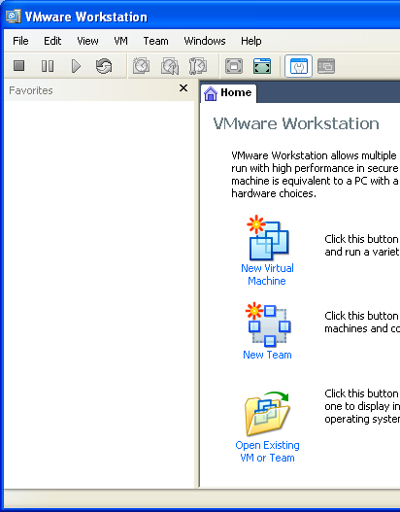
- Copy the Winnt.sif file to a blank floppy disk.
Preparing a New Virtual Machine
- Double-click the VMWare Workstation icon on the desktop.
- In the VMWare Workstation window, click the Home tab. Click the New Virtual Machine icon.
- At the Welcome to the New Virtual Machine Wizard screen, click Next.
- At the Select the Appropriate Configuration screen, accept the default selection of Typical and click Next.
- At the Select a Guest Operating System screen, make sure that the Microsoft Windows radio button is selected and in the Version box, select Windows XP Professional. Click Next.
- At the Name the Virtual Machine screen, enter a Virtual machine name of Your Name WinXP Pro Unattended. Do not change the Location. Click Next.
- At the Network Type screen, accept the default selection of Use Bridged Networking and click Next.
- At the Specify Disk Capacity screen, change the size to 7 GB. Do not check either of the boxes. Click Finish.
Creating a Partition on the Virtual Hard Disk
- The unattended installation process will not partition the hard disk, so before it starts, you have to partition and format the disk. We’ll use the Win 98 boot disk for that.
- Insert the Win 98 boot floppy disk.
- Start your virtual machine.
- While the machine is restarting, press F2 and set the BIOS boot order to Removable Devices, then CD-ROM Drive, then Hard Drive.
- Boot the virtual machine from the Windows 98 boot disk. If you are using a disk from bootdisk.com, it will ask you whether you want CD-ROM support. Type 2 Enter to disable the CD-ROM support (not that it matters).
- A message appears saying Windows 98 has detected that drive C does not contain a valid FAT or FAT32 partition, as shown below. In fact, it has no partition at all.
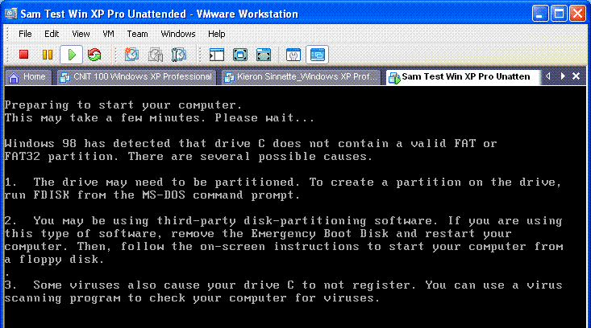

- When you see the A:> prompt, enter the following command, pressing the Enter key whenever you see the symbol Enter. Do not type the italic text – that’s just there for explanation.

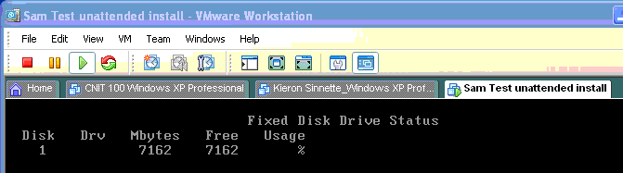
FDISK /STATUS. Enter Shows the current disk status
You should see one disk with approximately 7000 MB free, as shown below.

- When you see the A:> prompt, enter these commands, pressing the Enter key whenever you see the symbol Enter. Do not type the italic text – that’s just there for explanation.

FDISK 1/PRI:7000. Enter Creates a 7000 MB Primary DOS partition
FDISK /STATUS. Enter Shows the current disk status

You should see drive C: created with approximately 7000 MB available, as shown below.
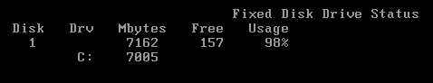

- Press Ctrl+Alt to release the mouse pointer from the virtual PC. From the VMWare menu bar, click VM, Power, Reset to restart your virtual PC. Click OK to restart the guest operating system.
- Boot the virtual machine from the Windows 98 boot disk again. If you are using a disk from bootdisk.com, it will ask you whether you want CD-ROM support. Type 2 Enter to disable the CD-ROM support (not that it matters).
- When you see the A:> prompt, enter these commands:

FORMAT C:. Enter Formats the new partition
Y Enter To proceed with format
WINXP Enter Assigns the volume label

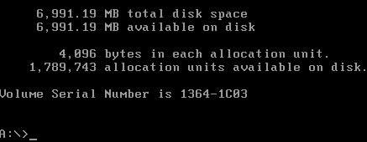
- You should see drive C: created with approximately 7000 MB available, as shown to the right on this page.

- If you are doing the project on a virtual PC, please capture this screen and save it as a JPEG. If you are working at home and don’t have a digital camera handy, just explain that in your email. Click outside the VMWare window to make the host operating system active. Then press Alt+PrntScn to copy this window to the clipboard.
- On the Start menu, click Run. Enter the command mspaint and press the Enter key. Paint opens.
- Press Ctrl+V on the keyboard to paste the image into the Paint window. Save the document in the Shared Documents folder with the filename Your Name Proj X4a. Select a Save as type of JPEG. Close Paint.
- Remove the Win 98 boot disk.

Performing a Fully Automated Installation of Windows XP Professional
- Insert the floppy disk with your Winnt.sif file on it.
- Verify that the Windows XP Installation CD is inserted.
- Press Ctrl+Alt to release the mouse pointer from the virtual PC. From the VMWare menu bar, click VM, Power, Reset to restart your virtual PC. Click OK to restart the guest operating system.
- While the machine is restarting, press F2 and set the BIOS boot order to, then CD-ROM Drive, then Hard Drive, then Removable Devices.
- When you see the message Press any key to boot from CD, press the SPACEBAR.
- The automated install should complete with no further intervention. It ends with a screen that says “Welcome to Microsoft Windows”.

Turning in your Project
- Email the JPEG image to me as an attachment to an e-mail message. Also attach the winnt.sif file. If you are working at home and cannot get a screen image, just send the Winnt.sif file and explain in the body of the email message that you were unable to capture a screen image. Send the message to: cnit.235@gmail.com with a subject line of CNIT 235 Proj X4 From Your Name, replacing Your Name with your own first and last name. Send a Cc to yourself.

Revised 6-25-06

