Getting Your Product Key
- Open a browser and go to www.ccsf.edu/cnit. Click on MSDN Academic Alliance. Click Log in.
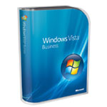
  - If you are working in the S214 lab, log in with your station number (something like S214-01) and the password your instructor wrote on the whiteboard.
  - If you are working at home, log in with your CCSF email address (something like flast01@ccsf.edu) and the password you received in the email you got at the start of the semester. Also check your hardware—you need at least an 800 MHz processor and 512 MB of RAM, and to get the pretty Aeroeffects, you need 1 GHz, 1 GB, and a video card with 128 MB of memory
(see http://technet.microsoft.com/en-us/windowsvista/aa905075.aspx).
- Click in the blue Software button. Click the box photo labeled Windows Vista Business DVD, as shown to the right on this page.
- Click the Add to Cart button. Click the I Agree button. Click the Check Out button. Enter your name and click the Next button. Click the underlined “Windows Vista Business DVD” link. Your Serial Number should appear. Write it in the box below.

Product key: ____________________________________________________________

Booting from the Vista DVD
- Insert the Vista DVD. Restart your machine. When you see the message Press any key to boot from CD or DVD, press the Enter key. If you don’t get a chance to boot from the DVD, restart the machine again, press F2 to enter the BIOS, and adjust the boot order to boot from the CD before the hard disk.
- When you see the Install Windows box, accept the default Language to install, Time and currency format, and Keyboard or input method and click Next.
- In the next screen, click Install now.
- Type in the product key you wrote in the box above on this page. Click Next.
- Accept the license and click Next.
- Click Custom.
Choosing the Installation Partition
- Be Careful – You can destroy data if you do this incorrectly! Don’t select any of the partitions that are already formatted – instead, click the line labeled Disk 0 Unallocated Space. That’s space I left on the internal hard drive just for Vista, which should be 15.9 GB. Click Next.
- Now wait – it will take a while to copy files and install, and your machine will restart twice. It took 20 minutes when I did it. Don’t type anything until you see a box saying Choose a user name and picture.
- At the Choose a user name and picture page, enter Student and no password and click Next.
- At the Type a computer name and choose a desktop background page, enter the computer name from the front panel of your tower (something like S214-01). Click one of the little background icons and click Next.
- At the Help protect windows automatically page, click Use recommended settings.
- At the Review your time and date settings page, verify that the time and date are correct and click Next.
- At the Select your computer’s current location page, click Work.
- At the next screen, click Start.

Activating Windows Vista
- Click Start, right-click Computer, and click Properties.
- In the System and Maintenance ► System ►box, at the bottom, you should see a Windows Activation section, as shown below Click Activate Windows now. In the User Account Control box, click Continue.
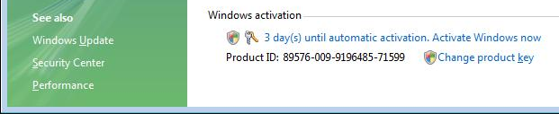

- In the Windows Activation box, click Activate Windows online now.
- In the Windows Activation box, you should see an Activation was successful message. Click the Close button. Notice that the Windows Activation section now shows your Product ID.

Setting the Default Operating System to Windows XP
- Most users of these computers want to use Windows XP, not Vista. So the default operating system should be changed back to Windows XP for them.
- If the System and Maintenance ► System ►box is not visible, click Start, right-click Computer, and click Properties.
- In the left pane of the System and Maintenance ► System ►box, click Advanced System Settings. In the User Account Control box, click Continue.
- In the System Properties box, on the Advanced tab, in the Startup and Recovery section, click the Settings button.
- In the Startup and Recovery box, change the Default operating system to Earlier version of Windows. Click OK.
- In the System Properties box, click OK.

Creating a Restore Point
- I discovered the hard way that Mcafee antivirus murders Vista dead, and there is no way to uninstall it, and no restore points. Since the system doesn’t do it for you automatically, you need to create your own restore point in case that happens to you.
- Click Start, right-click Computer and click Properties. Under Tasks, click System Protection. In the User Account Control box, click Continue.
- Click the Create button. In the Create a restore point box, enter a name of Fresh Install and click the Create button.

Rebooting into Windows XP
- You now have Vista installed and activated, but it’s not safe to use on the Internet yet because there is no antivirus software. So you need to use Windows XP to turn this project in.
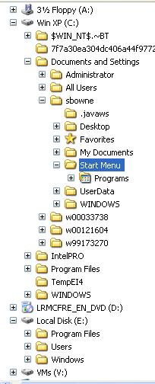
- Click the Start button (the Windows Logo button in the lower left corner). Point to the rightmost right-arrow, next to the padlock. In the pop-up menu, click Restart. Wait during restart to make sure that if you do nothing, it boots to Windows XP, not to Vista.
- Log in to the Windows XP system as usual.

Exploring the Dual-boot Folder Tree
- Right-click the Start button and click Explore. The Windows XP system volume’s folder tree will expand automatically to show the Start Menu folder. There should now be a second drive letter in the folder tree, containing the Vista operating system. In my example, Vista is on drive E: as seen from Windows XP. Click the + sign to the left of the Vista drive letter to expand it, so that both the Windows XP and the Vista trees are visible, as shown to the right on this page. The Vista tree should show a Users folder, and the Windows XP tree should show a Documents and Settings folder. That’s a simple way to tell the difference.

Saving the Screen Image
- Click on the Start Menu window to make sure it is the active window.
- Hold down the Alt key and press the PrintScrn key in the upper-right portion of the keyboard. That will copy the active window to the clipboard.
- Click Start, Programs, Accessories, Paint. In the untitled - Paint window, select Edit, Paste from the menu bar. The window image appears in the Paint window.
- In the untitled - Paint window, click File, Save. Save the document in the My Pictures folder (or any other place you wish, such as a floppy disk) with the filename Your Name Proj V1. Select a Save as type of JPEG.

Turning in your Project
- Open Internet Explorer, and use it to email the JPEG image to me as an email attachment. Send the message to: cnit.235@gmail.com with a subject line of CNIT 235 Proj V1 From Your Name, replacing Your Name with your own first and last name. Send a Cc to yourself.

Last Modified: 1-24-07

