Starting Your Computer
- Boot your computer to Vista. It should start without asking you to log in, automatically logging in as Student with no password.

Installing avast! Free Antivirus
- If you are working at home, go to avast.com and click Products, Free software, avast! 4 Home Edition. Then click the avast! 4 Home Download link. If you prefer to use some other antivirus product, feel free, but be cautious—I have killed a lot of Vista installations with antivirus products. You need to find something that is really written for Vista. I could not get McAfee or AVG to work at all—they both look ok, but when you restart they give errors. Mcafee gave me the blue screen of death and made me reinstall Vista from scratch.
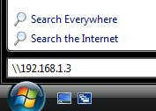
- If you are working in S214, follow the steps below:
  - Click the Start button (the Windows Logo button in the lower left corner). In the search box, type in \\192.168.1.3 as shown to the right on this page. Press the Enter key.
  - In the Network ► 192.168.1.3 window, double-click cnit235.
  - In the Network ► 192.168.1.3 ► cnit235 window, double-click _Software.
  - Drag the Avast folder to the desktop. Wait till the copy finishes.
  - To prepare for later portions of this project, drag the Firefox and VMware Player folders to your desktop too.
  - Close the Windows Explorer box (titled the Network ► 192.168.1.3 ► cnit235).
- Double-click the Avast folder to open it. Double-click the fsetupeng file.
- In the User Account Control box, click Continue.
- Click through the installer, accepting all the default selections. Accept the agreement. When it asks Do you wish to schedule a boot-time antivirus scan…, click No. Then click Finish to restart your machine. When your machine restarts, start it in Vista again.

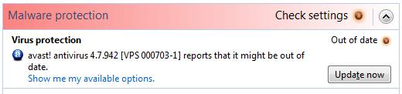
Displaying your Security Status
- Click Start, Control Panel. In the Security section, click Check this computer’s security status.
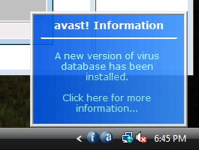
- In the Windows Security Center box, examine the Malware Protection status. If it shows that it might be out of date, as shown above on this page, just wait a couple of minutes and see if it automatically updates. If it does, you will see the message shown to the right on this page. If it doesn’t automatically update, click the Update now button in Windows Security Center.

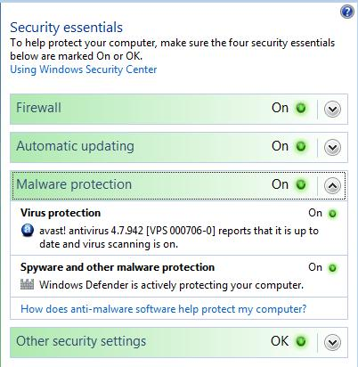
- After the update, all four items should show green On indicators. Expand the Malware protection section to show your virus protection and spyware protection information, as shown to the right on this page.

Saving the Screen Image
- Click on the Windows Security Center title bar to make sure it is the active window.
- Hold down the Alt key and press the PrintScrn key in the upper-right portion of the keyboard. That will copy the active window (Windows Security Center) to the clipboard.
- Click Start and click in the Search box. Type in mspaint and press the Enter key to open Paint. In the untitled - Paint window, select Edit, Paste from the menu bar. The window image appears in the Paint window.
- In the untitled - Paint window, click File, Save. Save the document in the Student ► Pictures folder (or any other place you wish, such as a floppy disk) with the filename Your Name Proj V2a. Select a Save as type of JPEG.

Updating Vista
- Click Start, All Programs, Windows Update.
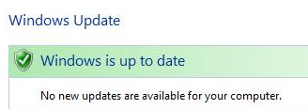
- You should see the message Windows is up to date as shown to the right on this page. If you don’t, follow the instructions on your screen to install all recommended updates until you see the Windows is up to date message.

Saving the Screen Image
- Click on the Control Panel ► System and Maintenance ► Windows Update ► box to make sure it is the active window.
- Hold down the Alt key and press the PrintScrn key in the upper-right portion of the keyboard. That will copy the active window to the clipboard.
- Click Start and click in the Search box. Type in mspaint and press the Enter key to open Paint. In the untitled - Paint window, select Edit, Paste from the menu bar. The window image appears in the Paint window.
- In the untitled - Paint window, click File, Save. Save the document in the Student ► Pictures folder (or any other place you wish, such as a floppy disk) with the filename Your Name Proj V2b. Select a Save as type of JPEG.

Optional but Recommended -- Installing Firefox
- You can use Internet Explorer for all your browsing, if you are comfortable with that. I can’t stand it, personally, because of all the security holes, but 90% of the people on the Internet do it. When I use Internet Explorer, I feel like I am eating something I found lying on the ground.
- If you are working at home, download AVG Free antivirus from getfirefox.com
- If you are working in S214, you already put the Firefox folder onto your desktop in step 3.
- Double-click the Firefox folder to open it. Double-click the file inside, with a name starting with Firefox Setup.
- In the User Account Control box, click Continue.
- Click through the installer, accepting all the default selections. I recommend that you make Firefox your default browser, and only use Internet Explorer when Firefox doesn’t work.

Installing VMware Player
- You really need VMware player. As you have seen, almost all the projects require the virtual machines—Vista would be almost worthless to us without it.
- If you are working at home, download VMware Player from vmware.com (click Products, Free Virtualization Products).
- If you are working in S214, you already put the VMware Player folder onto your desktop in step 3.
- Double-click the VMware Player folder to open it. Double-click the file inside, with a name starting with VMware-player.
- In the User Account Control box, click Continue.
- Click through the installer, accepting all the default selections. You will see a red warning saying Windows cannot verify the publisher of this driver software. Install it anyway.

Installing VMmanager
- VMmanager allows you to create VMware virtual machines, modify existing ones. It is a completely different product than Microsoft’s VM Manager – don’t confuse the two!
- If you are working at home, follow the steps below:
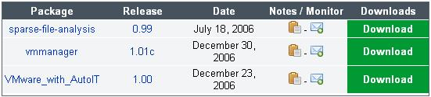
  - Open a browser and go to vmmanager.sourceforge.net. Click Download. Click Download VMmanager.
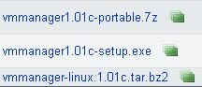
  - The next screen shows three packages, as shown to the right on this page. The package we want is vmmanager—the one in the middle. In the middle row, click the Download button.
  - The next screen again shows a choice of three files. The one we want is in the middle again. Click the vmmanager1.01c-setup.exe link. Save the file.
- If you are working in S214, just open the VMware Player folder on your desktop. The VMmanager installer is on the same server in our classroom.
- Double-click the VMmaUser Account Control box, click Allow.
- In the Installer Language box, accept the default selection of English and click OK.
- In the VMmanager v1.01c Setup box, click Next.
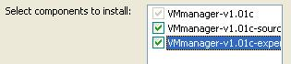
- Accept the agreement and click Next.
- The next box asks you to select which components to install. Check all three boxes, as shown to the right on this page! VMmanager won’t work unless you do this. Then click Next. Click Install.

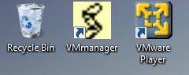
Saving the Screen Image
- Your desktop should now snow the VMmanager and VMware Player icons, as shown to the right on this page, in addition to other items such as the Recycle bin.
- Press the PrintScrn key to copy the whole desktop to the clipboard.
- Click Start and click in the Search box. Type in mspaint and press the Enter key to open Paint. In the untitled - Paint window, select Edit, Paste from the menu bar. The desktop image appears in the Paint window.
- In the untitled - Paint window, click File, Save. Save the document in the Student ► Pictures folder (or any other place you wish, such as a floppy disk) with the filename Your Name Proj V2c. Select a Save as type of JPEG.

Turning in your Project
- Open Internet Explorer in the virtual machine, and use it to email the JPEG images to me as attachments to one e-mail message. Send the message to: cnit.235@gmail.com with a subject line of CNIT 235 Proj V2 From Your Name, replacing Your Name with your own first and last name. Send a Cc to yourself.

Last Modified: 1-23-07

