How to adjust VMWare to allow two virtual NICs mapped to the physical NICs

- Sam has to do this – it cannot be done without logging in as a local Administrator on the host OS.
- Log in as a local Administrator.
- Start VMWare Workstation, but do not start any virtual machine.
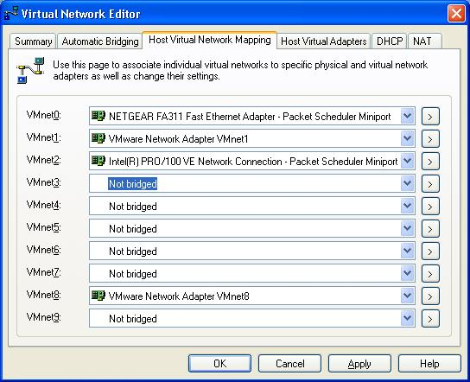
- Click Edit, Virtual Network Settings.
- On the Automatic Bridging tab, clear the Automatically choose… check box.
- On the Host Virtual Network Mapping tab, make sure VMnet0 is set to NETGEAR and VMnet2 is set to Intel as shown below. Click OK.

