What You Need
- A computer running Windows XP Professional, with at least 512 MB of RAM and several GB of storage available. Each virtual machine is 2-4 GB, or even larger if you install a lot of software on the virtual machine
- A broadband Internet connection so you can download large files

VMware Player
- Open a browser and go to vmware.com. Click Products, Free Virtualization Products.
- Click the Download VMware Player button. Under Latest Version, click the Download Now button.
- Fill in the form and click the Submit button.
- Accept the agreement.
- Find the VMware player for Windows file. Click the Download button and save the installer. Notice the MD5 hash—it would be wise to confirm the hash of the downloaded file to make sure it’s correct.
- Double-click the downloaded file and install VMware player. You can now use virtual machines at home, but you cannot create them with the player. To create virtual machines, see the next section.

VMmanager
- VMmanager allows you to create VMware virtual machines, and the modify existing ones. It is a completely different product than Microsoft’s VM Manager – don’t confuse the two!
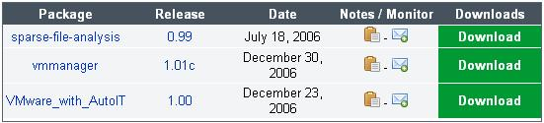
- Open a browser and go to vmmanager.sourceforge.net. Click Download. Click Download VMmanager.
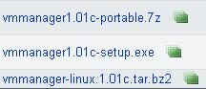
- The next screen shows three packages, as shown to the right on this page. The package we want is vmmanager—the one in the middle. In the middle row, click the Download button.
- The next screen again shows a choice of three files. The one we want is in the middle again. Click the vmmanager1.01c-setup.exe link. Save the file.
- Double-click the downloaded file to start the installer. In the Installer Language box, accept the default selection of English and click OK.
- In the VMmanager v1.01c Setup box, click Next.
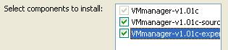
- Accept the agreement.
- The next box asks you to select which components to install. Check all three boxes, as shown to the right on this page! VMmanager won’t work unless you do this. Then click Next. Click Install.

Last Modified: 1-18-07 1 pm

