General
- Every time the instructions tell you to open the server’s file shares by entering \\192.168.1.2 or \\192.168.3.1, enter this IP address instead: \\192.168.1.3

Project 1
Step 1: Log in with:
    - User name: Your CCSF Student ID, unless it starts with @. If your ID starts with @, replace the @ with X.
    - Password: changeme
Once you get logged in, press Ctrl+Alt+Delete and click the Change Password… button. Change your password to something you can remember.
Step 2: Don’t do Step 2. We won’t use that ISO image this semester. Instead, use the ISO image on the V: drive, in the Install folder, named en_winxp_pro_with_sp2.iso. This is a single-user installation disk, so you will need a product key. Your instructor will show you how to retrieve a key from the MSDNAA system that you can use in the lab.
Step 12: Before starting your virtual machine, do the procedure below to adjust the network settings. If you don’t do this, your virtual machine will not be able to connect to the Internet.

Adjusting Network Settings
- The Ethernet settings on VMware Workstation are set to match the two physical network interfaces on our lab machines, so you will need to adjust network settings. This only has to be done once for each virtual machine. If you are working at home, this probably won’t be necessary.
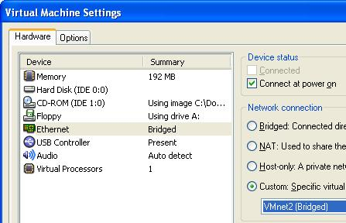
- In the Windows XP Professional – Vmware Workstation window, on the left side, click the Edit virtual machine settings link.
- In the Virtual Machine Settings box, on the Hardware tab, click the Ethernet item to select it. On the right side, click the Custom radio button and select VMnet2 (Bridged) as shown to the right on this page. Click the Add button.
- In the Welcome to the Add Hardware Wizard screen, click Next.
- In the Hardware Type screen, click Ethernet Adapter and click Next.
- In the Network Type screen, on the right side, click the Custom radio button and select VMnet0 (default Bridged). Click Finish.
- In the Virtual Machine Settings screen, click OK.
Step 18: Because you didn’t do Step 2, there is no ISO file on your desktop. Instead, navigate to the V:\Install folder and double-click the en_winxp_pro_with_sp2.iso file.

Project 2
Step 17: Instead of \\192.168.1.2, enter this IP address instead: \\192.168.1.3
Step 18: Instead of \\192.168.1.2, you will see \\192.168.1.3
Step 22: In the figure, instead of \\192.168.1.2, you will see \\192.168.1.3

Project 4
Step 13: Instead of \\192.168.1.2, you will see \\192.168.1.3
Step 22: In the figure, instead of \\192.168.1.2, you will see \\192.168.1.3

Last Modified: 1-19-07 8 am

