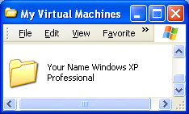
On Your Old Machine

- Make sure that the virtual machine is not running – close VMWare completely.

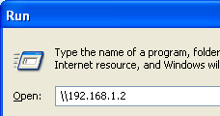
- Open My Documents. Open My Virtual Machines. Find the folder with your name on it, as shown in the upper-right figure on this page.

- Click Start, Run. In the Run box, enter \\192.168.1.2 and click OK.

- An Instructor1 machine … window opens. Double-click the cnit235 folder.
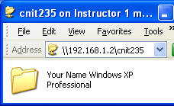
- Drag the folder with your name on it from the My Virtual Machines window into the cnit235 window, as shown to the right on this page. The copy will take 5 – 15 minutes.

On Your New Machine

- Open My Documents. Open My Virtual Machines.
- Click Start, Run. In the Run box, enter \\192.168.1.2 and click OK. An Instructor1 machine … window opens. Double-click the cnit235 folder.

- Drag the folder with your name on it from the cnit235 window into the My Virtual Machines window, as shown to the right on this page. The copy will take 5 – 15 minutes.
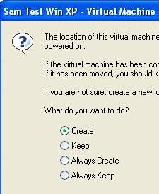
- To launch the machine, start VMWare Workstation from the desktop icon, and on the Home tab, click Open Existing VM or Team. Open the My Documents folder and the My Virtual Machines folder. Open the folder with your name on it and double-click the winxppro file.

- When you see the window shown to the right on this page, asking whether to create a new identifier, accept the default selection of Create and click OK.

- When the new machine starts up, log in and click Start, right-click My Computer, and click Properties. On the Computer Name tab, click the Change button. Change the computer name to match the new station number. Click OK. Close all windows and restart the virtual machine.
Last modified 9-30-05

