E-mail From MSDNAA
- You should have received an e-mail with the subject: Welcome to MSDN Academic Alliance: Online Software System. This e-mail has your username and password in it. You cannot download any software without that information.
Getting Your Windows XP Professional Activation Code
- Open Internet Explorer and go to http://msdn06.e-academy.com/CCoSF_IT
- Click the LOG IN button.
- Log in with the user name and password from your e-mail message.
- Click the Software near the top of the page.
- Click on the picture of Windows XP Professional.
- Click Download only and click ADD TO CART.
- The Student Use Guidelines appear. Scroll down and click I Agree at the bottom.
- A View Shopping Cart screen appears. Click CHECK OUT.
- On the Customer Information screen, fill in your name and click Next.
- On the Order Details screen, click on the blue Windows XP Professional link.
- Your product activation code appears. Save this number – I recommend copying it into an e-mail message or NotePad file immediately.
Downloading the CD Image (not necessary if you got a CD from your instructor)
- Scroll down and click one of the gray Download Software buttons.
- Download the file to your desktop. It is a small file named Simon.exe.
- Close all windows and double-click the Simon.exe file. A License Authorization and Software Installation window opens.
- Accept the default download location of C:\Temp and click the gray button to proceed.
- Wait for the red progress indicator at the bottom of the License Authorization and Software Installation window to reach 100%. It will then check the file’s CRC (Cyclic Redundancy Check – a code made by combining all the bytes in the file) to make sure it is correct.
- When the red progress indicator vanishes, click the gray Launch Install button.
- A C:\TEMP folder opens containing a file named en_winxp_pro_with_sp1a.iso. This is an image file to be written to a CD-ROM.
Installing NTI CD-Maker
- If you want to do this in S214, you need NTI CD-Maker. If it's not already on your computer, ask your instructor to install it on the host operating system. NTI CD-Maker does not work from a virtual machine.
Recording a CD From an Image
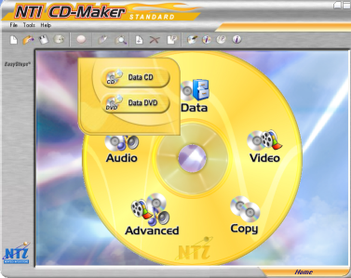
- The next step depends on what CD burning software you have. The instructions below are for the NTI CD-Maker.
- Click Start, All Programs, NTI CD-Maker, NTI CD-Maker 6 Standard.
- The NTI-CD Maker window opens, as shown to the right on this page. Click Data, then click Data CD.

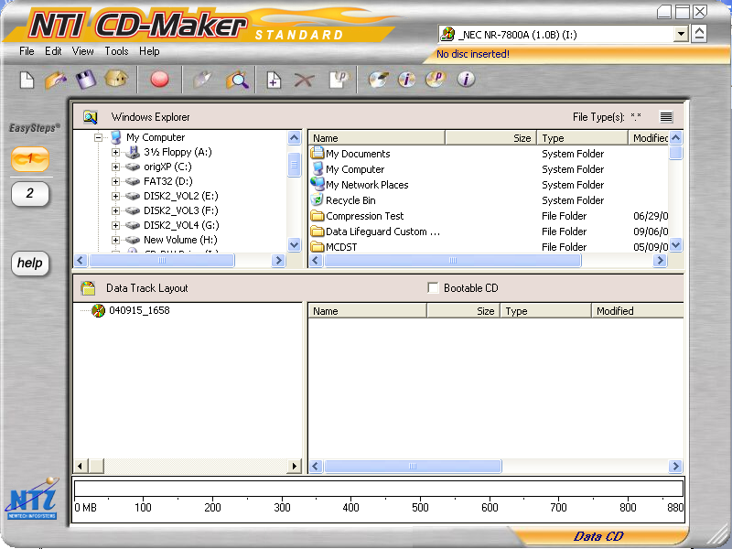
- Now a different NTI-CD Maker window opens, as shown to the right on this page. From the menu, click File, then click Create disc from ISO image file.

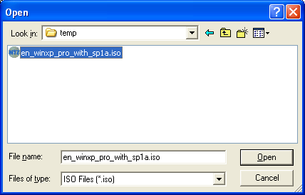
- In the Open box, navigate to C:\Temp, click the image file, and click Open as shown to the right on this page.
- Insert a blank CD when prompted to.
- In the NTI Write CD window, click Start.
- When the CD pops out, label it with a felt-tipped pen. That’s an installation disk. The best thing to do is to write the product activation code you got in step 15 above right on the CD, or on the envelope, because you will need them both together to install the operating system.

Revised 1-17-06

