Starting Your Computer
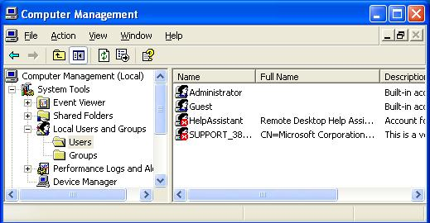
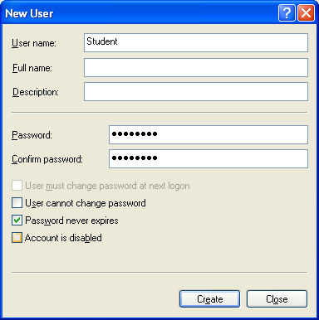
- Start your computer with the appropriate L removable hard drive in it. Boot it up to the Windows XP operating system. If you are the first student to use the machine, it will automatically log you in as CNIT, and you will not see any login screen. If you are not the first student to do this project, you will see a login screen with two choices: CNIT and Student. In that case, log in as Student with a password of P@ssw0rd and skip to step 9.

Creating the Student Account
- Click Start, right-click My Computer, and click Manage. In Computer Management, in the left pane, expand Local Users and Groups, and click the Users container to open it, as shown to their right on this page.
- Right-click in an empty portion of the right pane and select New User.
- In the New User box, enter a User Name of Student and a Password of P@ssw0rd in both the Password and the Confirm Password boxes. Clear the User must change password at next logon box. Check the Password never expires box. Make sure your entries match the example to the right on this page and click Create.
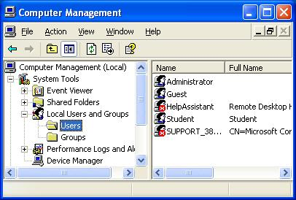
- In the New User box, click Close.
- The Computer Management window should now show a Student account, as shown to the right on this page.
- Click Start, Log Off. In the Log Off Windows box, click Log Off.
- Log on as Student with a password of P@ssw0rd.

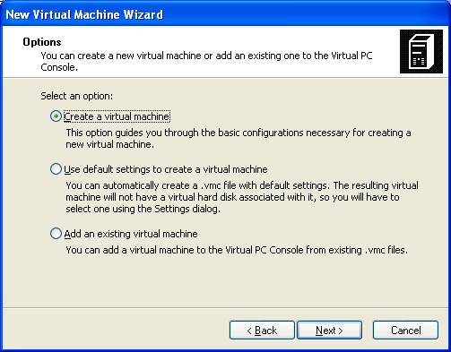
Starting Microsoft Virtual Machine
- We will use a program called Microsoft Virtual Machine, which simulates a computer on top of the existing Windows XP operating system. That way you can practice installation and other activities without changing (and possibly damaging) the existing operating system.
- Click Start, All Programs, Microsoft Virtual PC.
- The New Virtual Machine Wizard may open automatically. If it does not open automatically, click the gray New button to open it.
- At the Welcome to the New Virtual Machine Wizard screen, click Next.
- At the Options screen, accept the default selection of Create a virtual machine as shown to the right on this page. Click Next.
- At the Virtual Machine name and Location screen, enter a name of YourName WinXP. Do not enter the literal text ‘YourName” but put your own name there. Click Next.
- At the Operating System screen, select Windows XP. Click Next.
- At the Memory screen, accept the default selection of Using the recommended RAM. Click Next.
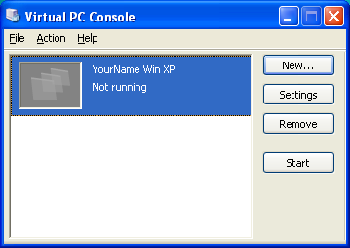
- At the Virtual Hard Disk Options screen, select A new virtual hard disk. Click Next.
- At the Virtual Hard Disk Location screen, accept the default name and location (this puts the virtual machine in the My Documents folder). Click Next.
- At the Completing the New Virtual Machine Wizard screen, click Finish.
- In the Virtual PC Console window, verify that the machine with your name on it is selected and click the gray Start button, as shown to the right on this page.
- A YourName Win XP – Microsoft Virtual PC 2004 window opens, and ends with a message saying Reboot and Select proper Boot device or Insert Boot Media in selected Boot device.
- Insert a Windows XP installation CD labeled XP2 into the CD-ROM drive. These CDs have Windows XP Professional with Service Pack 2.
- Click the title bar of the YourName Win XP window to make it active. Press Enter. The virtual PC should boot from the CD.

Text mode setup
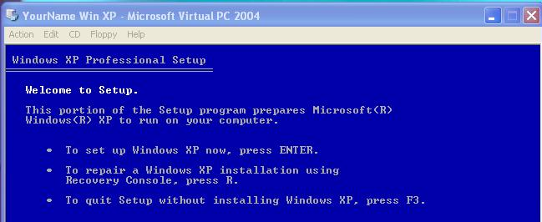
- At the blue Welcome to Setup screen, press Enter to set up Windows now, as shown to the right on this page.
- At the blue Windows XP Licensing Agreement screen, press F8.
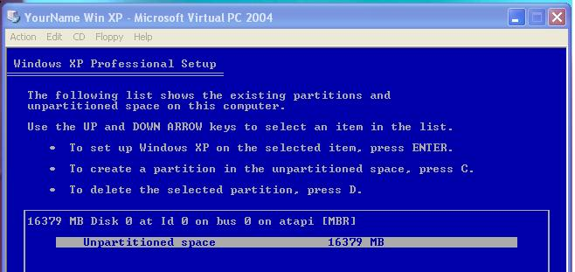
Partitions
- At the blue Windows XP Professional Setup screen you can set up partitions. The machine starts with a large amount of Unpartitioned Space as shown in the figure to the right (your actual amount of space may be different). Press C to create a partition.

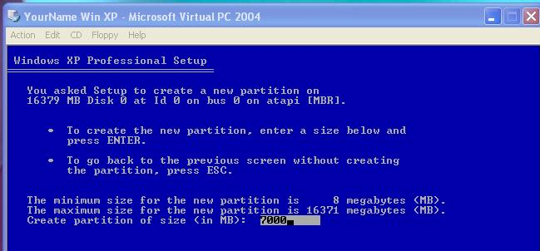

- Change the size of the partition to 7000 MB as shown to the right on this page. Press Enter.

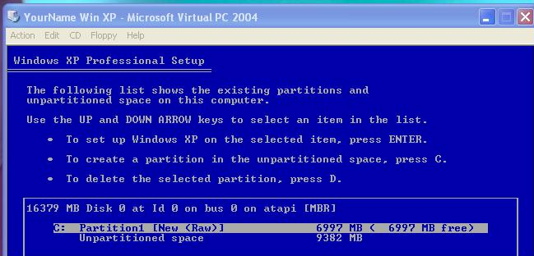

- The next screen shows the new partition you just created as the C: drive, as shown in the figure to the right on this page. Verify that the C: partition is selected and press Enter.

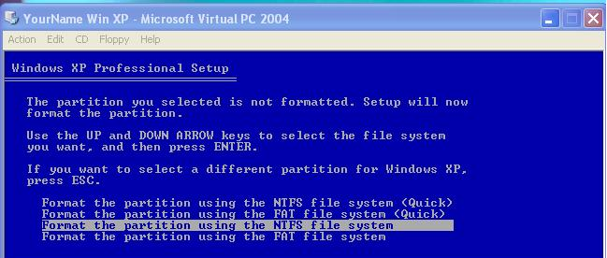
- The next screen gives you four options for formatting the drive. Accept the default selection of Format the partition using the NTFS file system and press Enter. Wait while the partition formats, and files are copied.

GUI mode setup
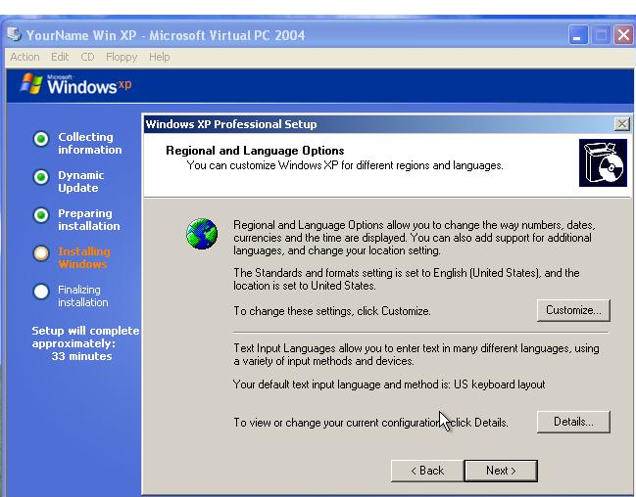
- Your virtual machine reboots and opens a graphical blue screen. Now you wait longer, but you have something more interesting to look at.
- In the Regional and Language Options screen, as shown to the right on this page, click Next.

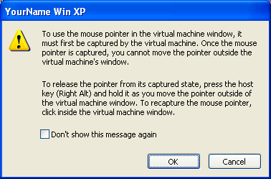
- A YourName Win XP box opens as shown to the right on this page, explaining how the mouse pointer can be used in Virtual PC windows. Read it and click OK.
- Move the mouse pointer into the YourName Win XP – Microsoft Virtual PC 2004 window, and point to the Next button in the Regional and Language Options screen. Click there. Note that your mouse pointer is now captured – it cannot move outside the virtual PC window. The way to move it out is to hold down the right Alt key. Try moving in and out of the Virtual PC window to see how it works.
- In the Virtual PC Window, in the Personalize Your Software screen, enter your name and CCSF as your organization and click Next.

- On the Personalize Your Software screen, enter your name and an organization of CCSF and click Next.
- Type in the Product Key from the whiteboard in the classroom and click Next.
- Next is the Computer Name and Administrator Password screen. Give your computer the name printed on its front panel label, which will be something like S214-08, with a suffix of v, so the final name will be S214-08v or something similar. (The v stands for virtual.) Enter a password of P@ssw0rd in both boxes and click Next.

Do Not Forget The Administrator Password! If you do, you will have to reinstall Windows XP in order to do a later project with the Recovery Console. Forgetting the Administrator password is a common error, and it makes you look like a fool to your boss – make a habit of always writing down the password in a safe place when you install Windows.

- On the Date and Time Settings screen, click Next.
- On the Networking Settings screen, click Next.
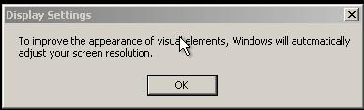
- On the Workgroup or Computer Domain screen, accept the default of a workgroup named WORKGROUP and click Next.
- A Display Settings window pops up as shown to the right on this page. Click OK, and in the Monitor Settings window, click OK again.

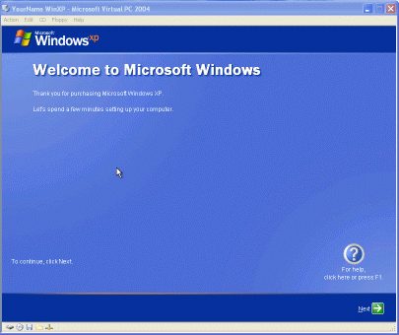
Windows Welcome
- A blue decorative window appears, with a large Welcome to Microsoft Windows at the top, as shown to the right on this page. Click Next.
- On the Help protect your PC screen, select Help protect my PC by turning on Automatic Updates now. Click Next.
- On the How will this computer connect to the Internet? screen, select Local Area Network. Click Next.
- On the Setting up a High Speed Connection screen, check these two boxes: Obtain IP Automatically and Obtain DNS Automatically. Click Next.
- On the Ready to Register with Microsoft? screen, select No, not at this time. Click Next.
- At the Who will use this computer? screen, enter your own name in the Your name box, and Waldo in the 2nd User box. Click Next.
- At the Thank You! screen, click Finish.
- A Windows XP screen appears showing you a choice of two users: YourName and Waldo, as shown on the next page.

Turning in your Project
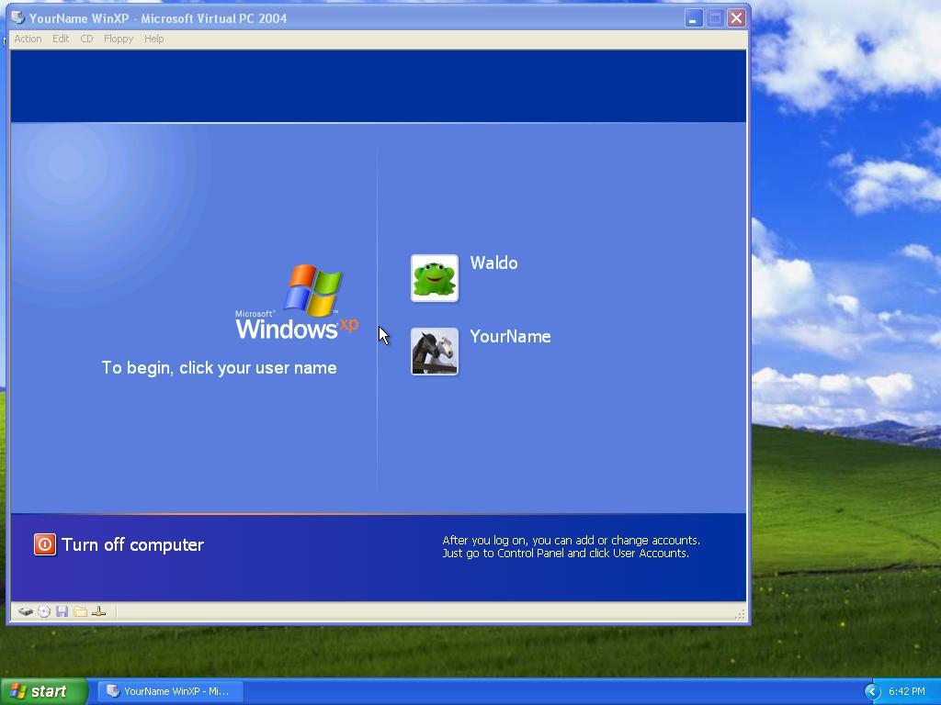
- You have now completed Project 1. The only thing that remains is to turn it in. To do that, you need to make a JPEG image of the screen and email it to me, as explained below. Note the hand symbol just below this text: that indicates screen images that you must capture and turn in.
- Hold down the right Alt button on the keyboard and move the mouse pointer out of the YourName WinXP window. Click an empty portion of the Windows XP desktop outside the YourName WinXP window, so that the YourName WinXP title bar is dimmed, as shown in the figure above.
- Press the PrintScrn key in the upper-right portion of the keyboard. That will copy the whole desktop to the clipboard.
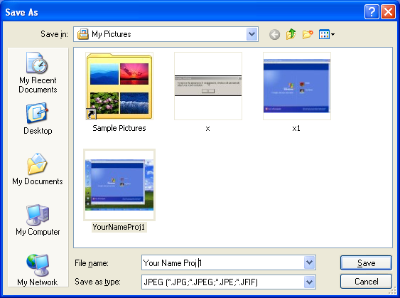
- Click Start, Programs, Accessories, Paint. In the untitled - Paint window, select Edit, Paste from the menu bar. The desktop appears in the Paint window, with only a corner of it visible.
- In the untitled - Paint window, click File, Save. Save the document in the My Pictures folder (or any other place you wish, such as a floppy disk) with the filename Your Name Proj 1. Select a Save as type of JPEG, as shown in the figure to the right on this page.
- Email the JPEG image to me as an attachment. Send it to: cnit.235@gmail.com with a subject line of CNIT 235 Proj 1 From Your Name, replacing Your Name with your own first and last name. Send a Cc to yourself.
- In the YourName Win XP – Microsoft Virtual PC 2004 window, click Start, Turn Off Computer, Turn Off.
Last Modified: 1-26-05 5 pm

