Starting Your Computer
- Start your computer with the appropriate L removable hard drive in it. Log in with the account information your instructor provided to you. In Fall 2005, the User name is CNIT235 with a password of windowsxp

Starting VMWare Workstation
- We will use a program called VMWare Workstation, which simulates a computer on top of the existing Windows XP operating system. That way you can practice installation and other activities without changing (and possibly damaging) the existing operating system.
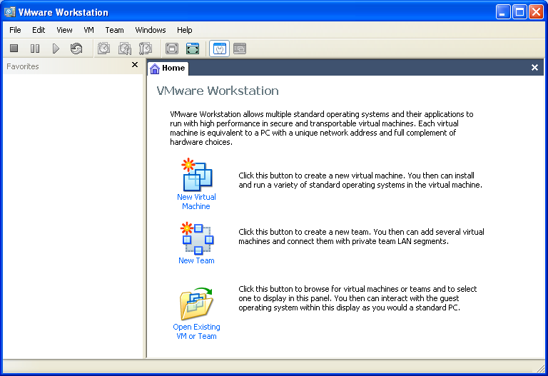
- Double-click the VMWare Workstation icon on the desktop.
- A VMWare Workstation window opens as shown to the right on this page. Click the New Virtual Machine icon.
- At the Welcome to the New Virtual Machine Wizard screen, click Next.
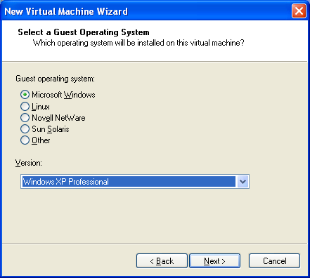
- At the Select the Appropriate Configuration screen, accept the default selection of Typical and click Next.
- At the Select a Guest Operating System screen, make sure that the Microsoft Windows radio button is selected and in the Version box, select Windows XP Professional, as shown to the right on this page. Click Next.

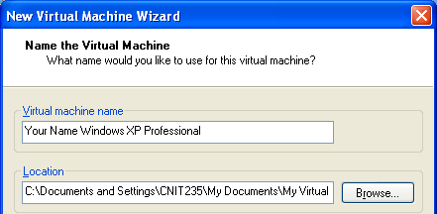
- At the Name the Virtual Machine screen, enter a Virtual machine name of Your Name Windows XP Professional as shown to the right on this page. Do not use the literal words “Your Name” – put in your own name. Do not change the Location. Click Next.
- At the Network Type screen, accept the default selection of Typical and click Next.
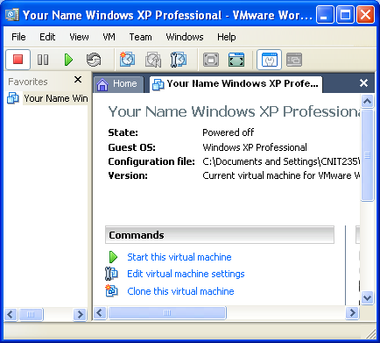
- At the Select the Appropriate Configuration screen, accept the default selection of Use Bridged Networking and click Next.
- At the Specify Disk Capacity screen, change the size to 7 GB. Do not check either of the boxes. Click Finish.
- You should now see a window like the one shown to the right on this page, with Your Name Windows XP Professional in large gray letters near the top. In the Commands section in the middle of the window, click Start this virtual machine.
- A Your Name Windows XP Professional – Virtual Machine opens saying The keyboard hook timeout value …. Click OK to close the box.
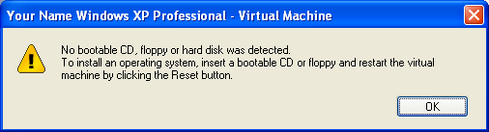
- The virtual machine starts, and attempts to boot up, but there is no operating system installed, so it ends with the message shown on to the right on this page.

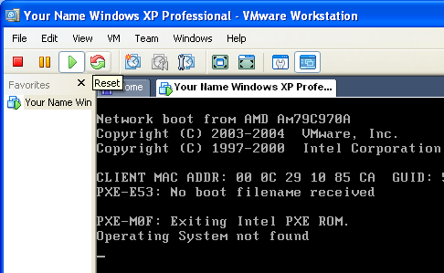
- Insert a Windows XP installation CD labeled XP2 into the CD-ROM drive. These CDs have Windows XP Professional with Service Pack 2. Then click the Reset button as shown to the right on this page. When a VMWare Workstation box opens asking Are you sure that you want to restart the guest operating system? click OK. In the next box, click OK.
- The virtual machine should boot from the CD.

Text mode setup
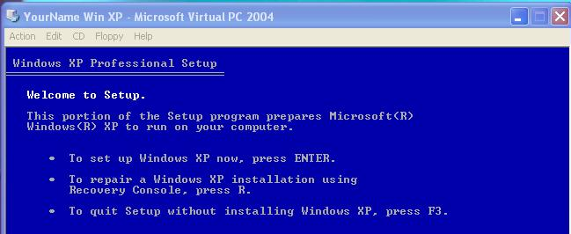
- At the blue Welcome to Setup screen, press Enter to set up Windows now, as shown to the right on this page.
- At the blue Windows XP Licensing Agreement screen, press F8.

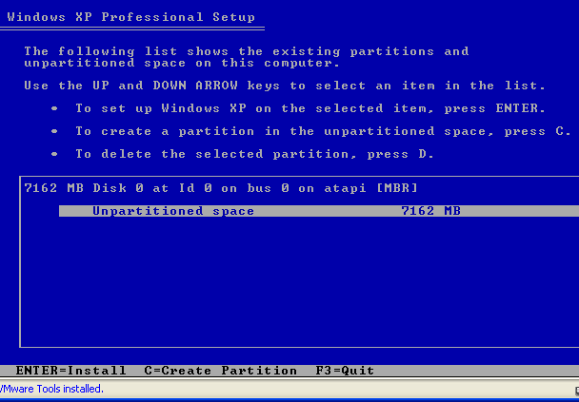
Partitions
- At the blue Windows XP Professional Setup screen you can set up partitions. The machine starts with 7162 MB of Unpartitioned Space as shown in the figure to the right (your actual amount of space may be different). Press C to create a partition.

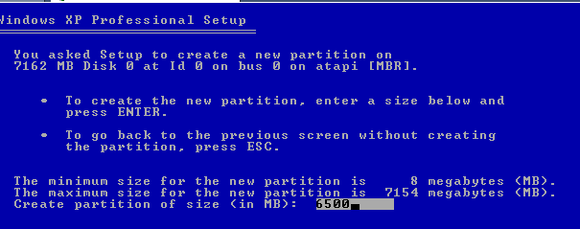
- Change the size of the partition to 6500 MB as shown to the right on this page. Press Enter.

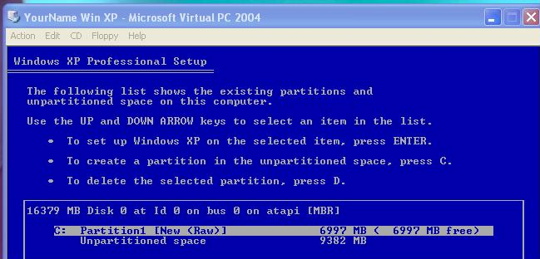

- The next screen shows the new partition you just created as the C: drive, as shown in the figure to the right on this page. Verify that the C: partition is selected and press Enter.

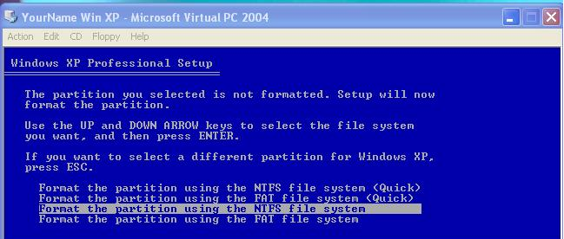
- The next screen gives you four options for formatting the drive. Accept the default selection of Format the partition using the NTFS file system and press Enter. Wait while the partition formats, and files are copied.

GUI mode setup
- Your virtual machine reboots and opens a graphical blue screen. Now you wait longer, but you have something more interesting to look at.
- In the Regional and Language Options screen, click Next.

- In the Virtual PC Window, in the Personalize Your Software screen, enter your name and CCSF as your organization and click Next.
- On the Personalize Your Software screen, enter your name and an organization of CCSF and click Next.
- Type in the Product Key from the whiteboard in the classroom and click Next.
- Next is the Computer Name and Administrator Password screen. Give your computer the name printed on its front panel label, which will be something like S214-08, with a suffix of v, so the final name will be S214-08v or something similar. (The v stands for virtual.) Enter a password of P@ssw0rd in both boxes and click Next.

Do Not Forget The Administrator Password! If you do, you will have to reinstall Windows XP in order to do a later project with the Recovery Console. Forgetting the Administrator password is a common error, and it makes you look like a fool to your boss – make a habit of always writing down the password in a safe place when you install Windows.

- On the Date and Time Settings screen, click Next.
- On the Networking Settings screen, click Next.
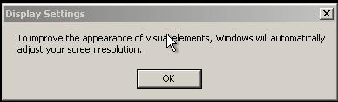
- On the Workgroup or Computer Domain screen, accept the default of a workgroup named WORKGROUP and click Next.
- A Display Settings window pops up as shown to the right on this page. Click OK, and in the Monitor Settings window, click OK again.

Windows Welcome
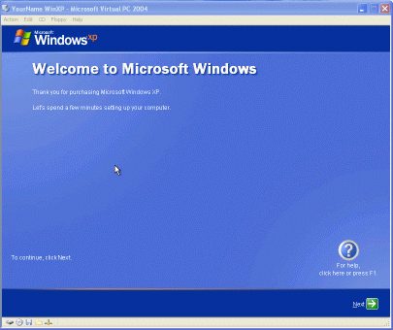
- A blue decorative window appears, with a large Welcome to Microsoft Windows at the top, as shown to the right on this page. Click Next.
- On the Help protect your PC screen, select Help protect my PC by turning on Automatic Updates now. Click Next.
- On the How will this computer connect to the Internet? screen, select Local Area Network. Click Next.
- On the Setting up a High Speed Connection screen, check these two boxes: Obtain IP Automatically and Obtain DNS Automatically. Click Next.
- On the Ready to Register with Microsoft? screen, select No, not at this time. Click Next.
- At the Who will use this computer? screen, enter your own name in the Your name box, and Waldo in the 2nd User box. Click Next.
- At the Thank You! screen, click Finish.
- A Windows XP screen appears showing you a choice of two users: YourName and Waldo, as shown on the next page.

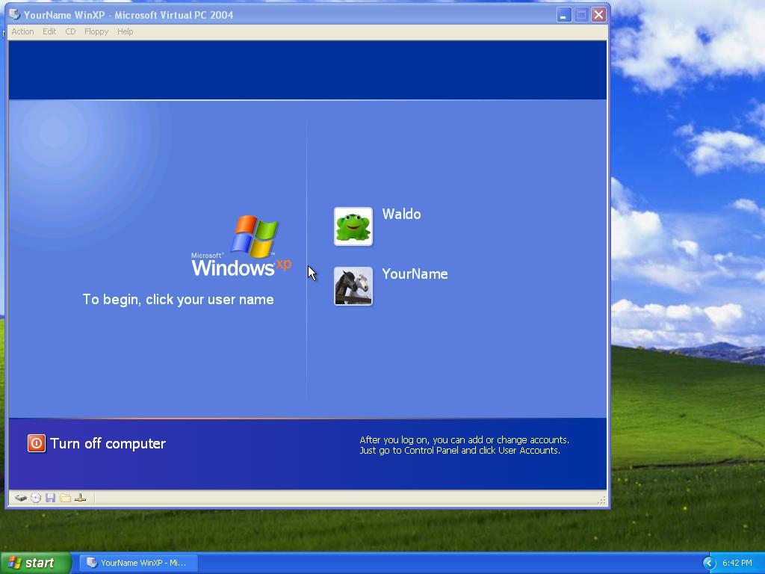
Turning in your Project
- You have now completed Project 1. The only thing that remains is to turn it in. To do that, you need to make a JPEG image of the screen and email it to me, as explained below. Note the hand symbol just below this text: that indicates screen images that you must capture and turn in.
- Press Ctrl+ Alt on the keyboard to release the cursor from within the Virtual Machine window. Move the mouse pointer out of the Your Name Windows XP Professional window. Click an empty portion of the Windows XP desktop outside the Your Name Windows XP Professional window, so that the Your Name Windows XP Professional title bar is dimmed.
- Press the PrintScrn key in the upper-right portion of the keyboard. That will copy the whole desktop to the clipboard.
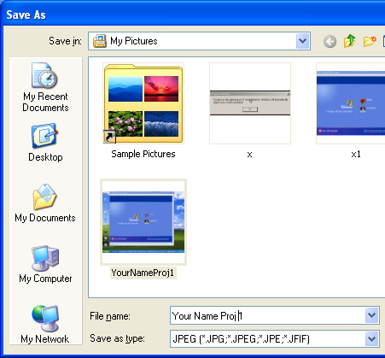
- Click Start, Programs, Accessories, Paint. In the untitled - Paint window, select Edit, Paste from the menu bar. The desktop appears in the Paint window, with only a corner of it visible.
- In the untitled - Paint window, click File, Save. Save the document in the My Pictures folder (or any other place you wish, such as a floppy disk) with the filename Your Name Proj 1. Select a Save as type of JPEG, as shown in the figure to the right on this page.
- Email the JPEG image to me as an attachment. Send it to: cnit.235@gmail.com with a subject line of CNIT 235 Proj 1 From Your Name, replacing Your Name with your own first and last name. Send a Cc to yourself.
- In the YourName Win XP – Microsoft Virtual PC 2004 window, click Start, Turn Off Computer, Turn Off. Last Modified: 8-26-05

