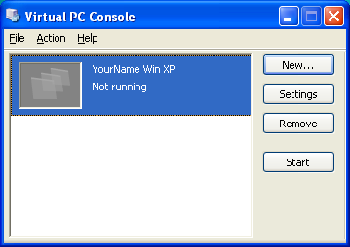
Starting Your Computer
- Start your computer with the appropriate L removable hard drive in it. Boot it up to the Windows XP operating system and log in as Student with a password of P@ssw0rd.

Starting Microsoft Virtual Machine
- In the Virtual PC Console window, verify that the machine with your name on it is selected and click the gray Start button, as shown to the right on this page.
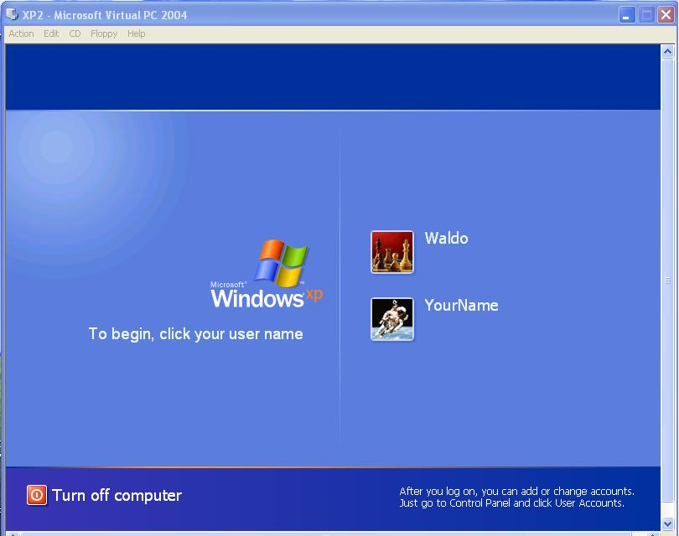
- A YourName Win XP – Microsoft Virtual PC 2004 window opens, and Windows XP starts. When you see the screen shown to the right on this page, click the YourName icon to log in. No password is required.

Installing Virtual Machine Additions
- In the Virtual PC Console window, hold down the right Alt key to move the mouse pointer up to the menu bar and then release the Alt key. Click Action, Install or Update Virtual Machine Additions. In the next box, click Continue. An InstallShield Wizard box opens and you see a progress indicator moving.

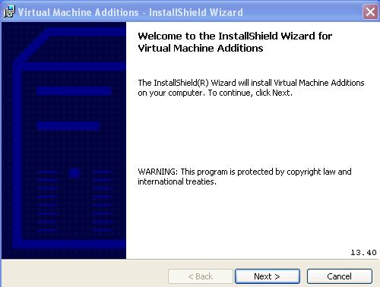
- A Virtual Machine Additions - InstallShield Wizard box opens as shown to the right on this page. Click Next.
- When you see the message InstallShield Wizard Completed, click Finish.
- A Virtual Machine Additions Installer Information box opens saying You must restart your computer …. Click Yes. Wait while your virtual PC shuts down and restarts.
- Click the YourName icon to log in.

Checking Internet Connectivity
- Click Start, Internet. Internet Explorer should open and display the msn.com web page. If you cannot open the Web page, call your instructor over to help you.

Checking Windows Version
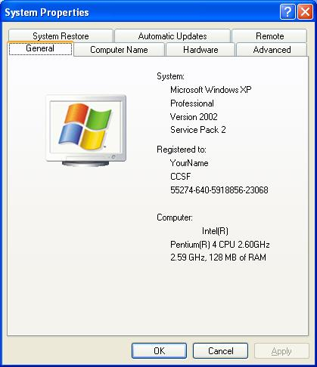
- Click Start, right-click My Computer, and click Properties. Examine the System Properties window and compare it to the example to the right on this page. You should see that you have Windows XP Professional with Service Pack 2 and 128 MB of RAM.

Updating Windows XP
- Although you have Service Pack 2 installed, there have been additional updates to Windows XP since then. It is very important to make sure you have all the updates because many of them are critical for security, so the next step is to make sure your Windows XP is fully updated, using the Microsoft Update Web site.
- Click Start, Help and Support. In the Pick a task section, click on Keep your computer up-to-date with Windows Update.
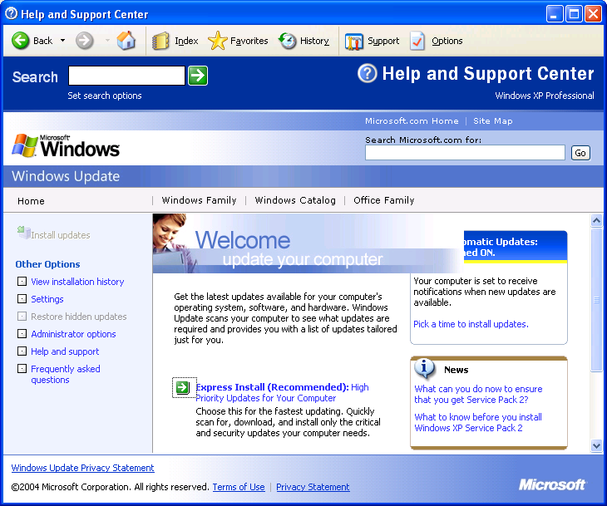
- If a Security Warning box opens asking if you want to install and run software, click Yes.
- If a Get the latest Windows Update software page appears, click the gray Install Now button.
- Your Help and Support Center window should now look like the figure to the right on this page. In the lower-center, find the blue Express Install (Recommended) link and click it. Wait while Windows Update scans your system. If an internet Explorer box pops up saying When you send information to the Internet, it might be possible for others to see that information…, click Yes.

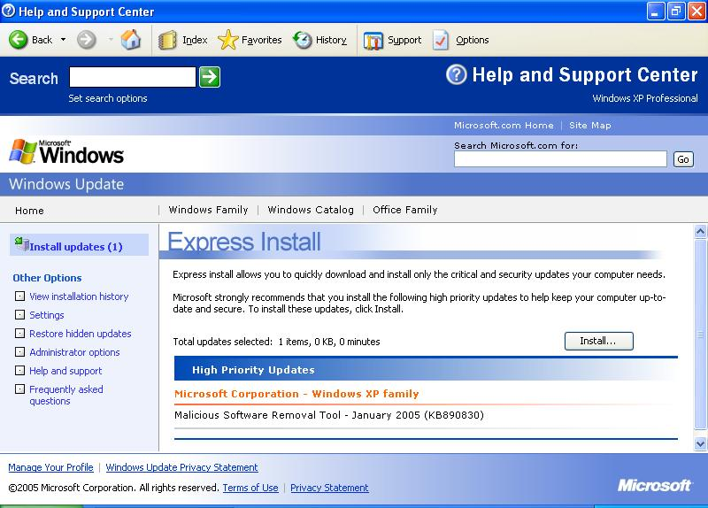
- If Windows Update finds any updates you need, it will show them in a screen like the one to the right on this page. Click the gray Install button. You may have to click an I Accept button to agree to a license agreement.
- Wait while the updates download and install. It should only take a couple of minutes in the computer lab, but it might take a long time if you have a dial-up Internet connection. You can continue using your computer for other things while the update proceeds, but it may respond more slowly. When you see the message You have successfully updated your computer, click Close.
- Often you cannot install all the Windows Updates at once. Some of them require restarting your computer, or must be installed singly for other reasons. If you see a Review and install remaining updates now link, click it and install any more updates that are recommended.
- When you see the message shown at the top of the next page, saying Your machine appears to be up-to-date, you are done updating. Notice the hand icon I placed on this image: that icon will not appear on your screen -- it is there to indicate to you that you need to save this image to turn in for credit. Do the following steps to make a screen image of this window showing that you completed the update process.

Saving the Screen Image
- Hold down the right Alt button on the keyboard and move the mouse pointer out of the YourName WinXP window. Click an empty portion of the Windows XP desktop outside the YourName WinXP window, so that the YourName WinXP title bar is dimmed.
- Press the PrintScrn key in the upper-right portion of the keyboard. That will copy the whole desktop to the clipboard.
- Click Start, Programs, Accessories, Paint. In the untitled - Paint window, select Edit, Paste from the menu bar. The desktop appears in the Paint window, with only a corner of it visible.
- In the untitled - Paint window, click File, Save. Save the document in the My Pictures folder (or any other place you wish, such as a floppy disk) with the filename Your Name Proj 2a. Select a Save as type of JPEG.

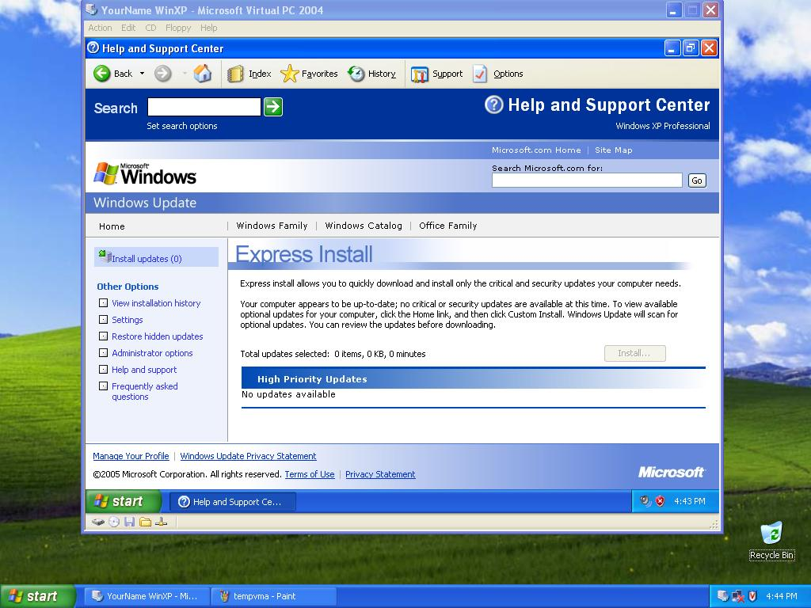

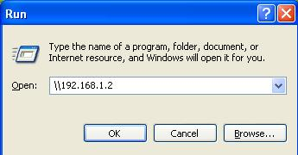
Mapping the CNIT 235 Shared Folder to Drive Z
- In the YourName WinXP window, click Start, Run. In the Run box, enter \\192.168.1.2 as shown to the right on this page. Press Enter.

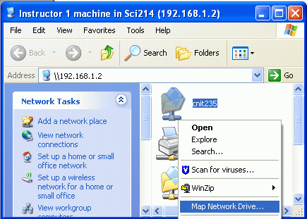
- An Instructor1 machine in Sci214 (192.168.1.2) window opens as shown to the right on this page. This is the shared drive on the server that we will use for many purposes in this class, so you will need to map it to a drive letter for convenient access. Right-click the CNIT235 folder and click Map Network Drive.

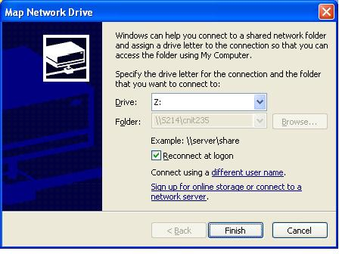
- In the Map Network Drive window, accept the default Drive letter of Z:, as shown to the right on this page, and click the Finish button.
- Close the Instructor1 machine in S214 window.

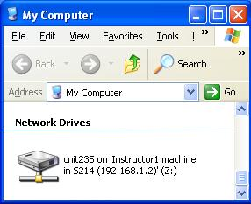
- Click Start, My Computer. Find the cnit235 on Instructor1 machine … icon, as shown to the right on this page, and make sure it is visible.

Saving the Screen Image
- Hold down the right Alt button on the keyboard and move the mouse pointer out of the YourName WinXP window. Click an empty portion of the Windows XP desktop outside the YourName WinXP window, so that the YourName WinXP title bar is dimmed.
- Press the PrintScrn key in the upper-right portion of the keyboard. That will copy the whole desktop to the clipboard.
- Click Start, Programs, Accessories, Paint. In the untitled - Paint window, select Edit, Paste from the menu bar. The desktop appears in the Paint window, with only a corner of it visible.
- In the untitled - Paint window, click File, Save. Save the document in the My Pictures folder (or any other place you wish, such as a floppy disk) with the filename Your Name Proj 2b. Select a Save as type of JPEG.

Installing McAffee Antivirus
- In the YourName WinXP window, click Start, My Computer. Double-click Z: to open the shared folder. Double-click _Software to open the folder. Resize the Software window so that you can see part of your desktop. Drag the Antivirus folder to your desktop. After the folder is done copying, close the Software window.
- Double-click the Antivirus folder to open it. Double-click the red Setup icon. Wait while a FEAD 2.3 Optomizer window shows progress, and another installer window opens and closes.
- When you see a McAffee VirusScan Enterprise Setup window, click Next.
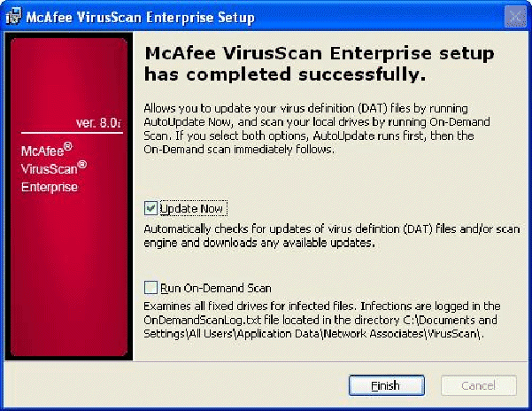
- In the next window, click I accept the terms of the license agreement and click OK.
- In the Select Setup Type box, accept the default selection of Typical and click Next.
- In the Ready to Install box, click Install.
- When you see the McAffee VirusScan Enterprise setup has completed successfully screen shown to the right on this page, leave the Update now box checked, but uncheck the Run-On-Demand Scan box (because that will take a long time). Click Finish. McAffee will update itself.
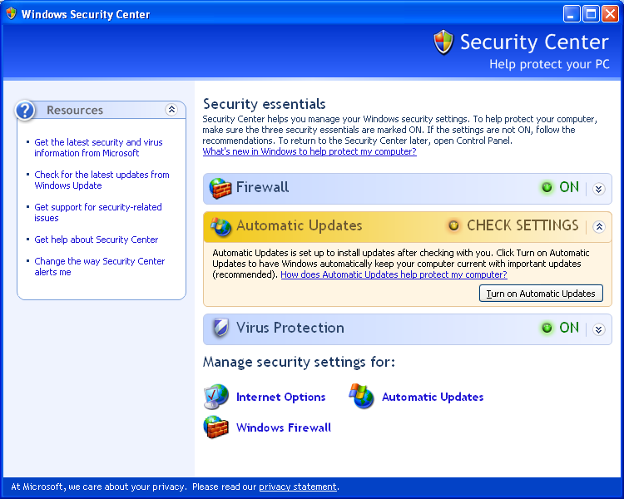
- Click Start, Control Panel, Security Center. You will see a Windows Security Center window showing that the Virus Protection is ON, as shown to the right on this page.

Saving the Screen Image
- Hold down the right Alt button on the keyboard and move the mouse pointer out of the YourName WinXP window. Click an empty portion of the Windows XP desktop outside the YourName WinXP window, so that the YourName WinXP title bar is dimmed.
- Press the PrintScrn key in the upper-right portion of the keyboard. That will copy the whole desktop to the clipboard.
- Click Start, Programs, Accessories, Paint. In the untitled - Paint window, select Edit, Paste from the menu bar. The desktop appears in the Paint window, with only a corner of it visible.
- In the untitled - Paint window, click File, Save. Save the document in the My Pictures folder (or any other place you wish, such as a floppy disk) with the filename Your Name Proj 2c. Select a Save as type of JPEG.

Turning in your Project
- Email the three JPEG images to me as three attachments to one e-mail message. Send the message to: cnit.235@gmail.com with a subject line of CNIT 235 Proj 2 From Your Name, replacing Your Name with your own first and last name. Send a Cc to yourself.
- In the YourName Win XP – Microsoft Virtual PC 2004 window, click Start, Turn Off Computer, Turn Off.
Last Modified: 1-26-05 5 pm

