If you are replacing your computer with a new one, or erasing a hard disk completely and installing Windows XP on it, you will need to use either FAST (File and Settings Transfer) or USMT (User State Migration Tool) to transfer user files and desktop settings from one machine to another. File and Settings Transfer Wizard (FAST) uses a graphical interface and can be run on any computer using Windows 95 or later. The more advanced tool is User State Migration Tool (USMT) which can be used in command-line mode, but only with machines that are in a domain.

We will use FAST to save the user state on a network share.

Starting Your Computer
- Start your computer with the appropriate L removable hard drive in it. Boot it up to the Windows XP operating system and log in as Student with a password of P@ssw0rd.

Attempting to Create a Personal Account from the Student Account
- Click Start, right-click My Computer, and click Manage. In Computer Management, in the left pane, expand Local Users and Groups, and click the Users container to open it, as shown to their right on this page.
- Right-click in an empty portion of the right pane and select New User.
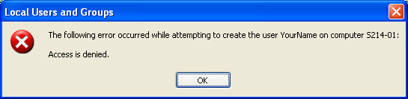
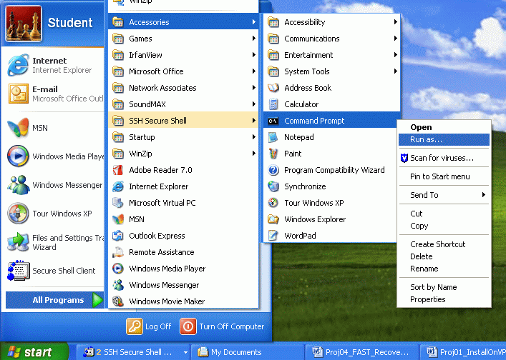
- In the New User box, enter a User Name of ___________ (insert your own name) and a Password of P@ssw0rd in both the Password and the Confirm Password boxes. Clear the User must change password at next logon box. Check the Password never expires box. Click Create. You see an error message as shown to the right on this page, because the Student account does not have Administrative privileges.
- Close all windows.

Running Computer Management with Elevated Privileges
- Click Start. All Programs, right-click Command Prompt, and click Run As…, as shown to the right on this page.
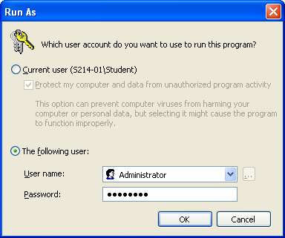
- In the Run As box, select the The following user: radio button, and use the User Name: Administrator with a password of password, as shown to the right on this page. Click OK.
- In the Command Prompt window, enter compmgmt.msc and press Enter. A Computer Management window opens.

- In Computer Management, in the left pane, expand Local Users and Groups, and click the Users container to open it, as shown to their right on this page.
- Right-click in an empty portion of the right pane and select New User.
- In the New User box, enter a User Name of ___________ (insert your own name) and a Password of P@ssw0rd in both the Password and the Confirm Password boxes. Clear the User must change password at next logon box. Check the Password never expires box. Click Create.
- In the New User box, click Close.
- The Computer Management window should now show your account. Close all windows.
- Close all windows. Click Start, Log Off. In the Log Off Windows box, click Log Off.
- Log on as ___________ (insert your own name) with a password of P@ssw0rd.

Mapping the CNIT 235 Shared Folder to Drive Z
- You already did this for the virtual PC, but since the virtual PC runs so slowly, we will be using the host operating system for many projects, so you need to map it to drive Z too.
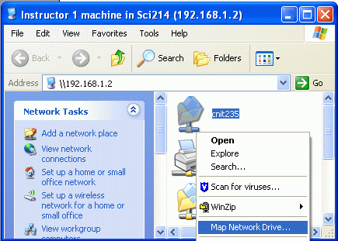
- Click Start, Run. In the Run box, enter \\192.168.1.2. Press Enter.
- An Instructor1 machine in Sci214 (192.168.1.2) window opens as shown to the right on this page. Right-click the CNIT235 folder and click Map Network Drive.
- In the Map Network Drive window, accept the default Drive letter of Z: and click the Finish button.
- Close all windows.

Customizing Your Profile
- Desktop Settings: Right-click the desktop and click Properties. Click the Desktop tab. Select a background you like and click OK.
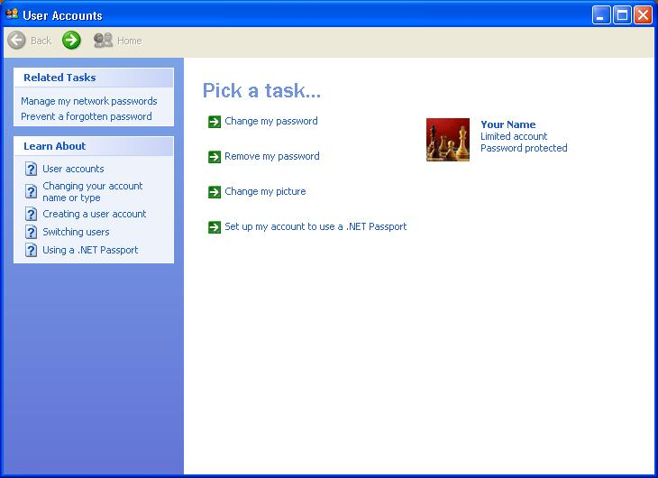
- Internet Explorer Favorites: Click Start, Internet. Go to my Web page samsclass.info and click Favorites, Add to Favorites, OK. Go to a few more pages you like and add them to your Favorites. Close Internet Explorer.
- Picture: Under the Pick a task… header, as shown to the right on this page, click Change my picture. Click on a picture you like and click the Change Picture button. Close all windows.

Saving Your Settings with the File and Settings Transfer (FAST) Wizard
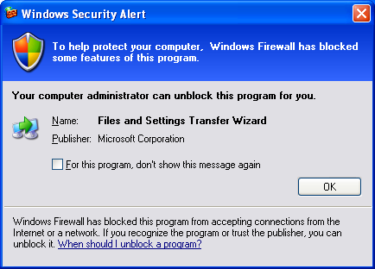
- Click Start, All Programs, Accessories, System Tools, File and Settings Transfer Wizard.
- The File and Settings Transfer Wizard opens. Read the information and click Next.
- In the Which computer is this? screen, click Old computer and click Next.
- A Windows Security Alert box opens, as shown to the right on this page – Service Pack 2 has blocked this action. To continue, we will need to unblock it.
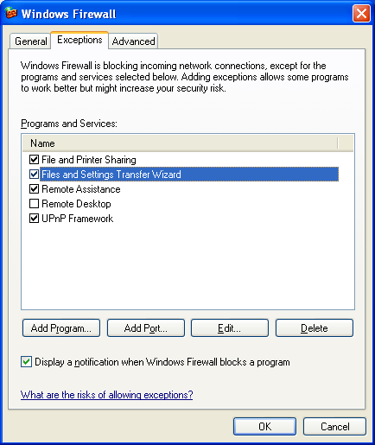
- Click Start, Control Panel. In the Control Panel window, in the left pane, click Switch to Classic View. Point to Security Center and right-click – there is no Run As… option. To make that option appear, hold down the Shift key on the keyboard and right-click. Click Run As… and run this item as Administrator with a password of password.
- In the Windows Firewall window, click the Exceptions tab. Check the File and Settings Transfer Wizard box, as shown to the right on this page.
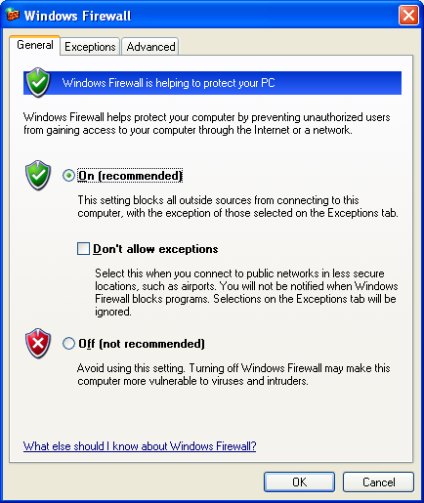

- In the Windows Firewall window, click the General tab. Verify that the On (recommended) button is selected, and that the Don’t allow exceptions box is clear, as shown to the left on this page. Click OK.

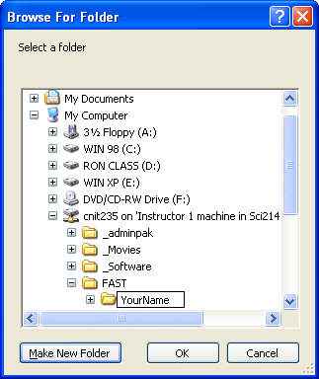
- Close all windows.
- Click Start, All Programs, Accessories, System Tools, File and Settings Transfer Wizard.
- The File and Settings Transfer Wizard opens. Click Next.
- In the Which computer is this? screen, click Old computer and click Next.
- In the Select a transfer method screen, click Other. Then click the Browse button. Expand My Computer, expand cnit235 on ‘Instructor 1 machine…, and click on FAST. Click the Make New Folder button and name the folder with your first and last name. In the Browse for Folder window, click OK. In the File and Settings Transfer Wizard window, click Next.
- In the What do you want to transfer? screen, click Settings only. Click Next.
- In the Completing the Collection Phase screen, click Finish.
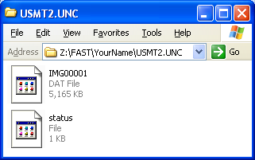
- Click Start, My Computer and open drive Z (labeled cnit235 on 'Instructor 1 machine in Sci214 (192.168.1.2)'). Open the FAST folder and the folder with your name on it. You should see a folder named Usmt2.unc. Open that folder. You should see two files: IMG00001.dat and status, as shown to the right on this page. Your files may have different sizes.

Saving the Screen Image
- Press the Alt+PrintScrn keys on the keyboard. That will copy the active window to the clipboard.
- Click Start, Programs, Accessories, Paint. In the untitled - Paint window, select Edit, Paste from the menu bar. The image appears in the Paint window.
- In the untitled - Paint window, click File, Save. Save the document in the My Pictures folder (or any other place you wish, such as a floppy disk) with the filename Your Name Proj 4a. Select a Save as type of JPEG. Close Paint.
- Close Windows Explorer.

Restoring Your Settings to Another Machine with the FAST Wizard

Picking a Partner
- Pick another student to be your partner and make sure your partner has reached this same step.

Creating an Account for Your Partner
- Click Start, Control Panel.
  - Hold down the Shift key on the keyboard and right-click User Accounts. Click Run As…. Run the program as Administrator with a password of password.
  - In the Pick a task… section, click on Create a new account.
  - In the Name the new account screen, enter your partner’s name and click Next.
  - In the Pick an account type screen, select Limited. Click Create Account.
  - Close all windows.
- Click Start, Log Off. In the Log Off Windows window, click Log Off.

Copying Your Personal Settings to Your Partner’s Computer
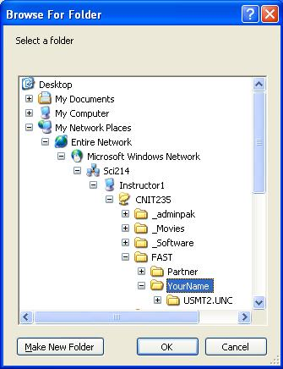
- Switch machines with your partner. You should see a Windows Welcome screen with several choices, including one with your name. Click on your name. Notice that you do not need any password, because no password has been assigned to the account on this computer.
- Click Start, All Programs, Accessories, System Tools, File and Settings Transfer Wizard.
- The File and Settings Transfer Wizard opens. Click Next.
- In the Which computer is this? screen, click New computer and click Next.
- In the Do you have a Windows XP CD? screen, click I don’t need the Wizard Disk. I have already collected my files and settings from my old computer and click Next.
- In the Where are the files and settings? screen, click Other. Then click the Browse button. Notice that you cannot get to the network share from My Computer because the Z drive mapping has not been performed for this profile. Instead, expand My Network Places, Microsoft Windows Network, Sci214, Instructor1, CNIT235, and FAST and click the folder with your name on it, as shown in the figure to the right on this page. Click OK.
- In the Where are the files and settings? screen, click Next. Wait for the transfer to finish.
- In the Completing the File and Settings Transfer Wizard screen, click Finish.
- In the File and Settings Transfer Wizard box, click Yes to log off.
- Click your name to log on. Examine your profile and answer the questions at the top of the next page.

A: Did the FAST wizard attach your password to the new computer? ______________

B: Did your desktop background transfer to the new computer? ______________

C: Did your Internet Explorer Favorites transfer to the new computer? ______________

D: Did your Login Picture (shown on the Windows Welcome page)
transfer to the new computer? ______________

E: Did your Drive Mapping for the Z: drive transfer to the new computer? ______________

Turning In your Project
- Email the JPEG image to me as an attachment. Answer the questions above in the body of the email message. Send it to: cnit.235@gmail.com with a subject line of CNIT 235 Proj 4 From Your Name, replacing Your Name with your own first and last name. Send a Cc to yourself.

Last Modified: 1-31-05 5pm

