Starting Your Computer
- Start your computer with the appropriate L removable hard drive in it. Boot it up to the Windows XP operating system. Start your virtual PC and log in with your own account.

Getting an .NET Passport
- Open an Internet Explorer window and go to passport.net. In the top left part of the window, click Sign up.
- When you see the question “Do you have an e-mail address?”, accept the default selection of Yes and click Continue.
- When you see the heading “Create credentials”, fill in the form and click Continue.
- When you see the heading “Review and sign the Agreements”, enter your email address and click I Accept.
- When you see the heading “You’ve created credentials”, your .NET Passport is complete. Close Internet Explorer.

Starting Windows Messenger
- Click Start, All Programs, Windows Messenger.
- In the Windows Messenger window, click Click here to sign in.
- The .NET Passport Wizard opens. Click Next.
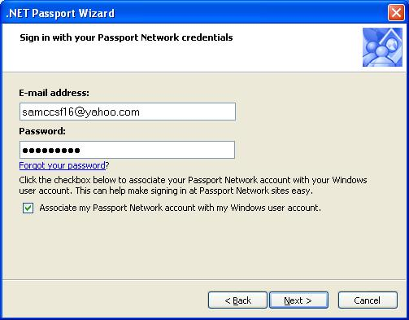
- When you see the question “Do you have an e-mail address?”, accept the default selection of Yes and click Next.
- When you see the question “Have you already signed up?”, accept the default selection of Yes and click Next.
- When you see the message “Sign in with your Passport Network credentials”, as shown to the right on this page, enter the email address and password you chose above. Clear the Associate my Passport Network account with my Windows user account box and click OK.
- When you see the message “You’re done!”, click Finish.

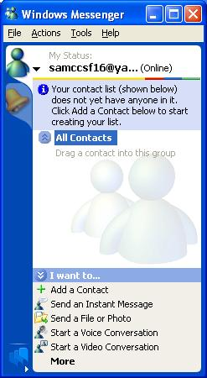
- A Windows Messenger window appears, as shown to the right on this page.
- In the Windows Messenger window, at the bottom, click Add a Contact.
- In the Add a Contact window, accept the default selection of By e-mail address or sign-in name and click Next.
- Choose a partner in the class who has already signed in to Windows Messenger. In the next screen, enter your partner’s email address and click Next.
- The next screen should say Success! Click Finish.
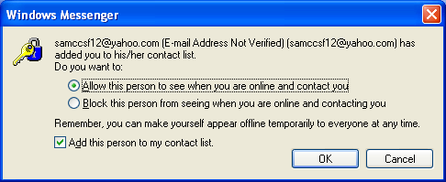
- Your partner will get a message like the one below. Your partner must click OK before you can proceed.

- When you see the message “Success!”, click Finish.

To Activate Remote Assistance:
Make sure Remote Assistance is enabled
- Click Start, Right-click My Computer, and click Properties.
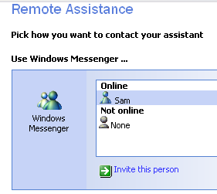
- Click the Remote tab. In the Remote Sessions box, click OK. Verify that the Allow Remote Assistance invitations to be sent from this computer box is checked.
- Click OK to close System Properties.

Send a Remote Assistance Request
- Click Start, All Programs, Remote Assistance. Help and Support Center opens.
- Click Invite someone to help you.
- In the Help and Support Center, the right pane is titled Remote Assistance, as shown to the right on this page. You should see your partner’s email address in the Windows Messenger section under the Online header. Click your partner’s sign-in name and click the blue Invite this person link.
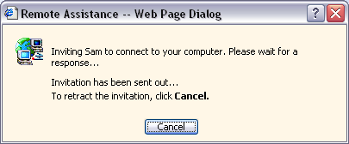
- You will see a Remote Assistance – Web Page Dialog box as shown to the right on this page. Don’t click anything, just wait.

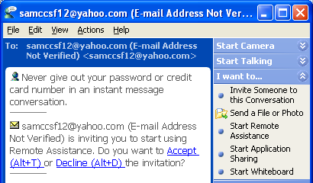

- Your partner will see a message like that shown on the right, saying Do you want to accept or decline the invitation?. Your partner must click the blue Accept link.

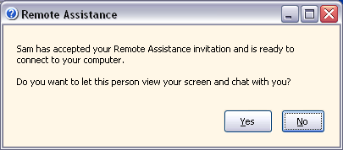

- You will see a Remote Assistance box as shown to the right on this page, saying Do you want to let this person view your screen and chat with you?. Click Yes.

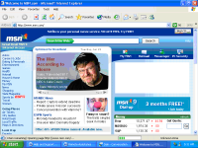

Using Remote Assistance in Screen View Only mode

- Remote Assistance is confusing at first, because your screen looks a lot like your partner’s screen. To clean things up, minimize all your windows and open Internet Explorer on your machine. Now your screen should look like the image to the right on this page. Your Web page may be different.

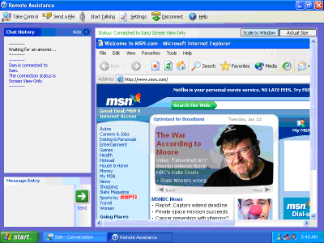
- At this point, your partner should maximize the Remote Assistance window, so that their screen looks like the image to the right on this page. The large right pane of the Remote Assistance window shows what is happening on your screen.

- On your screen, move the mouse and click on a link in the Web page. Your partner should be able to see everything you do in the Remote Assistance screen. Notice that your partner cannot see your whole screen without scrolling – that is an annoyance that can be fixed. Your partner should now click the Scale to Window button in the upper-right of the Remote Assistance window, so that your partner’s screen looks like the image on the next page. Your partner can now see a shrunken image of your whole screen, including your taskbar and Start button.

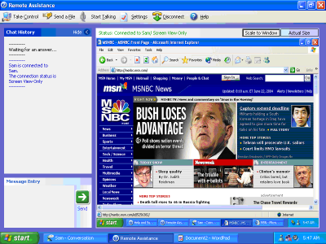

Saving the Screen Image
- On your partner’s machine, press Alt+PrintScrn on the keyboard.
- Click Start, Programs, Accessories, Paint. In the untitled - Paint window, select Edit, Paste from the menu bar. The image appears in the Paint window.
- In the untitled - Paint window, click File, Save. Save the document in the My Pictures folder (or any other place you wish, such as a floppy disk) with the filename Your Name Proj 5. Select a Save as type of JPEG. Close Paint.
- This is one way to use Remote Assistance – your partner can see your screen, and send you messages by typing in the Chat History bar on the left. Your partner should now type in a message like Hi there, what can I do to help you?
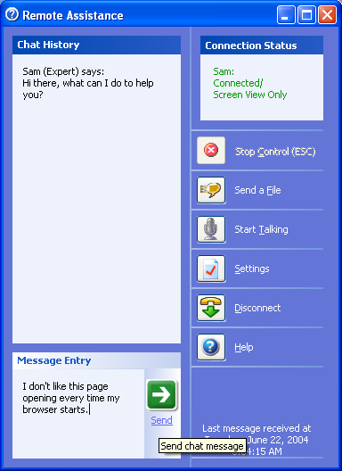
- On your screen, the Remote Assistance chat window should pop up, delivering your partner’s message. Try communicating a simple problem to your partner: For example, suppose you do not like the Home page in your browser, and you want help changing it. Explain what you want by typing text in this window and follow the instructions from your helper to fix it. Your partner should try to guide you through the process using the text chat only.

Using Remote Assistance in Control mode
- As you can probably tell, this is not really the best way to solve complicated problems, because the user may not understand the instructions or obey them properly. Your partner should now click the Take Control button in the upper-left of the Remote Assistance window.
- A Remote Assistance – Web Page Dialog box will pop up on your screen, asking you Would you like to let your partner take control of your computer? Click Yes.
- On your partner’s screen, a Remote Assistance – Web Page Dialog pops up on your screen, with a message that begins You are now sharing control. Click OK.
- Let your partner control your screen. Now your partner’s keyboard and mouse control your computer. Perform a simple action, like resetting the Home page. Notice how the screen looks, and how the motion is somewhat delayed. Also try moving the mouse on your machine while your partner is moving it – both mice are effective, so that it can be confusing.
- To end the control, press the Esc key on your keyboard. A message appears on your partner’s machine, and also on yours, indicating that the control has ended.
- To end the Remote Assistance session, your partner should click the Disconnect button on the toolbar of the Remote Assistance screen.

Switching Roles
- Repeat the activity, with your partner requesting assistance and you providing it, so you can see how it works in both Screen View and Control mode. Your partner should make up a new problem for you to solve, such as wanting a higher screen resolution.

Turning In your Project
- Email the JPEG image to me as an attachment. Send it to: cnit.235@gmail.com with a subject line of CNIT 235 Proj 5 From Your Name and YourPartner’s Name. You and your partner only have to turn in one image for both of you. Send a Cc to yourself. Last modified 9-1-05

