Starting Your Computer
- Start your computer with the appropriate L removable hard drive in it. Boot it up to the Windows XP operating system and log in as Student with a password of P@ssw0rd.

Starting Microsoft Virtual Machine
- Click Start, All Programs, Microsoft Virtual PC. In the Virtual PC Console window, verify that the machine with your name on it is selected and click the gray Start button.
- A YourName Win XP – Microsoft Virtual PC 2004 window opens, and Windows XP starts. When you see the Windows Welcome screen, click the icon with your name on it. No password should be required – if it asks for a password, use P@ssw0rd. Remember that you are an Administrator of the virtual machine, so you will not have to elevate your privileges to change the boot.ini file.
- When the virtual machine’s desktop appears, type Right Alt-Enter to maximize it. A window may appear explaining to you that the way to exit full-screen mode is also Right Alt-Enter. If that window appears, click Continue.

Observing the boot.ini file
The boot.ini file is needed to start your machine. We’ll look at it, damage it, and fix the damage using the Recovery Console. That’s why we are using the Virtual PC, so the damage will not break the host operating system.
- Click Start, Control Panel.
- In Control Panel, click Performance And Maintenance.
- In Performance And Maintenance, click System.
- In System Properties, click the Advanced tab
- In the Startup and Recovery section, click Settings button
- In the System startup section, click the Edit button.
- The boot.ini file will open in Notepad. The file should look like the example below.
[boot loader]
timeout=30
default=multi(0)disk(0)rdisk(0)partition(1)\WINDOWS
[operating systems]
multi(0)disk(0)rdisk(0)partition(1)\WINDOWS="Microsoft Windows XP Professional" /noexecute=optin /fastdetect

Breaking boot.ini
- If the boot.ini file is damaged, your machine cannot start up. Let’s break it in a fairly simple way. Add an x after the WINDOWS in the line beginning default and in the line containing Windows XP Professional without a class period, so your file looks like the example below. The added characters have been shaded for emphasis. This change will prevent the boot loader from finding the operating system.
[boot loader]
timeout=30
default=multi(0)disk(0)rdisk(0)partition(1)\WINDOWSx
[operating systems]
multi(0)disk(0)rdisk(0)partition(1)\WINDOWSx="Microsoft Windows XP Professional" /noexecute=optin /fastdetect

- In the boot – Notepad window, click File, Save. Close Notepad. Close all windows.

- Click Start, Turn Off Computer, Restart to restart the virtual PC. It won’t start up, and gives you an error message saying hal.dll is missing or corrupt.

Fixing boot.ini with Recovery Console
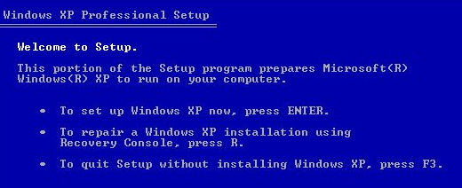
- Insert a Windows XP CD. Use one with Service Pack 2 slipstreamed into it (they are labeled XP2). Press Right Alt+Del to restart your virtual PC. Don’t press Ctrl+Alt+Del, because that will exit Virtual PC and start Task Manager in the host operating system. When you see the message Press any key to start from CD, press any key. The system boots from the CD. It may take a couple of tries to make it work. For some reason hitting the F2 key during bootup seemed to help when I did it.
- When you see the Welcome to Setup screen shown to the right on this page, press R to repair a Windows XP installation using Recovery Console.
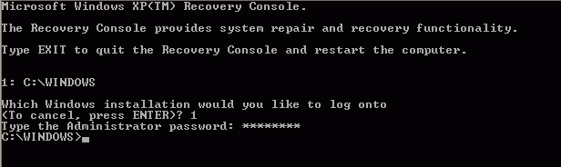
- You will see a text screen titled Microsoft Windows XP(TM) Recovery Console, as shown to the right on this page. This is the Recovery Console – it is not friendly or easy to use, and it is intended only for experts.
- At the Which windows installation would you like to log on to question, enter 1 Enter.
- When it asks for the Administrator password, enter P@ssw0rd Enter.
- You will see a C:\WINDOWS> prompt. Enter the HELP command, followed by the Enter key. Each command must be terminated with the Enter key, so I will stop mentioning it explicitly from now on.
- Help lists the available commands. Notice that one of the commands is BOOTCFG. Press the space bar to finish the help message and give you a C:\WINDOWS> prompt.
- Enter BOOTCFG /? to learn about the BOOTCFG command. Read the information: this is a new feature in the Windows XP recovery console and it is very handy.
- Enter BOOTCFG /REBUILD. Recovery console scans your disk to find Windows installations.
- After it locates Windows, it asks you
Add installation to boot list? (Yes/No/All)
- Type Y and press the Enter key.
- When it asks Enter load identifier type in Windows XP Fixed.
- When it asks Enter OS load options type in /noexecute=optin /fastdetect.

- Type Right Alt-Enter to return the virtual PC window to a normal size. This is necessary so you can capture the screen to turn in your homework.
- When the command prompt C:\WINDOWS returns, type in EXIT to leave Recovery Console. Your virtual PC restarts. Hold down the right Alt key to move the mouse outside the Virtual PC window and click on the host system’s desktop to make the virtual PC window’s title bar become faded, as shown below on this page.
- When you see the choice of two operating systems, as shown below on this page, press the PrintScrn key. The BOOTCFG /REBUILD command added the repaired operating system as a new choice in the boot.ini file, leaving the old broken option as a second choice. Your virtual PC should start normally.
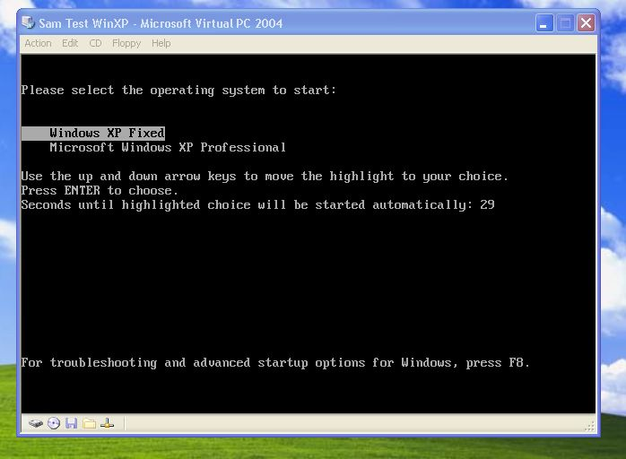

- In the host operating system (not the virtual PC), click Start, Programs, Accessories, Paint. In the untitled - Paint window, select Edit, Paste from the menu bar. The image appears in the Paint window.
- In the untitled - Paint window, click File, Save. Save the document in the My Pictures folder (or any other place you wish, such as a floppy disk) with the filename Your Name Proj 6a. Select a Save as type of JPEG. Close Paint.

Cleaning up boot.ini
- Click in the virtual PC window to make it active. When you see the Windows Welcome screen, click the icon with your name on it.
- Now we’ll remove the useless extra line from the BOOT.INI file.
- In the virtual PC window, click Start, Control Panel.
- In Control Panel, click Performance And Maintenance.
- In Performance And Maintenance, click System.
- In System Properties, click the Advanced tab
- In the Startup and Recovery section, click Settings button
- In the System startup section, click the Edit button.
- The boot.ini file will open in Notepad. Edit the file to remove the line with the x in it, as shown highlighted below. Close Notepad. Save your changes.
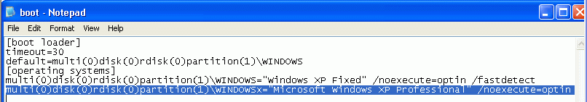

- In the virtual PC window, close all windows. Click Start, Turn Off Computer, Restart to restart the virtual PC. Verify that your virtual PC starts normally.

Turning In your Project
- Email the JPEG image to me as an attachment. Send it to: cnit.235@gmail.com with a subject line of CNIT 235 Proj 6 From Your Name. Send a Cc to yourself.

Last modified 1-31-05

