Starting Microsoft Virtual Machine
- Click Start, All Programs, Microsoft Virtual PC.
- In the Virtual PC Console window, verify that the machine with your name on it is selected and click the gray Start button.
- A YourName Win XP – Microsoft Virtual PC 2004 window opens, and Windows XP starts. When you see the Windows Welcome screen, click the YourName icon to log in. If a password is required, it should be P@ssw0rd.

Viewing the Display Adapter Driver
- In the YourName Win XP window, click Start, right-click My Computer, and click Manage.
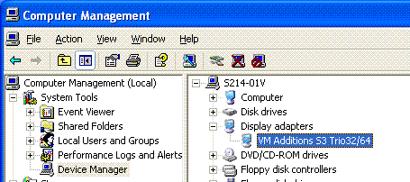
- In Computer Management, in the left pane, click Device Manager. In the right pane, expand Display Adapters. You should see VM Additions S3 Trio32/64 as shown to the right on this page. This is the driver for the Virtual Machine desktop that lets you drag and drop files from the virtual desktop to the host operating system’s desktop. Minimize Computer Management.

Using Drag-and-drop File Transfer
- In the YourName Win XP window, right-click on an empty portion of the desktop and select New, Text Document. Name the document YourNameDrag. Drag the file from the virtual PC’s desktop to the host operating system’s desktop and drop it. It may take two attempts, but you should be able to drag the file from one desktop to another.

Installing the Wrong Display Adapter Driver
- In the YourName Win XP window, restore the Computer Management window. In the Display adapters section, Double-click VM Additions S3/Trio32/64.
- In the VM Additions S3 Trio 32/64 Properties window, click the Driver tab. Click the Update Driver button.
- In the Hardware Update Wizard, the first screen asks Can Windows connect to Windows Update to search for software? Click No, not at this time and click the Next button.
- In the next screen, click Install from a list or a specific location (Advanced) and click the Next button.
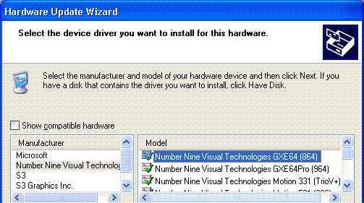
- In the next screen, click Don’t search. I will choose the driver to install and click the Next button.
- The next screen shows four possible device drivers. Clear the Show compatible hardware box to see more options. In the Manufacturers list, click Number Nine Visual Technologies, and in the Model list, select Number Nine Visual Technologies GXE64 (864) as shown to the right on this page. Click the Next button.
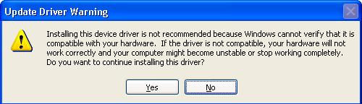
- An Update Driver Warning appears as shown to the right on this page. A sensible person might stop here, but the point of this exercise is to break the virtual PC and then fix it, so click Yes.
- After the driver installs, click Finish to close the Hardware Update Wizard. Close the VM Additions S3 Trio 32/64 Properties window. When a System Settings Change box opens asking if you want to restart your computer, click Yes.
- After the Virtual PC restarts, click on your name to log in as usual.

Attempting to Use Drag-and-drop File Transfer
- In the YourName Win XP window, right-click on an empty portion of the desktop and select New, Text Document. Name the document YourNameDrag2. Try to drag the file from the virtual PC’s desktop to the host operating system’s desktop and drop it. You cannot do it, because the driver no longer allows it.

Using Device Manager to View Your Display Adapter Driver
- In the YourName Win XP window, click Start, right-click My Computer, and click Manage.
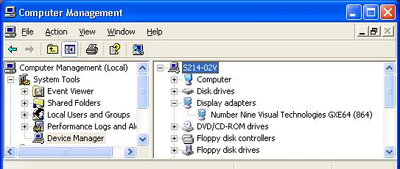
- In Computer Management, in the left pane, click Device Manager. In the right pane, expand Display Adapters. You should see Number Nine Visual Technologies GXE64 (864) as shown below on this page.

Saving the Screen Image
- Move the mouse pointer out of the YourName WinXP window. Click an empty portion of the Windows XP desktop outside the YourName WinXP window, so that the YourName WinXP title bar is dimmed.
- Press the PrintScrn key in the upper-right portion of the keyboard. That will copy the whole desktop to the clipboard.
- Click Start, Programs, Accessories, Paint. In the untitled - Paint window, select Edit, Paste from the menu bar. The desktop appears in the Paint window, with only a corner of it visible.
- In the untitled - Paint window, click File, Save. Save the document in the My Pictures folder (or any other place you wish, such as a floppy disk) with the filename Your Name Proj 7c. Select a Save as type of JPEG.

Using Driver Rollback to Restore the Previous Display Adapter Driver
- In the Computer Management window, double click Number Nine Visual Technologies GXE64 (864).
- In the Number Nine Visual Technologies GXE64 (864) Properties box, click the Driver tab, and click the Roll Back Driver button.
- A box appears saying Are you sure ….
- Click Yes. The name of the Property box changes back to VM Additions S3 Trio 32/64 Properties.
- Click Close to close the VM Additions S3 Trio 32/64 Properties box.
- When a System Settings Change box opens asking if you want to restart your computer, click Yes.
- After the Virtual PC restarts, click on your name to log in as usual.

Using Drag-and-drop File Transfer
- In the YourName Win XP window, right-click on an empty portion of the desktop and select New, Text Document. Name the document YourNameDrag3. Try to drag the file from the virtual PC’s desktop to the host operating system’s desktop and drop it. You should succeed now.

Turning in your Project
- Email the JPEG image to me as an attachment to an e-mail message. Send the message to: cnit.235@gmail.com with a subject line of CNIT 235 Proj 7 From Your Name, replacing Your Name with your own first and last name. Send a Cc to yourself.

Revised 9-7-05

