Starting Your Computer
- Start your computer with the appropriate L removable hard drive in it. Boot it up to the Windows XP operating system and log in as Student with a password of P@ssw0rd.

Starting Microsoft Virtual Machine
- Click Start, All Programs, Microsoft Virtual PC.
- In the Virtual PC Console window, verify that the machine with your name on it is selected and click the gray Start button.
- A YourName Win XP – Microsoft Virtual PC 2004 window opens, and Windows XP starts. When you see the Windows Welcome screen, click the YourName icon to log in. If a password is required, it should be P@ssw0rd.

Setting the Network Connection to Limited
- You will be removing the antivirus software from the virtual PC, so before doing that it should be disconnected from the Internet. It will still be possible to move files to and from the virtual PC by dragging them from the host operating system’s desktop, and that will give the host operating system’s antivirus software a chance to stop viruses from entering.
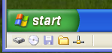
- Look at the bottom left of your Virtual PC window. You will see five icons as shown to the right on this page. The rightmost one is the network connection icon. Hold down the right Alt button, point to the network connection icon, and right-click. Click Networking Settings. If a Note – Networking Settings box opens, click OK.
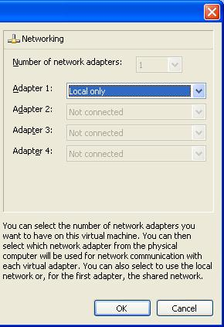
- In the right pane of the Settings for YourName Win XP window, in the Adapter 1: line, select Local Only as shown to the right on this page. This will permit the Virtual PC to network with other virtual PCs on the same machine, but not with any other device on the network. Click OK.

Removing McAffee Antivirus
- Because we have only 512 MB of RAM, the virtual PC runs slowly. To speed it up we will remove the antivirus software.
- In the YourName Win XP window , click Start, Control Panel. In Control Panel, click Add or Remove Programs.
- In the Add or Remove Programs window, you should see a McAffee VirusScan Enterprise item. Click the Remove button. An Add or Remove Programs box opens asking Are you sure …. Click Yes. A Windows Installer box opens. Wait while the program uninstalls.

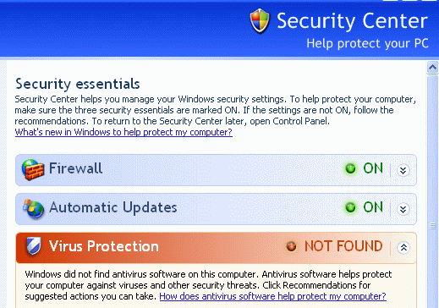
Saving the Security Center Screen Image
- In the YourName Win XP window, click Start, Control Center, Security Center. You should see a Windows Security Center window showing that Virus Protection is NOT FOUND as shown to the right on this page.
- Hold down the right Alt button on the keyboard and move the mouse pointer out of the YourName WinXP window. Click an empty portion of the Windows XP desktop outside the YourName WinXP window, so that the YourName WinXP title bar is dimmed.
- Press the PrintScrn key in the upper-right portion of the keyboard. That will copy the whole desktop to the clipboard.
- Click Start, Programs, Accessories, Paint. In the untitled - Paint window, select Edit, Paste from the menu bar. The desktop appears in the Paint window, with only a corner of it visible.
- In the untitled - Paint window, click File, Save. Save the document in the My Pictures folder (or any other place you wish, such as a floppy disk) with the filename Your Name Proj 7a. Select a Save as type of JPEG.

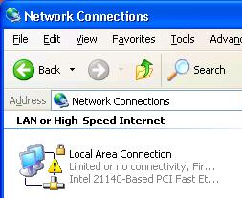
Saving the Network Settings Screen Image
- In the YourName Win XP window, close all windows. Click Start, Control Center, Network and Internet Connections, Network Connections . You should see a Network Connections window showing a Local Area Connection icon with a yellow warning triangle on it, and the message Limited or no connectivity, as shown to the right on this page.
- Hold down the right Alt button on the keyboard and move the mouse pointer out of the YourName WinXP window. Click an empty portion of the Windows XP desktop outside the YourName WinXP window, so that the YourName WinXP title bar is dimmed.
- Press the PrintScrn key in the upper-right portion of the keyboard. That will copy the whole desktop to the clipboard.
- Click Start, Programs, Accessories, Paint. In the untitled - Paint window, select Edit, Paste from the menu bar. The desktop appears in the Paint window, with only a corner of it visible.
- In the untitled - Paint window, click File, Save. Save the document in the My Pictures folder (or any other place you wish, such as a floppy disk) with the filename Your Name Proj 7b. Select a Save as type of JPEG.

Viewing the Display Adapter Driver
- In the YourName Win XP window, click Start, right-click My Computer, and click Manage.
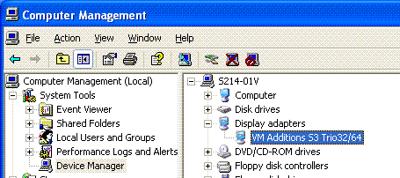
- In Computer Management, in the left pane, click Device Manager. In the right pane, expand Display Adapters. You should see VM Additions S3 Trio32/64 as shown to the right on this page. This is the driver for the Virtual Machine desktop that lets you drag and drop files from the virtual desktop to the host operating system’s desktop. Minimize Computer Management.

Using Drag-and-drop File Transfer
- In the YourName Win XP window, right-click on an empty portion of the desktop and select New, Text Document. Name the document YourNameDrag. Drag the file from the virtual PC’s desktop to the host operating system’s desktop and drop it. It may take two attempts, but you should be able to drag the file from one desktop to another.

Installing the Wrong Display Adapter Driver
- In the YourName Win XP window, restore the Computer Management window. In the Display adapters section, Double-click VM Additions S3/Trio32/64.
- In the VM Additions S3 Trio 32/64 Properties window, click the Driver tab. Click the Update Driver button.
- In the Hardware Update Wizard, the first screen asks Can Windows connect to Windows Update to search for software? Click No, not at this time and click the Next button.
- In the next screen, click Install from a list or a specific location (Advanced) and click the Next button.
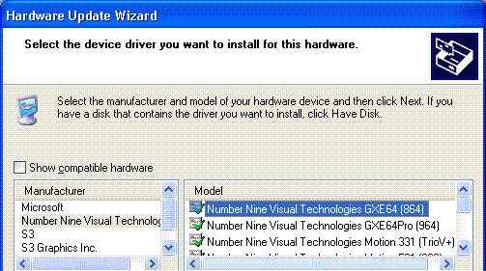
- In the next screen, click Don’t search. I will choose the driver to install and click the Next button.
- The next screen shows four possible device drivers. Clear the Show compatible hardware box to see more options. In the Manufacturers list, click Number Nine Visual Technologies, and in the Model list, select Number Nine Visual Technologies GXE64 (864) as shown to the right on this page. Click the Next button.

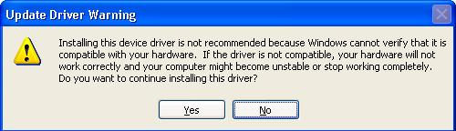
- An Update Driver Warning appears as shown to the right on this page. A sensible person might stop here, but the point of this exercise is to break the virtual PC and then fix it, so click Yes.
- After the driver installs, click Finish to close the Hardware Update Wizard. Close the VM Additions S3 Trio 32/64 Properties window. When a System Settings Change box opens asking if you want to restart your computer, click Yes.
- After the Virtual PC restarts, click on your name to log in as usual.

Attempting to Use Drag-and-drop File Transfer
- In the YourName Win XP window, right-click on an empty portion of the desktop and select New, Text Document. Name the document YourNameDrag2. Try to drag the file from the virtual PC’s desktop to the host operating system’s desktop and drop it. You cannot do it, because the driver no longer allows it.

Using Device Manager to View Your Display Adapter Driver
- In the YourName Win XP window, click Start, right-click My Computer, and click Manage.
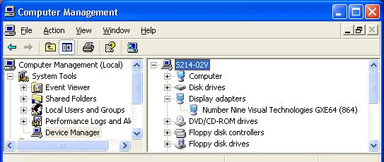
- In Computer Management, in the left pane, click Device Manager. In the right pane, expand Display Adapters. You should see Number Nine Visual Technologies GXE64 (864) as shown below on this page.

Saving the Screen Image
- Move the mouse pointer out of the YourName WinXP window. Click an empty portion of the Windows XP desktop outside the YourName WinXP window, so that the YourName WinXP title bar is dimmed.
- Press the PrintScrn key in the upper-right portion of the keyboard. That will copy the whole desktop to the clipboard.
- Click Start, Programs, Accessories, Paint. In the untitled - Paint window, select Edit, Paste from the menu bar. The desktop appears in the Paint window, with only a corner of it visible.
- In the untitled - Paint window, click File, Save. Save the document in the My Pictures folder (or any other place you wish, such as a floppy disk) with the filename Your Name Proj 7c. Select a Save as type of JPEG.

Using Driver Rollback to Restore the Previous Display Adapter Driver
- In the Computer Management window, double click Number Nine Visual Technologies GXE64 (864).
- In the Number Nine Visual Technologies GXE64 (864) Properties box, click the Driver tab, and click the Roll Back Driver button.
- A box appears saying Are you sure ….

Saving the Screen Image
- Hold down the right Alt button on the keyboard and move the mouse pointer out of the YourName WinXP window. Click an empty portion of the Windows XP desktop outside the YourName WinXP window, so that the YourName WinXP title bar is dimmed.
- Press the PrintScrn key in the upper-right portion of the keyboard. That will copy the whole desktop to the clipboard.
- Click Start, Programs, Accessories, Paint. In the untitled - Paint window, select Edit, Paste from the menu bar. The desktop appears in the Paint window, with only a corner of it visible.
- In the untitled - Paint window, click File, Save. Save the document in the My Pictures folder (or any other place you wish, such as a floppy disk) with the filename Your Name Proj 2c. Select a Save as type of JPEG.

- Click Yes. The name of the Property box changes back to VM Additions S3 Trio 32/64 Properties.
- Click Close to close the VM Additions S3 Trio 32/64 Properties box.
- When a System Settings Change box opens asking if you want to restart your computer, click Yes.
- After the Virtual PC restarts, click on your name to log in as usual.

Using Drag-and-drop File Transfer
- In the YourName Win XP window, right-click on an empty portion of the desktop and select New, Text Document. Name the document YourNameDrag3. Try to drag the file from the virtual PC’s desktop to the host operating system’s desktop and drop it. You should succeed now.

Turning in your Project
- Email the three JPEG images to me as three attachments to one e-mail message. Send the message to: cnit.235@gmail.com with a subject line of CNIT 235 Proj 7 From Your Name, replacing Your Name with your own first and last name. Send a Cc to yourself. Revised 2-1-05

