This project can be done on any network containing at least two networked Windows XP (Pro or Home) machines with Service Pack 2.

Choosing a Partner
- You will need to use two machines, so find a partner near you and work together. You will turn in one e-mail for both of you, with both names in the subject line, and get the same grade. Choose one machine to be the Client and the other machine to be the Server (it will be a file server, sharing a folder).

Starting The Computers
- Start both the Client and Server computers with the appropriate L removable hard drives. Boot them to the Windows XP operating system and log in with your own account, or as Student with a password of P@ssw0rd. Make sure both machines have Service Pack 2 (all the machines in S214 do).

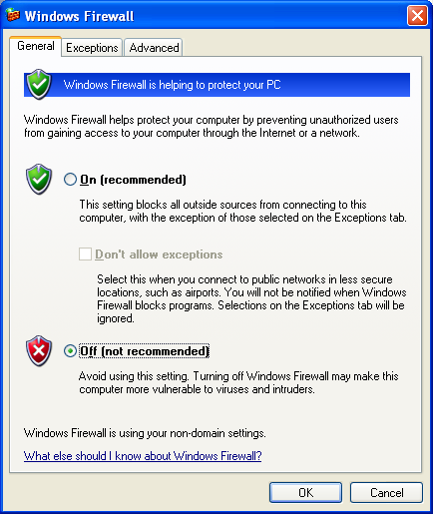
Turning off Windows Firewall
Do this on both the Client and Server computers.
- Click Start, Control Panel. If you see the Pick a Category header, click Switch to Classic View in the left pane.
- Hold down the Shift key on the keyboard and right-click Windows Firewall. Click Run as…. Click the Administrator radio button, enter a password of password, and click OK.
- A Windows Firewall box opens as shown to the right on this page. Click Off (not recommended) and click the OK button.

Saving the Network Connections Screen Image
Do this on the Client computer.
- Click Start, My Computer. In the Common Tasks pane, in the Other Places section, click My Network Places.
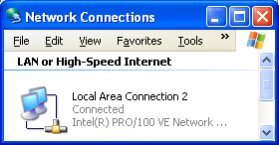
- In the My Network Places window, in the Common Tasks pane, in the Network Tasks section, click View Network Connections.
- The Network Connections window opens, as shown to the -right on this page. Click View, Tiles from the menu bar. You should see a Local Area Connection 2 icon like that shown to the right on this page, without a little padlock icon on it.

- Click the title bar of the Network Connections window to make sure it is active. Hold down the Alt key and press the PrintScrn key in the upper-right portion of the keyboard. That will copy the window to the clipboard.
- Click Start, Programs, Accessories, Paint. In the untitled - Paint window, select Edit, Paste from the menu bar. The window appears in the Paint window.
- In the untitled - Paint window, click File, Save. Save the document in the Shared Documents folder with the filename Your Name and Partner’s Name Proj 8a. Select a Save as type of JPEG.

Network Setup Wizard
Do this on both the Client and Server computers.
Before you can share files, you need to run the Network Setup Wizard. The Network Setup Wizard will open the firewall for file sharing, and adjust NTFS permissions and Group Policy. We will cover those settings in more detail in later chapters, but here we will just use the wizard for its intended purpose – to make it easy to share files.
- Close all windows.
- Click Start, Control Panel. If you see the Pick a Category header, click Switch to Classic View in the left pane.
- Hold down the Shift key on the keyboard and right-click Network Setup Wizard. Click Run as…. Click the Administrator radio button, enter a password of password, and click OK.
- At the Welcome to the Network Setup Wizard screen, click Next.
- At the Before you continue… screen, click Next.
- At the The wizard found disconnected network hardware screen, click the Ignore disconnected network hardware box and click Next.
- At the Select a connection method screen, click This computer connects to the Internet through a residential gateway or through another computer on my network and click Next.
- At the Give this computer a description and name screen, click Next.
- At the Workgroup name screen, enter SCI214 and click Next.
- At the File and printer sharing screen, click Turn on file and printer sharing and click Next.
- At the Ready to apply network settings screen, click Next.
- At the You’re almost done… screen, click Just finish the wizard; I don’t need to run the wizard on other computers and click Next.
- At the Completing the Network Setup Wizard screen, click Finish.

Enabling the Guest Account
Do this on both the Client and Server computers.
In a workgroup, users who connect over the network are treated as Guest users. We must therefore enable the Guest account to allow file sharing.
- Close all windows.
- Click Start, Control Panel. If you see the Pick a Category header, click Switch to Classic View in the left pane.
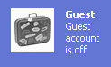
- Hold down the Shift key on the keyboard and right-click User Accounts. Click Run as…. Click the Administrator radio button, enter a password of password, and click OK.
- In the User Accounts window, find the Guest icon. If it says Guest account is off, as shown to the right on this page, do the next two steps to enable it. If the Guest account is already turned on, you don’t need to turn it on again.

  - Click the Guest icon.
  - Under the Do you want to turn on the guest account? header, click the Turn On the Guest Account button.

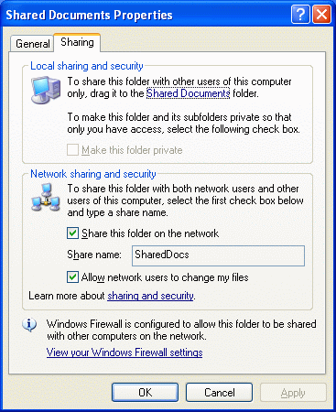
Sharing the “Shared Files” Folder Over the Network
Do this on the Server computer.
The Shared Files folder is intended to allow all the users of a single computer to share files, but it can also be used to share files over the network. However, only an Administrator can share it. I have not found a convenient way to temporarily elevate privileges for this task, so we will use Fast User Switching.
- Click Start, Log Off. In the Log Off Windows box, click Switch User.
- Click the icon for CNIT. No password is required.
- Click Start, My Computer. Right-click the Shared Documents folder and click Sharing and Security.
- In the Shared Documents Properties box, on the Sharing tab, check both the Share this folder on the network box and the Allow network users to change my files box, as shown to the right on this page. (If a previous student has already configured file sharing on your computer, the boxes may already be checked. If they are checked, just leave them checked.) Click OK.
- .The Shared Documents folder should show a hand under the folder icon, as shown to the right on this page.

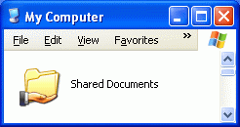
Saving the Shared Documents Screen Image
Do this on the Server computer.
- Click the title bar of the My Computer window to make sure it is active. Hold down the Alt key and press the PrintScrn key in the upper-right portion of the keyboard. That will copy the window to the clipboard.
- Click Start, Programs, Accessories, Paint. In the untitled - Paint window, select Edit, Paste from the menu bar. The window appears in the Paint window.
- In the untitled - Paint window, click File, Save. Save the document in the Shared Documents folder with the filename Your Name and Partner’s Name Proj 8b. Select a Save as type of JPEG.
- Click Start, Log Off. In the Log Off Windows box, click Log Off. Log in with your own account, or as Student with a password of P@ssw0rd

File Sharing With No Firewall
Do this on the Client computer.
- Close all windows.
- Look at the front panel of your computer (or open My Computer Properties) and find the name of your computer. It should be something like S214-02, where 02 will probably be a different number.
- Find the name of your Server computer. It should be something like S214-01, where 01 will probably be a different number.
- On your machine, click Start, Run and enter
\\S214-01
replacing 01 with the actual number on your Server computer. A window should open showing a Shared Docs folder. That shows that file sharing is working properly.
- Close the SharedDocs window.

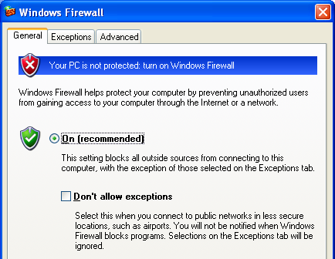
Turning The Client’s Firewall On (Allowing Exceptions)
Do this on the Client computer.
- Click Start, Control Panel.
- Hold down the Shift key on the keyboard and right-click Windows Firewall. Click Run as…. Click the Administrator radio button, enter a password of password, and click OK.
- A Windows Firewall box opens. Make sure the On (recommended) radio button is selected. Make sure the Don't allow exceptions box is cleared, as shown to the right on this page.

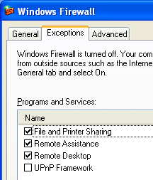

- In the Windows Firewall box, click the Exceptions tab. Verify that the File and Printer Sharing box is checked, as shown in the figure to the right on this page.
- In the Windows Firewall box, click the OK button.

Observing the Local Area Connection Icon
Do this on the Client computer.
- Click Start, My Computer. In the Common Tasks pane, in the Other Places section, click My Network Places.
- In the My Network Places window, in the Common Tasks pane, in the Network Tasks section, click View Network Connections.
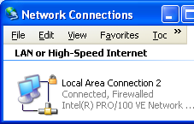
- The Network Connections window opens, as shown to the upper-right on this page. You should see a Local Area Connection 2 icon like that shown to the right on this page, with a little padlock icon on it, indicating that this connection is protected by Windows Firewall.

Saving the Network Connections Screen Image
Do this on the Client computer.
- Click the title bar of the Network Connections window to make sure it is active. Hold down the Alt key and press the PrintScrn key in the upper-right portion of the keyboard. That will copy the window to the clipboard.
- Click Start, Programs, Accessories, Paint. In the untitled - Paint window, select Edit, Paste from the menu bar. The window appears in the Paint window.
- In the untitled - Paint window, click File, Save. Save the document in the Shared Documents folder with the filename Your Name and Partner’s Name Proj 8c. Select a Save as type of JPEG.

File Sharing with the Client’s Firewall On (Allowing Exceptions)
Do this on the Client computer.
- On your machine, click Start, Run and enter
\\S214-01
replacing 01 with the actual number on your Server computer. A window should open showing a shared folder. Double-click that folder. Answer the question in the box below.
- Close the SharedDocs window.

A: Can you open a file share when the Client’s firewall is set to On With Exceptions allowed? __________

Turning On the Client’s Firewall (No Exceptions)
Do this on the Client computer.
- In Control Panel, hold down the Shift key on the keyboard and right-click Windows Firewall. Click Run as…. Click the Administrator radio button, enter a password of password, and click OK.
- A Windows Firewall box opens. Click On (recommended). Check the Don't allow exceptions box. Click the OK button.

File Sharing with the Client’s Firewall On (No Exceptions)
Do this on the Client computer.
- Close the SharedDocs window.
- Click Start, Run and enter
\\S214-01
replacing 01 with the actual number on your Server computer. A window should open showing a shared folder. Double-click that folder. Answer the question in the box below.
- Close the SharedDocs window.

B: Can you open a file share when the Client’s firewall is set to On With No Exceptions? ___________

Turning On the Server’s Firewall (With Exceptions)
Do this on the Server computer.
- Click Start, Control Panel.
- Hold down the Shift key on the keyboard and right-click Windows Firewall. Click Run as…. Click the Administrator radio button, enter a password of password, and click OK.
- A Windows Firewall box opens. Click On (recommended). Make sure the Don't allow exceptions box is cleared.
- In the Windows Firewall box, click the Exceptions tab. Verify that the File and Printer Sharing box is checked.
- In the Windows Firewall box, click the OK button.

File Sharing with the Server’s Firewall On(Allowing Exceptions)
Do this on the Client computer.
- Close the SharedDocs window.
- Click Start, Run and enter
\\S214-01
replacing 01 with the actual number on your Server computer. A window should open showing a shared folder with your partner's name on it. Double-click that folder. Answer the question in the box below.
- Close the SharedDocs window.

C: Can you open a file share when your partner's firewall is set to On With Exceptions allowed? _______

Turning On the Server’s Firewall (No Exceptions)
Do this on the Server computer.
- In Control Panel, hold down the Shift key on the keyboard and right-click Windows Firewall. Click Run as…. Click the Administrator radio button, enter a password of password, and click OK.
- A Windows Firewall box opens. Click On (recommended). Check the Don't allow exceptions box. Click the OK button.

File Sharing with the Server’s Firewall On (No Exceptions)
Do this on the Client computer.
- Close the SharedDocs window.
- Click Start, Run and enter
\\S214-01
replacing 01 with the actual number on your Server computer. Answer the question in the box below.
- Close the SharedDocs window.

D: Can you open a file share when your partner's firewall is set to On With No Exceptions? __________

Returning Both Firewalls to the Normal On State (Allowing Exceptions)
Do this on both the Client and Server computers. You should leave the computers with the firewall On, allowing exceptions, to protect the computers while still leaving them with normal network functions.
- Click Start, Control Panel.
- Hold down the Shift key on the keyboard and right-click Windows Firewall. Click Run as…. Click the Administrator radio button, enter a password of password, and click OK.
- A Windows Firewall box opens. Click On (recommended). Make sure the Don't allow exceptions box is cleared. This is the normal way to leave your firewall, so your machine is protected but still useful.

Turning in your Project
Do this on the Client computer.
- Email the three JPEG images to me as three attachments to one e-mail message. You will find two images in the Shared Folders on the Client computer, and one in the Shared Folders on the Server machine. Answer the four questions in the boxes on the previous pages in the body of the message. Send the message to: cnit.235@gmail.com with a subject line of CNIT 235 Proj 8 From Your Names, replacing Your Names with your own first and last name, and your partner's first and last name. Send a Cc to yourself.
Revised 2-8-05

