This project can be done on any network containing at least two networked Windows XP (Pro or Home) machines with Service Pack 2.

Choosing a Partner
- You will need to use two machines, so find a partner near you and work together. You will turn in one e-mail for both of you, with both names in the subject line, and get the same grade. Choose one machine to be the Client and the other machine to be the Server (it will be a file server, sharing a folder).

Starting the Computers
- Start both the Client and Server computers with the appropriate L removable hard drives. Start the virtual machines on both of them and log in with your usual accounts.

Network Setup Wizard
Do this on both the Client and Server computers.

Before you can share files, you need to run the Network Setup Wizard. The Network Setup Wizard will open the firewall for file sharing, and adjust NTFS permissions and Group Policy. We will cover those settings in more detail in later chapters, but here we will just use the wizard for its intended purpose – to make it easy to share files.

- Close all windows.
- Click Start, Control Panel. If you see the Pick a Category header, click Switch to Classic View in the left pane.
- Double-click Network Setup Wizard.
- At the Welcome to the Network Setup Wizard screen, click Next.
- At the Before you continue… screen, click Next.
- At the Select a connection method screen, click This computer connects to the Internet through a residential gateway or through another computer on my network and click Next.
- At the Give this computer a description and name screen, click Next.
- At the Workgroup name screen, enter S214 and click Next.
- At the File and printer sharing screen, click Turn on file and printer sharing and click Next.
- At the Ready to apply network settings screen, click Next.
- At the You’re almost done… screen, click Just finish the wizard; I don’t need to run the wizard on other computers and click Next.
- At the Completing the Network Setup Wizard screen, click Finish.
- When you are prompted to, restart your virtual machine and log in again.

Enabling the Guest Account
Do this on both the Client and Server computers.
In a workgroup, users who connect over the network are treated as Guest users. We must therefore enable the Guest account to allow file sharing.
- Click Start, Control Panel. If you see the Pick a Category header, click Switch to Classic View in the left pane.
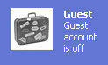
- Double-click User Accounts.
- In the User Accounts window, find the Guest icon. If it says Guest account is off, as shown to the right on this page, do the next two steps to enable it. If the Guest account is already turned on, you don’t need to turn it on again.

  - Click the Guest icon.
  - Under the Do you want to turn on the guest account? header, click the Turn On the Guest Account button.
- Close all windows.

Sharing the “Shared Files” Folder over the Network
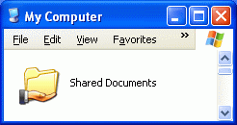
Do this on the Server computer.
The Shared Files folder is intended to allow all the users of a single computer to share files, but it can also be used to share files over the network.
- Click Start, My Computer.
- .The Shared Documents folder should show a hand under the folder icon, as shown to the right on this page. If it does not show the hand, do the next three steps to turn on sharing.

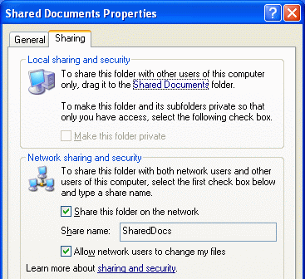
  - Right-click the Shared Documents folder and click Sharing and Security.
  - In the Shared Documents Properties box, on the Sharing tab, check both the Share this folder on the network box and the Allow network users to change my files box, as shown to the right on this page.
  - Click OK to close the Shared Documents Properties box.

Saving the Shared Documents Screen Image From the Server
Do this on the Server computer.
- Click the title bar of the My Computer window to make sure it is active. Hold down the Alt key and press the PrintScrn key in the upper-right portion of the keyboard. That will copy the window to the clipboard.
- Click Start, Programs, Accessories, Paint. In the untitled - Paint window, select Edit, Paste from the menu bar. The window appears in the Paint window.
- In the untitled - Paint window, click File, Save. Save the document in the Shared Documents folder with the filename Your Name and Partner’s Name Proj 8a. Select a Save as type of JPEG.

File Sharing

Client computer name: __________________

Server computer name: __________________
Do this on the Client computer.
- Close all windows.
- Click Start, right-click My Computer, and click Properties. Click the Computer Name tab. Find your Full computer name. It should be something like S214-02v, where 02 will probably be a different number. Write the name in the box to the upper right on this page.
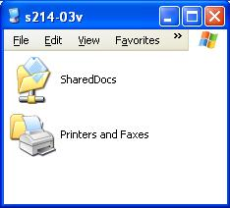
- Find the name of your Server computer the same way. It should be something like S214-01v, where 01 will probably be a different number. Write the name in the box to the upper right on this page.
- On your client machine, click Start, Run and enter
\\server
replacing server with your Server computer name from the box to the upper right on this page . A window should open with your server computer’s name in the title bar, showing a Shared Docs folder, as shown to the right on this page. Notice that the folder shows a network cable icon under it instead of a hand, to indicate that you are connecting to it as a client over the network.

Saving the Shared Documents Screen Image From the Client
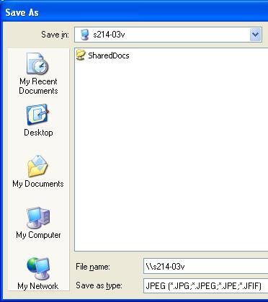
Do this on the Client computer.
- Hold down the Alt key and press the PrintScrn key in the upper-right portion of the keyboard. That will copy the window to the clipboard.
- Click Start, Programs, Accessories, Paint. In the untitled - Paint window, select Edit, Paste from the menu bar. The window appears in the Paint window.
- In the untitled - Paint window, click File, Save As…. In the Save As… dialog box, in the File name: box, type in
\\server
replacing server with your Server computer name from the box to the upper right on this page. Press the Enter key. Your Save As dialog box should look like the one shown to the right on this page.
- Double-click the Shared Docs folder to open it. Save the image with the filename Your Name and Partner’s Name Proj 8b. Select a Save as type of JPEG.

Observing the Local Area Connection Icon
Do this on the Client computer.
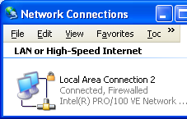
- Click Start, My Computer. In the Common Tasks pane, in the Other Places section, click My Network Places.
- In the My Network Places window, in the Common Tasks pane, in the Network Tasks section, click View Network Connections.
- The Network Connections window opens, as shown to the upper-right on this page. You should see a Local Area Connection icon like that shown to the right on this page, with a little padlock icon on it, indicating that this connection is protected by Windows Firewall.
- Why didn’t the firewall prevent file sharing? Because it is smarter than the Internet Connection Firewall provided with Windows XP prior to Service Pack 2, and allows exceptions, as you will see below.

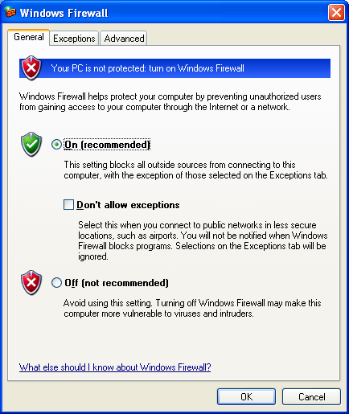
Observing Firewall Settings
Do this on the Client computer.
- Click Start, Control Panel.
- Double-click Windows Firewall.
- A Windows Firewall box opens as shown to the right on this page. Verify that the On (recommended) radio button is selected. (The Network Setup Wizard turned it on.) Make sure the Don't allow exceptions box is cleared, as shown to the right on this page.

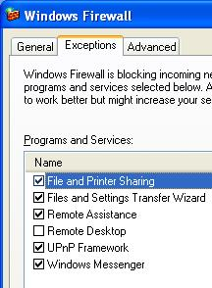

- In the Windows Firewall box, click the Exceptions tab. Verify that the File and Printer Sharing box is checked, as shown in the figure to the right on this page. The Network Setup Wizard did that for you also.
- In the Windows Firewall box, click the OK button.
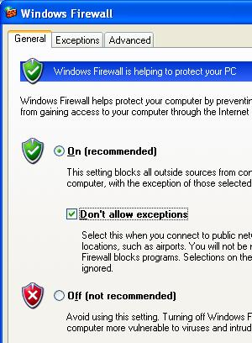

Turning On the Client’s Firewall (No Exceptions)
Do this on the Client computer.
- Click Start, Control Panel. Double-click Windows Firewall.
- A Windows Firewall box opens. Click On (recommended). Check the Don't allow exceptions box, as shown to the right on this page. Click the OK button.

File Sharing with the Client’s Firewall On (No Exceptions)
Do this on the Client computer.
- Close all windows.
- On your client machine, click Start, Run and enter
\\server
replacing server with your Server computer name. A window should open with your server computer’s name in the title bar, showing a Shared Docs folder, just as it did before.
- Windows Firewall will not prevent a Client from accessing shared folders, for the same reason it won’t stop a Client from viewing Web pages – it uses Stateful Packet Filtering. Stateful filtering allows packets through if you have requested them, so when you opened the shared folder the firewall knew it should let the network packets responding to that request into your computer.

Turning On the Server’s Firewall (No Exceptions)
Do this on the Server computer.
- Click Start, Control Panel. Double-click Windows Firewall.
- A Windows Firewall box opens. Click On (recommended). Check the Don't allow exceptions box, as shown to the upper right on this page. Click the OK button.

File Sharing with the Server’s Firewall On (No Exceptions)
Do this on the Client computer.
- Close all windows.
- On your client machine, click Start, Run and enter
\\server
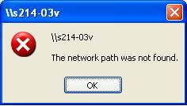
replacing server with your Server computer name. There is a long delay – about 30 seconds – while your client machine waits for a response from the server.
- A box opens saying The network path was not found, as shown to the right on this page.

Returning Both Firewalls to the Normal On State (Allowing Exceptions)
Do this on both the Client and Server computers. You should leave the computers with the firewall On, allowing exceptions, to protect the computers while still leaving them with normal network functions.
- Click Start, Control Panel. Double-click Windows Firewall.
- A Windows Firewall box opens as shown to the right on this page. Verify that the On (recommended) radio button is selected. Clear the Don't allow exceptions box.
- In the Windows Firewall box, click the OK button.
- On the Client computer, open the server shared folder again to verify that the firewall is now allowing file sharing again.

Saving the Screen Image From the Client
Do this on the Client computer.
- Hold down the Alt key and press the PrintScrn key in the upper-right portion of the keyboard. That will copy the window to the clipboard.
- Click Start, Programs, Accessories, Paint. In the untitled - Paint window, select Edit, Paste from the menu bar. The window appears in the Paint window.
- In the untitled - Paint window, click File, Save As…. In the Save As… dialog box, in the File name: box, type in
\\server
replacing server with your Server computer name from the box to the upper right on this page. Press the Enter key. Your Save As dialog box should look like the one shown to the right on this page.
- Double-click the Shared Docs folder to open it. Save the image with the filename Your Name and Partner’s Name Proj 8c. Select a Save as type of JPEG.

Turning in your Project
Do this on the Server computer.
- Email the three JPEG images to me as three attachments to one e-mail message. All the images should be in the Shared Documents folder. Send the message to: cnit.235@gmail.com with a subject line of CNIT 235 Proj 8 From Your Names, replacing Your Names with your own first and last name, and your partner's first and last name. Send a Cc to yourself.

Revised 12-9-05

