This project can be done on any Windows XP Pro machine for which you have administrative rights.
NTFS Permissions Facts
- These powerful file and folder security features are not available on FAT or FAT32 partitions, but only on NTFS ones.
- You must have Simple File Sharing turned off to use NTFS Permissions
- The owner of a file or folder, and users with Full Control permission, can assign permissions to it
- The NTFS Folder Permissions are
  - Read, Write, List Folder Contents, Read and Execute, Modify, Full Control
- The NTFS File Permissions are
  - Read, Write, Read and Execute, Modify, Full Control
Multiple NTFS Permissions
- This can happen because a user may belong to groups, so the same user may have 2 or more different permissions applicable to the same file or folder
- Allow Permissions are Cumulative
  - Example: If a user has Read permission, and is in a group with Write permission, that user has both Read and Write permission.
- File Permissions are Separate From Folder Permissions
  - NTFS file permissions take priority over NTFS folder permissions
  - Example: A user with Modify permission for a file will be able to change it even if that user has only Read permissions for the folder containing the file
- Deny Overrides Other Permissions
  - If a user has Full Control permission, and is in a group with Write permission set to Deny, that user can not Write
Permissions Inheritance
- By default, permissions from the parent folder are inherited by all objects within that folder
- Inherited permissions appear grayed-out in the properties box
- To prevent permission inheritance, clear the Allow inheritable permissions from parent to propagate to this object check box in the Security tab of the object’s Properties
  - You must choose to Copy inherited permissions from the parent folder or Remove the inherited permissions
Ensuring That There is a Limited Account Named Student
- Log in with an account that has local Administrative rights, such as the CNIT account. The CNIT account does not require any password.
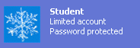
- Click Start, Control Panel. Click User Accounts. Click Change an account. Look for the Student account, which should be a Limited account, as shown to the right on this page. If the Student account is not present, click Create a new account and create it. If it is not a Limited account, click Student and click Change the account type. Close all windows when you are done.

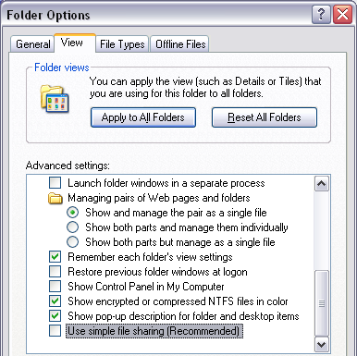
Activity: Applying NTFS Permissions
Turning Off Simple File Sharing
- Click Start, My Computer. Click Tools, Folder Options. Click the View tab. Scroll to the last item and uncheck Use simple file sharing (Recommended) as shown in the figure to the right on this page. Click the OK button to close Folder Options.
Creating the YourNameNTFSData Folder
- Click Start, My Computer. Double-click the E: drive to open it (if your system drive is not E:, use your system drive instead). If necessary, click Show the contents of this folder.
- Right-click an empty portion of the E: window and select New, Folder to create a new folder. Name the folder YourNameNTFSData, replacing YourName with your own name.
Observing NTFS Permissions for the YourNameNTFSData Folder
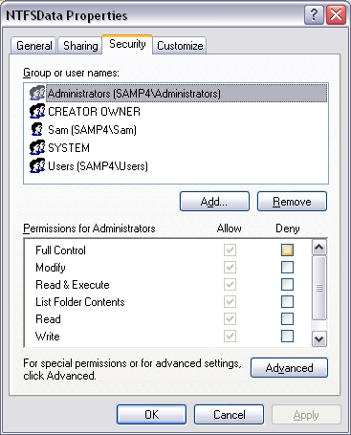
- Right-click the YourNameNTFSData folder and click on Properties to open a YourNameNTFSData Properties box. Click the Security tab. This displays the Access Control List, also known as NTFS Permissions. Note that the Administrators group has Full Control. Full Control means that all permissions are allowed, so all the boxes are checked. The gray check boxes indicate that these are inherited permissions.
- Click the CREATOR OWNER item in the top of the YourNameNTFSData Properties box. Note that the Permissions list shows no check boxes, but that if you scroll to the bottom, you see that the CREATOR OWNER has Special Permissions.
- Click the Users item in the top of the YourNameNTFSData Properties box. Note that the Permissions list shows four check marks: Read & Execute, List Folder Contents, Read, and Special Permissions. This means that all Users can read the files in the folder, including all people logged in to the domain, or on to the local machine.
- As you can see, figuring out what permissions a certain user has could be confusing. There are two tools available to make it easier: Advanced Security Settings and Effective Permissions.
Observing Advanced Security Settings for Yourself
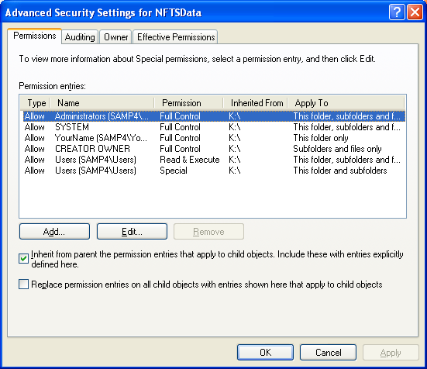
- Click the Advanced button. You should see an Advanced Security Settings for YourNameNTFSData window as shown to the right on this page. This page helps you figure out what each user can do to some extent, because it lists all the permissions in a table so you can see them all at once.
- Notice that your login name appears in this chart, and that you have Full Control.
Observing Effective Permissions for Yourself
- But to make things really easy, click the Effective Permissions tab. Click the Select button. In the Select User or Group box, enter your logon name, as shown below on this page, and click OK.
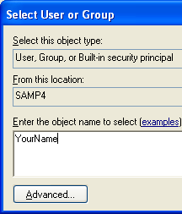

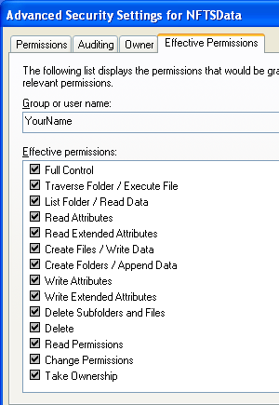

- Now you can see your login name in the Group or User Name box, and the effective permissions you have, as shown to the right on this page. You have all 14 possible permissions for the file – this is also known as Full Control.
Observing Effective Permissions for the Users Group
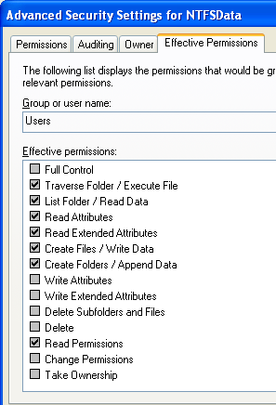
- In the Advanced Security Settings for YourNameNTFSData window, on the Effective Permissions tab, click the Select button. In the Select User or Group box, enter Users and click OK.
- You should see several boxes checked, as shown to the right on this page: Users have permissions to List Folder / Read Data and to Create Files / Write Data, among others – Users can read and write files, but not delete them. Press Alt+PrntScn to copy this window to the clipboard.
- Click the title bar of the Advanced Security Settings for YourNameNTFSData window to make sure it is active. Hold down the Alt key and press the PrintScrn key in the upper-right portion of the keyboard. That will copy the window to the clipboard.
- Click Start, Programs, Accessories, Paint. In the untitled - Paint window, select Edit, Paste from the menu bar. The window appears in the Paint window.
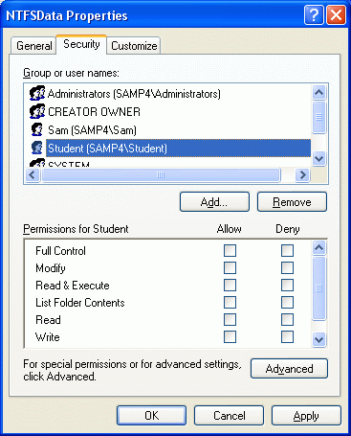
- In the untitled - Paint window, click File, Save. Save the document in the Shared Documents folder with the filename Your Name Proj 9a. Select a Save as type of JPEG.
- Close the Advanced Security Settings for YourNameNTFSData window.
Removing Inherited Permissions for the YourNameNTFSData Folder
- Click the Users item in the top of the YourNameNTFSData Properties box. Click the Remove button to remove the Users group. A Security box opens explaining that you must prevent this object from inheriting permissions. Read the message and click OK to close it. You cannot remove inherited permissions without blocking permission inheritance first.
- Click the Advanced button to open the Advanced Security Settings for YourNameNTFSData window. Clear the Inherit from parent … check box. When a Security box opens, select Copy.
- Click OK to close the Advanced Security Settings for YourNameNTFSData window.
- Now the YourNameNTFSData Properties box shows the same information as before, but the check boxes are no longer grayed out.
Removing Permissions for the Users group
- Click the Users item in the top of the YourNameNTFSData Properties box. Click the Remove button to remove the Users group. This removes all permissions for the Users group.
Adding an Entry With No Permissions for Student
- Click the Add button. . In the Select User or Group box, enter Student and click OK. Clear all the check boxes, as shown to the right on this page. Click the OK button.
- Now Student has no permissions to use this folder, and the Users group doesn’t either.
Trying to Open YourNameNTFSData as Student
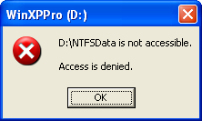
- Click Start, Log off, Switch User and log in locally as Student. The password should be P@ssw0rd.
- Click Start, My Computer. Double-click the E: drive to open it (if your system drive is not E:, use your system drive instead). If necessary, click Show the contents of this folder.
- Double-click the folder YourNameNTFSData. You should see a message similar to the example shown to the right on this page – the folder won’t even open, because Student has no permissions to access it. (Your drive letter may be different.)
Creating the Important Info Document
- Click Start, Log off, Switch User and log in with the same account you used in step 1 (CNIT).
- Click Start, My Computer. Double-click the E: drive to open it (if your system drive is not E:, use your system drive instead). If necessary, click Show the contents of this folder.
- Double-click the folder YourNameNTFSData to open it.
- In the YourNameNTFSData window, right-click and select New, Text Document. Name the document Important Info.
- Double-click Important Info to open it in Notepad. Type in This is important information. Users can read this, but they are not permitted to change it. Save the file. Close Notepad.
Giving Users Read Access to the YourNameNTFSData Folder
- In the YourNameNTFSData folder, click the Up button on the toolbar (it looks like a folder with a green up-arrow on it). This returns you to the root of the E: drive.
- Right-click the YourNameNTFSData folder and select Properties. Click the Security tab. Note that Users and Student are not in the list anymore – an entry with no permissions has no effect, so Windows removed them.
- Click the Add button. In the Select User or Group box, enter Users and click OK. This time, leave the boxes checked that Windows chose by default: Read & Execute, List Folder Contents, and Read. These permit the Users to read but not change or delete files. In the YourNameNTFSData Properties window, click the OK button.
Creating the ChangesOK Folder and the Changeme File
- Open the YourNameNTFSData folder and create a new folder inside it named ChangesOK.
- Right-click the ChangesOK folder, click Properties, and click the Security tab.
- Click Users in the top pane. The lower pane shows the Read & Execute, List Folder Contents, and Read boxes checked with faded gray check marks, indicating that these permissions have been inherited from the containing folder. Click the Allow box in the Full Control line. Note: You can add more permissions without blocking permission inheritance first.

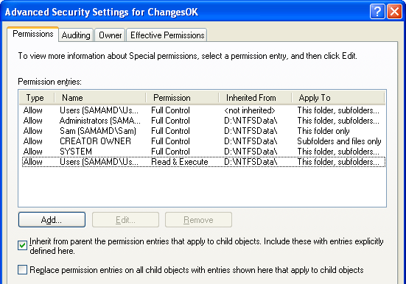
- In the ChangesOK Properties window, on the Security tab, click the Advanced button. An Advanced Security Settings for ChangesOK window opens, as shown to the right on this page. Note the top entry, showing the Users have Full Control and that this permission is not inherited.
- Click the title bar of the Advanced Security Settings for ChangesOK window to make sure it is active. Hold down the Alt key and press the PrintScrn key in the upper-right portion of the keyboard. That will copy the window to the clipboard.
- Click Start, Programs, Accessories, Paint. In the untitled - Paint window, select Edit, Paste from the menu bar. The window appears in the Paint window.
- In the untitled - Paint window, click File, Save. Save the document in the Shared Documents folder with the filename Your Name Proj 9b. Select a Save as type of JPEG.
- Click the OK button to close the Advanced Security Settings for ChangesOK window.
- Click the OK button to close the ChangesOK Properties window.
Now all Users have Full Control of the ChangesOK folder
- Double-click the ChangesOK folder to open it.
- In the ChangesOK window, right-click and select New, Text Document. Name the document Changeme.
- Double-click Changeme to open it in Notepad. Type in Users can change or delete this file. Save the file. Close Notepad.
Observing the Effects of NTFS Permissions
- Click Start, Log off, Switch User and log in locally as Student. The password should be P@ssw0rd.
- Click Start, My Computer. Double-click the E: drive to open it (if your system drive is not E:, use your system drive instead). If necessary, click Show the contents of this folder.
- Double-click the folder YourNameNTFSData to open it. You can now open the folder, because Users have Read access to this folder, and Student is a member of the Users group.
- Double-click the Important Info file. You can open and read it. Type in some additional text and click File, Save. You cannot save the revised version, because you do not have permission to change files in the YourNameNTFSData folder. Close the Notepad box. Close Notepad. Do not save changes.
- Double-click the ChangesOK folder to open it.
- Double-click the Changeme file. You can open and read it. Type in some additional text and click File, Save. You can save the revised version, because you do have permission to change files in the ChangesOK folder. Delete the Changeme file. You can do that too.
Notice that Student has Full Control over the ChangesOK folder, even though Student does not have Full Control of YourNameNTFSData, its containing folder. This unusual situation is a potential security risk – even if a folder is made secure with NTFS permissions, that does not necessarily mean that all the folders inside it are secure. This is not allowed in UNIX, but it is default behavior in Windows. It can be fixed, by removing the Bypass Traverse Checking right in Group Policy. We will discuss Group Policy later in the course.
Creating the Students Secrets File
- Right-click on an empty space in the ChangesOK window and select New, Text Document. Name the document Students Secrets. You should be able to create it with no problem.
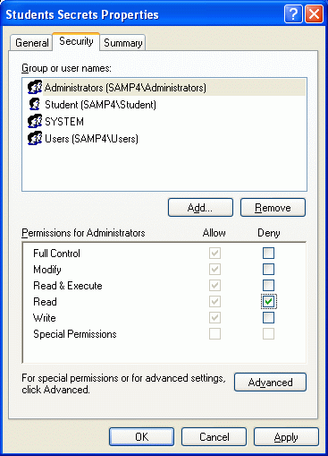
- Double-click the Students Secrets file to open it in Notepad. Type in The administrator can’t see this!. Save the file. Close Notepad.
Using the Deny NTFS Permission
- Suppose you want to prevent the Administrator from seeing the document you made. Right-click on Students Secrets and select Properties to open a Students Secrets Properties window. Click the Security tab.
- Verify that Administrators is selected and check the Deny box in the Read row, as shown in the figure to the right on this page. Note that you do not have to remove inherited permissions to add additional permissions, even when they are Deny permissions.
- Click OK. A Security box pops up warning you that you are adding a Deny permission which will over-ride other permissions. Read the box and click Yes to continue.
Observing the Effects of the Deny NTFS Permission
- Click Start, Log off, Log off and log in with the same account you used in step 1 (CNIT).
- Click Start, My Computer. Double-click the E: drive to open it (if your system drive is not E:, use your system drive instead). If necessary, click Show the contents of this folder.
- Open the YourNameNTFSData folder. Open the ChangesOK folder. Double-click the Students Secrets file. A Notepad message box opens saying Access is Denied. Notepad launches, but the secret message is not visible. You are a member of the local Administrators group, so the Deny permission applies to you.
- Click OK to close the Notepad box. Close NotePad.
Taking Ownership of a File
- In the ChangesOK folder, right-click Students Secrets and select Properties.
- In the Students Secrets Properties box, click the Security tab. A Security box opens showing that you cannot view the current settings, but you can change them. Click OK to close the dialog box.
- In the Students Secrets Properties box, click the Advanced button.
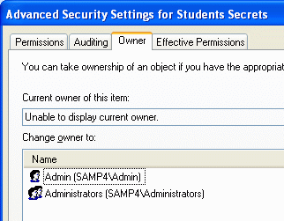
- In the Advanced Security Settings for Students Secrets window, click the Owner tab. Your window should now look like the figure to the right on this page – note that the Current owner of this file say s Unable to display current owner. That's because you do not have Read permission.
- Click the title bar of the Advanced Security Settings for Students Secrets window to make sure it is active. Hold down the Alt key and press the PrintScrn key in the upper-right portion of the keyboard. That will copy the window to the clipboard.
- Click Start, Programs, Accessories, Paint. In the untitled - Paint window, select Edit, Paste from the menu bar. The window appears in the Paint window.
- In the untitled - Paint window, click File, Save. Save the document in the Shared Documents folder with the filename Your Name Proj 9c. Select a Save as type of JPEG.
- Click Administrators in the list under the Change owner to: header. Click the OK button.
- In the Students Secrets Properties box, click the OK button.
- Right-click Students Secrets and select Properties.
- In the Students Secrets Properties box, click the Security tab. Now you can view and change the properties normally, because you now own this file.
- Clear the Deny permission for the Administrators group. Click OK to close the Students Secrets Properties box.
- Double-click Students Secrets. Now you should be able to open it and read the contents.

Turning in your Project
- Email the three JPEG images to me as three attachments to one e-mail message. They Shared Documents folder Send the message to: cnit.235@gmail.com with a subject line of CNIT 235 Proj 9 From Your Name, replacing Your Name with your own first and last name. Send a Cc to yourself.

Revised 2-13-05

