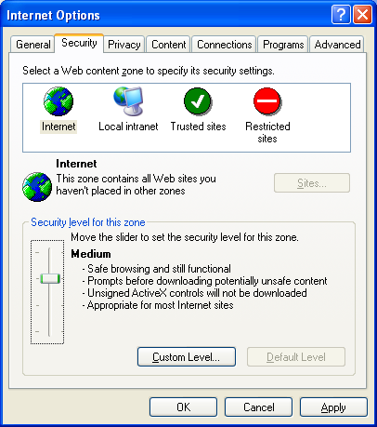
This project can be done on any Windows XP machine with Service Pack 2.
- Log in with any account, such as the one with your name on it. You should not use an account with Administrative rights when using Internet Explorer.
Ensuring That Internet Explorer Security is at its Default Settings
- Click Start, All Programs, Internet Explorer. Click Tools, Internet Options. Click the Security tab. Click the globe labeled Internet to select the Internet security zone. Verify that the security level shown in the lower portion of the window is Medium, as shown in the figure to the right on this page. If it shows something else, such as Custom, click the Default Level button. Once the security is set to Medium, the Default Level button is grayed out.

Installing Microsoft AntiSpyware (Beta)
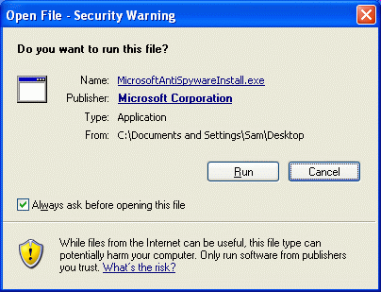
- Open My Computer. Open the shared drive Z:. Open the _Software folder and the Microsoft AntiSpyware folder. Drag the MicrosoftAntiSpywareInstall.exe file to your desktop. Right-click the installer file and click Run As….
- An Open File – Security Warning box appears, to warn you that this file was downloaded from the Internet, as shown to the right on this page. Click Run.
- In the Run As box, click the The following user: radio button. Use a User name: of Administrator with a password of password. Click OK.
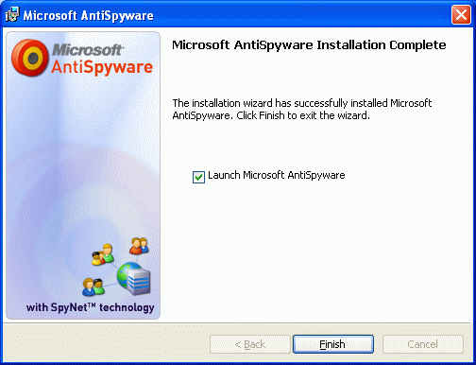
- In the Microsoft AntiSpyware box, click Next. Accept the license agreement and click Next. Accept the default installation folder and click Next. Click Install.
- When you see the Microsoft AntiSpyware Installation Complete message, as shown to the right on this page, click the Launch Microsoft AntiSpyware box and click Finish.

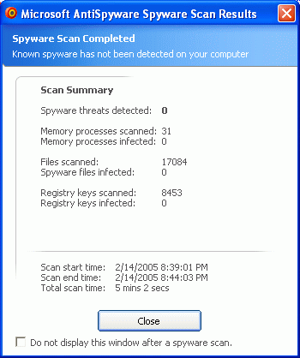
- In the Microsoft AntiSpyware Setup Assistant box, click Next.
- In the next screen, accept the default selection of Yes, automatically keep Microsoft AntiSpyware updated (recommended) and click Next.
- In the next screen, accept the default selection of Yes, keep me more secure (recommended) and click Next.
- In the next screen, accept the default selection of Yes, I want to help fight spyware (recommended) and click Finish.
- In the Spyware's Final Step screen, click Run Scan Now.
- In the next window, accept the default selection of Run an intelligent quick scan and click Run Scan Now. Wait until the scan finishes.
- When you see the Microsoft AntiSpyware Scan Results window shown to the right on this page, click its title bar to make sure it is active.
- Hold down the Alt key and press the PrintScrn key in the upper-right portion of the keyboard. That will copy the window to the clipboard.
- Click Start, Programs, Accessories, Paint. In the untitled - Paint window, select Edit, Paste from the menu bar. The window appears in the Paint window.
- In the untitled - Paint window, click File, Save. Save the document in the Shared Documents folder with the filename Your Name Proj 10a. Select a Save as type of JPEG.
- If no Spyware was found, click Close to close the Microsoft AntiSpyware Scan Results window. If Spyware was found, follow the on-screen prompts to learn what it is. You should probably remove it, unless it is a program you deliberately installed and want.
Turning off Microsoft AntiSpyware
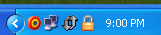
- In the Notification Area in the lower-right corner of the desktop, find the Microsoft AntiSpyware icon. It looks like an off-center bullseye, as shown to the right on this page. Right-click it and click Shutdown Microsoft AntiSpyware. In the Shutdown Microsoft AntiSpyware? Box, click Yes.
Why are we turning Microsoft AntiSpyware off? Because when I tested the homework, AntiSpyware was unreliable – on one machine, it stopped the ActiveX controls from PC Pitstop and totally replaced the the Internet Explorer warnings discussed in your book, but on my other machine it did not. I recommend that you re-enable AntiSpyware later and get used to it, but I don't know how to use it reliably enough to build it into a required project in any more depth.
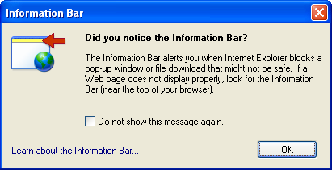
Running PC Pitstop ActiveX Tests
- Open Internet Explorer and go to pcpitstop.com. In the left column, click Check ActiveX. An Information Bar box opens, as shown to the right on this page. Click OK.
- Click the yellow Information bar near the top of the Internet Explorer window, and click Install ActiveX Control.
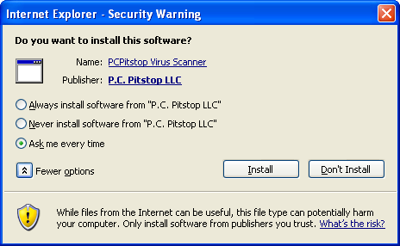
- In the Internet Explorer – Security Warning box, click the More Options button, to make your window show all the options as shown to the right on this page. Click the Internet Explorer – Security Warning title bar to make sure it is the active window.
- Hold down the Alt key and press the PrintScrn key in the upper-right portion of the keyboard. That will copy the window to the clipboard.
- Click Start, Programs, Accessories, Paint. In the untitled - Paint window, select Edit, Paste from the menu bar. The window appears in the Paint window.
- In the untitled - Paint window, click File, Save. Save the document in the Shared Documents folder with the filename Your Name Proj 10b. Select a Save as type of JPEG.
- In the Internet Explorer – Security Warning box, click the Always install software from "P.C. Pitstop LLC" radio button, and click the Install button.
- The PC Pitstop test runs, and the date and time appears in the yellow box, indicating that ActiveX is operating.
- Close Internet Explorer.
Running PC Pitstop ActiveX Tests Again
- Open Internet Explorer and go to pcpitstop.com. In the left column, click Check ActiveX. The test runs, and the date and time appear in the yellow box. No warnings were issued, because P.C. Pitstop is now a Trusted Publisher.
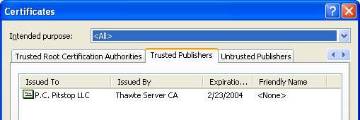
- In Internet Explorer, click Tools, Internet Options. Click the Content tab. Click the Publishers button. Click the Trusted Publishers tab. You should see P.C. Pitstop LLC, as shown to the right on this page.
- Click the Certificates title bar to make sure it is the active window.
- Hold down the Alt key and press the PrintScrn key in the upper-right portion of the keyboard. That will copy the window to the clipboard.
- Click Start, Programs, Accessories, Paint. In the untitled - Paint window, select Edit, Paste from the menu bar. The window appears in the Paint window.
- In the untitled - Paint window, click File, Save. Save the document in the Shared Documents folder with the filename Your Name Proj 10c. Select a Save as type of JPEG.
Removing PC Pitstop from the Trusted Publishers List
- In the Certificates window, click on the P.C. Pitstop line to select this publisher. Click the Remove button.
- In the Certificates window, click Yes.
- In the Certificates window, click Close.
- In the Internet Options window, click OK.
- Close Internet Explorer.
- Open Internet Explorer and go to pcpitstop.com. In the left column, click AntiVirus. In the next window, click PC Pitstop Virus Scan. After a minute or two, the file has downloaded, and an Information Bar box opens. Look at the Information bar – Internet Explorer no longer trusts PC Pitstop, so it is warning you about this Active X control.
- Close Internet Explorer.
- Open Internet Explorer and go to pcpitstop.com. In the left column, click Chack ActiveX. The date and time appears in the yellow box, showing that ActiveX is working. No warning messages appeared. That's because the ActiveX controls for this page were already loaded.
Managing Installed ActiveX Controls
- In the Internet Explorer window, click Tools, Internet Options.
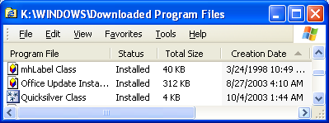
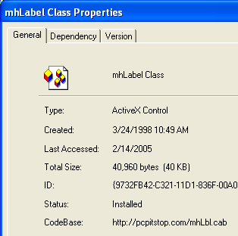
- In the Internet Options window, on the General tab, in the Temporary Internet Files section, click the Settings button. In the Settings box, click the View objects button. You should see a Downloaded Program Files window as shown to the right on this page. Find the mhLabel Class object in the list, right-click it, and click Properties.
- A mhLabelClass Properties box opens, as shown to the right on this page. Notice at the bottom the CodeBase: item shows that this is the object installed by pcpitstop.
- Click the mhLabelClass Properties title bar to make sure it is the active window.
- Hold down the Alt key and press the PrintScrn key in the upper-right portion of the keyboard. That will copy the window to the clipboard.
- Click Start, Programs, Accessories, Paint. In the untitled - Paint window, select Edit, Paste from the menu bar. The window appears in the Paint window.

- In the untitled - Paint window, click File, Save. Save the document in the Shared Documents folder with the filename Your Name Proj 10d. Select a Save as type of JPEG.
Attempting to Remove the Installed ActiveX Control
- Click OK to close the mhLabelClass Properties box.
- In the Downloaded Program Files window, right-click the mhLabelClass item and click Remove. A Remove Program File box opens telling you that you do not have the privileges to remove this file (which is strange, considering that you had the privileges to install it!).
- Click OK to close the Remove Program File box.
- Close the Downloaded Program Files window.
- Close the Settings box, the Internet Options box, and close Internet Explorer.
Attempting to Remove the Installed ActiveX Control Using Elevated Privileges
- Click Start, Control Panel. If it is not in Classic View, click Switch to Classic View in the left pane.
- Hold down the Shift key and right-click Internet Options. Click Run As…. Run the program as Administrator with a password of password.
- In the Internet Options window, on the General tab, in the Temporary Internet Files section, click the Settings button. In the Settings box, click the View objects button. Find the mhLabel Class object in the list, right-click it, and click Remove.
- The same error message appears, because although the Control Panel item was run as Administrator, the View Objects button launched Windows Explorer, and Windows Explorer cannot be run with elevated privileges.
- Close all windows.
Removing the Installed ActiveX Control as an Administrator
- Click Start, Log Off, Switch User. Click CNIT to log in with Administrative privileges.
- Click Start, Control Panel. If it is not in Classic View, click Switch to Classic View in the left pane.
- Double-click Internet Options.
- In the Internet Options window, on the General tab, in the Temporary Internet Files section, click the Settings button. In the Settings box, click the View objects button. Find the mhLabel Class object in the list, right-click it, and click Remove. In the Remove Program File box, click Yes.
- Click Start, Log Off, Log Off. Log in with your usual account, which does not have Administrative privileges.
Running PC Pitstop ActiveX Tests
- Open Internet Explorer and go to pcpitstop.com. In the left column, click Check ActiveX. An Information Bar box opens. This shows that the ActiveX control is no longer installed, and that PC Pitstop is no longer a trusted publisher.

Turning in your Project
- Email the four JPEG images to me as three attachments to one e-mail message. They Shared Documents folder Send the message to: cnit.235@gmail.com with a subject line of CNIT 235 Proj 10 From Your Name, replacing Your Name with your own first and last name. Send a Cc to yourself.

Revised 2-14-05

