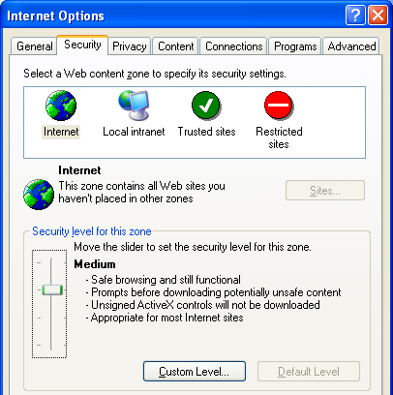
This project can be done on any Windows XP machine with Service Pack 2.
- Start your computer with the appropriate L removable hard drive. Start your virtual machine and log in with your own account. .
Ensuring That Internet Explorer Security is at its Default Settings
- Click Start, Internet. Click Tools, Internet Options. Click the Security tab. Click the globe labeled Internet to select the Internet security zone. Click the Default Level button. The Security Level changes to Medium. Once the security is set to Medium, the Default Level button is grayed out. Click OK to close Internet Options.
Installing Microsoft AntiSpyware (Beta)
- If you are working in Science 214, do step 4 below. If you are working at home, use Google to find Microsoft Antispyware and download it from the Internet, and then skip to step 5.
- Open My Computer. Open the shared drive Z:. (If there is no shared drive Z, click Start, Run, enter \\192.168.1.2, right-click the CNIT235 folder and select Map Network Drive to map it.) Open the _Software folder and the Microsoft AntiSpyware folder. Drag the MicrosoftAntiSpywareInstall.exe file to your desktop.
- Double-click the installer file.
- In the Microsoft AntiSpyware box, click Next. Accept the license agreement and click Next. Accept the default installation folder and click Next. Click Install.
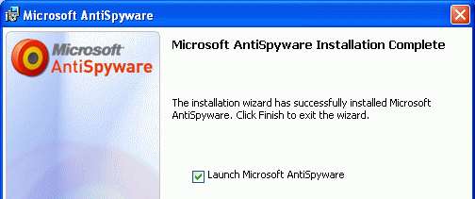
- When you see the Microsoft AntiSpyware Installation Complete message, as shown to the right on this page, click the Launch Microsoft AntiSpyware box and click Finish.
- In the Microsoft AntiSpyware Setup Assistant box, click Next.
- In the next screen, accept the default selection of Yes, automatically keep Microsoft AntiSpyware updated (recommended) and click Next.
- In the next screen, accept the default selection of Yes, keep me more secure (recommended) and click Next.
- In the next screen, accept the default selection of Yes, I want to help fight spyware (recommended) and click Finish.
- In the Spyware's Final Step screen, click Run Quick Scan Now. If a box pops up saying Your spyware signatures may be out of date, click Update Now. When the updates complete, click Close.
- Wait until the scan finishes.
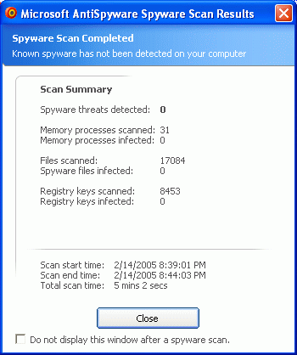
- When you see the Microsoft AntiSpyware Scan Results window shown to the right on this page, click its title bar to make sure it is active.
- Hold down the Alt key and press the PrintScrn key in the upper-right portion of the keyboard. That will copy the window to the clipboard.
- Click Start, Programs, Accessories, Paint. In the untitled - Paint window, select Edit, Paste from the menu bar. The window appears in the Paint window.
- In the untitled - Paint window, click File, Save. Save the document in the Shared Documents folder with the filename Your Name Proj 10a. Select a Save as type of JPEG.
- If no Spyware was found, click Close to close the Microsoft AntiSpyware Scan Results window. If Spyware was found, follow the on-screen prompts to learn what it is. You should probably remove it, unless it is a program you deliberately installed and want.
Turning off Microsoft AntiSpyware

- In the Notification Area in the lower-right corner of the desktop, find the Microsoft AntiSpyware icon. It looks like an off-center bullseye, as shown to the right on this page. Right-click it and click Shutdown Microsoft AntiSpyware. In the Shutdown Microsoft AntiSpyware? Box, click Yes.
Why are we turning Microsoft AntiSpyware off? Because when I tested the homework, AntiSpyware was unreliable – on one machine, it stopped the ActiveX controls from PC Pitstop and totally replaced the the Internet Explorer warnings discussed in your book, but on my other machine it did not. I recommend that you re-enable AntiSpyware later and get used to it, but I don't know how to use it reliably enough to build it into a required project in any more depth.
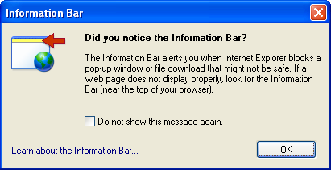
Running PC Pitstop ActiveX Tests
- Open Internet Explorer and go to pcpitstop.com. In the left column, click Check ActiveX. An Information Bar box opens, as shown to the right on this page. Click OK.
- Click the yellow Information bar near the top of the Internet Explorer window, and click Install ActiveX Control.
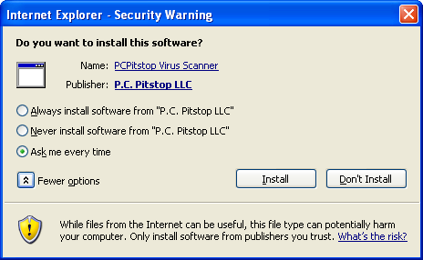
- In the Internet Explorer – Security Warning box, click the More Options button, to make your window show all the options as shown to the right on this page. Click the Internet Explorer – Security Warning title bar to make sure it is the active window.
- Hold down the Alt key and press the PrintScrn key in the upper-right portion of the keyboard. That will copy the window to the clipboard.
- Click Start, Programs, Accessories, Paint. In the untitled - Paint window, select Edit, Paste from the menu bar. The window appears in the Paint window.
- In the untitled - Paint window, click File, Save. Save the document in the Shared Documents folder with the filename Your Name Proj 10b. Select a Save as type of JPEG. Close Paint.
- In the Internet Explorer – Security Warning box, click the Always install software from "P.C. Pitstop LLC" radio button, and click the Install button.
- The PC Pitstop test runs, and the date and time appears in the yellow box, indicating that ActiveX is operating.
- Close Internet Explorer.
Running PC Pitstop ActiveX Tests Again
- Open Internet Explorer and go to pcpitstop.com. In the left column, click Check ActiveX. The test runs, and the date and time appear in the yellow box. No warnings were issued, because P.C. Pitstop is now a Trusted Publisher.
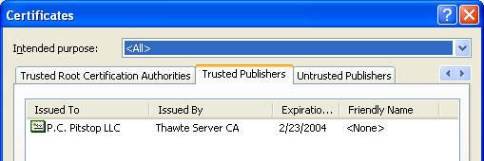
- In Internet Explorer, click Tools, Internet Options. Click the Content tab. Click the Publishers button. Click the Trusted Publishers tab. You should see P.C. Pitstop LLC, as shown to the right on this page.
- Click the Certificates title bar to make sure it is the active window.
- Hold down the Alt key and press the PrintScrn key in the upper-right portion of the keyboard. That will copy the window to the clipboard.
- Click Start, Programs, Accessories, Paint. In the untitled - Paint window, select Edit, Paste from the menu bar. The window appears in the Paint window.
- In the untitled - Paint window, click File, Save. Save the document in the Shared Documents folder with the filename Your Name Proj 10c. Select a Save as type of JPEG. Close Paint.
Removing PC Pitstop from the Trusted Publishers List
- In the Certificates window, click on the P.C. Pitstop line to select this publisher. Click the Remove button.
- In the Certificates window, click Yes.
- In the Certificates window, click Close.
- In the Internet Options window, click OK.
- Close Internet Explorer.
- Open Internet Explorer and go to pcpitstop.com. In the left column, click AntiVirus. In the next window, click PC Pitstop Virus Scan. After a minute or two, the file has downloaded, and an Information Bar box opens. Look at the Information bar – Internet Explorer no longer trusts PC Pitstop, so it is warning you about this Active X control.
- Close all windows.
- Open Internet Explorer and go to pcpitstop.com. In the left column, click Check ActiveX. The date and time appears in the yellow box, showing that ActiveX is working. No warning messages appeared. That's because the ActiveX controls for this page were already loaded.
Managing Installed ActiveX Controls
- In the Internet Explorer window, click Tools, Internet Options.
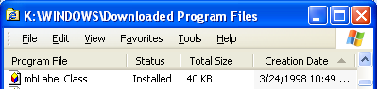
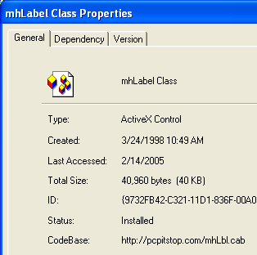
- In the Internet Options window, on the General tab, in the Temporary Internet Files section, click the Settings button. In the Settings box, click the View objects button. You should see a Downloaded Program Files window as shown to the right on this page. Find the mhLabel Class object in the list, right-click it, and click Properties.
- A mhLabelClass Properties box opens, as shown to the right on this page. Notice at the bottom the CodeBase: item shows that this is the object installed by pcpitstop.
- Click the mhLabelClass Properties title bar to make sure it is the active window.
- Hold down the Alt key and press the PrintScrn key in the upper-right portion of the keyboard. That will copy the window to the clipboard.
- Click Start, Programs, Accessories, Paint. In the untitled - Paint window, select Edit, Paste from the menu bar. The window appears in the Paint window.

- In the untitled - Paint window, click File, Save. Save the document in the Shared Documents folder with the filename Your Name Proj 10d. Select a Save as type of JPEG.
Attempting to Remove the Installed ActiveX Control
- Click OK to close the mhLabelClass Properties box.
- In the Downloaded Program Files window, right-click the mhLabelClass item and click Remove. In the Remove Program File box, click Yes. A Share Violation box opens telling you that this file is in use.
- Close all windows. Open Internet Explorer.
- In the Internet Explorer window, click Tools, Internet Options.
- In the Internet Options window, on the General tab, in the Temporary Internet Files section, click the Settings button. In the Settings box, click the View objects button.
- In the Downloaded Program Files window, right-click the mhLabelClass item and click Remove. In the Remove Program File box, click Yes. The file is deleted.
- Close all windows.
Running PC Pitstop ActiveX Tests
- Open Internet Explorer and go to pcpitstop.com. In the left column, click Check ActiveX. An Information Bar box opens. This shows that the ActiveX control is no longer installed, and that PC Pitstop is no longer a trusted publisher.

Turning in your Project
- Email the four JPEG images to me as three attachments to one e-mail message. They Shared Documents folder Send the message to: cnit.235@gmail.com with a subject line of Proj 10 From Your Name, replacing Your Name with your own first and last name. Send a Cc to yourself.

Revised 9-12-05

