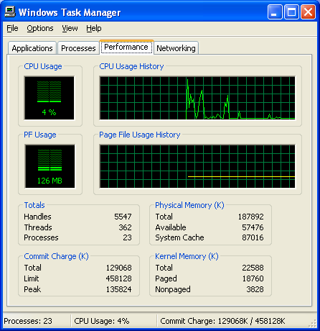
You can do this project on any Windows XP computer for which you have Administrative privileges, as long as that computer has more than 96 MB of RAM, which most modern machines do.
Memory Use by Windows
- Start or restart your virtual machine. You need to start this project from a freshly started machine, so that no RAM or Page file space has been allocated yet to programs.
- Log on with any account that has Administrative privileges, such as the account with your name.
- Wait until all the startup activities have completed, such as starting the antivirus software, and downloading new Spyware definitions for the Microsoft AntiSpyware scanner. Do not start any programs or open any windows.
- Right-click the taskbar (at the bottom of the screen) and select Task Manager. Click the Performance tab, as shown in the figure to the right on this page. Your numbers will be different from the example.
- In the Physical Memory section, find the Total and Available numbers. Write them in the box to the right on this page. If the Available values keeps changing, wait 30 seconds for it to settle down. If it still fluctuates, estimate the average value. It may not be steady, because even with no user-initiated programs running, there are processes using memory, like the virus scanner.

Total Physical Memory: ___________________________

Available Physical Memory: ___________________________

PF Usage: ___________________________

Processes: ___________________________

Commit Charge: ___________________________
- In the center left portion of the Task Manager window, you will see a green bar labeled PF Usage with a green number under the bar. Find that value and write it in the box above on this page. This measures the amount of hard disk space that has been reserved for virtual memory.
- In the Totals section, find the Processes number. Write it in the box on this page.
- In the lower right of the Task Manager window, find the Commit Charge. It is a fraction, like 133732K / 478060 K. You may have to resize the Windows Task Manager box too see it. What matters here is the first number. Write it in the box on the previous page.
Performance With All Available Memory
- If you have a clock or watch with a second hand available, use it to time how long your computer takes to perform the next step. If no clock is handy, just count the seconds by reciting them out loud.
- Click Start, Internet to open an Internet Explorer window. Measure how many seconds it takes to show your home page. Wait a few seconds until the numbers in Task Manager stop changing, and write them down on the first line of the table below.
- Repeat this process twice more, writing down the time, available memory, and PF usage each time.
- Now open 7 more Internet Explorer windows, so you have 10 of them open at once. Wait till they are all open and the Task Manager values become reasonably steady.
- Click Start, Internet Explorer to open an Internet Explorer window. Measure how many seconds it takes to show your home page. Wait a few seconds until the numbers in Task Manager stop changing, and write them down on the line numbered 11 in the table below.

IE Windows | Time to  Open (sec) | Available  Physical  Memory (K) | PF Usage (MB) | Processes | Commit Charge
1 | _________ | _________ | ____________ | _______ | _________________________
2 | _________ | _________ | ____________ | _______ | _________________________
3 | _________ | _________ | ____________ | _______ | _________________________
. . .
11 | _________ | _________ | ____________ | _______ | _________________________

- Examine the values in the table above and answer the questions in the box below.

Did it take longer to open the 11th window than the first one? _______________
Does opening more windows lower the Available Physical Memory? _______________
Does opening more windows increase PF Usage? _______________
Does opening more windows increase the number of Processes? _______________
Does opening more windows increase Commit Charge? _______________

Starting With Less Memory
Note:
The 96 MB value was chosen to make the performance change reasonable for the S214 lab machines. If you find that you get the same performance with 96 MB, lower the RAM to 64 MB instead.
- Close all windows.
- Click Start, right-click My Computer, and select Properties. On the Advanced tab, in the Startup and Recovery section, click the Settings button. In the System Startup section of the Startup and Recovery window, click the Edit button.
- The boot.ini file opens in Notepad. Find the line that opens your usual operating system, carefully copy it and paste it below the original line. Then add this switch to the end of the existing command line:
/MAXMEM=96
- Add 96 MB to the end of the description line in the new command line. This will start Windows XP with only 96 MB of RAM, which is only 32 MB more than the minimum amount that Microsoft regards as acceptable.

- Your boot.ini file should now resemble the example shown below, although your operating systems will have different labels and partition numbers.
[boot loader]
timeout=30
default=multi(0)disk(0)rdisk(0)partition(2)\WINDOWS
[operating systems]
multi(0)disk(0)rdisk(0)partition(2)\WINDOWS="Win XP Pro" /fastdetect
multi(0)disk(0)rdisk(0)partition(2)\WINDOWS="Win XP Pro 96MB" /fastdetect /MAXMEM=96

- Close Notepad and save changes.
- Restart your computer and select the 96MB operating system. Log in with the same account you used before.

Total Physical Memory: ___________________________

Available Physical Memory: ___________________________

PF Usage: ___________________________
- Open Task Manager, find the Total Physical Memory, Available Physical Memory, and PF Usage, and write them in the box to the right on this page.
- Repeat the process you used before to fill in the values in the chart below on this page, with various numbers of Internet Explorer windows open. Notice how slow the response is when you open the 11th window – that’s what computers are like when they are low on RAM.

Performance With 96 MB Memory

IE Windows | Time to  Open (sec) | Available  Physical  Memory (K) | PF Usage (MB) | Processes | Commit Charge
1 | _________ | _________ | ____________ | _______ | _________________________
2 | _________ | _________ | ____________ | _______ | _________________________
3 | _________ | _________ | ____________ | _______ | _________________________
. . .
11 | _________ | _________ | ____________ | _______ | _________________________

Did it take longer to open the 11th window than the first one? _______________
Does opening more windows lower the Available Physical Memory? _______________
Does opening more windows increase PF Usage? _______________
Does opening more windows increase the number of Processes? _______________
Does opening more windows increase Commit Charge? _______________

- After you have filled in the charts, turn in this handout with your name on it, or e-mail the answers to:
cnit.235@gmail.com

Last modified 9-12-05

