This project can be done on any Windows XP (Pro or Home) machine with an Internet connection.
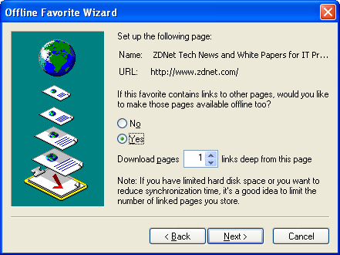
Offline Web Pages
- Open Internet Explorer.
- Go to www.zdnet.com. On the menu bar, click Favorites, Add to Favorites. In the Add Favorites box, click OK.
- On the menu bar, click Favorites. In the drop-down list of favorites, right-click ZDNet Tech News and White Papers for IT Professionals and select Make Available Offline.
- The Offline Favorite Wizard opens. Click Next.
- In the next screen, click Yes to make the links available offline, as shown in the figure to the right on this page. Leave the number of Download pages at 1 as shown, and click Next.
- In the next screen, accept the default selection of Only when I choose Synchronize from the Tools menu and click Next.
- In the next screen, this appears at the top of the page: Does this site require a password? Accept the default selection of No and click Finish.
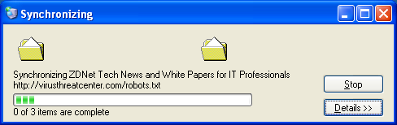
- Now you should see the Synchronizing window, as shown to the right on this page. Press Alt+PrtScn to copy this window to the clipboard.
- On the Start menu, click Run. Enter the command mspaint and press the Enter key. Paint opens.
- Press Ctrl+V on the keyboard to paste the image into the Paint window. Save the document in the Shared Documents folder with the filename Your Name Proj 13a. Select a Save as type of JPEG. Close Paint.
- When the Synchronizing window vanishes, go to the back of your computer and unplug the network cable.
- Open Internet Explorer (or click in an already-open IE window) and enter the address www.ccsf.edu. After a minute or two, you should see an error message, because IE cannot access the Internet.
- In the Internet Explorer menu bar, select Favorites, ZDNet Tech News and White Papers for IT Professionals. Once again, an error message appears because the page is not available.
- In the Internet Explorer menu bar, select File, Work Offline. An icon appears in the status bar, as shown to the right on this page.
- In the Internet Explorer menu bar, select Favorites, ZDNet Tech News and White Papers for IT Professionals. The ZDNet page opens, even though you may see a Web page unavailable while offline box. (You may have to close IE and re-open it to make the page appear.) Click one of the links and verify that you can open the first link normally, but not the second.
- Plug in your network cable again.
- In the Internet Explorer window, type in the address www.google.com and press the Enter key. In the Web page unavailable while offline box, click the Connect button. The Google page should open. If it does not, try restarting your machine. If that still does not get you back on the Internet, call the instructor over to help you.
Managing Cookies
- First let's clean up all the old cookies and other temporary internet files, to make it easier to see newly-created objects.
- Open Internet Explorer. From the menu bar, click Tools, Internet Options.
- In the Internet Options box, on the General tab, in the Temporary Internet Files section, click the Delete Cookies button. In the Delete Cookies box, click OK.
- In the Internet Options box, on the General tab, in the Temporary Internet Files section, click the Delete Files button. In the Delete Files box, check the Delete all offline content box and click OK.
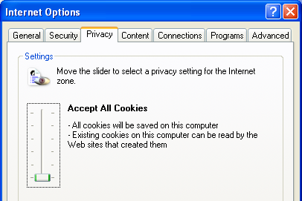
- In the Internet Options box, on the General tab, in the Temporary Internet Files section, click the Settings button. Notice the Temporary Internet Files Folder Current Location. It is usually in your profile, in the Local Settings\Temporary Internet Files subfolder. Make a note of its location, if it is not the default location described in the previous sentence, and click OK to close the Settings box.
- Now let's make sure your machine is set to accept all cookies.
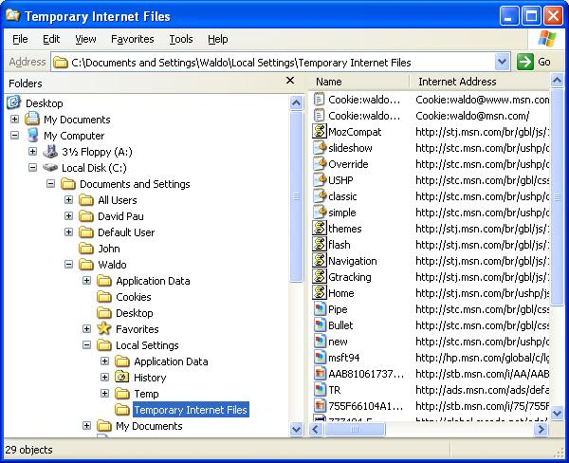
- In the Internet Options box, click the Privacy tab. Make sure the slider is at the bottom, so the text Accept All Cookies appears, as shown to the right on this page.
- Click OK to close Internet Options.
- Right-click the Start button and select Explore. Navigate to your Temporary Internet Files folder and open it, as shown to the right on this page. Note: the Local Settings folder is a hidden folder. If you don’t see it, click Tools, Folder Options, and on the View tab click Show hidden files and folders.
- That folder should contain a small number of objects – 29 when I tried it. Leave the Temporary Internet Files window open so you can watch objects appear in this folder.

- Click in the Internet Explorer window to make it active and go to support.microsoft.com.
- Click in the Temporary Internet Files window to make it active and select View, Refresh from its menu bar. There should a larger number of objects in this folder – 74 objects when I tried it.
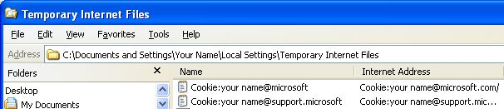
- Look in the Temporary Internet Files folder for a Cookie with your name on it, like the example shown below on this page. When you find the cookie, double-click it.

- An Internet Explorer box warns you that running a command on this item might be unsafe. Click Yes.
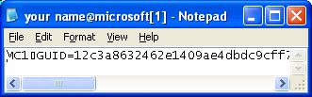
- The cookie opens in Notepad as shown to the right on this page. Press Alt+PrtScn to copy this window to the clipboard.
- On the Start menu, click Run. Enter the command mspaint and press the Enter key. Paint opens.
- Press Ctrl+V on the keyboard to paste the image into the Paint window. Save the document in the Shared Documents folder with the filename Your Name Proj 13b. Select a Save as type of JPEG. Close Paint.
- Now let's set your cookie security higher.
- In the Internet Explorer window, from the menu bar, click Tools, Internet Options.
- In the Internet Options box, click the Privacy tab. Move the slider to the High setting. Click OK to close Internet Options.
- In Internet Explorer, click the Refresh button to reload the support.microsoft.com Web page.
- You should see the blocked cookie icon appear in the status bar, as shown to the right on this page. Double-click that icon.

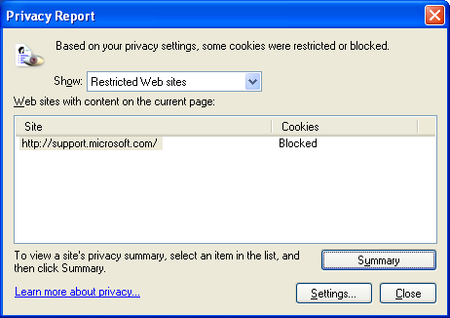
- A Privacy Report box opens as shown to the right on this page, showing that a cookie from http://support.microsoft.com was Blocked. Press Alt+PrtScn to copy this window to the clipboard.
- On the Start menu, click Run. Enter the command mspaint and press the Enter key. Paint opens.
- Press Ctrl+V on the keyboard to paste the image into the Paint window. Save the document in the Shared Documents folder with the filename Your Name Proj 13c. Select a Save as type of JPEG. Close Paint.
Turning in your Project
- Email the three JPEG images to me as attachments to one e-mail message. They are in the Shared Documents folder Send the message to: cnit.235@gmail.com with a subject line of CNIT 235 Proj 13 From Your Name, replacing Your Name with your own first and last name. Send a Cc to yourself.

Last modified 9-23-05

