This project can be done on any Windows XP Professional (not Home Edition) machine if you have Administrative privileges and a password on your account.
Adding a Password to Your Account
- Start your virtual machine (or a physical machine if you are working at home) and log in as usual, with Administrative privileges. This is necessary because Scheduled Tasks uses explorer.exe, and explorer.exe cannot easily be run with elevated privileges.
- To run Scheduled Tasks, you must have a password on your account. If you do not have a password, open User Accounts in Control Panel. Click the icon next to your account. Under the heading What do you want to change about your account?, click Create a password. Enter the password P@ssw0rd in both boxes (or use some other password you can remember) and click the Create Password.
- Close all windows, log off, and log on with your password.
Using the Scheduled Tasks Wizard
- In Control Panel, open Scheduled Tasks.
- Double-click Add a Scheduled Task to start the Scheduled Task Wizard.
- In the Scheduled Task Wizard, click Next.
- Find Freecell in the list of applications. Select it and click Next.
- In the next screen you specify a frequency for your task. For this demonstration, choose One time only, and click Next.
- In the next screen, choose a time 2 minutes in the future, based on your system clock in the lower-right corner, and click Next.
- In the next screen, enter your password twice (it is probably P@ssw0rd), and click Next.
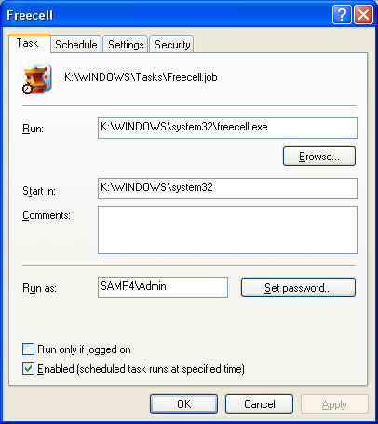
- In the next screen, click the Open advanced properties for this task when I click Finish, and click Next.
Exploring Advanced Properties
- A Freecell property sheet opens with four tabs, as shown to the right on this page.
- In the Freecell property sheet, click through all four tabs and answer the two questions in the box below. After you have answered them, click OK to close the property sheet.
- When a Freecell game window pops up, just close it.

How many times will Freecell run? _____________________
How long will Freecell continue to run, if no one closes it? _____________________

Saving a Screen Image of the Scheduled Task
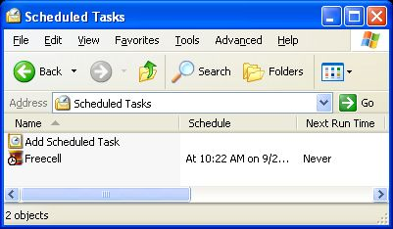
- You should see Freecell in the Scheduled Tasks folder, as shown in the figure to the right on this page. Press Alt+PrtScn to copy this window to the clipboard.
- On the Start menu, click Run. Enter the command mspaint and press the Enter key. Paint opens.
- Press Ctrl+V on the keyboard to paste the image into the Paint window. Save the document in the Shared Documents folder with the filename Your Name Proj 15a. Select a Save as type of JPEG. Close Paint.
Turning in your Project
- Email the JPEG image to me as an attachment to an e-mail message. Answer the questions in the box in the body of the e-mail message. Send the message to: cnit.235@gmail.com with a subject line of CNIT 235 Proj 15 From Your Name, replacing Your Name with your own first and last name. Send a Cc to yourself.

Last modified 9-23-05

