This project should be in S214, because it involves making irreversible changes to your hard drive and should not be attempted on home machines. If you choose to do it on a home machine, make sure you back up all your data first. You will need Windows XP Professional and a hard drive with unallocated space on it.
Use Your Virtual Machine
- Start VMWare and log in with your usual account, which has administrative rights over the virtual PC.
Opening Disk Management
- Click Start, right-click My Computer and select Manage. In the left pane, click Disk Management. Your Computer Management window should show a graphical display of your hard disk and the partitions on it in the lower-right, as shown below on this page. You should have one partition and some space marked Unallocated.
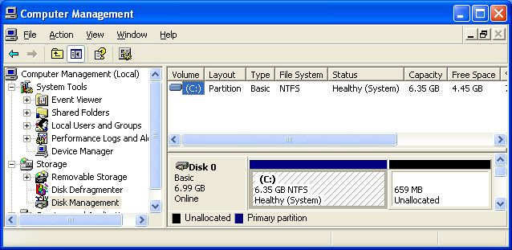

Disk 0 Should be Basic
- Look at the Disk 0 label in the lower right pane of Computer Management. It should say Basic as shown in the figure above. Later in this project, you will convert your virtual hard disk to Dynamic Disk. The process cannot be reversed except by reformatting the entire hard disk.
Creating a FAT Partition on a Basic Disk
- In the lower right portion of Disk Management, right-click the Unallocated section and select New Partition.
- The New Partition Wizard opens. Click Next.
- In the Select Partition Type screen, accept the default selection of Primary Partition and click Next.
- In the Select Partition Size screen, enter a value of 250 MB and click Next.
- In the Assign Drive Letter or Path screen, select a drive letter of N: and click Next.
- In the Format Partition screen, select a File System of FAT32. Leave the Allocation unit size at Default. Enter a Volume Label of FAT and click Next.
- In the Completing the New Partition Wizard screen, click Finish.
- You should see the formatting process in the Computer Management window. Some of the unallocated space will vanish and a new N: partition will appear. When the formatting is complete, the partition should show a status of Healthy in Computer Management.
- Close Computer Management.

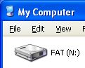
- Open My Computer. You should see a drive labeled FAT (N:) as shown to the right on this page.
Observing Drive Properties
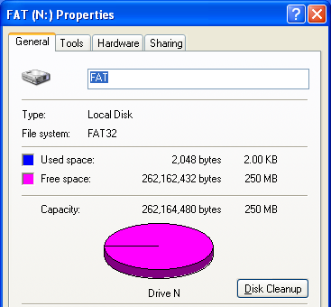
- In the My Computer window, right-click FAT (N:) and select Properties. A FAT (N:) Properties window opens as shown to the right on this page. Note the File System of FAT32 near the top of the window, and the fact that almost all the space is free, since you have not put any files on this drive yet. The Used space is 2,048 bytes – that’s where the File Allocation Table (FAT) is stored.
- Press Alt+PrtScn to copy this window to the clipboard.
- On the Start menu, click Run. Enter the command mspaint and press the Enter key. Paint opens.
- Press Ctrl+V on the keyboard to paste the image into the Paint window. Save the document in the Shared Documents folder with the filename Your Name Proj 19a. Select a Save as type of JPEG. Close Paint.
- Close the FAT (N:) Properties window.
- In the My Computer window, right-click the C: drive and select Properties. Note that the File System is NTFS and that more of the drive is used.
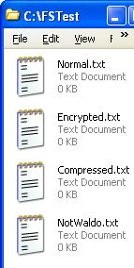
Creating the FSTest Folder
- In the My Computer window, double-click the C: drive to open it. Right-click an empty portion of the window and select New, Folder. Name the folder FSTest (for File System Test).
- Double-click the FSTest folder to open it.
- In the FSTest window, right-click an empty portion of the window and select New, Text Document. Name the document Normal.txt. Create three more documents the same way and name them Encrypted.txt, Compressed.txt, and NotWaldo.txt as shown in the figure to the right on this page.
- Right-click the Encrypted.txt file and select Properties. On the General tab of the Properties sheet, click the Advanced button. Check the Encrypt contents to secure data box. Click OK. Click OK. In the Encryption Warning box, check Encrypt the file only and click OK. Click in a blank portion of the FSTest window to deselect the file, and notice that the file name changes to a green font. Windows XP shows encrypted files in green.
- Right-click the Compressed.txt file and select Properties. On the General tab of the Properties sheet, click the Advanced button. Check the Compress contents to save disk space box. Click OK. Click OK. Click in a blank portion of the FSTest window to deselect the file, and notice that the file name changes to a blue font.
- Right-click the NotWaldo.txt file and select Properties. Click the Security tab of the Properties sheet. (If there is no Security tab, you probably have Simple File Sharing turned on. Click Tools, Folder Options, and uncheck it at the bottom of the box in the View tab.) Click the Add button. In the Select Users or Groups box, enter a name of Waldo and click OK. In the NotWaldo.txt Properties window, check the Deny box in the Full Control row for Waldo. Your NotWaldo.txt Properties window should look like the figure to the right on this page. Click OK. In the Security box, click Yes.
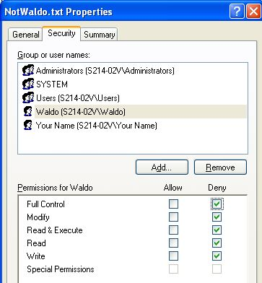
- Close all windows.
Copying the FSTest Folder to the FAT Partition
- Open My Computer. Resize the window to make it small and move it to the left side of your desktop. Double-click the C: drive to open it. If necessary, scroll until you can see the FSTest folder.
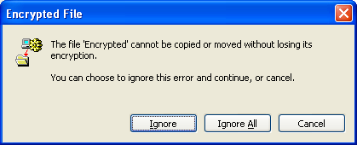
- Open another My Computer window. Position it at the right side of your desktop. If necessary, scroll until you can see the FAT (N:) partition.
- Right-click the FSTest folder C: window, drag it to the N: drive in the My Computer window, and drop it there. Select Copy Here from the shortcut menu.
- An Encrypted File box appears, as shown to the right on this page. Press Alt+PrtScn to copy this window to the clipboard.
- On the Start menu, click Run. Enter the command mspaint and press the Enter key. Paint opens.
- Press Ctrl+V on the keyboard to paste the image into the Paint window. Save the document in the Shared Documents folder with the filename Your Name Proj 19b. Select a Save as type of JPEG. Close Paint.
- In the Encrypted File box, click Ignore.
- In the My Computer window, double-click the N: drive to open it. Double-click the FSTest folder to open it. Note that the Encrypted.txt and Compressed.txt files are no longer colored.
- Right-click the Encrypted.txt file and select Properties. Note that there is no Advanced button – encryption and compression are unavailable on FAT32 formatted partitions. Click OK to close the Properties sheet.
- Right-click the Compressed.txt file and select Properties. Note that there is no Advanced button – encryption and compression are unavailable on FAT32 formatted partitions. Click OK to close the Properties sheet.
- Right-click the NotWaldo.txt file and select Properties. Note that there is no Security tab– no NTFS permissions are available on FAT32 formatted partitions. Click OK to close the Properties sheet.
- Close all windows.
Converting the N drive to NTFS
- Click Start, All Programs, Accessories, Command Prompt. In the Command Prompt window, enter the command
CONVERT /?
to see how the CONVERT command works. After you have read the options, enter this command to convert the N: drive to NTFS:
CONVERT N: /FS:NTFS
- When it asks Enter current volume label for drive N:, enter FAT.
- The conversion should proceed, showing messages on the screen. If you see an error message about forcing a dismount, that means you have left windows open showing files on N:. Close them and repeat the convert command.
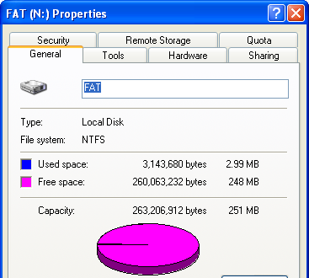
Observing the Converted N: Drive
- Open My Computer. Right-click the N: drive and select Properties. Note that the File System is now NTFS, and that more space is required for system files now than was previously used. Press Alt+PrtScn to copy this window to the clipboard.
- On the Start menu, click Run. Enter the command mspaint and press the Enter key. Paint opens.
- Press Ctrl+V on the keyboard to paste the image into the Paint window. Save the document in the Shared Documents folder with the filename Your Name Proj 19c. Select a Save as type of JPEG. Close Paint.
- Close the FAT (N:) Properties window.
- Double-click the N: drive. Right-click the FSTest folder and select Rename. Change the name to OldFSTest.
- Double-click the OldFSTest folder to open it. The four files are still there, because your data was preserved when the disk format was changed from FAT32 to NTFS. In the OldFSTest window, click the Up button on the toolbar to return to the FAT (N:) window.
- Open another My Computer window. Double-click the C: drive to open it. Right-click the FSTest folder, drag it into the FAT (N:) window, and drop it there. Select Copy Here from the shortcut menu.
- In the FAT (N:) window, double-click the FSTest folder to open it. Examine the properties of the files, and answer the following three questions:

Did the encrypted file remain encrypted when it was moved to the N: drive? __________

Did the compressed file remain compressed when it was moved to the N: drive? __________

Did the NotWaldo file retain its NTFS permissions when it was moved to the N: drive? __________
- Close all windows.
Converting to Dynamic Disk
- Click Start, right-click My Computer and select Manage. In the left pane, click Disk Management.
- In the lower pane, right-click Disk 0 and select Convert to Dynamic Disk.
- In the Convert to Dynamic Disk box, verify that Disk 0 is checked and click OK.
- In the Disks to Convert window, click Convert.
- A Disk Management window appears, warning you that you will not be able to start other installed operating systems. This is important for multi-boot machines – if you convert a multi-boot system disk from Basic Disk to Dynamic Disk, it will become a single-boot system. This is because the partition entries for all partitions on the disk are removed, except for the system and boot volumes of the currently running operating system. In this case, we are not using a multi-boot system, so click Yes.
- A Convert Disk to Dynamic window warns you that file systems will be dismounted. Click Yes.
- A Confirm box warns you that the machine will be restarted. Click OK.
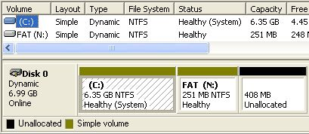
- When your machine restarts, log in again. After a couple of minutes, a System Settings Change box may appear, telling you that you need to restart again. If that happens, just click No.
- Click Start, right-click My Computer, and click Management. In Computer Management, in the left pane, click Disk Management. The disk now shows the word Dynamic under the Disk 0 label in the lower pane, as shown to the right on this page.
Extending the N: Drive
- In the lower pane of Disk Management, right-click the FAT (N:) volume and select Extend Volume….
- In the Welcome to the Extend Volume Wizard screen, click Next.
- In the Select Disks screen, the top portion is used to choose which dynamic disks to take space from. Since you have only one dynamic disk, leave the top portion unchanged. The lower portion is where you select how much space to add to your volume. In the Select the amount of space in MB box, enter 250 and click Next.
- In the Completing the Extend Volume Wizard screen, click Finish. Disk Management now shows two volumes labeled FAT (N:) in the lower pane, as shown to the right on this page. Note that in the upper pane, there is only one line for FAT (N:) and it shows a capacity of 501 MB.
Observing the Extended N: Drive
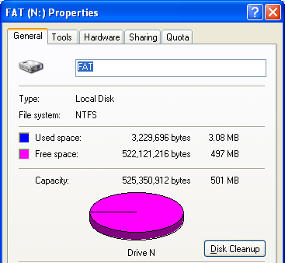
- Click Start, My Computer. Right-click the N: drive and select Properties. Now you have 497 MB or so available, as shown to the right on this page. Extending volumes is a way to add more space to a volume that is getting full, and a compelling reason to use Dynamic Disk. Press Alt+PrtScn to copy this window to the clipboard.
- On the Start menu, click Run. Enter the command mspaint and press the Enter key. Paint opens.
- Press Ctrl+V on the keyboard to paste the image into the Paint window. Save the document in the Shared Documents folder with the filename Your Name Proj 19d. Select a Save as type of JPEG. Close Paint.
- Close the FAT (N:) Properties window.
Extending the C: Drive
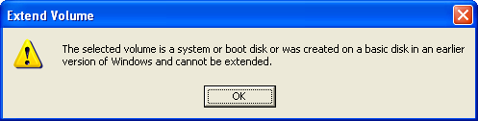
- In the lower pane of Disk Management, right-click the C: volume and select Extend Volume…. An Extend Volume box opens as shown to the right on this page – you cannot extend this volume.
Creating a Mount Point
- In the lower pane of Disk Management, right-click the Unallocated section and select New Volume.
- The New Volume Wizard opens. Click Next.
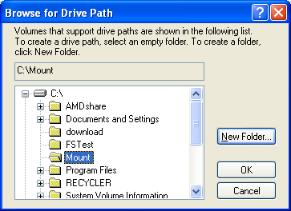
- In the Select Volume Type screen, note that there are three potential choices: Simple (a volume that is entirely contained on one physical disk), Spanned (a volume that includes space from two or more disks), and Striped (A volume that combines several disks to get faster read and write speed). However, the Spanned and Striped options are grayed out because your machine does not have two hard disks. Accept the default selection of Simple and click Next.
- In the Select Disks screen, leave the upper section unchanged. In the Select the amount of space in MB box, enter 125 and click Next.
- In the Assign a Drive Letter or Path screen, click Mount in the following empty NTFS Folder and click the Browse button.
- In the Browse for Drive Path box, select C:\ , click the New Folder button, and enter a name of Mount, as shown in the figure to the right on this page. Click the OK button.

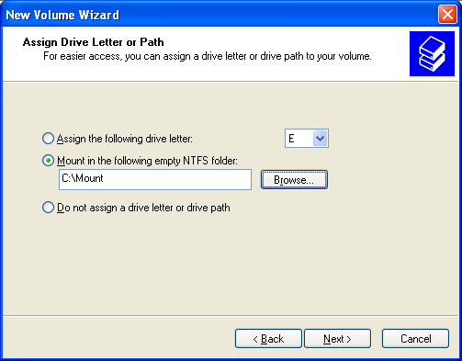
- The Assign Drive Letter or Path screen should now look like the figure to the right on this page. Click Next.
- In the Format Volume screen, click the File System list box arrow – there is no choice except NFTS, because only NTFS partitions can be mounted in folders. Click Next.
- In the Completing the New Volume Wizard screen, click Finish.

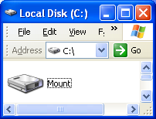
Observing the Mounted Volume
- Open My Computer and open C:. Note that Mount appears as a drive icon rather than a folder icon, as shown to the right on this page. Press Alt+PrtScn to copy this window to the clipboard.
- On the Start menu, click Run. Enter the command mspaint and press the Enter key. Paint opens.
- Press Ctrl+V on the keyboard to paste the image into the Paint window. Save the document in the Shared Documents folder with the filename Your Name Proj 19e. Select a Save as type of JPEG. Close Paint.
Turning in your Project
- Email the JPEG images to me as attachments to one e-mail message. Answer the questions in the boxes in the body of the e-mail message. Send the message to: cnit.235@gmail.com with a subject line of CNIT 235 Proj 19 From Your Name, replacing Your Name with your own first and last name. Send a Cc to yourself.

Last modified 9-30-05

