This project requires at least two computers, a hub and some network cables. Unless you have that equipment, you will have to do it in S214.
Choosing Machines for your LAN
- Select three or four adjacent machines in the room. They have to be near one another so that we won’t need long cables to connect them together. Up to four students may work together on this project. You only need send one e-mail message for whole group, with all the group member's names in the subject line.
Testing the Machines
- Start all the machines, and log in as CNIT (with no password) so that you have Administrative privileges. Open Internet Explorer, go to www.google.com, and do a search for something. If you see results, that proves that the machines are working properly and connecting to the Internet properly. If not, resolve the problems on the machines before changing the wiring.
Joining the TEMP Workgroup
- On each one of your machines, click Start, right-click My Computer¸ and select Properties.
- In the System Properties window, click the Computer Name tab. Click the Change button.
- In the Computer Name Changes window, click the Workgroup button and enter the workgroup name TEMP. Click the OK button.
- After a few seconds, a Computer Name Changes box appears, saying Welcome to the TEMP workgroup. Click OK.
- Close all windows and restart your computer. Log in as CNIT.
Wiring the LAN (Local Area Network)
- Put a hub on the table in the middle of your machines. Plug the power into the hub and make sure its front panel lights light up.
- Look at the back panel of one of your machines. There are two Network Interface Cards, but we are only using the built-in Intel one. Make sure you remember which port we are using.
- Remove the Ethernet cable from the back of your machine and plug in one of the additional cables your instructor has provided. Replace the cable on each machine with one that goes to a numbered port on the hub. It does not matter which port on the hub you use – they are all the same, except the Uplink port. If there is an Uplink port, don’t use it – just leave it empty. Your final network should look like the diagram to the right on this page. Each box marked W is a computer (Workstation).
Hub
4 3 2 1
W
W
W
W
Using the Network Setup Wizard to Make a Workgroup
- On each one of your machines, click Start, My Computer, My Network Places to open the My Network Places window.
- In the left pane of the My Network Places window, in the Network Tasks section, click the Set up a home or small office network link.
- At the Welcome to the Network Setup Wizard screen, click Next.
- At the Before you continue… screen, click Next.
- If a screen opens titled The wizard found disconnected network hardware, and the disconnected hardware is the NetGear adapter, check the Ignore disconnected network hardware box and click Next. If the Intel adapter is disconnected, that’s wrong: plug it in and click Back.
- At the Select a connection method screen, select Other and click Next.
- At the Other Internet connection methods screen, select This computer belongs to a network that does not have an Internet connection and click Next.
- If a screen opens titled Your computer has multiple connections, accept the default choice Determine the acceptable connections for me (Recommended) and click Next.
- At the Give this computer a description and a name screen, leave the description unchanged and verify that the Computer name is the same as the label on the front of your system unit (for example, S214-01), and click Next.
- At the Name your network screen, enter a name of WORKGROUP and click Next.
- If a File and printer sharing screen appears, select Turn on file and printer sharing and click Next.
- At the Ready to apply network settings screen, read the settings, and if they look correct, click Next.
- At the Please wait screen, wait for the animation to end. It might take a minute or longer.
- At the You’re almost done screen, click Just finish the wizard. I don’t need to run the wizard on other computers and click Next.
- At the Completing the Network Setup Wizard screen, click Finish.
- If you are prompted to, restart your machine.
Viewing Your Workgroup in My Network Places
- On any one of your machines, click Start, My Computer, My Network Places to open the My Network Places window.
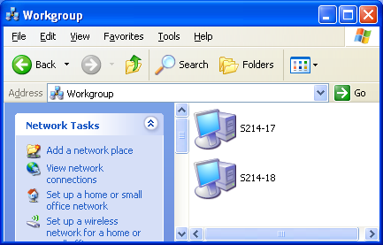
- In the left pane, in the Network Tasks section, click View workgroup computers. All the computers in your workgroup should appear, as shown to the right on this page. If they don’t, try pressing the F5 key to refresh the Workgroup window, and then try restarting all the machines. When the computers appear, press Alt+PrtScn to copy this window to the clipboard.
- On the Start menu, click Run. Enter the command mspaint and press the Enter key. Paint opens.
- Press Ctrl+V on the keyboard to paste the image into the Paint window. Save the document in the Shared Documents folder with the filename Your Name Proj 20a. Select a Save as type of JPEG. Close Paint.

- Right-click the Start button and select Explore. Navigate to the root of E: (or your system volume, if it is not E:) and create a new folder by clicking in an empty portion of the right pane and selecting New, Folder. Name the new folder WorkgroupShare. Right-click the WorkgroupShare folder and select Sharing and Security.
If you don't see a Sharing and Security item, you need to enable Simple File Sharing by opening My Computer, and in the My Computer window, clicking File, Folder Options, and on the View Tab, check Use simple file sharing (Recommended)
On the Sharing tab, select Share this folder on the network. In the Sharing box, click Yes. Click OK. A hand should now appear under the folder icon indicating that it is shared, as shown to the right on this page.
- Double-click the WorkgroupShare folder to open it. Right-click on an empty portion of the WorkgroupShare window and select New, Text Document. Give the document any name, double-click it to open it in Notepad, and enter some text. Save the document.
- Go to another machine in your workgroup. Click Start, My Computer, My Network Places to open the My Network Places window.

- In the left pane, in the Network Tasks section, click View workgroup computers. All the computers in your workgroup should appear. Find the computer that has the WorkgroupShare folder and double-click it. You may see a Connect to computername window, asking you for a name and password, if the account you are using is not recognized on the other machine. If that happens, enter a name of Administrator and a password of password. This is the primary disadvantage of workgroups – because there is no server, each user account must be created manually on each machine.
- When a window opens named \\computername, where computername is the name of the machine hosting the shared folder, you should see the WorkgroupShare folder. Double-click the WorkgroupShare folder to open it, and double-click the text document to open it. That shows that the network is working: you can share files with other members of the workgroup. Close all windows on both machines.
Internet Connection Sharing
- Choose one of your machines to act as the gateway to the Internet. Open Internet Explorer on that machine and try to open www.google.com and perform a search – you can’t do it, because the machine is not connected to the Internet now.
- Take the plug that used to connect to the Intel NIC in the back of your machine, and connect it to the NetGear NIC.
- Open Internet Explorer on that machine and try to open www.google.com and perform a search. You should see search results, demonstrating that this machine is now connected to the Internet.
Using the Network Setup Wizard to Create an Internet Gateway
- On your gateway machine, click Start, My Computer, My Network Places to open the My Network Places window.
- In the left pane of the My Network Places window, in the Network Tasks section, click the Set up a home or small office network link.
- At the Welcome to the Network Setup Wizard screen, click Next.
- At the Before you continue… screen, click Next.
- If a screen opens titled The wizard found disconnected network hardware, something is wrong. Both NICS should now be connected. Fix the connections and click Back.
- At the Select a connection method screen, select This computer connects directly to the Internet. The other computers on my network connect to the Internet through this computer and click Next.
- At the Select your Internet connection screen, verify that the NetGear adapteris selected and click Next.
- At the Give this computer a description and a name screen, leave the description unchanged and verify that the Computer name is the same as the label on the front of your system unit (for example, S214-01), and click Next.
- At the Name your network screen, enter a name of WORKGROUP and click Next.
- If a File and printer sharing screen appears, select Turn on file and printer sharing and click Next.
- At the Ready to apply network settings screen, read the settings, and if they look correct, click Next.
- At the Please wait screen, wait for the animation to end. It might take a minute or longer.
- At the You’re almost done screen, click Just finish the wizard. I don’t need to run the wizard on other computers and click Next.
- At the Completing the Network Setup Wizard screen, click Finish.
Testing the Internet Gateway’s Internet Connection
- Open Internet Explorer on that machine and try to open www.google.com and perform a search. You should see search results, demonstrating that this machine is now connected to the Internet.
Using the Network Setup Wizard to Connect the Your Other Workgroup Members to the Internet
- Do this Network Wizard process on each machine in your workgroup, except the gateway machine. Click Start, My Computer, My Network Places to open the My Network Places window.
- In the left pane of the My Network Places window, in the Network Tasks section, click the Set up a home or small office network link.
- At the Welcome to the Network Setup Wizard screen, click Next.
- At the Before you continue… screen, click Next.
- If a screen opens titled The wizard found disconnected network hardware, and the disconnected hardware is the NetGear adapter, check the Ignore disconnected network hardware box and click Next. If the Intel adapter is disconnected, that’s wrong: plug it in and click Back.
- At the Select a connection method screen, select This computer connects to the Internet through a residential gateway or through another computer on my network and click Next.
- If a screen opens titled Your computer has multiple connections, accept the default choice Determine the acceptable connections for me (Recommended) and click Next.
- At the Give this computer a description and a name screen, leave the description unchanged and verify that the Computer name is the same as the label on the front of your system unit (for example, S214-01), and click Next.
- At the Name your network screen, enter a name of WORKGROUP and click Next.
- If a File and printer sharing screen appears, select Turn on file and printer sharing and click Next.
- At the Ready to apply network settings screen, read the settings, and if they look correct, click Next.
- At the Please wait screen, wait for the animation to end. It might take a minute or longer.
- At the You’re almost done screen, click Just finish the wizard. I don’t need to run the wizard on other computers and click Next.
- At the Completing the Network Setup Wizard screen, click Finish.
Testing the Workgroup Member’s Internet Connection
- Open Internet Explorer and try to open www.google.com and perform a search. You should see search results, demonstrating that this machine is now connected to the Internet.
Shutting Down the Gateway Machine
- Shut down the gateway machine. Then try to run a Google search on the other machines in the workgroup. All of them are unable to contact the Internet, of course, because their only path to the Internet goes through the gateway machine.
Restarting the Gateway Machine
- Start the gateway machine. Then try to run a Google search on the other machines in the workgroup. They are again connected to the Internet.
Stopping the Internet Connection Sharing Service
- On the gateway machine, click Start, Administrative Tools, Services. In the right pane, select Windows Firewall/Internet Connection Sharing as shown in the figure below on this page. (If you do not have Service Pack 2, this service is named Internet Connection Firewall/Internet Connection Sharing .) Press Alt+PrtScn to copy this window to the clipboard.
- On the Start menu, click Run. Enter the command mspaint and press the Enter key. Paint opens.
- Press Ctrl+V on the keyboard to paste the image into the Paint window. Save the document in the Shared Documents folder with the filename Your Name Proj 20b. Select a Save as type of JPEG. Close Paint.
- Near the center of the window, there is a blue Stop the service link. Click the word Stop.
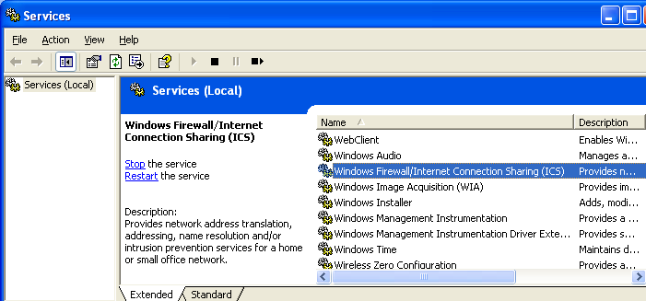

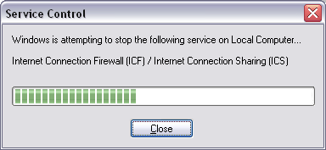
- A Service Control window opens as shown to the right on this page. After it finishes, the service is stopped.
- On the gateway machine, open Internet Explorer and try to do a Google search. You should succeed – this machine is still connected to the Internet.
- Go to a machine in your workgroup, open Internet Explorer and try to do a Google search. You will probably be able to open the main Google page, but not to get any search results. That’s because the main Google page is cached in the local Temporary Internet Files, but the search results are not. And your workgroup machines cannot connect to the Internet without the aid of the Windows Firewall/Internet Connection Sharing service on the gateway machine.
Restarting the Internet Connection Sharing Service
- On the gateway machine, in the Services window, verify that Internet Connection Firewall/Internet Connection Sharing is still selected. Click the blue Start link near the middle of the window.
- Go to a machine in your workgroup, open Internet Explorer and try to do a Google search. It should succeed now. Close all windows on both machines.
Renaming Network Connections on the Gateway
- On the gateway machine, click Start, My Computer, My Network Places. In the left pane, in the Network Tasks section, click View network connections. You should see two connections, named Local Area Connection and Local Area Connection 2. Those are not very useful names.
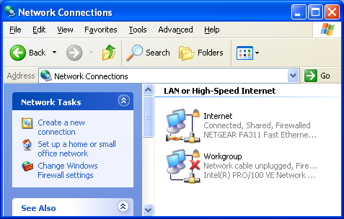
- To identify the connections, disconnect the power to your network hub. That will disconnect all the connections in your Workgroup. You will see one of the connections change its status to Network cable unplugged and a red X will appear over it. Right-click that connection, select Rename, and rename it Workgroup. Rename the other connection to Internet. Now your Network Connections window should look like the example shown to the right on this page. Press Alt+PrtScn to copy this window to the clipboard.
- On the Start menu, click Run. Enter the command mspaint and press the Enter key. Paint opens.
- Press Ctrl+V on the keyboard to paste the image into the Paint window. Save the document in the Shared Documents folder with the filename Your Name Proj 20c. Select a Save as type of JPEG. Close Paint.
- Notice the extra symbols on the Internet connection. The hand below it indicates that it is shared, and the padlock indicates that it is protected by the Internet Connection Firewall.
- Reconnect the power to your hub, so the red X disappears from the Workgroup connection.
Examining IP Addresses
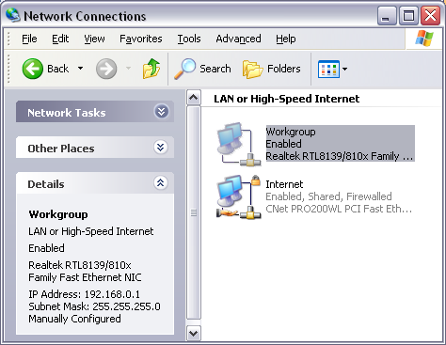
- On your Gateway machine, in the Network Connections window, click the Workgroup connection to select it. Scroll down in the left pane to see the Details section, as shown in the figure to the right on this page. Note the IP address: it should be 192.168.0.1. Internet connection sharing always assigns this value to the gateway machine. This is a Private IP Address – the 192.168 series is not used on the public Internet.
- In the Network Connections window, click the Internet connection to select it. Scroll down in the left pane to see the Details section. Note the IP address: is it public or private? Does this machine really connect directly to the Internet, or does it pass through another stage of Network Address Translation before it reaches the Internet? If you are not sure of the answers, call your instructor over to talk about it.
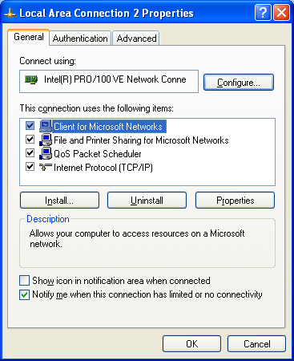
- Go to the other machines in your workgroup, open the Network Connections window, and find out what their IP addresses are. All the IP addresses in your workgroup should all start with 192.168.0.
Assigning Manual IP Addresses
- Go to one of the machines on your workgroup (not the gateway machine). Click Start, My Computer, My Network Places. In the left pane, in the Network Tasks section, click View network connections. Right-click the Intel adapter’s connection and select Properties. You should see a Properties sheet like the one shown to the right on this page. Click Internet Protocol (TCP/IP) to highlight it, and click the Properties button.

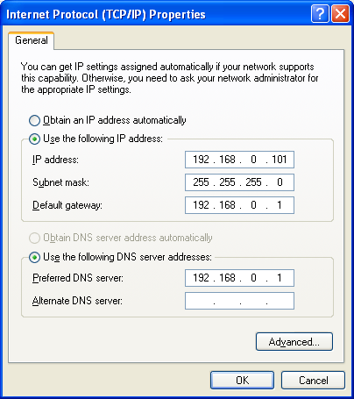
- In the Internet Protocol (TCP/IP) Properties window, click the Use the following IP address button. Enter an IP address of 192.168.0.101 as shown to the right on this page. You will find it clumsy to enter the address, because the Tab key does not move between the fields in the normal way. The insertion point moves to the next pane automatically if you enter a three-digit number in a pane, but if you enter a shorter number, use the . key to go to the next pane. After entering the last number in the IP address, press the Tab key once and the Subnet mask will automatically fill in for you.
- Enter 192.168.0.1 into the Default gateway and the Preferred DNS Server fields as shown to the right on this page and click OK.
- In the Local Area Connection 2 Properties window, click the Close button. Note this step – a large number of students close this window with the red X instead, and if you do that your changes are cancelled.
- Repeat the Assigning Manual IP Addresses (steps 87-90) for each machine in your workgroup (but not the Gateway machine), assigning each one a different IP address, so you end up with a network like the one shown below. You do not need to assign an IP address to the Gateway machine, because it has already been assigned the IP address 192.168.0.1.
Hub
To the Internet

192.168.0.101
192.168.0.102
192.168.0.103

Gateway
192.168.0.1

- Open Internet Explorer on each of the machines and do a search, to verify that they are all connecting to the Internet properly.
Creating an IP Address Conflict
- Go to the machine with the IP address 192.168.0.101 and shut it down.
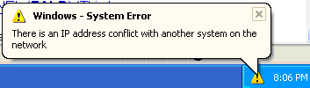
- Then go to the machine with the IP address 192.168.0.102 and repeat steps 87 to 90 to change its IP address to 192.168.0.101. Open Internet Explorer and do a search to verify that its connection is working.
- Restart the machine originally assigned the IP address 192.168.0.101. When it starts, a System Error message will appear on the other station using that number, as shown to the right on this page. Press PrtScn to copy this window to the clipboard.
- On the Start menu, click Run. Enter the command mspaint and press the Enter key. Paint opens.
- Press Ctrl+V on the keyboard to paste the image into the Paint window. Save the document in the Shared Documents folder with the filename Your Name Proj 20d. Select a Save as type of JPEG. Close Paint.
- The machine that just restarted may show a similar message – if it does, click OK to close the message and log in using an account with local administrative rights. Open Internet Explorer and try to do a Google search. You can’t – this machine is not connected to the workgroup at all. This is one of the main problems of manually assigned IP addresses: anyone in the workgroup who changes an IP address can create a conflict with a random other machine, which may be in a different room, creating confusing error messages and intermittent problems. It is far better to leave all the machines set for automatic IP address assignment and let the server assign the addresses so that there are never such conflicts.
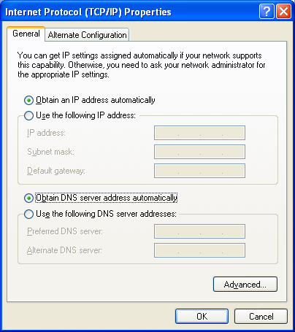
- On the machine that was originally assigned an IP address of 192.168.0.101, click Start, My Computer, My Network Places, and click View Network Connections. Select the Intel adapter’s connection and look at the IP Address in the lower portion of the left pane. The address is 0.0.0.0 – that indicates that this adapter is not able to use TCP/IP at all.
- Right-click the Intel adapter’s connection and select Properties. In the Local Area Connection 2 Properties window, highlight TCP/IP (Internet Protocol) and click the Properties button.
- In the Internet Protocol (TCP/IP) Properties window, click the Obtain an IP address automatically and Obtain DNS server address automatically items, as shown to the right on this page. Click OK. In the Local Area Connection 2 Properties window, click Close.
- Repeat steps 98-100 on each machine in your workgroup, except the Gateway. This will return your workgroup to automatic addressing which prevents IP address conflicts.
- Open a browser on each machine and do a search to make sure all of them can connect to the Internet.
Returning the Computers to Normal
- Return the network cables to their original positions.
Joining the Sci214 Workgroup
- On each one of your machines, click Start, right-click My Computer¸ and select Properties.
- In the System Properties window, click the Computer Name tab. Click the Change button.
- In the Computer Name Changes window, click the Workgroup button and enter the workgroup name Sci214. Click the OK button.
- Return the hub and patch cables to your instructor.
Turning Off Internet Connection Sharing
- On the gateway machine, you will need to disable Internet Connection Sharing by clicking Start, My Computer, My Network Places, and View Network Connections to open a Network Connections window.
- In the Network Connections window, right-click Internet and select Properties.
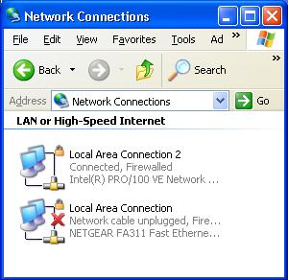
- On the Advanced tab of the Internet Properties window, clear the Allow other users to connect through this computer's Internet connection box.
- Click OK to close the Internet Properties window.
Renaming Network Connections on the Gateway
- In the Network Connections window, right-click the Intel connection and select Rename. Rename it to Local Area Connection 2. .
- In the Network Connections window, right-click the NETGEAR connection and select Rename. Rename it to Local Area Connection.
- Your Network Connections window should now look like the example to the right on this page. Press Alt+PrtScn to copy this window to the clipboard.
- On the Start menu, click Run. Enter the command mspaint and press the Enter key. Paint opens.
- Press Ctrl+V on the keyboard to paste the image into the Paint window. Save the document in the Shared Documents folder with the filename Your Name Proj 20e. Select a Save as type of JPEG. Close Paint.
Turning in your Project
- Gather all the Proj20 images onto one machine, using a shared folder.
- Email the JPEG images to me as attachments to one e-mail message. Send the message to: cnit.235@gmail.com with a subject line of CNIT 235 Proj 20 From All Group Member Names, replacing All Group Member Names with the full names of every group member. Send a Cc to yourself.

Last modified 3-17-05 9:45 am

