This project can be done on any Windows XP Pro or Home Version machine with an Internet connection and on a LAN with at least one other computer.
- Start your virtual machine and log in with your usual account, which has administrative privileges.
- Open Internet Explorer and open a Web page to make sure you are connected to the Internet.
Using PING
- PING is a convenient way to check the connection between two machines. Click Start, Run. In the Run box, enter CMD and press Enter. This opens a Command Prompt window.
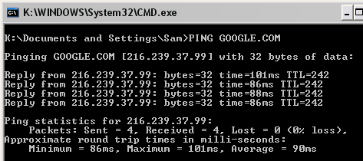
- At the Command Prompt, enter PING GOOGLE.COM
- You should see results like those shown to the right on this page: Four Reply lines, showing Packets: Sent = 4, Received = 4. The times don’t much matter – if you receive answers at all that proves that your machine is properly connected to the Internet. Press Alt+PrtScn to copy this window to the clipboard.
- On the Start menu, click Run. Enter the command mspaint and press the Enter key. Paint opens.
- Press Ctrl+V on the keyboard to paste the image into the Paint window. Save the document in the Shared Documents folder with the filename Your Name Proj 22a. Select a Save as type of JPEG. Close Paint.
Using IPCONFIG
- At the Command Prompt, enter IPCONFIG
- You should see the IP Address, Subnet mask, and Default gateway for your Local Area Connection. Since we are using DHCP, your IP Address should start 192.168. There may be a second connection with a different IP address – ignore that one.
- At the Command Prompt, enter IPCONFIG /ALL
- You should see a more complete list of your IP properties, including the duration of your DHCP lease – the time for which the IP address you are using is reserved for your use. Normally DHCP leases are automatically renewed before they expire, so the lease duration does not matter.
IP Address:
Subnet Mask:
Default Gateway:
DNS Server:
- Find the four numbers listed in the box to the right in the IPCONFIG / ALL list, and write them down in the box.
- You can release your machine from its DHCP lease, which is something you might do with a laptop if you are moving from one network to another. To do that, at the Command Prompt, enter IPCONFIG /RELEASE
- Now your IP address is zero, and you cannot use TCP/IP without an IP address. Try to PING GOOGLE.COM again – you can’t, because you are off the Internet.
- To get a new IP address from DHCP, at the Command Prompt, enter IPCONFIG /RENEW. On machines used as Servers in Project 22, you will see an error message because only one of the two NICs is connected to the network. The NIC with an IP address starting 192.168 should renew properly.
- Note the IP address you get. Is it the same as the one you got before, or different? Usually you get the same one.
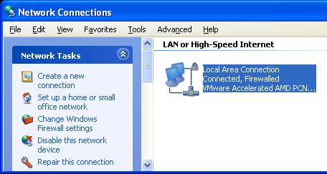
- The two commands IPCONFIG / RELEASE and IPCONFIG /RENEW are so commonly used that Windows XP created a graphical tool to do that process. To see it, click Start, right-click My Network Places, and click Properties. Click your Local Area Connection to select it. (If there are two connections, select the one labeled Internet.) In the left pane, in the Network Tasks section, Click Repair this connection. This does an IPCONFIG / RELEASE and an IPCONFIG /RENEW, as well as several other useful things, to repair many common connection problems.
Using NSLOOKUP
- At the Command Prompt, enter NSLOOKUP WWW.CCSF.EDU
- Your screen should resemble the output below: first there are a couple of error messages telling you that the DNS server did not correctly identify itself, and then a Non-authoritative answer of 147.144.1.212. This is the IP Address of the CCSF web page. The error messages show up because the domain controller in the lab is not set up to properly identify itself, which does not stop it from working. Press Alt+PrtScn to copy this window to the clipboard.
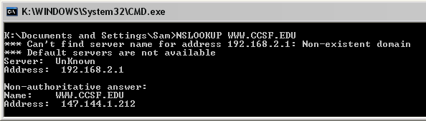

- On the Start menu, click Run. Enter the command mspaint and press the Enter key. Paint opens.
- Press Ctrl+V on the keyboard to paste the image into the Paint window. Save the document in the Shared Documents folder with the filename Your Name Proj 22b. Select a Save as type of JPEG. Close Paint.
Using Manual IP Addressing
- Click Start, My Network Places. In the left pane, in the Network Tasks section, click View network connections. Right-click the Local Area Connection (if there are two connections, use the one labeled Internet) and select Properties. In the Properties sheet, click Internet Protocol (TCP/IP) to highlight it, and click the Properties button.
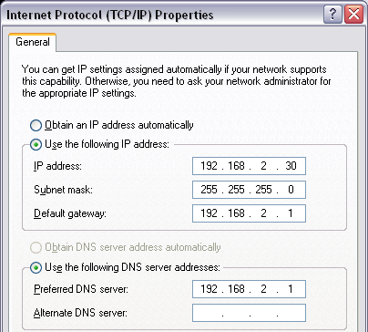
- In the Internet Protocol (TCP/IP) Properties window, click the Use the following IP address button. Enter the IP address, Subnet mask, Default gateway, and Preferred DNS Server addresses you wrote down on page 1 of these instructions. Press Alt+PrtScn to copy this window to the clipboard.
- On the Start menu, click Run. Enter the command mspaint and press the Enter key. Paint opens.
- Press Ctrl+V on the keyboard to paste the image into the Paint window. Save the document in the Shared Documents folder with the filename Your Name Proj 22c. Select a Save as type of JPEG. Close Paint.
- In the Internet Protocol (TCP/IP) Properties window, click OK. Click Close.
- PING GOOGLE.COM. You should get replies. If you don’t, return to the Internet Protocol (TCP/IP) Properties window and double-check your numbers.
The Effect of an Incorrect DNS Server
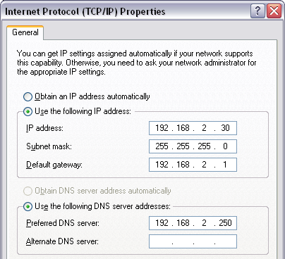
- Click Start, My Network Places. In the left pane, in the Network Tasks section, click View network connections. Right-click the connection you just set to manual IP addressing and select Properties. In the Properties sheet, click Internet Protocol (TCP/IP) to highlight it, and click the Properties button.
- In the Internet Protocol (TCP/IP) Properties window, change the Preferred DNS Server address to 192.168.2.250, as shown to the right on this page. Click OK. Click Close.
- Open Internet Explorer and try to open WWW.SFGATE.COM. It won’t open, because your computer cannot convert the domain name sfgate.com into an IP address.

- Type the IP address 66.35.240.8 into the Address bar of the Internet Explorer window and press the Enter key. The SF Gate page opens. You can use the Internet this way, as long as you know the numerical IP addresses of the sites you want to view.
- At a Command Prompt, enter PING CCSF.EDU
- After a pause of several seconds, you see an error message, because your machine cannot resolve the domain name to an IP address.
- At a Command Prompt, enter PING 147.144.1.212
- You should get replies, because your computer can contact Web sites by IP address.
- At a Command Prompt, enter NSLOOKUP SFGATE.COM
- You should get a message saying DNS request timed out, as shown below on this page. This demonstrates that the DNS server is not working, or that the DNS address is wrong. Press Alt+PrtScn to copy this window to the clipboard.
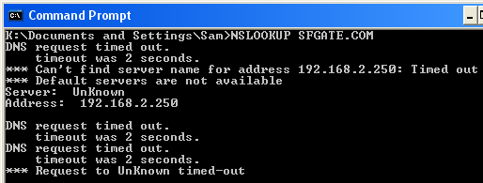

- On the Start menu, click Run. Enter the command mspaint and press the Enter key. Paint opens.
- Press Ctrl+V on the keyboard to paste the image into the Paint window. Save the document in the Shared Documents folder with the filename Your Name Proj 22d. Select a Save as type of JPEG. Close Paint.
Returning to Automatic IP Addressing
- Click Start, My Network Places. In the left pane, in the Network Tasks section, click View network connections. Right-click the Local Area Connection (if there are two connections, use the one labeled Internet) and select Properties. In the Properties sheet, click Internet Protocol (TCP/IP) to highlight it, and click the Properties button.
- In the Internet Protocol (TCP/IP) Properties window, click the Obtain an IP Address Automatically radio button. Click the Obtain DNS Server Address Automatically radio button. Click OK. Click Close.
- Ping CCSF.EDU. You should get replies – you are back on the Internet.
PINGs on a LAN
- Find a machine near you to use, perhaps a machine a partner is using – this will be called the Partners Machine.
- On your Partners Machine, open a Command Prompt and enter IPCONFIG /ALL. Find its IP address and write it down -- it should start with 192.168. The last numbers will be different for each machine. Also note the Partners Machine's Name from its front panel, which should be something like S214-01.
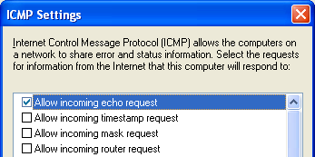
- On your Partner's Machine, click Start, Control Panel. Double-click Windows Firewall.
- In the Windows Firewall box, on the General tab, make sure the firewall is On with the Don't allow exceptions box cleared.
- In the Windows Firewall box, on the Advanced tab, in the ICMP section, click the Settings button. Make sure that the Allow incoming echo request box is checked, as shown to the right on this page.
- In the ICMP Settings box, click OK.
- In the Windows Firewall box, click OK.
- On your own machine, at a Command Prompt, enter Ping 192.168.x.y, replacing x and y with the numbers you noted in the step 44. You should get four replies.
- You can also refer to machines by their Computer Names. Enter PING S214-01v, replacing 01 with your Partners Machine's Name followed by a V (for Virtual). You should get replies, as shown below on this page. Press Alt+PrtScn to copy this window to the clipboard.
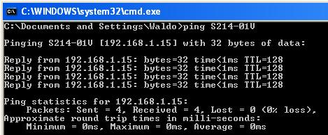

- On the Start menu, click Run. Enter the command mspaint and press the Enter key. Paint opens.
- Press Ctrl+V on the keyboard to paste the image into the Paint window. Save the document in the Shared Documents folder with the filename Your Name Proj 22e. Select a Save as type of JPEG. Close Paint.
Turning in your Project
- Email the JPEG images to me as attachments to one e-mail message. Send the message to: cnit.235@gmail.com with a subject line of CNIT 235 Proj 22 From Your Name, replacing Your Name with your own first and last name. Send a Cc to yourself.

Last modified 10-18-05

