This project can be done on any Windows XP Pro or Home Version machine.
Installing a Local Printer
- Log in to your virtual machine with your usual account (or any other account with Administrative privileges).
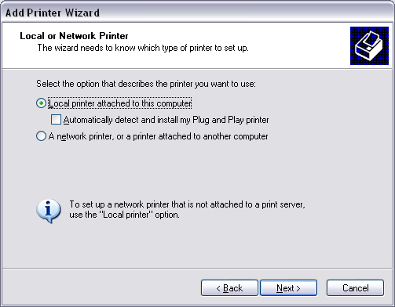
- Click Start, Printers and Faxes. (On Home Version, click Start, Control Panel, Printers and Faxes)
- In the left pane of the Printers and Faxes window, in the Printer Tasks section, click Add a printer.
- At the Welcome to the Add Printer Wizard screen, click Next.
- At the Local or Network Printer screen, select Local printer connected to this computer, and clear the Automatically detect and install my Plug and Play printer box, as shown to the right on this page, and click Next.
- At the Select a Printer Port screen, accept the default selection of Use the following port: LPT1, and click Next.
- At the Install Printer Software screen, select HP LaserJet 6L, and click Next.
- At the Name Your Printer screen, name it Printer1.
- At the Printer Sharing screen, click Share name, accept the default share name of Printer1, and click Next.
- At the Location and Comment screen, click Next.
- At the Print Test Page screen, click No, and click Next.
- At the Completing to the Add Printer Wizard screen, click Finish.
Creating a Second Printer
- The redirection project below requires two printers, so it’s easiest to just make another one while you are at it.
- In the left pane of the Printers and Faxes window, in the Printer Tasks section, click Add a printer.
- At the Welcome to the Add Printer Wizard screen, click Next.
- At the Local or Network Printer screen, select Local printer connected to this computer, verify that the Automatically detect and install my Plug and Play printer box is not checked, and click Next.
- At the Select a Printer Port screen, in the list box after the words Use the following port:, select LPT2. Click Next.
- At the Install Printer Software screen, verify that HP LaserJet 6L is already selected, and click Next.
- At the Use Existing Driver screen, accept the default selection of Keep existing driver (recommended), and click Next.
- At the Name Your Printer screen, name it Printer2. Under the question Do you want to use this printer as the default printer?, select No. Click Next.
- At the Printer Sharing screen, verify that the radio button next to Share name is selected, accept the default share name of Printer2, and click Next.
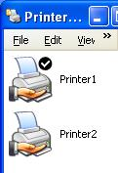
- At the Location and Comment screen, click Next.
- At the Print Test Page screen, accept the default selection of No, and click Next.
- At the Completing to the Add Printer Wizard screen, click Finish.
- The Printers and Faxes window should now show two printers, as shown to the right on this page. Press Alt+PrtScn to copy this window to the clipboard.
- On the Start menu, click Run. Enter the command mspaint and press the Enter key. Paint opens.
- Press Ctrl+V on the keyboard to paste the image into the Paint window. Save the document in the Shared Documents folder with the filename Your Name Proj 23a. Select a Save as type of JPEG. Close Paint.
Making Printer1 the Default Printer
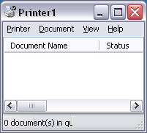
- In the Printers and Faxes window, Printer1 should show a white-on-black check mark next to it. Indicating that it is the default printer. If it does not, right-click Printer1 and click Set as Default Printer.
Observing Normal Printing
- Resize the Printers and Faxes window so that it is small and in the corner of your screen. Close or minimize all other windows.
- Double-click Printer1 to open the Print Queue, as shown to the right on this page.
- Click Start, Programs, Accessories, Notepad to open Notepad. Resize the windows so that all three are visible at once on your screen: Notepad, Printers and Faxes, and Printer1.
- Type some letters into Notepad—this project does not work if the notepad file is empty. From the Notepad menu bar, click File, Print. In the Print box, click the Print button. Watch the job appear in the HP LaserJet 6L window. It briefly shows a status of Spooling, and then either vanishes or just sits there for a minute or so before producing an error message and changing to a status of Error-Printing. This is normal printing, except for the minor detail that there is no actual print device connected.
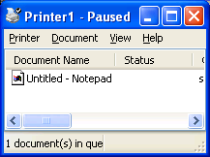
Pausing Printer1
- In the Printers and Faxes window, right-click Printer1 and select Pause Printing. This is normally used to fix a printer jam or some such temporary problem, but for us it will just stop the print jobs from vanishing.
- In the Notepad window, click File, Print. In the Print box, click Print. The print job briefly shows a status of Spooling and then it just sits in the queue with no status, as shown to the right on this page.
- In the Printer1 window, right-click the top Untitled – Notepad print job and select Cancel. In the Printers box, click Yes. The print job vanishes. If there are other print jobs in the queue, repeat the process to delete them also.

Printing Without Spooling
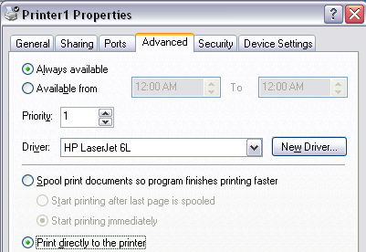
- In the Printers and Faxes window, right-click Printer1 and select Properties.
- In the Printer1 Properties window, on the Advanced tab, select Print directly to the printer, as shown to the right on this page. Click OK. The printer will no longer use spooling. As you will see below, it is inconvenient to use printers without spooling, because the program that is printing cannot do anything else until the print job is finished.

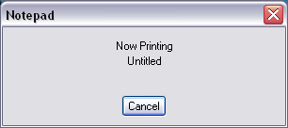
- In the Notepad window, click File, Print. In the Print box, click Print. Notepad is stopped, and a Notepad dialog box appears, as shown below on this page. Notepad will wait until the job actually prints. Press Alt+PrtScn to copy this window to the clipboard.
- On the Start menu, click Run. Enter the command mspaint and press the Enter key. Paint opens.
- Press Ctrl+V on the keyboard to paste the image into the Paint window. Save the document in the Shared Documents folder with the filename Your Name Proj 23b. Select a Save as type of JPEG. Close Paint.
- To clear the dialog box, in the Printer1 window, right-click the Untitled – Notepad print job and select Cancel. In the Printers box, click Yes. The print job vanishes, and the Notepad box closes.
Turning Spooling Back On
- In the Printers and Faxes window, right-click Printer1 and select Properties.
- In the Printer1 Properties window, on the Advanced tab, select Spool print documents so program finishes printing faster. Click OK.
Redirecting Print Jobs
- If a printer stops working, and you have a second printer that uses a compatible driver, you can redirect the print jobs to the second printer. To see this, let’s put some jobs in Printer1’s queue, and then redirect them to Printer2.
Creating Stuck Print Jobs in the Printer1 Queue
- In the Notepad window, click File, Print. In the Print box, click Print. This makes a print job stuck in the “Failed” printer’s queue. Make sure you have some letters typed in the Notepad window – redirection does not work with empty print jobs.
- Repeat the File, Print, Print process several more times to get 4 or 5 documents waiting in the queue for the paused Printer1.

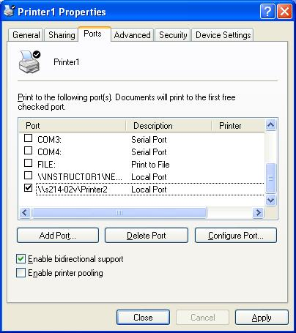
Redirecting Jobs from Printer1 to Printer2
- Double-click Printer2 to open its queue: it should be empty. Resize the windows so you can see the Printer1 queue, the Printer2 queue, and the Printers and Faxes window all at once.
- In the Printers and Faxes window, right-click Printer1 and select Properties.
- On the Ports tab, click the Add Port button. In the Printers Ports dialog box, click New Port.
- In the Port Name dialog box, enter \\S214-01v\Printer2, replacing 01 with your station number from the front panel of your computer. Click OK.
- In the Printer Ports box, click Close.
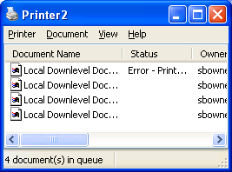
- The Printer1 Properties window should now show a check mark by the port you just created, as shown to the right on this page. That indicates that print jobs will be sent out that port, to Printer2. Click Close in the Printer1 Properties window.
- In the Printers and Faxes window, right-click Printer1 and select Resume Printing. The print jobs move from the Printer1 window to the Printer2 window, where they appear as Local Downlevel Document, as shown to the right on this page. Press Alt+PrtScn to copy this window to the clipboard.
- On the Start menu, click Run. Enter the command mspaint and press the Enter key. Paint opens.
- Press Ctrl+V on the keyboard to paste the image into the Paint window. Save the document in the Shared Documents folder with the filename Your Name Proj 23c. Select a Save as type of JPEG. Close Paint.

Turning in your Project
- Email the JPEG images to me as attachments to one e-mail message. Send the message to: cnit.235@gmail.com with a subject line of CNIT 235 Proj 23 From Your Name, replacing Your Name with your own first and last name. Send a Cc to yourself.

Last modified 10-18-05

