This project can be done on any Windows XP Pro machine on a network with another Windows XP machine.
Configuring Your Machine to Act as a VPN Server
- Log in to your virtual machine with your usual account (or any account with administrative privileges and a password).
- Click Start, My Computer, My Network Places. In the left pane, under Network Tasks, click View network connections.
- In Network Connections, under Network Tasks, click Create A New Connection
- The New Connection Wizard appears. If it asks for your location, give it your area code.
- On the Welcome to the New Connection Wizard page, click Next.
- On the Network Connection Type page, select Set Up An Advanced Connection and click Next.
- On the Advanced Connection Options page, select Accept Incoming Connections and click Next.
- If a Devices For Incoming Connections page appears, simply click Next. (These options are for setting up an incoming dial-up connection, direct cable connection, or infrared connection, and we don't need any of those.) This page appears only if your computer has an installed modem, serial port, parallel port, or IrDA port.
- On the Incoming Virtual Private Network (VPN) Configuration page, select Allow Virtual Private Connections and click Next.
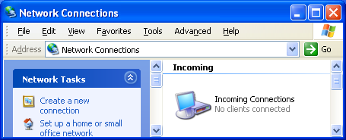
- On the User Permissions page, check your own account. Click Next.
- On the Networking Software page, accept the default (all items checked) and click Next.
- In the Completing the New Connection Wizard screen, click Finish. You should see an Incoming Connections icon in the Network Connections window, as shown to the right on this page. Your computer is now a VPN Server.
Configuring Another Machine to Act as a VPN Client
- Go to another virtual computer. This machine will be the VPN Client.
- Click Start, My Computer, My Network Places. In the left pane, under Network Tasks, click View network connections.
- In Network Connections, under Network Tasks, click Create A New Connection
- On the Welcome to the New Connection Wizard page, click Next.
- On the Network Connection Type page, select Connect To The Network At My Workplace and click Next.
- On the Network Connection page, select Virtual Private Network Connection and click Next.
- On the Connection Name page, enter YourNameVPN and click Next.
- On the VPN Server Selection page, type S214-01V, where 01 is the station number of your original Machine. Click Next.
- In the Completing the New Connection Wizard screen, click Finish.
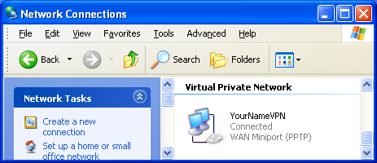
- The VPN will immediately attempt to connect, showing a blue box titled Connect YourNameVPN. Log in with your usual account and click Connect.
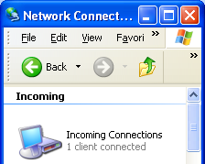
- On the VPN client machine, (your original machine), look in the Network Connections folder. You should see the word Connected under the YourNameVPN item, as shown to the right on this page.
- Return to your VPN Server (your original machine).
- Click Start, My Computer, My Network Places. In the left pane, under Network Tasks, click View network connections.
- You should see 1 client connected on the Incoming Connections item, as shown to the right on this page. . Press Alt+PrtScn to copy this window to the clipboard.
- On the Start menu, click Run. Enter the command mspaint and press the Enter key. Paint opens.
- Press Ctrl+V on the keyboard to paste the image into the Paint window. Save the document in the Shared Documents folder with the filename Your Name Proj 25a. Select a Save as type of JPEG. Close Paint.
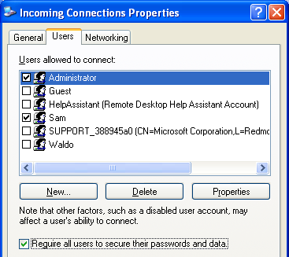
Requiring Encryption at the Server
- On your original machine (the VPN server), in the Network Connections folder, right-click Incoming Connections and select Properties. Click the Users tab and check the Require all users to secure their passwords and data check box, as shown to the right on this page. Click OK.
Reconnecting From the Client
- Return to the VPN Client machine. In the Network Connections folder, right-click the YourNameVPN item and select Disconnect.
- Right-click the YourNameVPN item and select Connect. Log in with your usual account and click Connect.
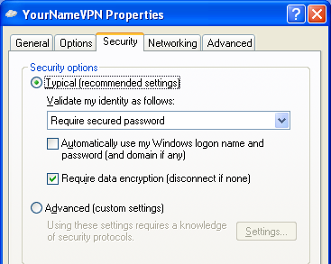
- You are able to connect, because Windows XP encrypts by default. To see that, right-click YourNameVPN and select Properties. Click the Security tab and you will see that the Require data encryption box is checked, as shown to the right on this page. Close the YourNameVPN Properties box. In the Network Connections box, click OK.
Trying to Connect Without Encryption
- On the VPN Client, in the Network Connections folder, right-click the YourNameVPN item and select Disconnect.
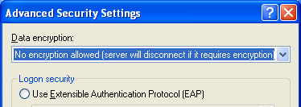
- Right-click YourNameVPN and select Properties. In the YourNameVPN Properties window, on the Security tab, click the Advanced (custom settings) radio button, and click the Settings button.
- In the Advanced Security Settings box, at the top, there is a Data encryption list box. Click the arrow and select No encryption allowed (server will disconnect if it requires encryption) as shown in the figure to the right on this page.
- Click OK in the Advanced Security Settings window.
- Click OK in the YourNameVPN Properties window.
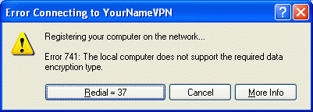
- Right-click the YourNameVPN item and select Connect. Log in with your usual account and click Connect. You get an error message, as show to the right on this page. Press Alt+PrtScn to copy this window to the clipboard.
- On the Start menu, click Run. Enter the command mspaint and press the Enter key. Paint opens.
- Press Ctrl+V on the keyboard to paste the image into the Paint window. Save the document in the Shared Documents folder with the filename Your Name Proj 25b. Select a Save as type of JPEG. Close Paint.
Turning in your Project
- Email the JPEG images to me as attachments to one e-mail message. Send the message to: cnit.235@gmail.com with a subject line of CNIT 235 Proj 25 From Your Name, replacing Your Name with your own first and last name. Send a Cc to yourself.

