This project can be done on any Windows XP Pro or Home Version machine.
- Log in to your virtual machine with your usual account, which has administrative privileges.
Installing a Fake Modem
- If you are using your home machine, and you already have a modem installed, skip to the Installing Fax Services section. Otherwise do the following steps to install a fake modem.
- In Control Panel, open Add Hardware.
- In the Add Hardware Wizard, click Next. Wait while the wizard searches for new hardware.
- At the Is the hardware connected? screen, click Yes, I have already connected the hardware and click Next. We don't really have a modem—we are lying to Windows XP.
- At the The following hardware is already installed on your computer screen, scroll to the bottom of the list and click Add a new hardware device. Click Next.
- At the The wizard can help you install other hardware screen, select Install the hardware that I manually select from a list (Advanced) and click Next.
- At the From the list below, select the type of hardware you are installing screen, select Modems and click Next.
- At the Install New Modem screen, select Don't detect my modem; I will select it from a list and click Next. Wait for a while – it took 2 minutes of waiting on my machine.
- When a list of Standard Modem Types opens, scroll to the bottom of the list and click Standard 56000 bps Modem. Click Next.
- At the Install New Modem screen, click the All ports button and click Next.
- When you see an Install New Modem screen with the words Modem installation is finished!, click Finish.
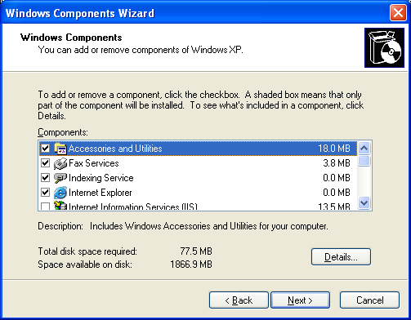
Installing Fax Services
- Insert a Windows XP Installation CD-ROM into the drive. If a Welcome to Windows XP box opens, click Exit to close it.
- In Control Panel, open Add or Remove Programs.
- In the Add or Remove Programs window, click Add/Remove Windows Components.
- In the Windows Components Wizard box, check Fax Services, as shown to the right on this page. Click Next. Wait while the progress bar moves.
- In the Completing the Windows Components Wizard box, click Finish.
- Close Add or Remove Programs.
- Close Control Panel.
Using Fax Console
- Click Start, All Programs, Accessories, Communications, Fax, Fax Console.
- If a Location Information box opens, enter your area code (415) and click OK.
- If a Phone and Modem Options box opens, click OK.
- At the Welcome to the Fax Configuration Wizard screen, click Next.
- At the Sender Information screen, enter your name, leaving the other information blank, and click Next.
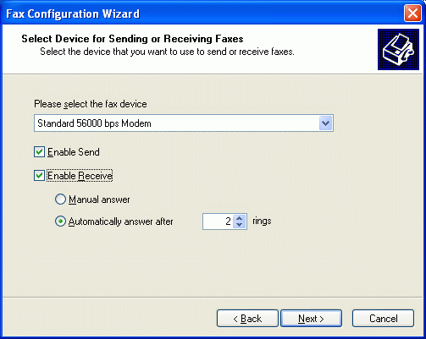
- At the Select Device for Sending or Receiving Faxes screen, accept the default selection of Standard 56000 bps modem. Check both the Enable Send and Enable Receive boxes, as shown to the right on this page, and click Next.
- At the Transmitting Subscriber Identification (TSID) screen, enter your name and click Next.
- At the Called Subscriber Identification (CSID) screen, enter your name and click Next.
- At the Routing Options screen, leave both boxes unchecked, and click Next.
- At the Completing the Fax Configuration Wizard screen, click Finish.
- A Fax Console window opens. If a Windows Security Alert box opens warning you that Windows Firewall has blocked some features of this program, click the Unblock button.
Sending a Fax
- Click Start, All Programs, Accessories, WordPad.
- In WordPad, type your name. Change the font to Arial size 48.
- In WordPad, click File, Print.
- In the Print box, click Fax and click Print.
- In the Send Fax Wizard box, click Next.
- At the Recipient Information screen, enter Your Name in the To: box (use your own name, not the literal words "Your Name"). Enter 555-1212 in the Fax number: box. Click Next.
- At the Preparing the Cover Page screen, click Next.
- At the Schedule screen, accept the default selection of Now and click Next.
- At the Completing the Send Fax Wizard screen, click Finish.
- Minimize the WordPad window.
Viewing the Outbox in Fax Console
- In the Fax Console window, click the Outbox. You should see a fax waiting to be sent, with your name showing as the Recipient, as shown below on this page. This is as far as we can get in sending a fax without an actual modem – it just sits in the outbox. Press Alt+PrtScn to copy this window to the clipboard.
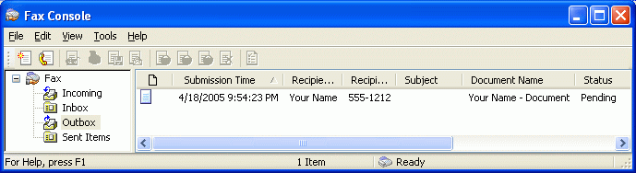

- On the Start menu, click Run. Enter the command mspaint and press the Enter key. Paint opens.
- Press Ctrl+V on the keyboard to paste the image into the Paint window. Save the document in the Shared Documents folder with the filename Your Name Proj 27a. Select a Save as type of JPEG. Close Paint.
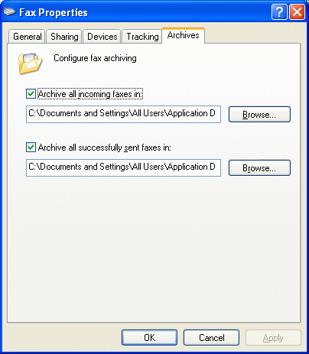
Viewing the Fax Archive Folder Location
- In the Fax Console window, click Tools, Fax Printer Configuration….
- In the Fax Properties box, click the Archives tab. You should see the archive folders locations as shown to the right on this page. Press Alt+PrtScn to copy this window to the clipboard.
- On the Start menu, click Run. Enter the command mspaint and press the Enter key. Paint opens.
- Press Ctrl+V on the keyboard to paste the image into the Paint window. Save the document in the Shared Documents folder with the filename Your Name Proj 27b. Select a Save as type of JPEG. Close Paint.
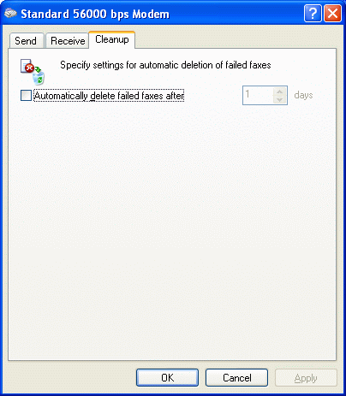
Viewing the Device-Specific Properties
- In the Fax Properties box, click the Devices tab. If there is more than one modem, select the one that is set to Send and Receive. Click the Properties button. You should see a Standard 56000 bps Modem property sheet, as shown to the right on this page. Examine the tabs and answer the questions on the next page.

A: What is the device's TSID? _________________________

B: How many retries will it perform to send a fax? _________________________

C: How many rings will it wait before answering incoming calls? _________________________

Turning in your Project
- Email the JPEG images to me as attachments to one e-mail message. Answer the questions in the body of the message. Send the message to: cnit.235@gmail.com with a subject line of Proj 27 From Your Name, replacing Your Name with your own first and last name. Send a Cc to yourself.

Last modified 10-31-05

