Starting Your Computer
- Start your virtual machine. Log in with your usual account, which has Administrative privileges. If your machine is a domain member, leave the domain first.

Setting a Restore Point in the Virtual Machine
- Before doing anything risky with your computer, it is a good idea to create a Restore Point so you can undo changes to your system if you need to. In the Virtual PC, click Start, Help and Support. In Help and Support Center window, in the Pick a Task section, click Undo changes to your computer with System Restore. In the next screen, select Create a Restore Point and click Next. In the next screen enter a Restore Point Description of Your Name Restore Point for Project 32 and click Create.
- When you see the Restore Point Created message, click Close.

Creating a Legal Notice Logon Dialog Box
- Click Start, Run. Enter REGEDIT and press the Enter key.
- In the left pane of the Registry Editor window, click the + sign to expand the HKEY_LOCAL_MACHINE key. Then expand these keys:
SOFTWARE\Microsoft\Windows NT\CurrentVersion\Winlogon
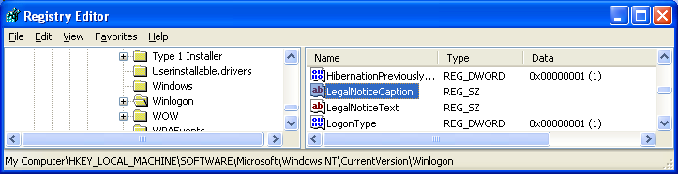
- Your Registry Editor window should look like the example shown below on this page. Find the LegalNoticeCaption value and double-click it.

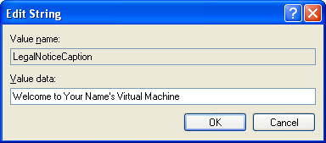
- An Edit String box opens. Enter the Value data: Welcome to Your Name's Virtual Machine as shown to the right on this page. Click OK.
- Find the LegalNoticeText value and double-click it. Enter the value Don't Tread on Me or any other message that suits you and click OK.

Removing System Properties From the My Computer Context Menu
- If Regedit is not already running, click Start, Run. Enter REGEDIT and press the Enter key.
- In the left pane of the Registry Editor window, click the + sign to expand the HKEY_CURRENT_USER key. Then expand these keys:
Software\Microsoft\Windows\CurrentVersion\Policies\Explorer
- Your Registry Editor window should resemble the example below. We need to add a new value to this key.

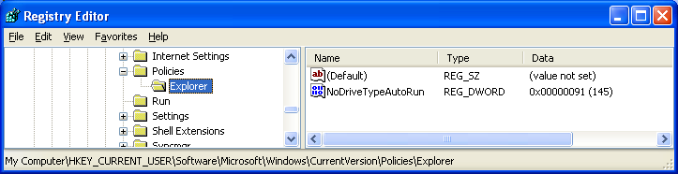
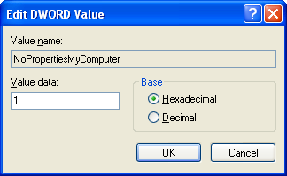
- In the Registry Editor window, click Edit, New, DWORD Value. Enter a value name of NoPropertiesMyComputer and press the Enter key.
- Double-click the NoPropertiesMyComputer value. In the Edit DWORD Value box, enter a Value data of 1, as shown to the right on this page. Click OK.
- Click Start, right-click My Computer, and observe the context menu. Properties is still there! But that does not mean you did anything wrong – the change will not happen until you restart the machine (or at least log off and log back on). We'll do that later.

Adding the Administrator Account to the Windows Welcome Screen
- If Regedit is not already running, click Start, Run. Enter REGEDIT and press the Enter key.
- In the left pane of the Registry Editor window, click the + sign to expand the HKEY_LOCAL_MACHINE key. Then expand these keys:
SOFTWARE\Microsoft\WindowsNT\CurrentVersion\Winlogon\
SpecialAccounts\UserList

- Your Registry Editor window should resemble the example below. We need to add a new value to this key.
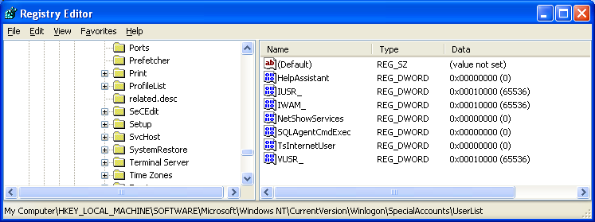

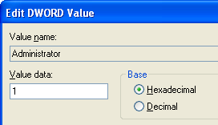
- In the Registry Editor window, click Edit, New, DWORD Value. Enter a value name of Administrator and press the Enter key.
- Double-click the Administrator value. In the Edit DWORD Value box, enter a Value data of 1, as shown to the right on this page. Click OK.
- Close Registry Editor.

Restarting the Virtual Machine
- Click Start, Turn Off Computer. Click Restart.

Capturing a Screen Image of the Legal Notice Logon Dialog Box
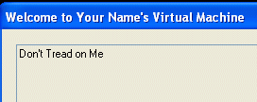
- When the Virtual PC shows the Legal Notice, as shown to the right on this page, move the mouse pointer out of the virtual machine window. Click an empty portion of the host Windows XP desktop, so that the virtual machine’s title bar is dimmed.
- Press the PrintScrn key in the upper-right portion of the keyboard. That will copy the whole desktop to the clipboard.
- On the Start menu, click Run. Enter the command mspaint and press the Enter key. Paint opens.
- Press Ctrl+V on the keyboard to paste the image into the Paint window. Save the document in the Shared Documents folder with the filename Your Name Proj 32a. Select a Save as type of JPEG. Close Paint.
- In the Welcome to Your Name's Virtual Machine box, click OK.

Capturing a Screen Image of the Windows Welcome Screen
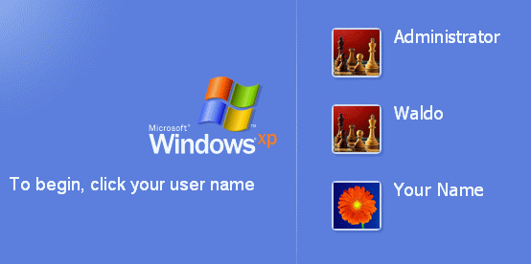
- When the Virtual PC shows the Windows screen, you should see the Administrator account on the list, as shown to the right on this page. You may have different names on the other accounts. Move the mouse pointer out of the virtual machine’s window. Click an empty portion of the host Windows XP desktop outside the virtual machine’s window, so that the title bar is dimmed.
- Press the PrintScrn key in the upper-right portion of the keyboard. That will copy the whole desktop to the clipboard.
- On the Start menu, click Run. Enter the command mspaint and press the Enter key. Paint opens.
- Press Ctrl+V on the keyboard to paste the image into the Paint window. Save the document in the Shared Documents folder with the filename Your Name Proj 32b. Select a Save as type of JPEG. Close Paint.
- In the YourName WinXP window, log in with your usual account.

Capturing a Screen Image of the My Computer Context Menu
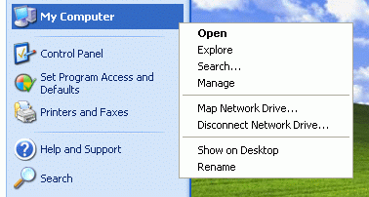
- When the desktop appears, click Start and right-click My Computer. You should see that Properties is absent from the context menu, as shown to the right on this page. Click an empty portion of the Windows XP desktop outside the YourName WinXP window, so that the YourName WinXP title bar is dimmed.
- Press the PrintScrn key in the upper-right portion of the keyboard. That will copy the whole desktop to the clipboard.
- On the Start menu, click Run. Enter the command mspaint and press the Enter key. Paint opens.
- Press Ctrl+V on the keyboard to paste the image into the Paint window. Save the document in the Shared Documents folder with the filename Your Name Proj 32c. Select a Save as type of JPEG. Close Paint.

Using System Restore
- In the Virtual PC, click Start, Help and Support. In Help and Support Center window, in the Pick a Task section, click Undo changes to your computer with System Restore. In the next screen, select Restore my computer to an earlier time and click Next.
- When the Select a Restore Point screen appears, select the restore point labeled Your Name Restore Point for Project 32.
- Click Next. If a window opens warning you that changes made after this point will not be monitored, click OK. Click Next again to perform the System Restore.
- Your Virtual PC should be back to its normal condition:
  - No Legal Notice should appear
  - Administrator should not be on the Windows Welcome screen
  - Properties should be on the My Computer context menu

Turning in your Project
- Email the JPEG images to me as attachments to one e-mail message. Send the message to: cnit.235@gmail.com with a subject line of Proj 32 From Your Name, replacing Your Name with your own first and last name. Send a Cc to yourself.

Revised 12-9-05
I got the first three hacks from theeldergeek.com.

