Downloading and Installing the Microsoft Baseline Security Analyzer (MBSA)
- Start your computer with the appropriate L removable hard drive. Start your virtual machine and log in with your own account. .
- If you are working in the lab, open the Z: shared drive (or click Start, Run and enter 192.168.1.2) and open the _Software folder. Open the MBSA folder and drag the installer to your desktop. If you are working at home, click link Ch 6c on my Web page or use Google to find Microsoft’s MBSA page. It’s a free download.
- Double-click the MBSASetup-EN.msi file.
- In the MBSA Setup screen, click Next.
- Accept the license agreement and click Next.
- Accept the default installation folder and click Next.
- Click Install.
- When you see a box saying Microsoft Baseline Security Analyzer Setup has completed successfully, click OK.
Scanning Your Computer With MBSA
- Click Start, All Programs, Microsoft Baseline Security Analyzer 1.2.1.
- In the Microsoft Baseline Security Analyzer window, click Scan a computer.
- In the Pick a computer to scan screen, notice that you can scan more than one computer with this tool, and that you can scan for many different problems. We will use the default selection to scan the local computer, and to scan for all the vulnerabilities. The only thing not checked by default is Use SUS Server which is not applicable – Software Update Services is a Microsoft service to manage updates, and it’s a good thing, but we are not using it in S214.
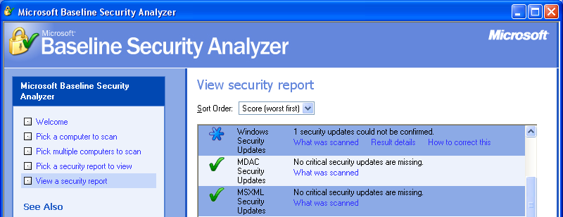
- Click Start Scan. Wait until the scan completes.
- When you see the View Security Report header, the scan is complete. Make sure the Windows Security Update line is visible, as shown to the right on this page. Press Alt+PrtScn to copy this window to the clipboard.
- On the Start menu, click Run. Enter the command mspaint and press the Enter key. Paint opens.
- Press Ctrl+V on the keyboard to paste the image into the Paint window. Save the document in the Shared Documents folder with the filename Your Name Proj X1a. Select a Save as type of JPEG. Close Paint.

Reading the Security Report
- Read the Security Report and answer the questions in the box below.

Examining the Security Update Database File’s Digital Signature
A: What version of the MBSA are you using? ____________________________________

B: In the Vulnerabilities section, what did it say about your File System?
_________________________________________________________________________
C: What was the result of the Password Expiration test?
_________________________________________________________________________

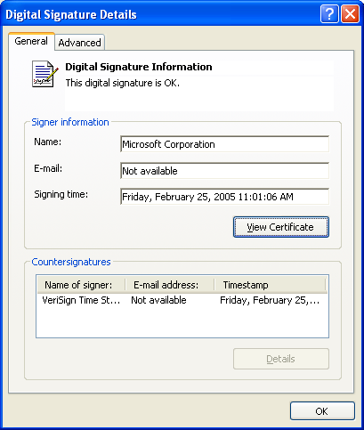
- The MBSA has tested to make sure all security updates are on your computer, but how can you be sure it was using the correct database? Let’s examine it.
- Open My Computer and navigate to C:\Program Files\Microsoft Baseline Security Analyzer. Right-click the mssecure_1033.cab file and click Properties.
- In the mssecure_1033.cab Properties dialog box, click the Digital Signatures tab. In the Signature list box, select the digital signature line, and click the Details button.
- A Digital Signature Details dialog box opens, as shown to the right on this page, showing that the digital signature is OK. Press Alt+PrtScn to copy this window to the clipboard.
- On the Start menu, click Run. Enter the command mspaint and press the Enter key. Paint opens.
- Press Ctrl+V on the keyboard to paste the image into the Paint window. Save the document in the Shared Documents folder with the filename Your Name Proj X1b. Select a Save as type of JPEG. Close Paint.
- Click OK to close the Digital Signature Details dialog box.
- Click Cancel to close the mssecure_1033.cab Properties dialog box.
Examining the Security Update Database File
- In the Microsoft Baseline Security Analyzer folder, find the mssecure.xml file. This file was extracted from the mssecure_1033.cab file when you scanned your computer.
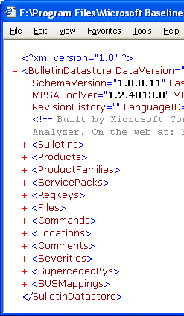
- Right-click the mssecure.xml file and click Open. The file opens in Internet Explorer. The Information bar opens warning that active content was blocked. Click in the Information bar and click Allow Blocked Content. In the Security Warning box, click Yes.
- This large file contains information about all released security bulletins used by the MBSA. It’s an XML file, so it can be collapsed like a folder view in Windows explorer.
- In Internet Explorer, in front of <Bulletins>, click the – (minus sign) to collapse the security bulletins listing.
- Collapse the other tags: <Products>, <ProductFamilies>, … until <SUSMappings>. Your window should now look like the example to the right on this page. Press Alt+PrtScn to copy this window to the clipboard.
- On the Start menu, click Run. Enter the command mspaint and press the Enter key. Paint opens.
- Press Ctrl+V on the keyboard to paste the image into the Paint window. Save the document in the Shared Documents folder with the filename Your Name Proj X1c. Select a Save as type of JPEG. Close Paint.

Turning in your Project
- Email the JPEG images to me as attachments to one e-mail message. Answer the questions in the box in the body of the e-mail message. Send the message to: cnit.235@gmail.com with a subject line of CNIT 235 Proj X1 From Your Name, replacing Your Name with your own first and last name. Send a Cc to yourself.

Last modified 9-12-05

