This project can be done on any Windows XP Pro machine for which you have administrative rights. But you can't use Windows XP Home Edition because it does not support Encrypted File Services.
Ensuring that Encrypted Files Show in Color
- Start your virtual machine. Log in with your usual account, which has Administrative privileges.
- Click Start, My Computer. Click Tools, Folder Options. On the View tab, name sure the Show encrypted or compressed NTFS files in color box is checked. Click OK to close Folder Options.
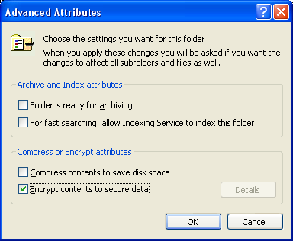
Creating the YourNameEncrypted Folder
- In the My Computer window, double-click the C: drive to open it. If necessary, click Show the contents of this folder.
- Right-click an empty portion of the C: window and select New, Folder to create a new folder. Name the folder YourNameEncrypted.
- Right-click the YourNameEncrypted folder and select Properties. On the General tab, click the Advanced button.
- In the Advanced Attributes window, check Encrypt contents to secure data box, as shown to the right on this page. Click OK.
- Click OK to close YourNameEncrypted Properties. Click on an empty portion of the window to deselect the YourNameEncrypted folder. Notice that the name of the folder is green – that’s the color Windows uses to denote encrypted files and folders.
- Double-click the YourNameEncrypted folder to open it. Right-click an empty portion of the YourNameEncrypted window and select New, Text Document to create a new document. Name the document Secret (the .txt file extension may or may not be visible, depending on your Folder Options settings).
- Double-click the Secret.txt file to open it in Notepad. Type in some text. Save the file and close Notepad.
- Click on an empty portion of the window to deselect the Secret.txt file. Notice that the file is green, because it is encrypted. Any file created in an encrypted folder is automatically encrypted.
Testing the Encryption as Waldo
- Log out. Do not use Fast User Switching. Log in again as Waldo. (If you are not working in S214, use any account other than the one you used in step 1, but don't use the Administrator account.)
- Click Start, My Computer. Double-click the C: drive to open it . If necessary, click Show the contents of this folder.
- Notice that the name of the YourNameEncrypted folder appears in green letters – that shows you that this folder has been encrypted. Double-click the YourNameEncrypted folder. The folder opens and you can see the name of the file inside. Remember this: file and folder names are not protected by encryption. Do not put confidential information in file names.
- Double-click the Secret.txt file. You get an Access is Denied message. Notepad starts, but the file's contents are not visible. Click OK to close the Notepad box. Close Notepad.
- What would happen if Waldo tried to change the encryption properties of the file to gain access? Right-click the Secret.txt file and select Properties. In the Secret.txt Properties box, click the Advanced button. Clear the Encrypt contents to secure data and click OK.
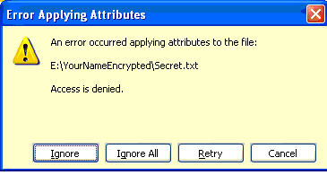
- In the Secret Properties box, click OK. An Error Applying Attributes box opens, as shown to the right in this page. Press Alt+PrntScn to copy this window to the clipboard.
- On the Start menu, click Run. Enter the command mspaint and press the Enter key. Paint opens.
- Press Ctrl+V on the keyboard to paste the image into the Paint window. Save the document in the Shared Documents folder with the filename Your Name Proj X2a. Select a Save as type of JPEG. Close Paint.
- Click Cancel to close the Error Applying Attributes box.
- Click Cancel to close the Secret.txt Properties box.
Testing the Encryption as Administrator
- Log out. Do not use Fast User Switching. When you see the Windows Welcome screen, press Ctrl+Alt+Insert twice to show a Windows 2000-style login box. (If you are not using a VMware virtual machine, use Ctrl+Alt+Delete). Log in as Administrator with a password of P@ssw0rd.
- Click Start, My Computer. Double-click the C: drive to open it. If necessary, click Show the contents of this folder.
- Double-click the YourNameEncrypted folder to open it.
- Double-click the Secret.txt file. You get an Access is Denied message. Close the Notepad box. Close Notepad. Even the Administrator cannot open another user's encrypted files.
Creating the Secret2 file
- Log out. Do not use Fast User Switching. Log in with your usual account.
- Right-click an empty portion of your desktop and select New, Text Document to create a new document. Name the document Secret2.
- Double-click the Secret2 file to open it in Notepad. Type in some text. Save the file and close Notepad.
- Open My Computer. Open drive C:. Open the YourNameEncrypted folder. Resize the window so you can see the desktop and the Secret2 file.
- Right-click the Secret2 file, hold down the right mouse button, and drag it into the YourNameEncrypted folder. Release the right mouse button and select Copy Here. . Click on an empty portion of the window to deselect the Secret2 file. Notice that the name of the file is green – it’s encrypted. When you copy a file into an encrypted folder, it becomes encrypted.
- In the YourNameEncrypted window, right-click the Secret2 file and select Rename. Name the file Copied Secret2.
- Right-click the Secret2 file on your desktop, hold down the right mouse button, and drag it into the YourNameEncrypted folder. Release the right mouse button and select Move Here. . Click on an empty portion of the window to deselect the Secret2 file. Notice that the name of the file is green – it’s encrypted. When you move a file into an encrypted folder, it becomes encrypted. Note that this is different than what happens to NTFS Permissions when you move a file into a new folder on the same partition.
- In the YourNameEncrypted window, right-click the Secret2 file and select Rename. Name the file Moved Secret2.
Testing the Encryption as Waldo
- Windows colored both files green, but are they really encrypted?
- Log out and log in again as Waldo (you may use Fast User Switching).
- Click Start, My Computer. Double-click the C: drive to open it.
- Double-click the YourNameEncrypted folder to open it.
- Double-click the Copied Secret2 file. You get an Access is Denied message. Close the Notepad box. Close Notepad.
- Double-click the Moved Secret2 file. You get an Access is Denied message. Close the Notepad box. Close Notepad.
- As you can see, no matter how you move or copy files into an encrypted folder, they remain encrypted.
Letting Waldo Access Your File: First Attempt
- Log out and Log in with your usual account (you may use Fast User Switching).
- Open My Computer. Open drive C:. Open the YourNameEncrypted folder.
- Right-click the Copied Secret2 file and select Properties. On the General tab, click the Advanced button.
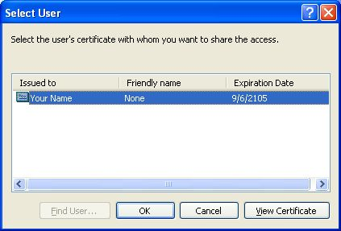
- In the Advanced Attributes window, in the Compress or Encrypt attributes section, click the Details button.
- In the Encryption Details for C:\YourNameEncrypted\Copied Secret2 box, click the Add button. A Select User box opens, as shown to the right on this page. But there is only one person on the list: YourName. That’s because Waldo does not have an encryption certificate. Windows XP does not create a certificate for a user until that user actually makes an encrypted file or folder, and Waldo has not encrypted any files or folders yet.
- Close all windows.
Creating a Certificate for Waldo
- Log out and log in again as Waldo (you may use Fast User Switching).
- Right-click the desktop and select New, Folder. Right-click the New Folder and select Properties. On the General tab, click the Advanced button.
- In the Advanced Attributes window, check Encrypt contents to secure data box. Click OK.
- Click OK to close New Folder Properties. Note that the folder name does not turn green – that’s a defect of the Desktop drawing routine. As you use Windows XP you will notice other such defects with things drawn on the Desktop.
- Now Waldo has an encryption Certificate.
Letting Waldo Access Your File – Second Attempt
- Log out and log in with your usual account (you may use Fast User Switching).
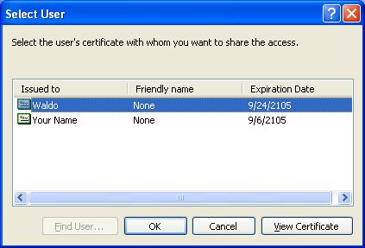
- Open My Computer. Open drive C:. Open the YourNameEncrypted folder.
- Right-click the Copied Secret2 file and select Properties. On the General tab, click the Advanced button.
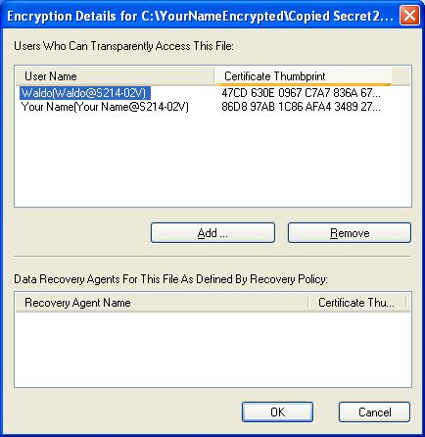
- In the Advanced Attributes box, in the Compress or Encrypt attributes section, click the Details button.
- In the Encryption Details for C:\YourNameEncrypted\Copied Secret2box, click the Add button. A Select User box opens, as shown to the right on this page. Now Waldo is on the list. Click Waldo. Click OK to close the Select User box.
- You should see an Encryption Details for C:\YourNameEncrypted\Copied Secret2 box showing two User Names as shown to the right on this page. If you are not using the machines in S214, the two names may be different from the ones shown in the sample. The Certificate Thumbprints will be different.
- Press Alt+PrntScn to copy this window to the clipboard.
- On the Start menu, click Run. Enter the command mspaint and press the Enter key. Paint opens.
- Press Ctrl+V on the keyboard to paste the image into the Paint window. Save the document in the Shared Documents folder with the filename Your Name Proj X2b. Select a Save as type of JPEG. Close Paint.
- Click OK to close the Encryption Details for C:\YourNameEncrypted\Copied Secret2box.
- Click OK to close the Advanced Attributes box.
- Click OK to close the Copied Secret2Properties box.
- Now both you and Waldo can access the files, but other accounts, such as Administrator, cannot.
Opening the Encrypted File as Waldo
- Log out and log in again as Waldo (you may use Fast User Switching).
- Open My Computer. Open drive C:. Open the YourNameEncrypted folder.
- Double-click the Copied Secret2 file. The file opens and you can now read the contents. Close Notepad.
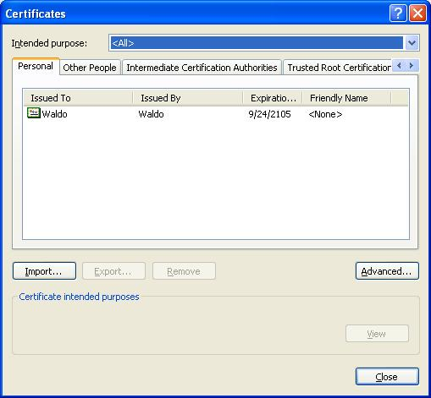
Exporting Waldo's Certificate
- You should still be logged in as Waldo.
- Open Internet Explorer. Click Tools, Internet Options. On the Content tab, click the Certificates button. You should see the Waldo certificate, as shown to the right on this page.
- Click the Waldo certificate once to select it. We'll export the certificate to the shared CNIT235 folder. Click the Export button.
- In the Welcome to the Certificate Export Wizard screen, click Next.
- At the Export Private Key screen, select Yes, export the private key and click Next.
- At the Export File Format screen, accept the default selection of Enable strong protection (requires IE 5.0, NT 4.0 SP4 or above) and click Next.
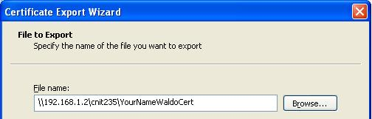
- At the Password screen, enter P@ssw0rd in both boxes and click Next.
- At the File to Export screen, enter a file name of:
\\192.168.1.2\cnit235\YourNameWaldoCert
as shown to the right on this page. Do not use the literal words YourName, but replace them with your own name.
- At the File to Export screen, click the Next button.
- In the Completing the Certificate Export Wizard screen, click Finish.
- A Certificate Export Wizard box opens saying The export was successful. Click OK to close it.
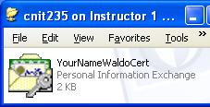
- Close all windows.
- Click Start, Run and type in \\192.168.1.2. Press the Enter key to open the shared network folder. Double-click the CNIT235 folder to open it. Scroll until you find the YourNameWaldoCert file, as shown to the right on this page. Press Alt+PrntScn to copy this window to the clipboard.
- On the Start menu, click Run. Enter the command mspaint and press the Enter key. Paint opens.
- Press Ctrl+V on the keyboard to paste the image into the Paint window. Save the document in the Shared Documents folder with the filename Your Name Proj X2c. Select a Save as type of JPEG. Close Paint.
Turning in your Project
- Email the JPEG images to me as attachments to one e-mail message. Send the message to: cnit.235@gmail.com with a subject line of CNIT 235 Proj X2 From Your Name, replacing Your Name with your own first and last name. Send a Cc to yourself.
Last modified 10-18-05

