This project can be done on any Windows XP Professional computer.
Starting Your Computer – Work in the Virtual Machine
- Start your virtual machine, and log in with your usual account, which has Administrative rights.
Creating the Joe User Account
- Click Start, Control Panel. Open User Accounts.
- In the Pick a task… section, click Create a new account.
- At the Name the new account screen, enter a name of Joe User and click Next.
- At the Pick an account type screen, select Limited and click Create Account.
Using a Limited Account: Setting the System Time
- Log out and log in as Joe User, which is a Limited account (it does not have Administrative privileges). You may use Fast User Switching.
- Double-click the system clock in the lower-right corner. You see an error message, because you do not have the right to change the system time.
Changing Local Group Policy to Allow Everyone to Change the System Time
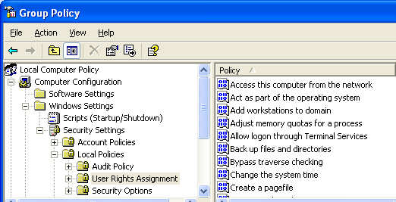
- Log out (do not use Fast User Switching) and log in with your personal account, which has Administrative privileges.
- Click Start, Run, type in gpedit.msc and press Enter.
- A Group Policy window should open as shown to the right on this page. In the left pane, expand Computer Configuration, Windows Settings, Security Settings, and Local Policies. Click User Rights Assignment.
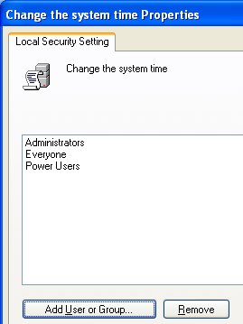
- In the right pane, double-click Change the system time. Click the Add User or Group button. In the Select Users or Groups window, enter Everyone and click OK. The Change the system time Properties window should now look like the example to the right on this page. Press Alt+PrtScn to copy this window to the clipboard.
- On the Start menu, click Run. Enter the command mspaint and press the Enter key. Paint opens.
- Press Ctrl+V on the keyboard to paste the image into the Paint window. Save the document in the Shared Documents folder with the filename Your Name Proj X3a. Select a Save as type of JPEG. Close Paint.
- In the Change the system time Properties window, click OK.
- Log off (you may use Fast User Switching), and log on as Joe User. Double-click the clock--now you can change it, because you have given Everyone that right.
Changing Local Group Policy to Deny Access to Control Panel
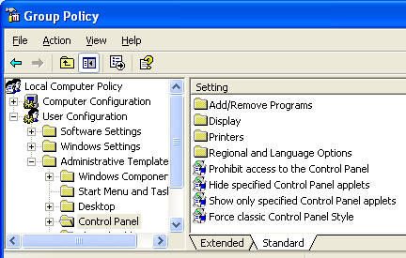
- Click Start, Control Panel. Control Panel opens, of course. But we can change that.
- Log out and log in with your personal account, which has Administrative privileges.
- Click Start, Run, type in gpedit.msc and press Enter.
- A Group Policy window should open as shown to the right on this page. In the left pane, expand User Configuration and Administrative Templates. Click Control Panel.
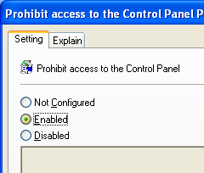
- In the right pane, double-click Prohibit access to the Control Panel.
- In the Prohibit access to the Control Panel Properties window, click Enabled, as shown to the right on this page. Note that there is no way to limit the users affected by this setting: it will apply to them all. Press Alt+PrtScn to copy this window to the clipboard.
- On the Start menu, click Run. Enter the command mspaint and press the Enter key. Paint opens.
- Press Ctrl+V on the keyboard to paste the image into the Paint window. Save the document in the Shared Documents folder with the filename Your Name Proj X3b. Select a Save as type of JPEG. Close Paint.
- In the Prohibit access to the Control Panel Properties window, click OK.
- Close Group Policy. Click Start. Control Panel is either missing or unusable. If Control Panel appears, click it and you will just get an error message.
Restoring Access to Control Panel
- Click Start, Run, type in gpedit.msc and press Enter.
- Expand User Configuration and Administrative Templates. Click Control Panel.
- In the right pane, double-click Prohibit access to the Control Panel.
- In the Prohibit access to the Control Panel window, click Not Configured. Click OK.
- Close Group Policy.
- Click Start. Make sure Control Panel can be opened. If you don’t see it, click Start, Run and enter GPUPDATE. That forces an immediate refresh of the Group Policy settings. If that still doesn’t work, restart the virtual machine.

Turning in your Project
- Email the JPEG images to me as attachments to one e-mail message. Send the message to: cnit.235@gmail.com with a subject line of CNIT 235 Proj X3 From Your Name, replacing Your Name with your own first and last name. Send a Cc to yourself.

Revised 12-9-05

