This project requires a network with at least two Windows XP Pro machines.
Creating the YourName Test 1.txt Test Document
- Log in to your virtual PC with your usual account, which has local Administrative rights. You may use either a domain account or a local account.
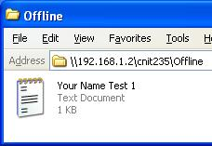
- Click Start, Programs, Accessories, Notepad. Type in some text. Save the file on your desktop as Your Name Test 1.txt. Do not use the literal string “Your Name” – use your own name. Close Notepad.
- Click Start, Run. In the Run box, enter \\192.168.1.2\CNIT235\Offline and press Enter. An Offline window opens.
- Drag the YourName Test 1.txt jnto the Offline window. You should see your file in the window, as shown to the right on this page.
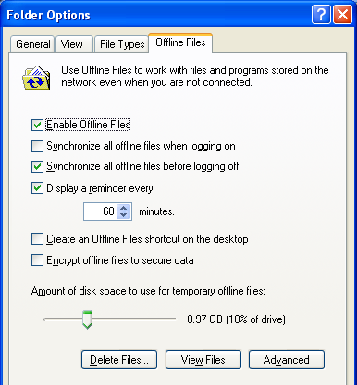
- On your desktop, drag the YourName Test 1.txt file into the Recycle bin. If necessary, confirm the delete.
Verifying that Offline Files are Enabled on Your Computer
- In the Offline window, click Tools, Folder Options. Click the Offline Files tab. Check the Enable Offline Files box, as shown to the right on this page. Read through all the options to make sure you understand them. Accept the default selections and click the OK button.
Making the YourName Test 1.txt Test Document Available Offline
- In the Offline window, right-click YourName Test 1.txt file. Click Make Available Offline.
- At the Welcome to the Offline Files Wizard screen, click Next.
- In the Offline Files Wizard box, check the Automatically synchronize the Offline Files when I log on and log off my computer box and click Next.
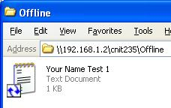
- In the Offline Files Wizard box, make sure that both the check boxes are checked: Enable Reminders and Create a shortcut to the Offline Files folder on my desktop. Click Finish.
- Notice that the YourName Test 1.txt file shows a blue double-arrow in the corner now, as shown to the right on this page, to indicate that it is a Offline File. Also, the Shortcut to Offline Files icon appears on your desktop.
Changing the Local Copy of the YourName Test 1.txt Test Document While Online
- In the Offline window, double-click the YourName Test 1.txt file. The file opens in NotePad. Type in some additional text and save the file. Close Notepad.
- Find a partner and go use their machine for a minute. It does not matter what user account they are logged in as.
- On your partner’s machine, open the \\192.168.1.2\CNIT235\Offline share, if necessary. Double-click the YourName Test 1.txt file. The changes you just made are there, because while you are connected to the network the offline file works normally. Close Notepad. Return to your original computer.
Disconnecting Your Computer From the Network
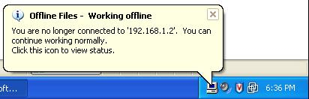
- On the back panel of your computer, unplug the network cable.
- Open Internet Explorer and try to open a Web page you have not already used today, such as sfgate.com. Verify that you cannot open it. Close Internet Explorer.
- An Offline Files – Working Offline message should appear on your virtual PC, as shown to the right on this page.
Changing the Local Copy of the YourName Test 1.txt Test Document While Offline
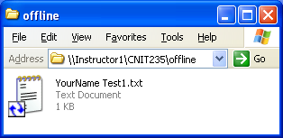
- Look at your Offline window. Note that all the other files have vanished—only the file you made available offline is still there, as shown to the right on this page. Although the path to this file is still \\192.168.1.2\CNIT235\Offline , it is not actually on a network share: it is a local cached copy. Double-click the YourName Test 1.txt file. The file opens in NotePad. Type in some additional text and save the file. Close Notepad.
- Find a partner and go use their machine for a minute. It does not matter what user account they are logged in as.
- On your partner’s machine, open the \\192.168.1.2\CNIT235\Offline share, if necessary. Double-click the YourName Test 1.txt file. The changes you just made are not there, because your machine is off the network. It has no way to update the network share. Close Notepad. Return to your original computer.
Enabling Your Network Connection
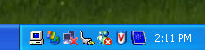
- Plug the network cable back into the rear panel of your computer. After a few seconds, your network connection should be restored. Open Internet Explorer in your virtual PC and verify that you can access Web pages again.
- Find the Offline Files icon (it looks like a monitor, as shown to the right on this page) at the left of the Notification Area in the lower right corner of your desktop. Click it to open an Offline Files Status box. Read the box, and click the OK button in that box.
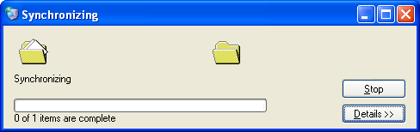
- You should see a Synchronizing box, as shown to the right on this page. If a Close Open Files box appears, read it, close all open files and folders, and click OK.
- When the Synchronizing is complete, the network file will show the changes you made. Open the file from your partner’s machine and verify that the changes are there.

Disconnecting Your Computer From the Network
- On the back panel of your computer, unplug the network cable. Wait until the Offline Files – Working offline message appears.
Changing the Local Copy of the YourName Test 1.txt Test Document While Offline
- In the Offline window, double-click the YourName Test 1.txt file. The file opens in NotePad. Type in some additional text and save the file. Close Notepad.
Changing the Network Shared Copy of the YourName Test 1.txt Test Document While you are Offline
- Find a partner and go use their machine for a minute. It does not matter what user account they are logged in as.
- On your partner’s machine, open the \\192.168.1.2\CNIT235\Offline share, if necessary. Double-click the YourName Test 1.txt file. Type in some additional text and save the file. Close Notepad. You have now set up a File Conflict, in which both the offline and shared documents have changed, so there is no longer a clear way to tell which file is the most current.
Resolving File Conflicts
- Plug the network cable back into the rear panel of your computer. After a few seconds, your network connection should be restored. Open Internet Explorer in your virtual PC and verify that you can access Web pages again.
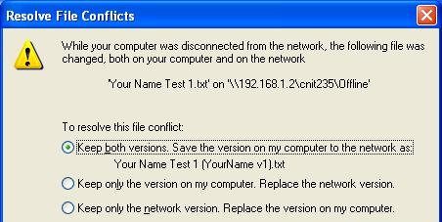
- Find the Offline Files icon at the left of the Notification Area in the lower right corner of your desktop. Click it to open a Offline Files Status box, and click the OK button in that box.
- You should see a Synchronizing box for a second or two, and then the Resolve File Conflicts box opens as shown to the right on this page. Read through the box and make sure you understand it. Then press Alt+PrntScn to copy that image to the clipboard.
- On the Start menu, click Run. Enter the command mspaint and press the Enter key. Paint opens.
- Press Ctrl+V on the keyboard to paste the image into the Paint window. Save the document in the Shared Documents folder with the filename Your Name Proj X5. Select a Save as type of JPEG. Close Paint.
- In the Resolve File Conflicts box, accept the default selection of Keep both versions and click the OK button.
- Examine the files in the network shared folder. There are now two files with your name on them: YourName Test 1.txt and YourName Test 1 (yourname v1).txt. Open them and make sure you understand why they are different.
- In the Offline window, click Tools, Folder Options. Click the Offline Files tab. Uncheck the Enable Offline Files box and click the OK button.
- Email the JPEG image to me an attachment to an e-mail message. Send the message to: cnit.235@gmail.com with a subject line of Proj X5 From Your Name, replacing Your Name with your own first and last name. Send a Cc to yourself.

