Starting Your Computer – Work in the Virtual Machine
- Start one of the machines with Windows Vista Beta on them. They are labeled on the board – at the time of this writing they are L3, L8, L17, and L20. Boot the machine to Vista. Log on as Administrator with no password. your computer. Log in as Student with a password of P@ssw0rd. Start your Virtual Machine and log in with your personal account, which has Administrative rights. Don’t use Virtual PC in full-screen mode for this project – leave some of the host machine’s desktop visible.

Security

User Account Control
- Log on as administrator and start a command prompt by clicking Start, Run, and then typing command.
- Create a new user account with your first name by typing Net user YourName /add. The account will be created with a blank password.
- Create a new user account with your first name followed by Admin by typing:
Net user YourNameAdmin protection /add
The account will be created with the password protection.
- Add YourNameAdmin to the local administrators group by typing:
Net localgroup administrators YourNameAdmin /add
- Turn on User Account Control by clicking Start, Programs, Turn UAC Settings On or Off. Click Yes when asked whether you want to enable this security feature. A Windows Security box opens saying “For this change to take effect, you must first log off and then log on again”. Click Log off now.
- Log back on by clicking YourName (NOT YourNameAdmin). Leave the password blank to log on as a standard user, which is an account that is not a member of the local administrators group.
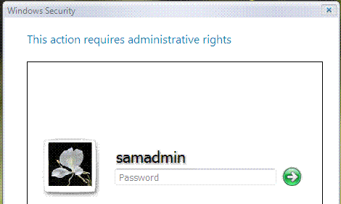
- Double-click the clock in the lower right-hand corner of the taskbar. Note that the clock now successfully opens so that you can view the date and time zone. In Microsoft Windows XP, a non-administrative user is not able to open the clock.
- Click the Unlock button in the date/time control panel. A Windows Security box opens, asking for administrative credentials, as shown to the right on this page.
- Click on the desktop to make all the windows inactive. Press PrtScn to capture the whole screen, including the Windows Security box.
- Click Start, All Programs, Accessories, Paint. When Paint opens, click Edit, Paste.
- Press Ctrl+V on the keyboard to paste the image into the Paint window. Save the document on the desktop with the filename Your Name Proj X6a. Select a Save as type of JPEG. Close Paint.

- In the Windows Security box YourNameAdmin is already selected as the account. Type in protection for the password and click the green circle with the arrow in it. The clock applet is now unlocked.
- Change the clock to a different time and click OK. Note that the time in the lower right-hand corner of your taskbar has been updated.
- Double-click the clock in the lower right-hand corner of the taskbar again. Note that the control panel applet is again locked. It locked automatically after you closed the applet in the previous step.
- Log off by clicking Start, clicking the arrow next to Lock, and then clicking Logoff. In the Log Off Windows box, click Log off. Click YourNameAdmin to log on and use protection as the password. You will now be logged on to an account that has administrative privileges.
- In Windows Vista, even accounts that are members of the local administrators group will run the desktop, and common applications such as e-mail clients, with low privileges. These accounts will be prompted for their credentials when performing an administrative operation, such as changing the clock.
- As YourNameAdmin the administrator, double-click the clock in the lower right-hand corner of the taskbar again, then click the Unlock button. Note that rather than being asked for different credentials as you were when you were logged on as Toby, you're simply prompted for your password for this administrative operation. Type the password protection. The clock will be unlocked, and you'll be able to change it. Change it back to the correct time.

Microsoft Internet Explorer (IE) Security
- Open Internet Explorer. Type in a few URL s and visit the sites, for example, google.com, yahoo.com, and samsclass.info.
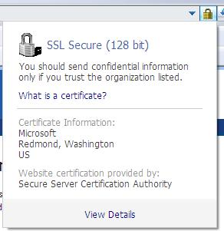
- Click the Internet Explorer address bar drop-down menu to see all the sites you have visited. To clean this browsing history, go to the Tools menu and click Delete Browsing History. In the Delete Browsing History, click Yes. This will erase all cookies, history, web form data, passwords, and temporary files.
- Go to passport.net, then click the Sign In link in the upper right-hand corner of the page. Note how the Secure Sockets Layer (SSL) lock icon now appears to the right side of the address bar to show that you're on a secure site, rather than just appearing in the lower right-hand corner of the browser window. Click the lock icon next to the address bar, and you'll see information about the site's owner and certificate, as shown to the right on this page. This helps ensure that you're not on a phishing site.
- Click on the desktop to make all the windows inactive. Press PrtScn to capture the whole screen, including the SSL Secure box.
- Click Start, All Programs, Accessories, Paint. When Paint opens, click Edit, Paste.
- Press Ctrl+V on the keyboard to paste the image into the Paint window. Save the document on the desktop with the filename Your Name Proj X6b. Select a Save as type of JPEG. Close Paint.

Desktop Management
In Windows Vista, Windows contains rich instrumentation that gives IT professionals the tools to monitor and manage system state, ongoing operations, and performance trends. The following will introduce you to the new event format in Windows Vista, the new Event Viewer, and the new task scheduler.
- From the Start menu, select Run and enter MMC. If you are prompted to enter a password, enter protection
- This will launch the new Microsoft Management Console (MMC) 3.0. Maximize the Console Root window.
- From the File menu, select Add/Remove Snap-in.
- Add the following snap-ins, as shown below:
- Windows Event Viewer (select local machine if prompted)
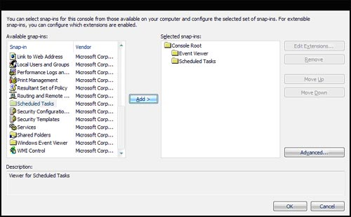
- Scheduled Tasks

- Click OK to close the Add/Remove Snap-ins window.

- In the left-hand pane, expand the Event Viewer node. Note that Global Logs, Application Logs, and Views are now available. Global logs unify multiple logs throughout the system, providing you with a single place to look for information. In Windows Vista, many components that formerly stored information in private text logs have adopted the standard event-logging format.
- Expand the Global Logs node and select System. A list of events will appear in the upper middle pane. Select any of these events to see more information about the event in the bottom middle pane.
- Click the Details tab in the lower middle pane to see the new schematized (XML) representation of the event you selected. Schematized events are easier to manipulate and manage than the text-based events they replace.
- Note the Actions pane on the right-hand side. In Windows Vista, you can create event filters, create views, and even attach a task to an event.
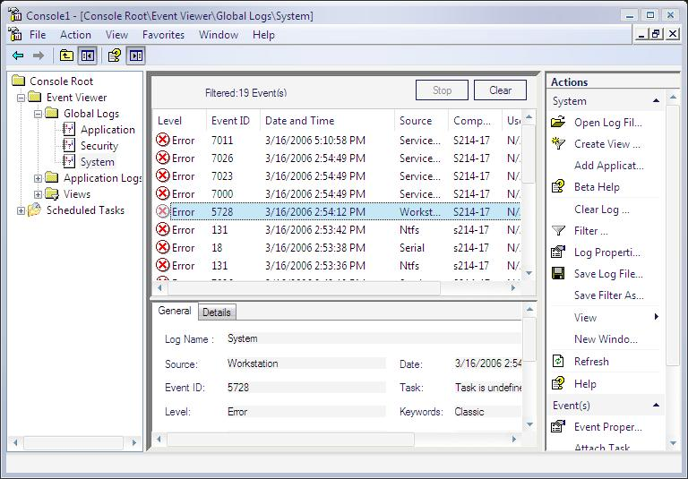
- In the Actions pane, click Filter. In the pop-up window that appears, go to Level, then select Error and Critical. Click OK. You now see only see a subset of events — those marked with a level of Critical or Error, as shown below on this page.

- Click on the desktop to make all the windows inactive. Press PrtScn to capture the whole screen, including the SSL Secure box.
- Click Start, All Programs, Accessories, Paint. When Paint opens, click Edit, Paste.
- Press Ctrl+V on the keyboard to paste the image into the Paint window. Save the document on the desktop with the filename Your Name Proj X6c. Select a Save as type of JPEG. Close Paint.

End-User Productivity

Getting Started
- Log on to Windows Vista.
- Notice the new visuals on the logon screen. While this is updated from Windows XP's logon screen, these are not the final start-up visuals.
- Click the Start button. Notice the new text entry field in the bottom left-hand corner. This Quick Search Box lets you find and launch any application by typing the name of that application. If you want to just browse the installed applications, click the Programs button to see your applications in a more efficient way.
- Open some of the Explorers (e.g., Music, Documents, Photos). If your PC has a graphics card that has an updated Windows Vista driver, the frames of all the windows will feature translucent glass. In addition, you will now see subtle animations when you open, close, minimize, or maximize any windows.

Turning in your Project
- Email the JPEG images to me as attachments to one e-mail message. Send the message to: cnit.235@gmail.com with a subject line of CNIT 235 Proj X6 From Your Name. Send a Cc to yourself.

Based on a Microsoft Vista Tour page I found here: http://www.microsoft.com/technet/windowsvista/evaluate/sgtour.mspx
Revised 3-16-05

