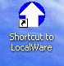
The sample tests are only available in S211 and S214.
- Start your computer. Log in with the usual account. Do not use a Virtual Machine.
- Look on the desktop for a Shortcut to LocalWare icon, as shown to the right on this page. If it’s not there, try a different machine. The lab monitor should know which computers have the sample test.
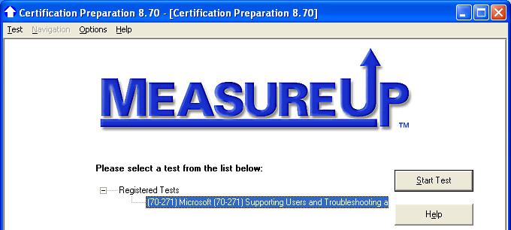
- Double-click the Shortcut to LocalWare icon. A window with a large MeasureUp banner should open, as shown to the right on this page. Click the 70-271 line in the middle of the screen, and click the Start Test button.

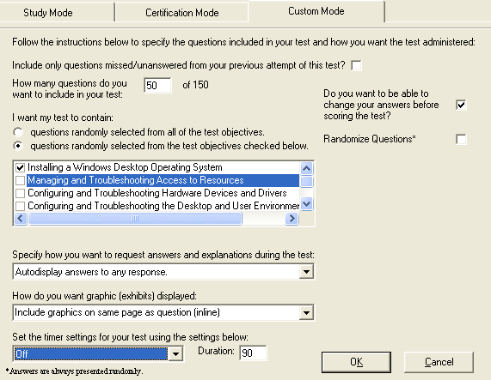
- In the next window, click the Custom Mode tab. I recommend that you use these settings, as shown to the right on this page:
- In the center list of objectives, uncheck all of them except the desired objective(s).
- On the right side, uncheck the Randomize Questions box
- In the Specify how you want to request answers and explanations during the test drop-down list box, select Autodisplay answers to any response.
- In the Set the timer settings for your test using the settings below drop-down list box, select Off.
- Click the OK button.
- In the next screen, click the Start Test button. Take notes as you go through the questions so we can discuss them at the review sessions.
Last revised 11-10-05

