CNIT 235: Bowne

Adjusting Network Settings on Drives L3, L6, L9, L12, L15, & L18

I changed the networking settings on these drives, to prepare them for project 20. That means that each virtual machine on those drives must be adjusted before it can reach the Internet. When you do project 20, you will change these settings again to something different, but don't worry about that until you do project 20.

To get the virtual machines back on the Internet, do this:

- Start VMware Workstation
- Select your virtual machine, but do not start it.
- Click the blue Edit Virtual Machine Settings link on the left side.
- Select Ethernet in the left pane and in the right pane click the Custom radio button, and select VMnet3 from the drop-down list, as shown below on this page. Click OK.
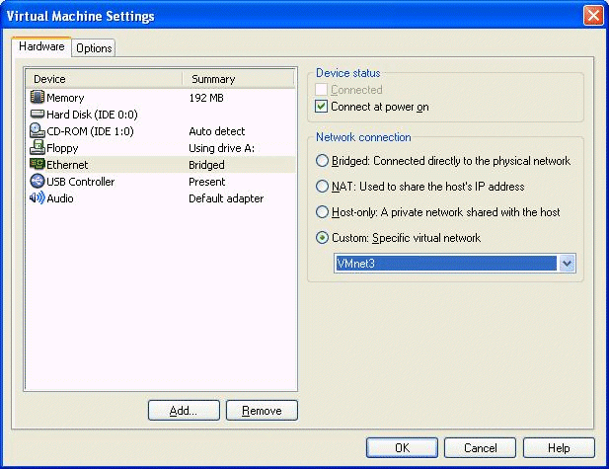

- Start your virtual machine. Your virtual machine should now connect to the Internet.

