Observing the Effect of Limited Accounts
- Start your computer. You should see the Windows Welcome screen with several user names on it, including one named Waldo. Click on your name and log in with a password of password.
- Click Start, Control Panel. Click User Accounts. Click on Waldo.
- In the What do you want to change about Waldo’s account? screen, click Change the account type.
- In the Pick a new account type for Waldo screen, click Limited. Click Change Account Type.
- Close the What do you want to change about Waldo’s account? screen.
- Close all windows and log out. Log in as Waldo.
- Click Start, Control Panel, User Accounts. Note that you cannot see the other user’s accounts or change them. Waldo does not have administrative privileges – Waldo can change his own account settings but no one else’s.
- Double-click the clock in the lower right part of the screen. You see a message saying You do not have the proper privilege level to change the System Time. That’s another thing Limited accounts cannot do.
- Close all windows and log out.

Allowing Shared Folders in Your Profile
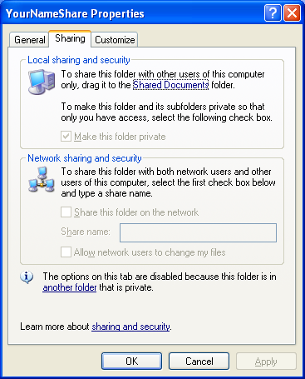
- Log in with your own account, which has administrative privileges.
- Right-click on the desktop and select New, Folder. Enter a folder name as YournameShare, using your own name instead of Yourname.
- Right-click the YournameShare folder and select Sharing and Security.
- There are two possible boxes you might see now. If the YournameShare Properties window has the sharing boxes grayed out, as shown to the right on this page, continue to do the steps on this page. If it looks like the figure on the top of the page 3, skip to step 14.
  - You cannot share this folder because you chose to make your folders private when you added a password to this account. The desktop is one of your folders, so it is private too.
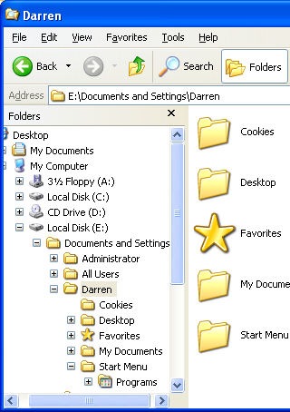
  - To make sharing possible, right-click the Start button and select Explore. You will see an expanded tree as shown to the right on this page. There is a folder named Start Menu and a folder under it named Programs. Look at the fifth folder above Start Menu and find the folder with your name on it. This folder is the one that contains your User Profile – all the files and settings that customize your experience, including your desktop.

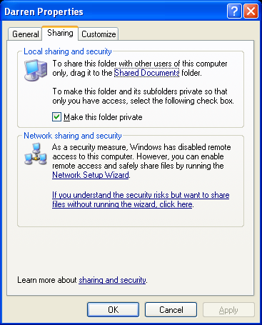
  - Right-click the folder with your name on it and select Properties. That opens a window titled Yourname Properties, as shown to the right on this page. Uncheck the Make this folder private box and click OK. That will allow you to share files on your desktop.
  - Close all windows.
  - Right-click the YournameShare folder and select Sharing and Security.
  - Now proceed to step 14.

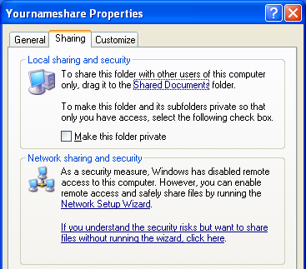
Bypassing the Network Setup Wizard
- The YournameShare Properties window should look like the figure to the right on this page. In the Network sharing and security section, this message appears: As a security measure, Windows has disabled remote access to this computer. Click the lower link that begins If you understand the security risk … link.
- In the Enable File Sharing window, select Just enable file sharing and click OK. (The Network Setup Wizard would enable Internet Connection Sharing on this machine, which is useful for home networks but not commonly used in schools or businesses.)

Sharing a Folder (Read-Only)
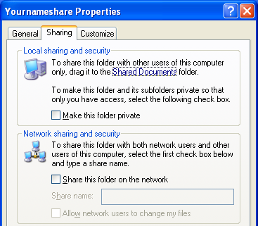
- Now you should see the Share this folder on the network option in the lower pane of the YournameShare Properties window as shown in the figure to the right on this page.
- Check the Share this folder on the network box. Uncheck the Allow network users to change my files box. Click OK. (If your share name is longer than 12 characters, you will get a warning box telling you that earlier operating systems will not be able to access it. Click Yes.)
- Open the YournameShare folder, right-click an empty portion of the window and select New, Text Document. Name the document Shared Data and double-click it to open it in Notepad. Type a few words into the document and save it.
- Close all windows.

Accessing a Read-Only Shared Folder
- Find a partner who has reached this step of this project. Go use your partner’s machine. It does not matter which account you are logged in with – you can use your partner’s account, your account on that machine (if you have one), or the Waldo account.
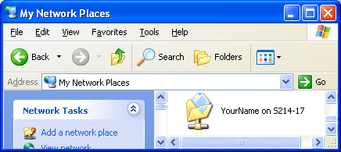
- On your partner’s computer, click Start, My Computer. In the left pane, click My Network Places. You should find a folder named YournameShare on S214-17 (with your computer name instead of S214-17). If it is not there, refreshing the page with the F5 key, or waiting, may help. If you are waiting more than 3 minutes, try restarting both your original machine and your partner’s machine.

- When your shared folder is visible, double-click it to open it. You should see the Shared Data file.
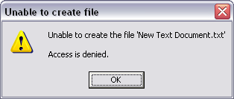
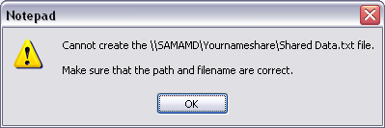
- Double-click the Shared Data file to open it in Notepad. You should be able to read the text. Type some additional text in the file and click File, Save to save it. You should get a Cannot create … error message as shown to the right on this page, because you did not allow network users to change your files. Click OK to close the error message. Close the Save As… box. Close Notepad. Do not save changes.
- Right-click an empty spot in the shared folder’s window and select New, Text Document. You should get an Unable to create file error message as shown to the right on this page, because you did not allow network users to change your files.
- Close all windows.

Using Simple File Sharing to Share a Folder (Full Control)
- Return to your original machine. Click the Start button and look at the name at the top of the menu – it should be your own name. If it is not, log out and log in with your own account, to make sure you have administrative privileges.
- Right-click the YournameShare folder and select Sharing and Security.
- Verify that the Share this folder on the network box is checked. Check the Allow network users to change my files box. Click OK.
- On your partner’s computer, open the shared folder.
- On your partner’s computer, double-click the Shared Data file to open it in Notepad. Type some additional text in the file and click File, Save to save it. You should have no trouble saving the modified file.
- On your partner’s computer, right-click an empty spot in the shared folder’s window and select New, Text Document. You should have no trouble creating the file.
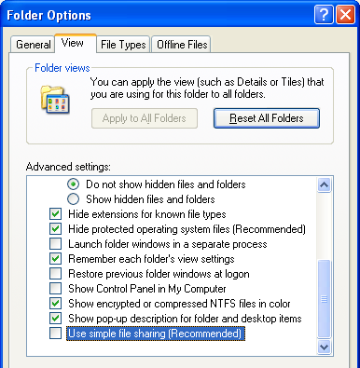
- On your partner’s computer, close all windows, and click Start, Log Off. When you see the Log Off Windows box, leave the screen that way.

Turning off Simple File Sharing
- Return to your original machine.
- Click Start, Control Panel. Click Appearances and Themes. Click Folder Options.
- In the Folder Options window, click the View tab. In the Advanced Settings box, scroll to the bottom and uncheck Use simple file sharing (Recommended), as shown to the right on this page. Click OK. Close the Appearances and Themes window.

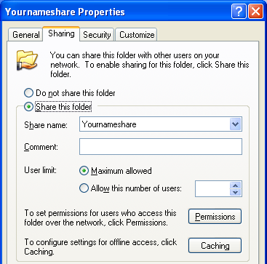
- Right-click the YournameShare folder and select Sharing and Security. Now you see a Windows-2000-style window as shown to the right on this page. There are more options here – you can control the share permissions with the Permissions button, and the NTFS security settings with the Security tab.
- Click the Permissions button. A Permissions for YournameShare window opens, showing that Everyone has Full Control access to the shared folder, when accessing it over the network. That’s what Simple File sharing does. Close the Permissions for YournameShare window.
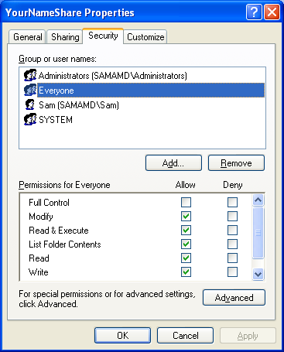
- Click the Security tab. Here you can see the NTFS permissions for this folder, which control access to it by any user, whether they connect over the network or by logging in locally to the machine that has the folder. There are several groups or user names listed here. Click on Everyone. You will see that the Everyone group has five of the six basic permissions checked, as shown to the right on this page. Close the YournameShare Properties window.

Turning Simple File Sharing On
- Click Start, Control Panel. Click Appearances and Themes. Click Folder Options.
- In the Folder Options window, click the View tab. In the Advanced Settings box, scroll to the bottom and check Use simple file sharing (Recommended). Click OK. Close the Appearances and Themes window.

Simulation: Permissions
- Open My Computer. Click My Network Places in the left pane.
- Find the shared folder named CNIT235 on Instructor1 and double-click it.
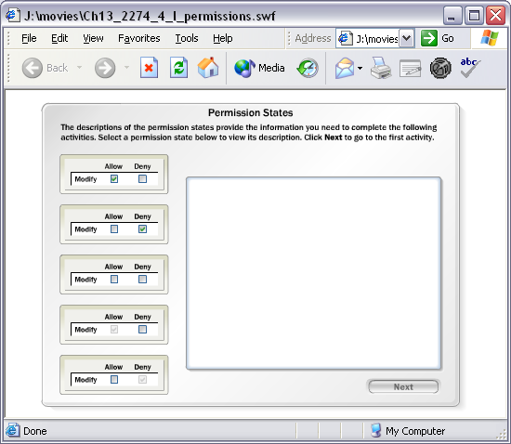
- Find the file Permissions.swf and drag it to your desktop. After it has been copied, close all windows.
- Double-click the Permissions.swf file and go through the activity. If a Windows box opens saying Windows cannot open this file, click Select the program from a list and click OK. In the Open With… box, verify that Internet Explorer is highlighted and click OK. A shockwave animation should open as shown to the right on this page. Go through the animation to practice applying permissions.

Last modified 8-26-04

