- Log in to the server as a local Administrator.
- Click Start, Run, and enter DCPROMO
- At the Welcome to the Active Directory Installation Wizard screen, click Next.
- At the Operating System Compatibility screen, click Next.
- At the Domain Controller Type screen, accept the default setting of Domain controller for a new domain and click Next.
- At the Create a New Domain screen, accept the default selection of Domain in a new forest and click Next.
- At the New Domain Name screen, enter a domain name of s214.com and click Next.
- At the NETBIOS Domain Name screen accept the default selection of S214 and click Next.
- At the Database and Log Folders screen, accept the default selections and click Next.
- At the Shared System Volume screen, accept the default selection and click Next.
- At the DNS Registration Diagnostics screen, there will be a Diagnostic Results message, warning you that this domain name is not accepted as a real Internet domain name. That’s OK because we only want to use it in the lab, so it does not have to be accepted by real Internet DNS servers. Therefore, click Install and configure the DNS server on this computer, and set this computer to use this DNS server as its preferred DNS server. Then click Next.
- At the Permissions screen, accept the default selection of Permissions compatible only with Windows 2000 or Windows Server 2003 operating systems and click Next.
- At the Directory Services Restore Mode Administrator Password screen, enter password in both boxes and click Next.
- At the Summary screen, click Next.
- An Active Directory Installation Wizard window opens with an animation of a pencil writing in a book. Wait for it to finish – it may take 5 minutes or longer.
- At the Completing the Active Directory Installation Wizard screen, click Finish.
- Restart your server when you are prompted to.
- When you log in, you will see the domain name in the third line of the log in screen. Log in as Administrator.
- Click Start, right-click My Computer, and select Manage. Expand Services. If your computer is a DHCP server, you will have to authorize it by right-clicking on it and selecting Authorize.
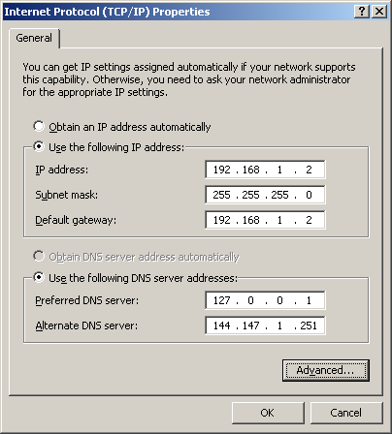
- The domain controller should have a static IP address. To make these settings, open Control Panel, Network Connections, right-click your LAN connection and select Properties. Then click TCP/IP and click Properties.
- The domain controller should also have two DNS servers: one of 127.0.0.1 so it tries to resolve domain names itself, and a second one that points to your ISP’s DNS server (or the default gateway, if you are using a DNS proxy) to resolve external domain names.
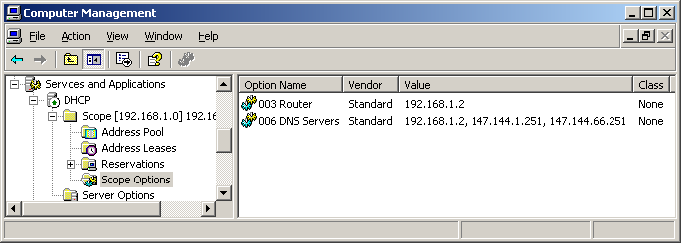
- The client computers will have to set the domain controller as their DNS server. If you are using DHCP, you should set it to distribute the correct DNS server address. To do that, open Computer Management, expand Services and Applications, DHCP, Scope, and select Scope Options as shown in the figure below. Then double-click DNS Servers and set the domain controller to be the first DNS server in the list.

Revised 5-11-05

