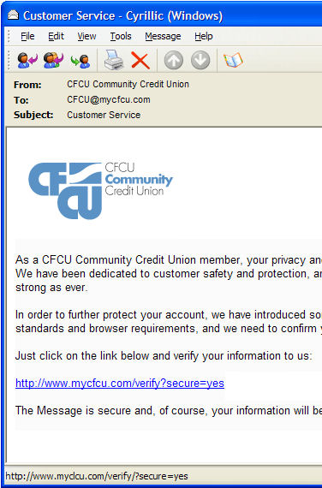
Ch 1: Understanding Internet Risk

Attacks

Fraud

Tricking you into giving criminals your

Money

Passwords

Credit card number

etc.

Hijackers

Take control of your computer

Identity Theft

Criminals pretend to be you, with

Social Security Number

Credit Card Number

Bank Account login info

They take your money & ruin your credit

Phishing

Email tries to trick you

Goal is usually to get your password

See link Ch 1a on my Web page

samsclass.info

Phishing Timeline

See link Ch 2g
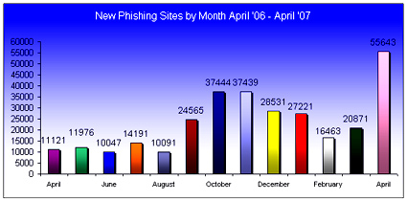

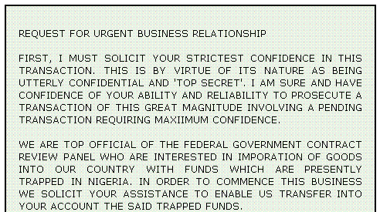
The "Nigerian" Scam
Get rich quick

They trick you into sending money to them to bribe officials, etc.

Also called "419 scam"

See links Ch 1h-j

Spam

Unsolicited email

Scams -- get-rich offers, messages from banks, etc.

Click on links or opening attachments, malware gets on your computer

Hint: Use Gmail to stop spam

But—privacy concerns (links Ch 1b & Ch 1c)


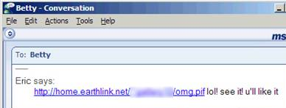
Spim

Instant message spam

See links Ch 1k & Ch 1l

Image from microsoft.com

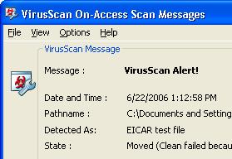

Viruses

Viruses reproduce and spread from one computer to another

If you get infected, your machine can harm other machines

ALWAYS RUN ANTIVIRUS SOFTWARE

McAfee is free to CCSF students (Link 1m & n)

AVG is free to everyone (Link 1o)

Norton is popular but costs money (Link 1p)

Panda is reportedly the best, but costs money (Link 1q)

Viruses and Worms

Viruses are attached to a file, such as a Word Document

Worms travel by email or other means, not attached to a file

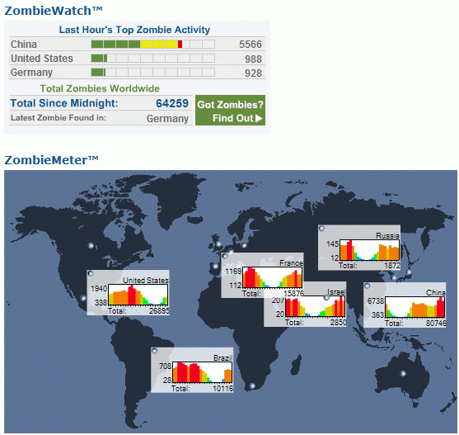
They both can

Hijack your computer

Destroy files

Steal personal information

Hint: Get a Mac, or use Linux

Spyware, Adware, Trojans

Spyware

Collects keystrokes or other data

Adware

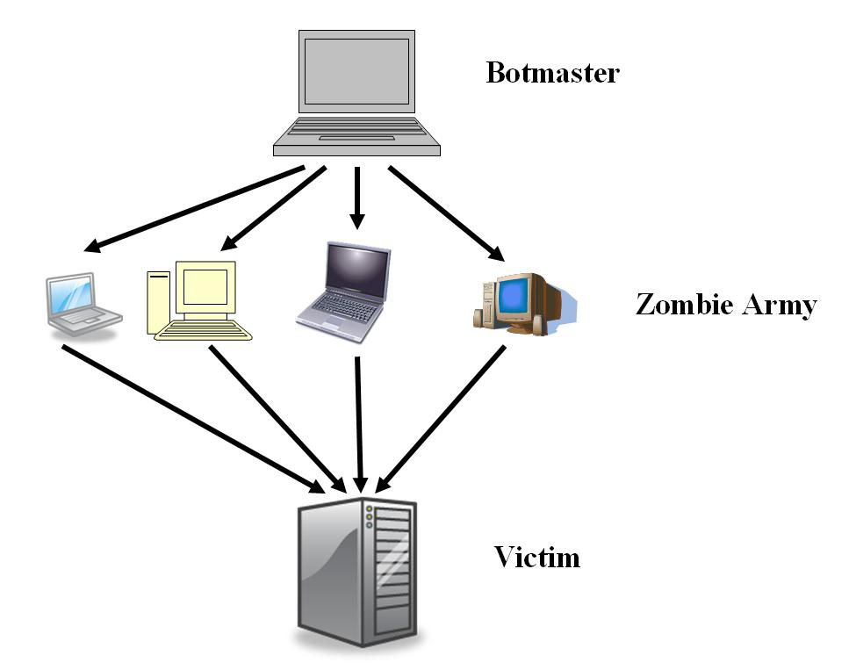
Displays ads on your screen

Trojan Horses

Makes your computer a "zombie" machine, controlled by a criminal

Zombies

Machines controlled by criminals

Used to send spam, or perform attacks on Web sites

See links Ch 1d – 1f on my Web page

samsclass.info

Distributed Denial of Service

Botnet Control Panel

This is what the criminals see when managing their zombie army

Link Ch 1g

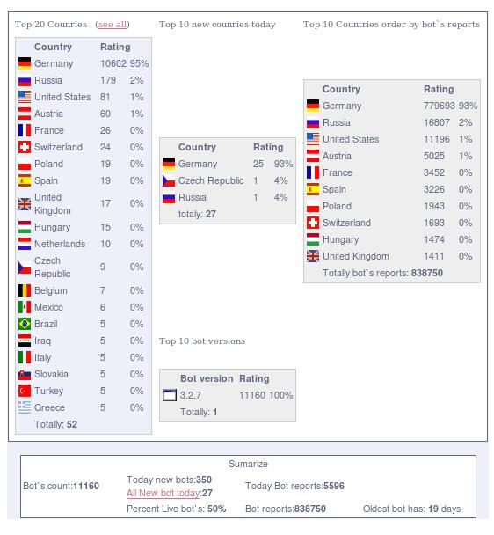

Chapter 2: Preventing Identity Theft

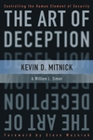
How Identity is Stolen

Database break-ins

TJX: Largest consumer data theft ever

Because they used WEP for their wireless network

See links Ch 2a-d

Insiders also sell data to criminals

Social Engineering

Tricking or conning people

The most dangerous part of any computer network is the people

See link Ch 2e

Phishing and Spoofing

Phishing

Sending an email message or instant message to get a victim to click on a link

Spoofing

Making a counterfeit website to collect personal data

HTTP v. HTTPS

Never enter anything private into an http: page

ALWAYS look for the https: or the padlock symbol

Advantages of HTTPS

HTTPS guarantees:

Confidentiality

No one can read the data except the intended recipient

Integrity

No one can alter the data you send

Authenticity

The person receiving the data is really who they claim to be
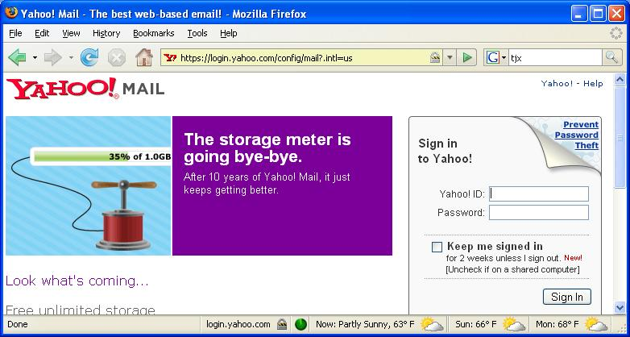

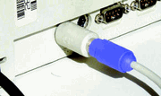
Keystroke Loggers

Software or Hardware

Records everything you type

Hardware keyloggers can't be detected by antivirus programs, or any other security software

See link Ch 2f

Preventing Identity Theft

Be suspicious of websites that ask for your personal data

Don't click links in email or instant messages hastily

Watch for warnings from your browser—don't use sites that produce them

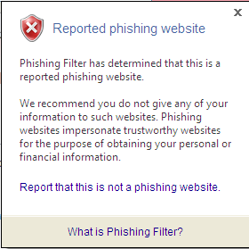
Use antivirus and antispyware software

Check your bank statements

Browser Safety

Internet Explorer is very unsafe

The newest version is a little safer with its "Phishing Filter"

Firefox is MUCH safer (link Ch 1r)

Opera is probably even safer than Firefox (link Ch 1s)

Avoid Internet Explorer!

Last modified 6-10-07

