Ch 3: Firewalls

Phone Numbers

You can’t just buy a phone and make phone calls

You also have to pay money to a phone company, and they give you a phone number

Without that number you cannot send or receive phone calls

IP Addresses

You can’t just connect a computer to the Internet

You need to pay money to an Internet Service Provider, and they give you an IP Address

Without an IP Address, you cannot send or receive data to the Internet

Even if you go to a place with “Free Internet Access,” someone paid for the Internet service

IPv4

Internet Protocol Version 4

Currently used on the Internet

Each IP address has four numbers in the range 0-255 separated by periods

Ex: 147.144.51.1

Some day we will all switch to IPv6, which has much longer addresses like this:

20a1:0db8:85a3:08d3:1319:8a2e:0370:7334

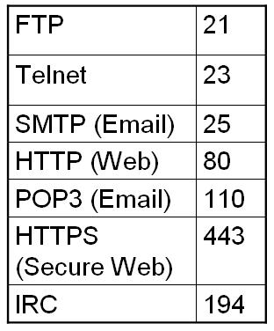
See link Ch 3a

Phone Extensions

Sometimes a company has one phone number shared by many people

So a Phone extension is added to the phone number, like 111, 112, 113, etc.

Port Numbers

Computers send more than one kind of data to the Internet

Email, Web pages, music, chat, instant messages, etc.

The traffic is distinguished by Port Numbers that are added to the IP Address

Common TCP Ports

See links Ch 3b & 3c

Port Scanning

If you want to see a Web page, your browser sends a request to Port 80

If you want to send E-mail, you send packets to port 25 on a server

But if you want to find out what a server can do, you could just send a lot of packets of all different types

Why do Port Scans?

To test your security settings, primarily the firewall

To find vulnerabilities, because you are a criminal trying to hack into a system illegally

Therefore, port scans of real network servers can be flagged by intrusion detection systems, and get people all upset

The Matrix Reloaded

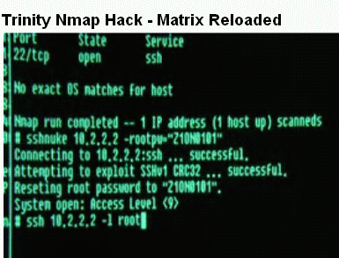
Trinity uses Nmap

Video at link Ch 3f


Port Scans Can be Illegal

An aggressive Port Scan can tie up a server, or even crash it

That might make port scans a Denial of Service, which is a crime

Link Ch 3e

Professor Packetslinger

of the School of Loose Screws

See link Ch 3d

A professor assigned a project doing an unauthorized scan of a real network

Hot debate raged about the ethics

Project 4x: Port Scanning

In Project 4x, you download a port scanner called NMAP

Use it to scan a computer in S214 to see what the firewall does

DO NOT use it to scan other people’s servers without permission

You will get in trouble if you do

You have been warned!

Understanding Firewalls

Firewalls are hardware devices or software installed on a system and have two purposes

Controlling access to all traffic that enters an internal network

Controlling all traffic that leaves an internal network

Firewalls let traffic on some ports through, but block other traffic

Hardware Firewalls

Advantage of hardware firewalls

Faster than software firewalls (more throughput)

Disadvantages of hardware firewalls

Usually filter incoming traffic only (link Ch 13i)

More expensive

Software Firewalls

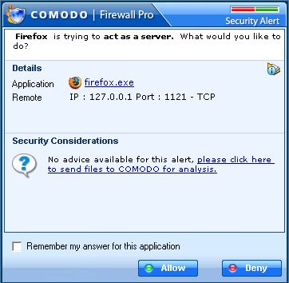
Advantages of software firewalls

Customizable: can interact with the user to provide more protection

Cheap, often free

Firewalls Compared

Comodo is the best

Microsoft Windows Firewall is the worst

See link Ch 3g

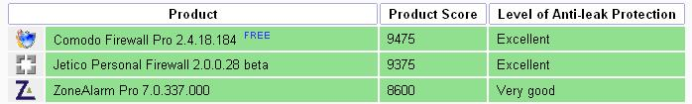

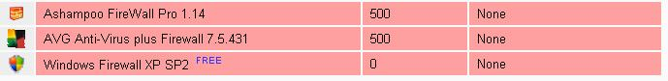

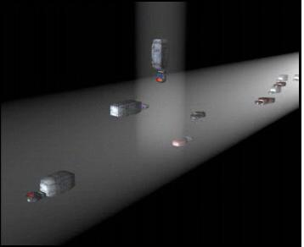

Warriors of the Net

Free video about networking

Warriorsofthe.net (link Ch 3h)

We'll Skip Chapter 4

We already covered malware enough in chapters 1 and 2

Last modified 6-12-07

