Ch 9: Wireless Security

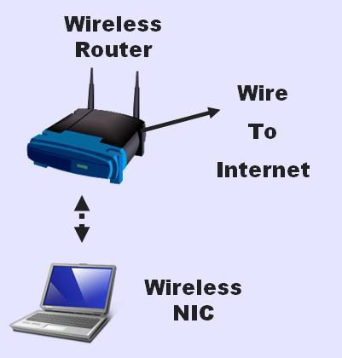
Components of a Wireless (Wi-Fi) Network

Wireless Router

Wireless network interface card (WNIC)

Ethernet cable to connect AP to Internet

Wireless Router

Wireless Router receives and sends radio signals

It also connects to the Internet with an Ethernet cable

It bridges the wireless network with the wired network

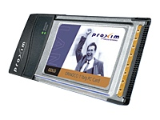
Wi-Fi NICs

To connect to a Wi-Fi network, you need a Network Interface Card (NIC)

The most common type is the PCMCIA card

Designed for laptop computers

USB and PCI Wi-Fi NICs

USB

Can be used on a laptop or desktop PC

PCI

Installs inside a desktop PC
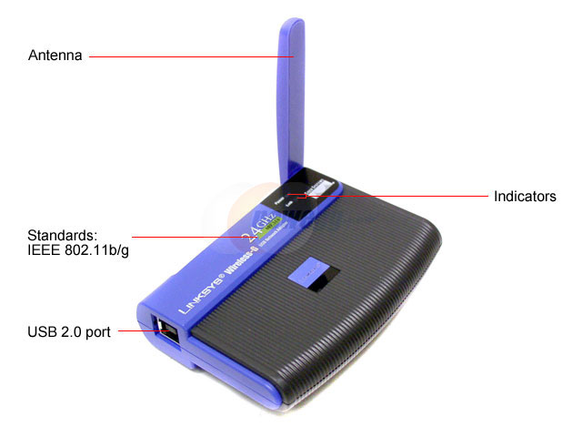
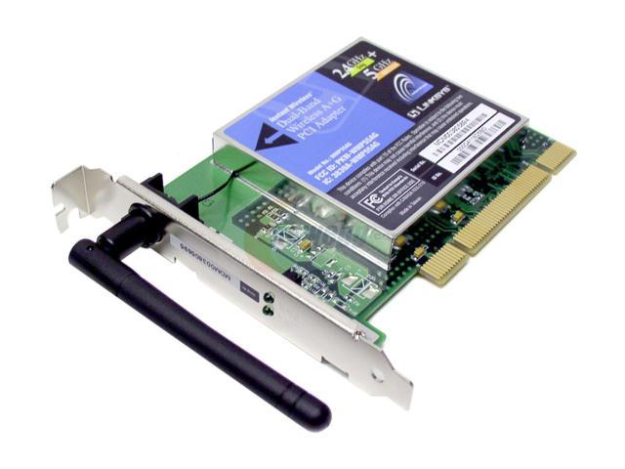
PCMCIA
PCI
USB

Wireless Network Standards

802.11b

Max. speed 11 megabits per second

Range 100 to 150 feet

802.11g

Max. speed 54 megabits per second

Range 100 to 150 feet

802.11a

Max. speed 54 megabits per second

Range 25 to 75 feet

All Devices Must Match

Your Wireless Router must use the same standard as your Network Interface Card

Older devices use 802.11b

Newer ones can usually support 802.11g or 802.11b

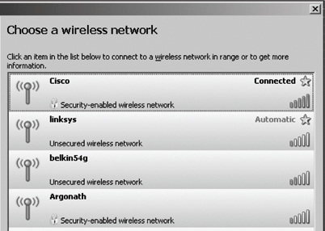
"Wireless-N" devices are even faster

Service Set Identifiers (SSIDs)

Name used to identify the wireless local area network (WLAN)

The AP usually broadcasts the SSID

Service Set Identifiers (SSIDs)

The SSID is set on the Access Point

The Channel is also set on the Access Point

Usually channel 1, 6, or 11

Configuring a Wireless Router

Most devices allow access through any Web browser

Connect a computer to the Wireless Router

Open a browser

Enter the Wireless Router's IP address

Provide the Wireless Router's logon name and password

Name and Password

The Wireless Router name and password starts with something simple and obvious like 'admin' and no password

You should change it to something only you know

If you forget your password, hold down the reset button on the back of the router for 10 seconds to restore factory settings

Encryption

Everything you send through a wireless network can be received by any other computer nearby

You need to encrypt the traffic for privacy

Wireless Security Options

Wired Equivalent Privacy (WEP) encryption

Out of date

Can be easily hacked into

WPA (WiFi Protected Access )

Much safer than WEP

WPA-PSK (Pre-Shared Key) is the most common type

WPA2 is even safer
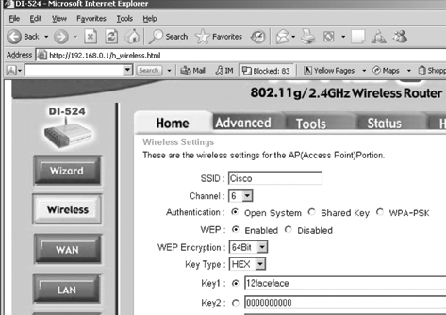

Essential Security Measures

Change your router's password

Choose a password that is not a dictionary word

Use WPA (or WPA2) encryption

Choose a key that is not a dictionary word

Optional Security Measures

Change your SSID

Turn off SSID Broadcast

These changes make your network a little harder for hackers to find

Won't stop serious hackers

WEP encryption

If you have old equipment that cannot use WPA, WEP is better than no encryption at all

Disabling SSID Broadcasts

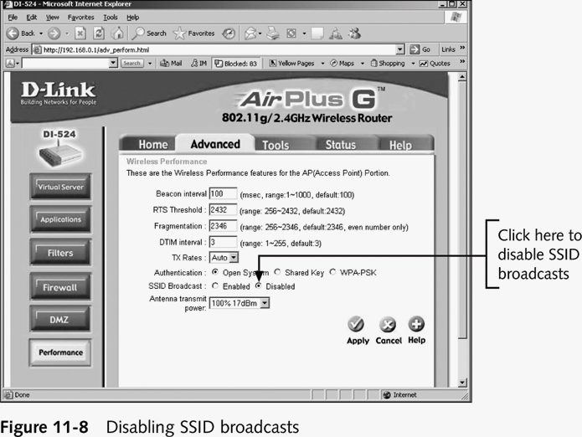

WEP Encryption is Risky

WEP is not trustworthy

TJX: Largest consumer data theft ever

Because they used WEP for their wireless network

See links Ch 2a-d

Last modified 6-20-07

