Ground Rules
Use a Virtual Machine – Don’t Even THINK of Doing this to a Machine You Love!
- This project will break your machine. You may very well never be able to fix it again, without reformatting the hard disk and reinstalling Windows. So use a virtual PC – that’s what they are for! Whatever you do, do NOT try this on someone else’s computer, or on a computer with valuable or private information, emails, etc. Remember what side of the fence we are on: Our ultimate goal is to FIX broken machines, not to take machines people love and ruin them.

Making Your VM (Virtual Machines) Folder
- Start your computer in S214, and log in as CNIT30. There is no password.
- Click Start, My Computer. Double-click the VMs (V:) drive to open it.
- In the VMs (V:) window, right-click the empty space and click New, Folder. Name the folder YOUR NAME VMs replacing YOUR NAME with your own name.

Copying a Windows XP Virtual Machine into Your VM Folder
- In the VMs (V:) window, double-click the Hacking folder to open it. Right-click the Win XP Pro for Hacking folder and click Copy.
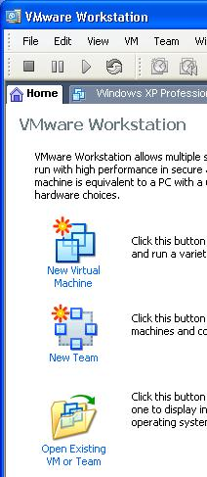
- In the Hacking window, click the Up button on the toolbar. Right-click the YOUR NAME VMs folder and click Paste. Wait until the copy is finished. This will be your personal Virtual Machine.
- In the VMs (V:) window, double-click the YOUR NAME VMs folder to open it. Right-click on the Win XP Pro for Hacking folder and select Rename from the context menu. Give it a new name of Your Name Wrecked Win XP Pro.
Launching VMWare
- Click Start, All Programs, VMWare, VMWare Workstation. If you see a “Tip of the day” box, click Close. If you see a “VMware Web Check” box, click Cancel.
- In the VMWare Workstation window, from the menu bar, click View, “Go to Home Tab. You should see a screen with three large icons, as shown to the right on this page. Click the Open Existing VM or Team icon.
- In the Open box, click “My Computer”. Double-click the “VMs (V:)” drive to open it. Double-click the YOUR NAME VMs folder to open it. Double-click the “Your Name Wrecked Win XP Pro” folder. Double-click on the “Windows XP Professional.vmx” file. (The .vmx filename extension may not be visible.)

- The VMWare Workstation window reappears, with a tab labeled “Windows XP Professional”. In the left pane, click the blue Start this virtual machine link.
- If a “Windows XP Professional – Virtual Machine” box opens with a long message about product activation, click OK.
- A “Windows XP Professional – Virtual Machine” box opens asking if it should create a new unique identifier (UUID). Accept the default selection of Create and click OK.
- A “Windows XP Professional – Virtual Machine” box opens warning you that the default sound device cannot be opened. Click OK.
- If a “Windows XP Professional – Virtual Machine” box opens with message about the keyboard timeout hook value, click OK.
- When the virtual PC launches, click Student to log in. There is no password. Student has Administrative privileges over the virtual PC.
Make Sure you Have Antivirus Software Running
- If you do this project on a machine without antivirus software, you might mess up not only your computer, but other computers! It’s generally considered safe to allow a virtual PC to get spyware, but it is NOT safe to allow a virtual PC to get viruses, because the viruses can spread to your host system and to other computers on your network.
- Look at the Notification Area on the lower right of your virtual PC’s desktop, next to the clock. If you see messages warning you that your antivirus software may be out of date, close them. You should see a shield icon with a red V on it.
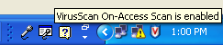
- Hover the mouse over the red V icon and wait a few seconds. You should see the message “VirusScan On-Access Scan is enabled”, as shown to the right on this page. That shows that McAfee Antivirus is running. If you are using some other antivirus product, such as Norton or AVG, you should see some icon there indicating that it is protecting you.
- If you don’t have any antivirus software running, STOP HERE and install it. You can get a free copy of McAfee Antivirus from your instructor, and you can also get AVG AntiVirus free at this website:
http://free.grisoft.com/doc/2/lng/us/tpl/v5
Updating Your Antivirus Software
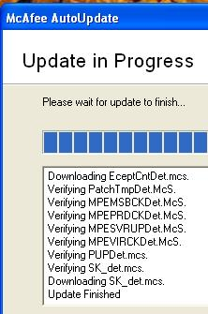
- Right-click the red V icon and click “Update Now…”. You should see a box saying “Update in Progress”, as shown to the right on this page. Wait until the update is finished, and then click the Close button.
Testing Your Antivirus Software
- Open a Web browser and go to eicar.com
- On the upper right of the eicar.com page, click the box labeled “AntiMalware Testfile”.
- The next page of the Web site explains what the antivirus test file is – glance through it. It’s a harmless program that is used to test virus scanners. It is not a real virus, but it will set off virus scanners.
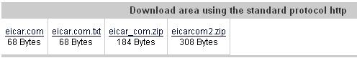
- Scroll to the bottom of this Web page and find the “Download area using the standard protocol http” section, as shown to the right on this page. On the left side, click the eicar.com link.

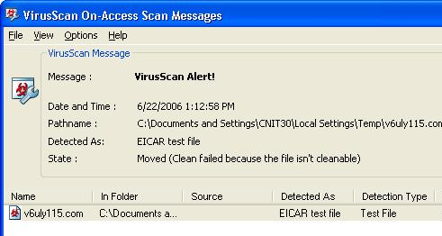
- You should see a “VirusScan Alert” appear, as shown to the right on this page. If you are not using McAfee, the alert box will look different, but it should still say EICAR somewhere on it.

Capturing a Screen Image
- You need to turn in an image of this screen to get full credit for this portion of the project. Note the hand symbol above on this page—that indicates screen images that you must capture and turn in.

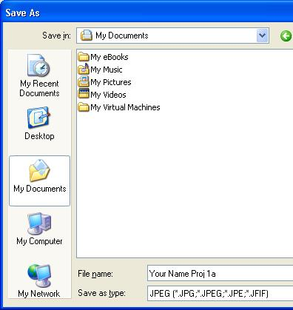
- Move the mouse pointer out of the VMWare Workstation window. Click on the host Windows XP's desktop.
- Make sure the “VirusScan Alert” is visible. Press the PrintScrn key in the upper-right portion of the keyboard. That will copy the whole desktop to the clipboard.
- Click Start, Programs, Accessories, Paint. In the untitled - Paint window, select Edit, Paste from the menu bar. The desktop appears in the Paint window, with only a corner of it visible.
- In the untitled - Paint window, click File, Save. Save the document in the My Pictures folder (or any other place you wish, such as a floppy disk) with the filename Your Name Proj 1a. Select a Save as type of JPEG, as shown in the figure to the right on this page.

Installing HijackThis!
- HiJack This is a wonderful program that can be used to diagnose Spyware infections. It’s best to install it before you get infected. HiJack This is NOT antispyware – it does not protect your machine. It just makes it easier to fix problems when they do occur.
- If you are in Science 214, use the procedure below to get HiJack This from the server in that room. If you are working at home, download it from:
http://majorgeeks.com/download3155.html
- In your virtual PC, click Start, Run. Enter \\192.168.1.3 and click OK. If you are prompted for a name and password, enter a User name of CNIT and leave the password blank.

- An Instructor1 Machine in Sci214 window opens. Double-click the CNIT 30 folder. Drag the hijackthis Zip archive to the desktop of your virtual PC.
- Double-click the hijackthis Zip archive. In the hijackthis.zip window, drag the HijackThis executable file to your desktop, as shown to the right on this page.

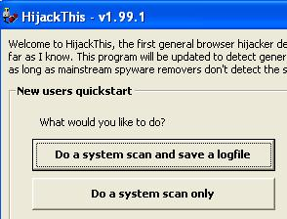
Scanning a Clean Machine with HijackThis!
- Double-click the HijackThis executable file. A HijackThis warning box opens. Read it and click OK.
- A Hijack This window opens, as shown to the right on this page. Click the Do a system scan and save a logfile button.

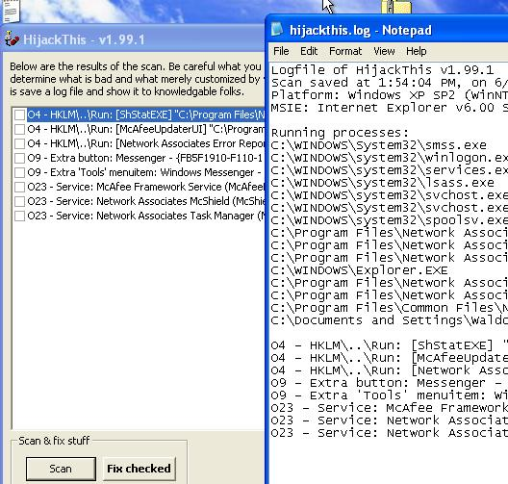
- Two windows appear, as shown to the right on this page. The two windows show the same information – processes, registry keys, toolbars, and services that look suspicious to Hijack This. The text file is more complete, but harder to read. This is what a clean machine looks like – there are only a few entries.
- Close both of the HijackThis windows.

Finding Horrible Junk to Install
- Pick some awful stuff to install. If there are known sites or programs you have had problems with in the past, use them! Make this class as relevant to your real-world problems as you can. My only requirement is that you get some junk on the machine that appears in a spyware scan later; I recommend that you get it wrecked so that Internet Explorer doesn’t work anymore. That’s usually the point at which people call Tech Support.
- If you don’t know of any horrible junk yourself, either install “Dog Days” as explained below, or read this Web page that lists the ten worst sites to download stuff from, according to McAfee:
http://blog.siteadvisor.com/2006/01/the_webs_download_disasters_in.shtml
(link Ch 1t on my Web page, samsclass.info).
Installing the Dog Days Screensaver

- Open Internet Explorer and go to RatLoaf.com
- At the top of the Web page, in the gray bar, as shown to the right on this page, click the letter D. Scroll down to "Dog Days Screensaver"—it was the eleventh item from the top when I did it. Click it.
- Install everything it tells you to, as if you trusted these people. It takes 15 or 20 clicks worth of stuff, including many warnings that what you are doing is a bad idea. It is installing TONS of Spyware.

Scanning an Infected Machine with HijackThis!
- Double-click the HijackThis executable file. In the Hijack This window, click the "Do a system scan and save a logfile" button.
- A hijackthis – Notepad window appears with a lot of information in it, but it’s not easy to tell what it means. Luckily, there is a free online analysis tool to help.
- Click anywhere in the hijackthis – Notepad window to make it active. Press Ctrl+A to select everything, and then press Ctrl+C to copy it to the clipboard.
- Open a browser and go to hijackthis.de
- Scroll down in the Web page to find the box labeled “You can paste a logfile into this textbox”.
- Press Ctrl+V to paste the logfile into the box. Scroll to the bottom of the window and click the Analyze button.
- You should see the items rated as Safe or Nasty as shown below. Scroll down and find something nasty, as shown below:
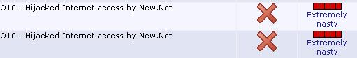

Capturing a Screen Image
- Move the mouse pointer out of the VMWare Workstation window. Click on the host Windows XP's desktop.
- Press the PrintScrn key in the upper-right portion of the keyboard. Click Start, Programs, Accessories, Paint. In the untitled - Paint window, select Edit, Paste from the menu bar.
- In the untitled - Paint window, click File, Save. Save the document in the My Pictures folder (or any other place you wish, such as a floppy disk) with the filename Your Name Proj 1b. Select a Save as type of JPEG.

Turning in your Project
- Email the JPEG images to me as attachments to a single Email message. Send it to: cnit.30@gmail.com with a subject line of Proj 1 From Your Name, replacing Your Name with your own first and last name. Send a Cc to yourself.
Last Modified: 6-11-07

